DigiWear:A full stack product delivery solution

Table of Contents
1. Introduction
2. Objectives
3. Features
- Homepage
- Login/register
- Cart page
- Order page
- Stripe checkout page
- MyOrders page
- Admin panel
4. Tech stack
5. Application flow
6. Database structure
- Users DB
- Orders DB
- items DB
7. Challenges and Solutions
8. Future Enhancements
9. Conclusion
Introduction
Here’s a suggestion for your project report introduction for the cloth delivery application:

---

### Introduction

The Cloth Delivery Application is an innovative solution aimed at revolutionizing the online shopping experience for clothing items. The application enables users to browse a wide variety of clothing options, select their desired products, and have them delivered directly to their doorstep. Through this platform, customers can easily search for clothing by category, brand, or size, while enjoying a seamless checkout process and secure payment options.

The application is designed to cater to the needs of both men, women, and children, offering diverse categories such as casual wear, formal wear, accessories, and more. With an intuitive user interface, real-time order tracking, and personalized recommendations based on user preferences, this application enhances customer satisfaction and provides an easy, efficient, and reliable shopping experience.

The system is powered by modern technologies, including a responsive front-end developed with React and a robust back-end using Node.js and MongoDB for smooth data handling and management. It also integrates secure payment systems, ensuring safe and hassle-free transactions for users.

Through this application, users can expect a user-friendly interface, a wide range of clothing products, and a reliable delivery system, making it the perfect solution for anyone seeking convenience in online shopping.
Objectives
- Intuitive and Responsive User Interface for Browsing, Ordering, and Tracking
- Design a visually appealing and easy-to-navigate interface that allows users to browse items by category, view detailed information about each item, and add items to their cart.
- Enable a smooth, responsive design so that the application is accessible on various devices, including mobile phones, tablets, and desktops, providing users with a consistent experience across platforms.
- Develop a seamless order flow, from item selection to checkout, that minimizes the number of steps required for users to complete an order.

2. Secure Payment Processing with Stripe Integration
- Integrate Stripe to handle payments securely, ensuring users can complete transactions without worry about data security.
- Enable tokenized transactions through Stripe, which adds a layer of protection by not storing sensitive payment information directly within the application.
- Streamline the checkout process to improve user experience, with clear error handling and confirmation messages to guide users through each stage of the payment.



3. Efficient Order Management System for Administrators
- Provide administrators with an intuitive admin panel that includes functionality to add, update, and remove menu items quickly.
- Allow administrators to view all orders in real-time, with the ability to update order statuses (e.g., "Processing," "Out for Delivery," "Delivered") so users are informed of their order progress.
-4. Real-Time Order Tracking for Users
- Develop a "My Orders" page for users to view all their past and current orders, providing transparency and enhancing user trust.
- Enable real-time order tracking, where users can check the current status of their order, reducing the need for manual customer inquiries.
5. Flexible Menu Management with Category-Based Browsing
- Allow administrators to categorize items to improve user experience by simplifying menu navigation.
- Enable quick updates and additions to the menu, allowing administrators to add new dresses with images, descriptions, prices, and categories, which are instantly visible to users.
- Ensure that menu items removed by the administrator are immediately reflected on the user-facing menu, maintaining accuracy in available items.
6. User Profile and Order History Management
- Implement a secure user profile section where users can view their order history and check the status of ongoing orders, which helps in retaining user engagement and loyalty.
- Include logout functionality to allow users to securely end their sessions, ensuring privacy and data security.

7. Scalability and Future-Ready Design
- Develop the application in a modular way that allows for future feature additions, such as customer reviews, loyalty rewards, and promotional deals.
- Ensure the database and backend architecture can handle an increase in user volume and orders, making the application scalable as demand grows.
-These objectives aim to build a fully functional, robust food delivery system that provides both a streamlined experience for users and effective management tools for administrators. Through this application, the goal is to deliver a reliable and user-centric solution for modern online ordering and delivery services.

FEATURES
1)HOMEPAGE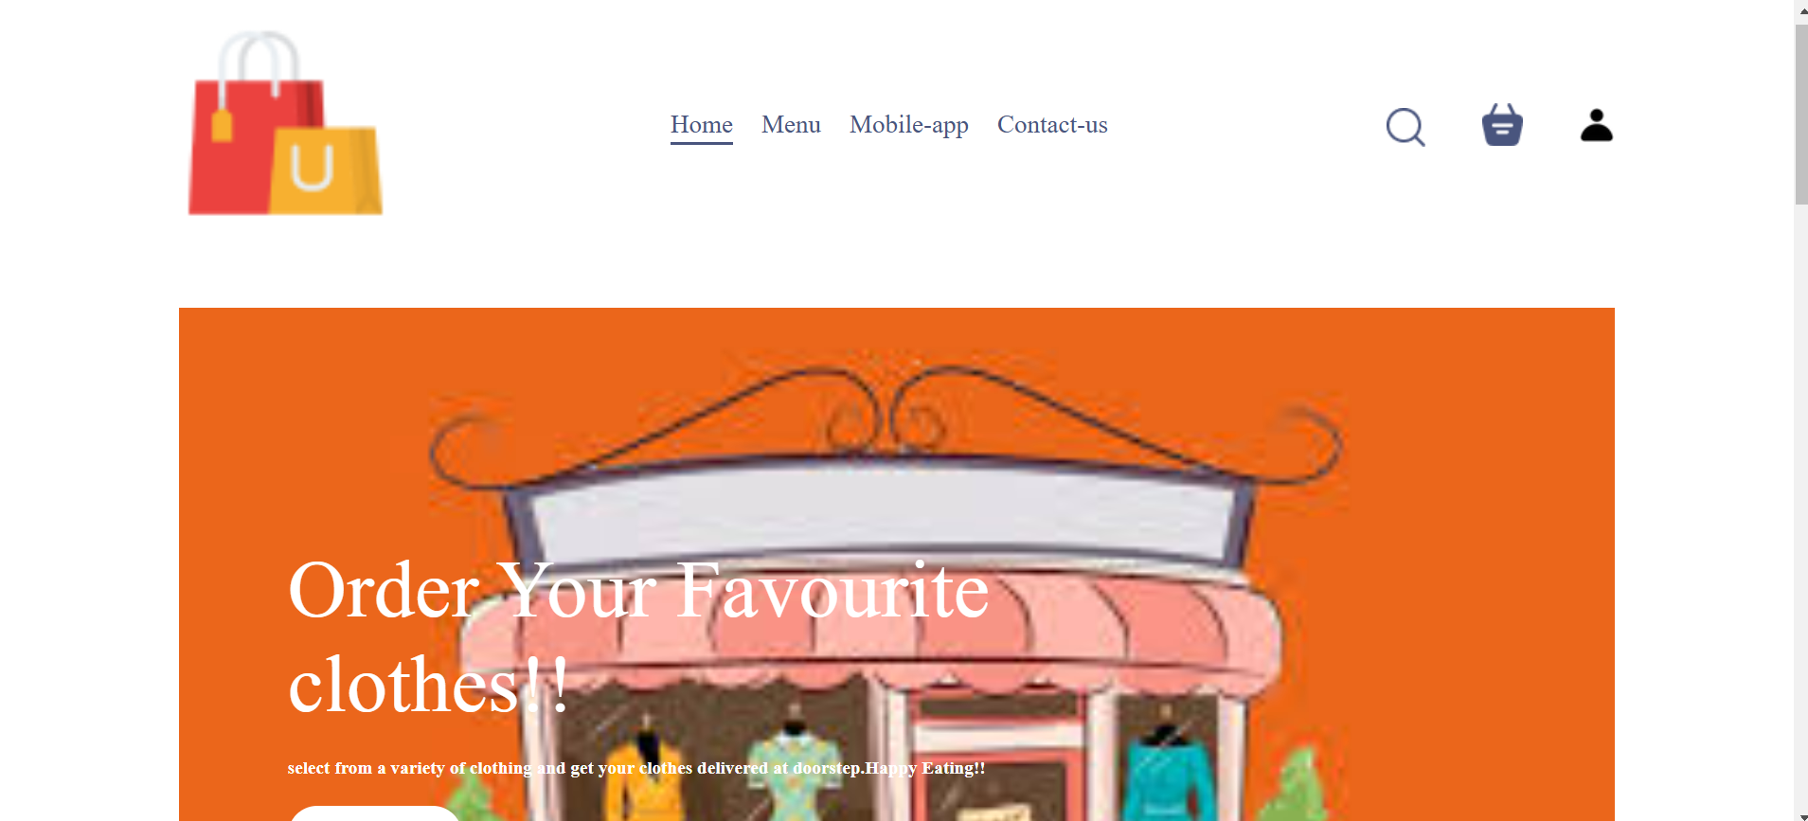
FIG:Screenshot of homepage showing navbar.the navbar has three options
- Serach
- Bag(on click redirects the user to cart page where the user can view the items they have added in their bag and sub total)
- sign in(on clicking displays the login /register component without redirecting)
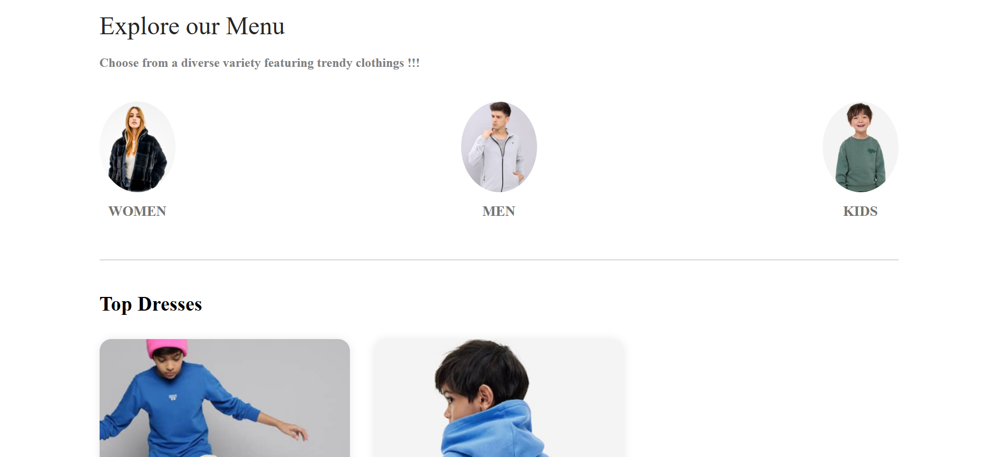
Fig:screenshot of the explore menu part of the home page.
The customer can view the menu category wise by clicking on the category(men,women,kids etc.)

FIG:screenshot of the footer
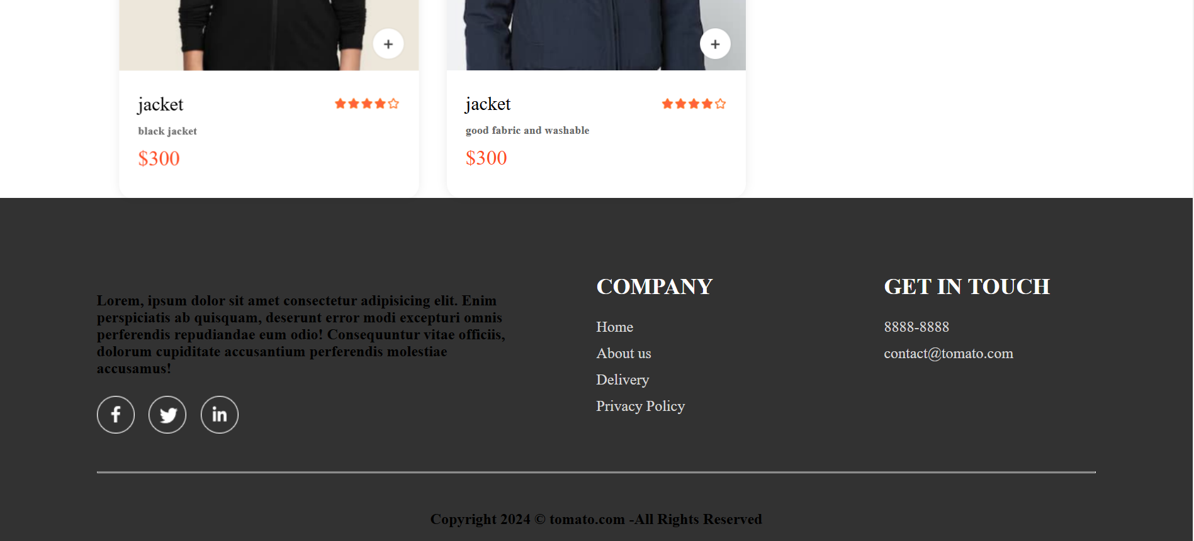
The customer can scroll down to the footer or by clicking on “contact-us” present in the navbar.

- LOGIN/REGISTER
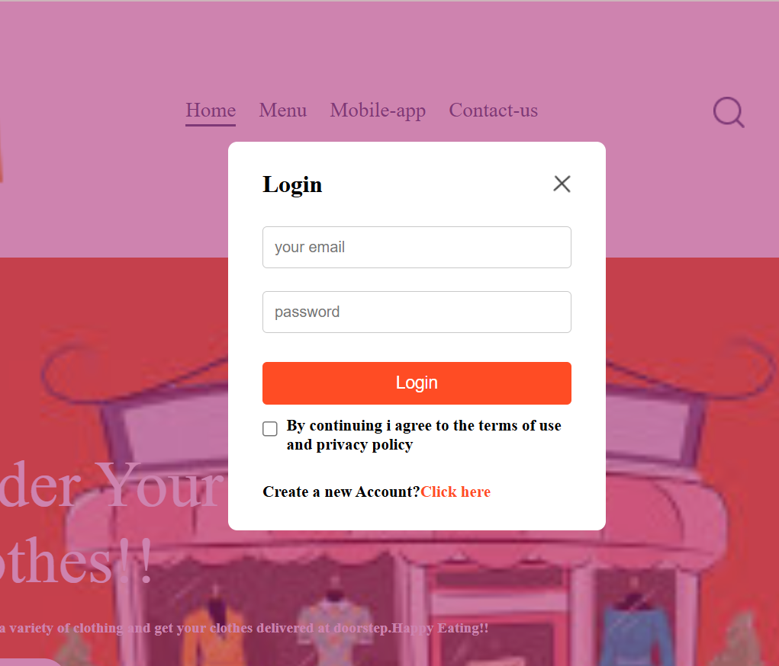

FIG:screenshot of the login popup
The login/register feature in this online delivery application allows users to securely log in or create an account. Implemented in LoginPopup.jsx, it uses the StoreContext to manage user sessions by setting a token upon successful login or registration. The axios library handles asynchronous requests to the backend, where users are authenticated or registered through API calls (/api/user/login or /api/user/register), with the server responding by issuing a token if successful. This token is then stored in local storage, enabling persistent user sessions across reloads. Conditional rendering is used to toggle between the login and signup forms, and users must agree to terms and conditions before proceeding. Additionally, the feature provides a smooth UX with state-driven UI changes based on user actions.

On clicking on the “click here” ,the register component pops up
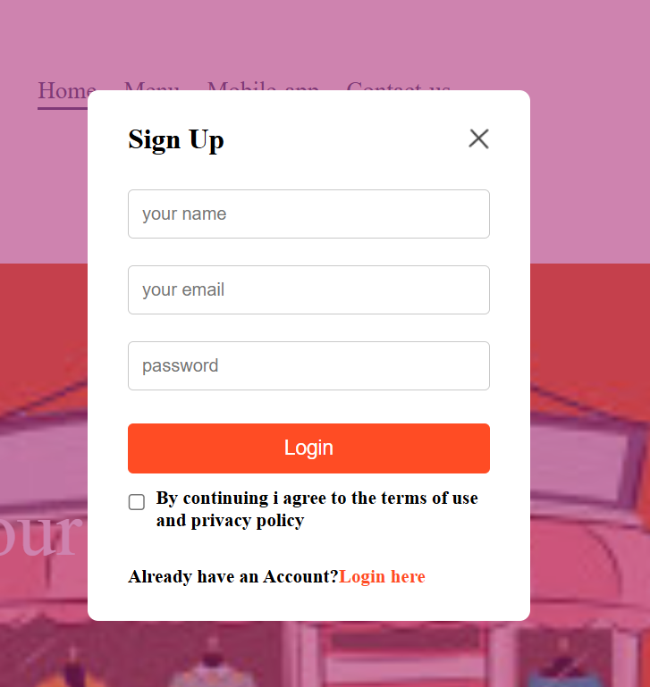

FIG:screenshot of the register popup
- CART PAGE

On clicking on the bag icon in the navbar of the homepage the user is directed to the cart page .

FIG:screenshot of the cart page.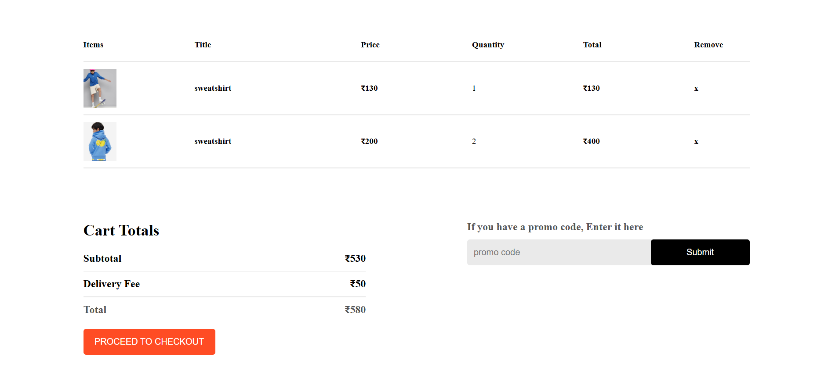

The Cart page in this online delivery application, implemented in `Cart.jsx`, displays a summary of the user’s selected items, including item details, quantity, and total cost. It leverages React’s `useContext` hook to access shared states from `StoreContext`, such as `cartItems`, `item_list`, and `currency`. Each item in the cart can be removed individually using the `removeFromCart` function. The page dynamically calculates the subtotal, delivery fee, and final total based on the current cart contents, using the `getTotalCartAmount` function to retrieve and display the updated amount. Users can enter promo codes, though it’s non-functional in the code provided. With a simple button click, users are navigated to the checkout page (`/order`) to complete their purchase. The page is styled using `Cart.css` for layout and design.
- ORDER PAGE

On clicking on “PROCEED TO CHECKOUT”,the customer is directed to the order page
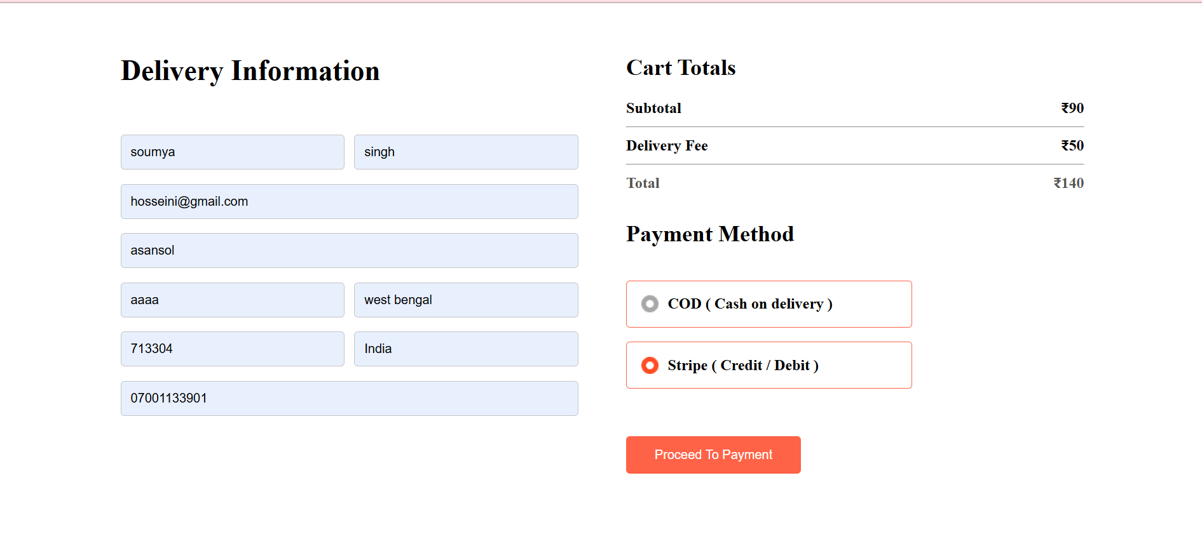FIG:screenshot of the order page

The Place Order page in this online delivery application, implemented in `PlaceOrder.jsx`, collects user delivery details, calculates the total cost, and provides payment options. The page accesses `StoreContext` to retrieve the cart items, total amount, and user token, and uses React’s `useState` to manage form inputs and payment selection (`COD` or `Stripe`). User data is gathered in controlled form fields, and when the form is submitted, `axios` sends the order details to the backend (`/api/order/place` for Stripe and `/api/order/placecod` for COD), passing the token in the header. Stripe orders redirect to an external checkout page, while COD orders navigate to the user’s orders page on success. The page also ensures users are signed in and have items in the cart before proceeding.

- STRIPE CHECKOUT PAGE

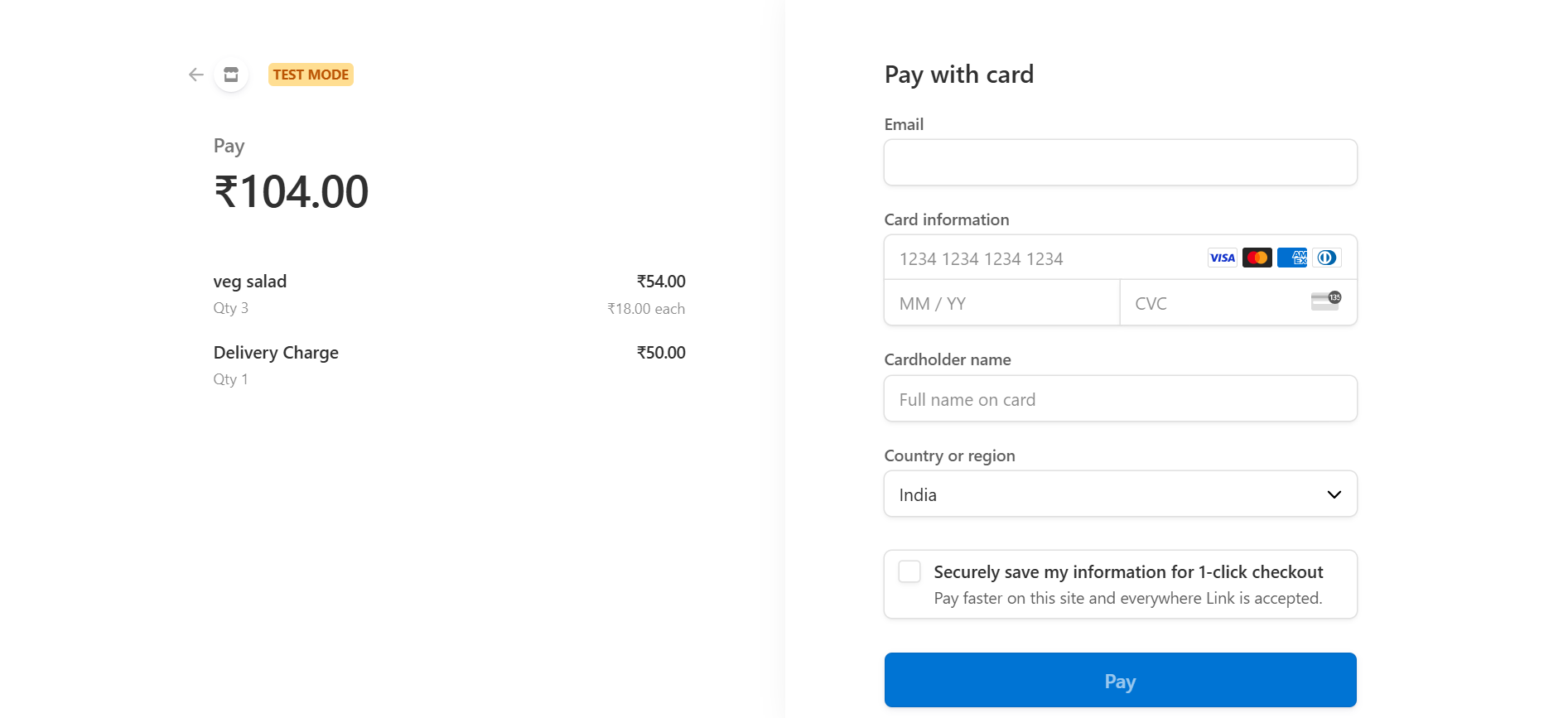
The Stripe payment integration in this food delivery application is implemented in `orderController.js` within the `placeOrder` function. When a user places an order, the order details (user ID, items, amount, and address) are saved in the database, and any existing cart data is cleared for the user in `userModel`. An array namely `line_items` array is created for Stripe’s checkout session, containing each item with its price and quantity, as well as a separate item for the delivery charge. The `stripe.checkout.sessions.create()` function initializes a payment session, redirecting the user to a success or cancel URL, which includes the order ID for verification. On successful payment, the `verifyOrder` function updates the order’s payment status, confirming the transaction. Stripe is configured using the secret key, and currency is set to INR.

On filling the necessary details ,when the user clicks on pay ,the user is directed to MyOrders page on successful completion of the payment .

- MyOrders PAGE
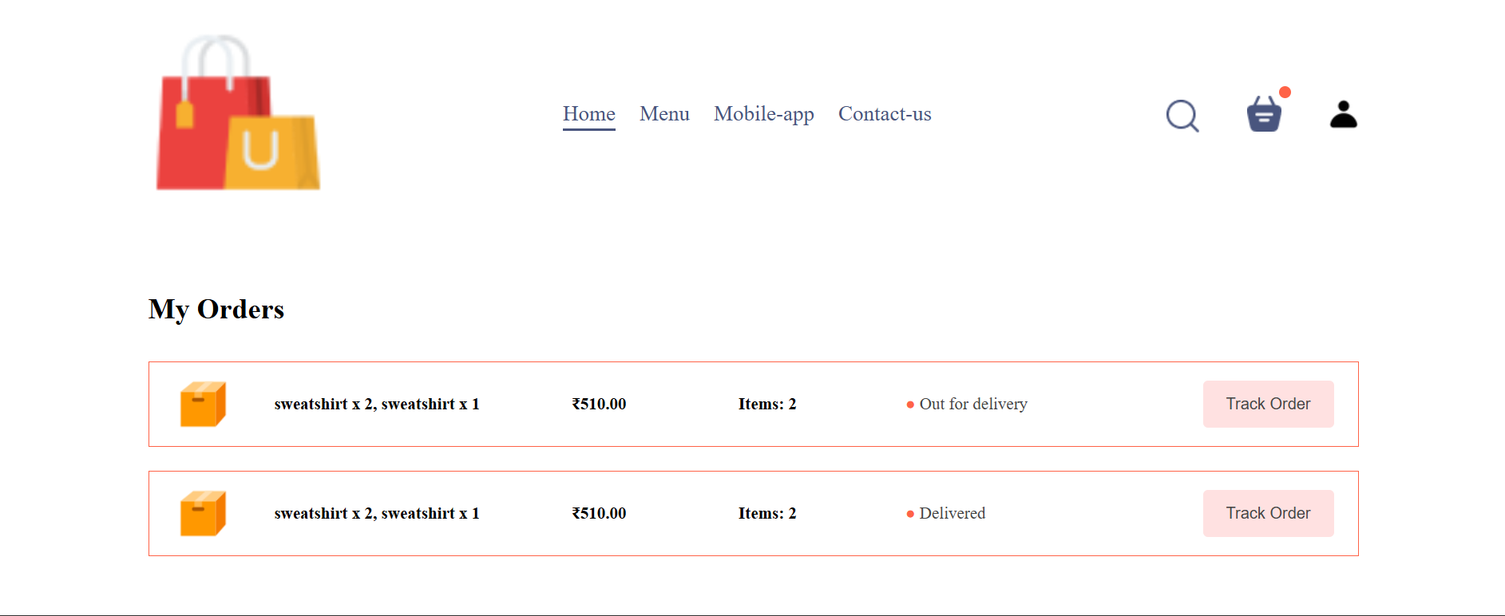

FIG:screenshot of MyOrder page
The user can track order status by clicking on “Track Order” and the status will be updated .
The `MyOrders` page allows users to view their past orders with order details fetched from the backend using an API call to `/api/order/userorders`. It retrieves and displays a list of user-specific orders by sending the user token in the request headers for authentication. Each order shows item names, quantities, total amount, item count, and current order status. The user can also click a "Track Order" button to refresh the list of orders. This page is styled with CSS and integrates `StoreContext` for global state management, accessing variables like the API `url`, `token`, and `currency` from the context.

The user can also visit the MyOrders page by clicking on the Orders option from the dropdown of profile icon
In the navbar of the homepage
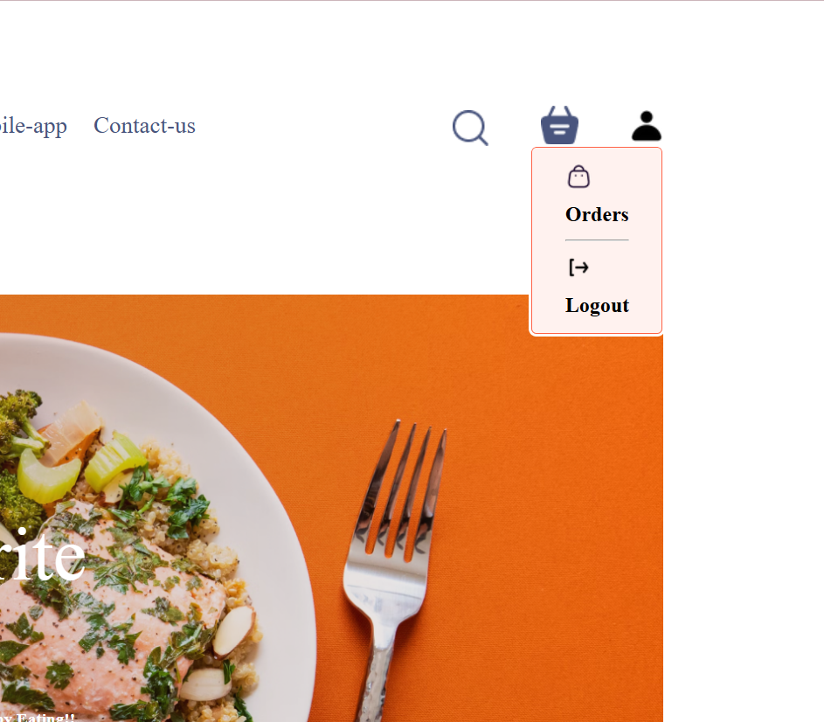

- ADMIN PANEL

The Admin panel has three pages
A)AddItem page

B)ListItem page

- ViewOrders page

- AddItems Page

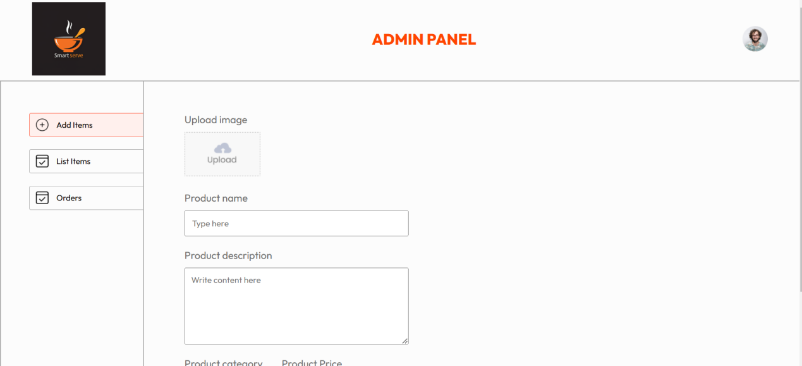

FIG:screenshot of the AddItems page of the admin panel

The `AddItems` page in the admin panel enables administrators to add new food items to the menu. Built with React, this page includes a form that captures the item’s name, description, price, category, and an image. The image upload utilizes a file input, with a preview generated using `URL.createObjectURL()`. When the form is submitted, the data, including the uploaded image, is packaged in `FormData` and sent via a POST request to the backend endpoint (`/api/food/add`) using Axios. On successful addition, the form resets, and feedback is displayed to the user using the `react-toastify` library for notifications. The page is styled using the `Add.css` file for layout and design.

- ListItems page

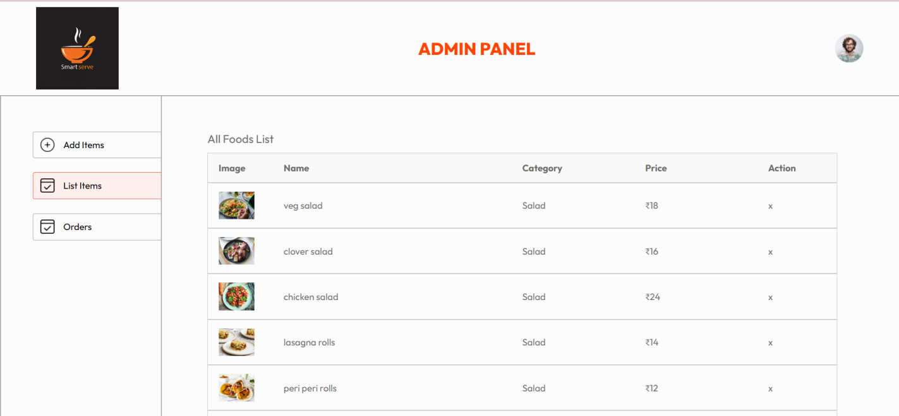

The `ListItems` page in the admin panel displays all food items currently available in the system. Developed using React, this page fetches the food list from the backend via a GET request to the `/api/food/list` endpoint using Axios, with success and error messages provided through the `react-toastify` library. Each food item is presented in a tabular format, showcasing its image, name, category, and price. Administrators can remove an item by clicking an "x" icon, which triggers a POST request to the `/api/food/remove` endpoint, followed by a refresh of the food list. The UI is styled using the `List.css` file for a clear and organized layout.

- ViewOrders page

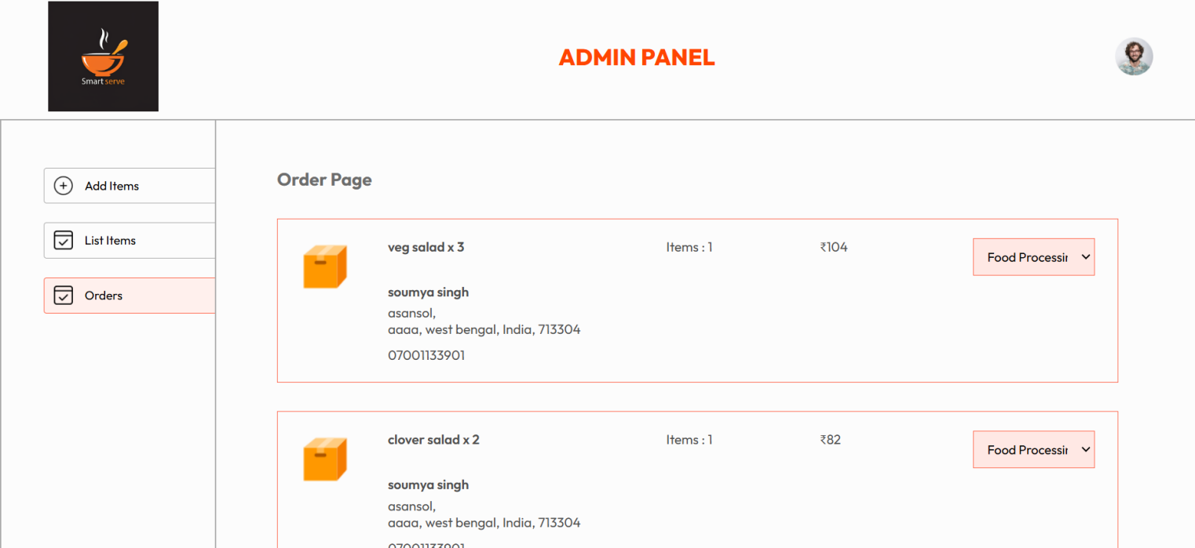

The `ViewOrders` page in the admin panel allows administrators to manage and track customer orders. Built with React, this page retrieves all orders from the backend via a GET request to the `/api/order/list` endpoint, utilizing Axios for data fetching. Orders are displayed in a structured layout, including details such as item names, quantities, customer information, and total amount formatted with the specified currency. Administrators can update the order status through a dropdown menu, which sends the new status to the backend via a POST request to the `/api/order/status` endpoint. The user interface is styled using `Orders.css`, and error handling is incorporated with toast notifications for better user experience. The order list is reversed for displaying the most recent orders at the top.
TECH STACK

• Frontend: React.js for a dynamic, responsive user interface.
• Backend: Node.js and Express.js for RESTful APIs and server logic.
• Database: MongoDB for efficient data storage and retrieval.
• Payment: Stripe API for secure payment processing.
• Language: JavaScript for both frontend and backend.

APPLICATION FLOW

• User Registration & Login: Users register or log in to access the main application features.
• Browse & Select Items: Users navigate the menu by categories, adding desired items to their cart.
• Cart Review & Checkout: Users can review their cart, make adjustments, and proceed to Stripe for payment.
• Order Placement & Tracking: After checkout, users can track their order status on the "My Orders" page.
• Admin Management: Admins manage the menu items and orders from a separate panel, ensuring a smooth operational flow.

Database Structure
- Users: Stores user information, including login credentials and order history.
- Orders: Stores order details, including items ordered, payment status, and order status updates.
- Food: Stores details of available food items, including images, descriptions, prices, and categories.
Below are the screenshots of the database(MongoDb Atlas)
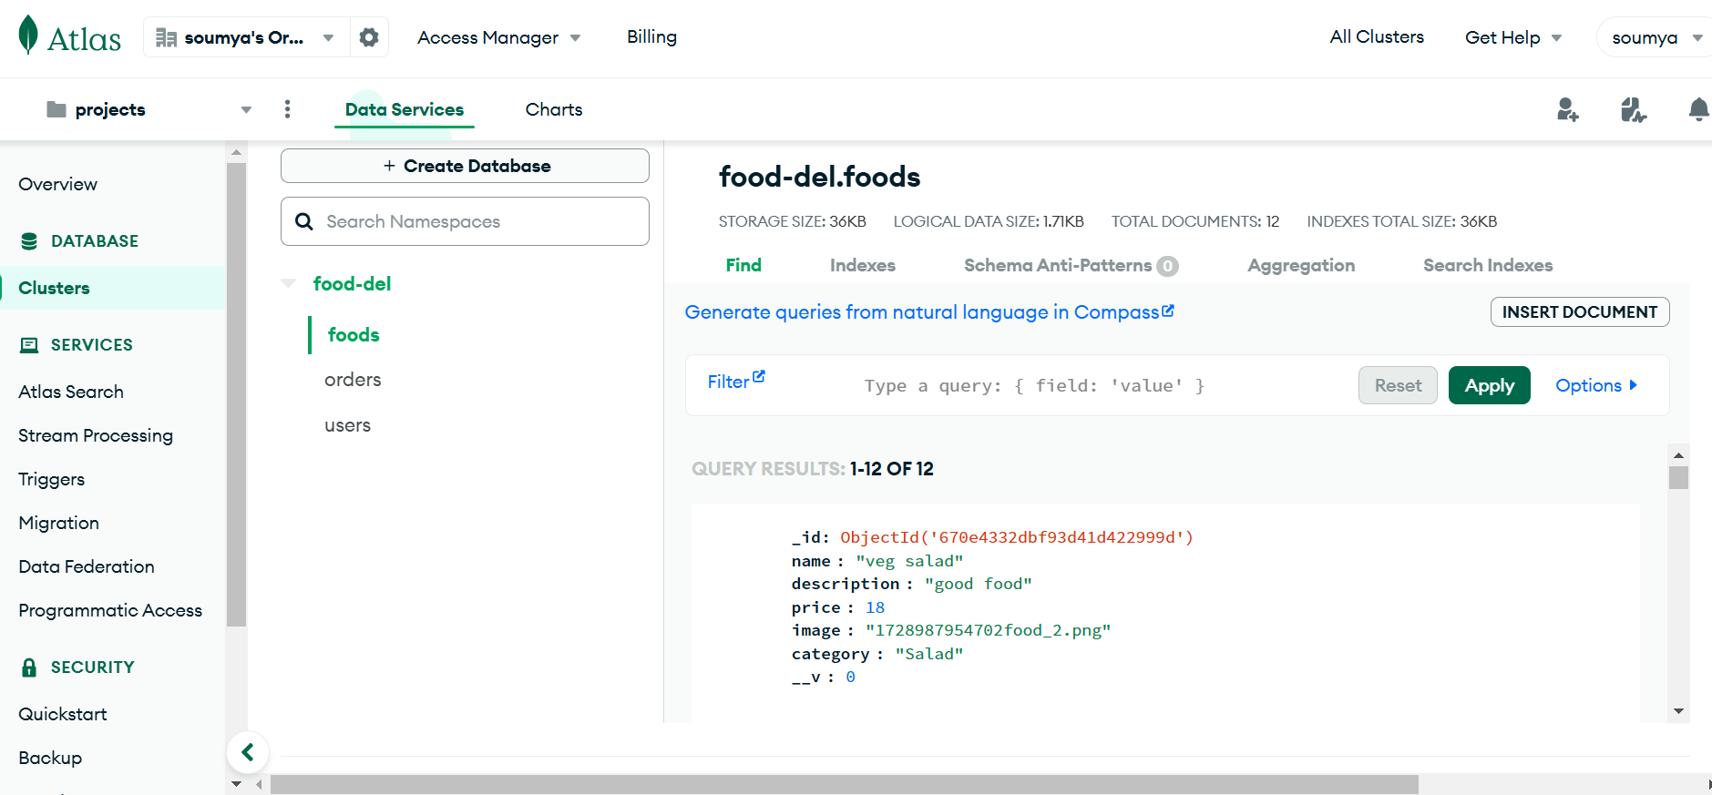
Fig:food model
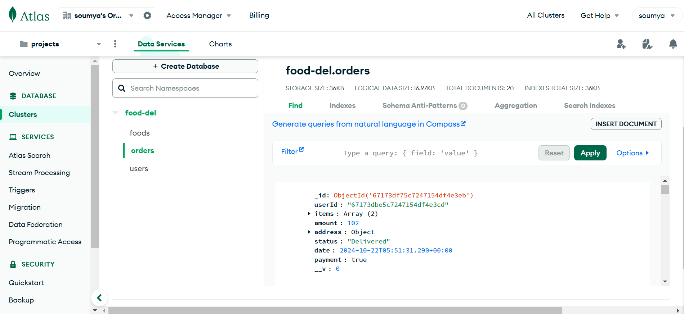Fig:Orders model
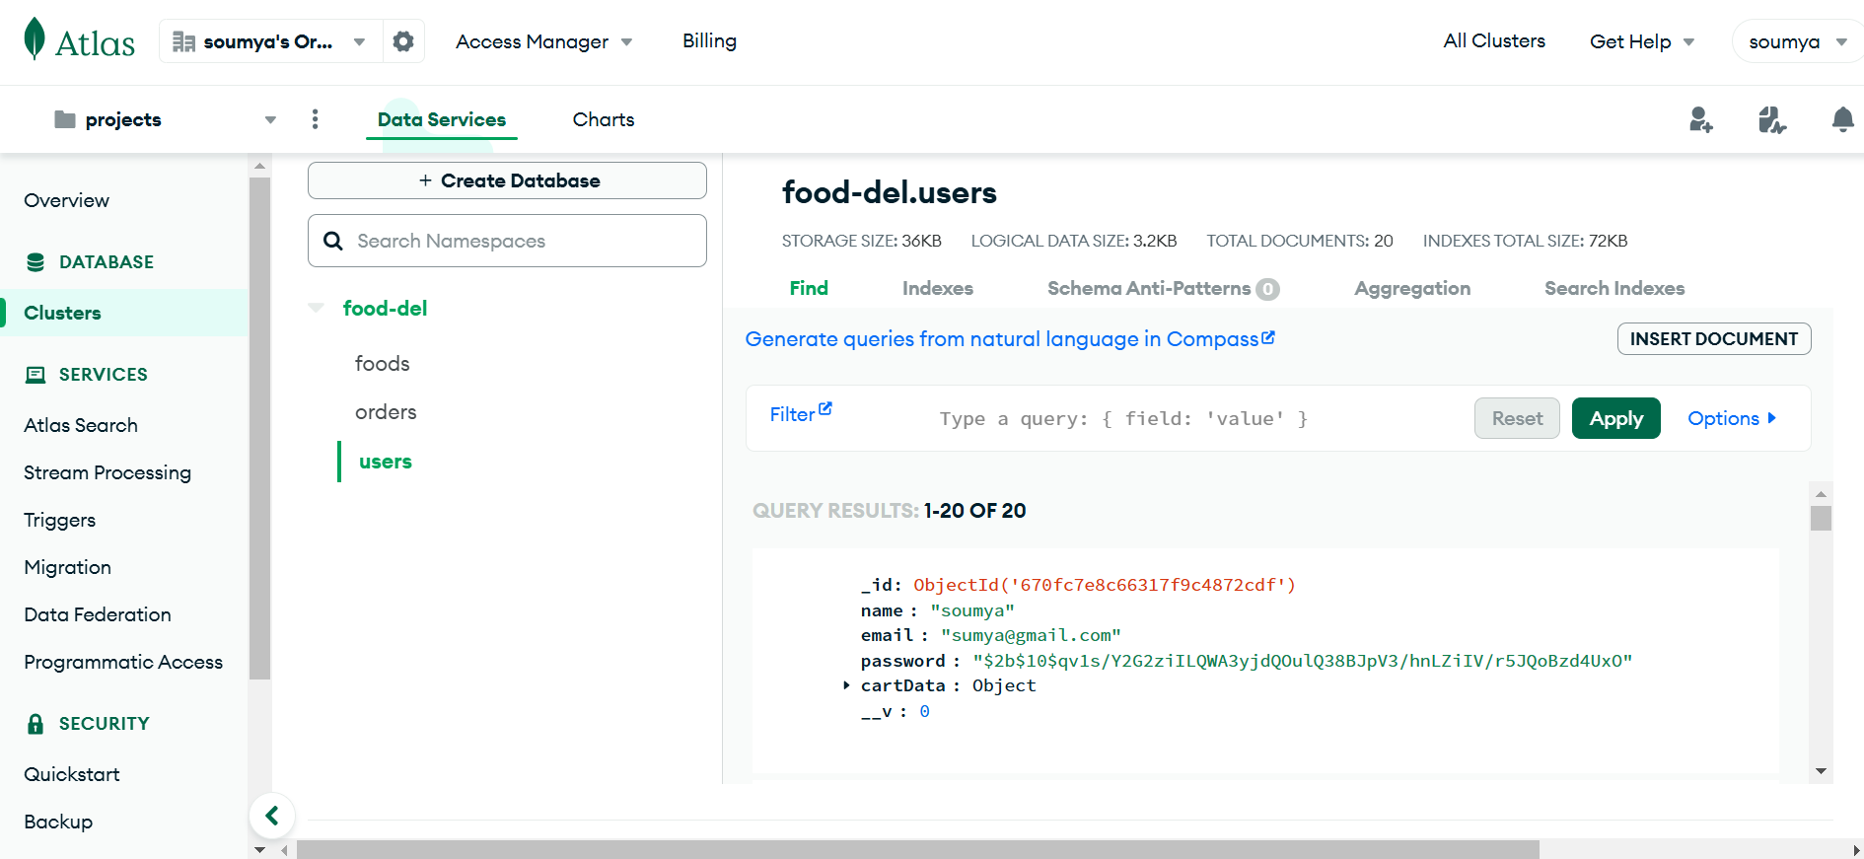
Fig:Users model
Challenges & Solutions
Challenge: Implementing secure payment.
Solution: Integrated Stripe, ensuring secure, tokenized transactions.
Challenge: Real-time order status tracking.
Solution: Developed efficient order status updates on the backend with quick front-end display updates.
. Future Enhancements
Add customer feedback and rating system for each order.
Implement push notifications for order status updates.
Add analytics for admin insights on popular items and customer behavior

CONCLUSION
The Full-Stack Food Delivery Application represents a significant achievement in harnessing modern web technologies to create a seamless food ordering experience. Built with the MERN stack, it combines React for the frontend, Express and Node.js for the backend, and MongoDB for data storage, ensuring a dynamic and responsive interface. The integration of Stripe for secure payments enhances user confidence while features like real-time order tracking and intuitive admin tools streamline operations.

Throughout development, we faced challenges, such as implementing secure payment solutions and ensuring real-time updates, which were effectively addressed through thoughtful solutions like JWT for authentication. This project not only meets its objectives but also lays the groundwork for future enhancements and scalability. Ultimately, it showcases how technology can transform the food delivery industry, creating a more connected and user-friendly experience.

