**Task:** Deploy a static website (ecomm) using s3 bucket and if u have domain u can attach it domain.

**Procdure:**

1. Open S3 in Console
2. Create a Bucket With a unique Name

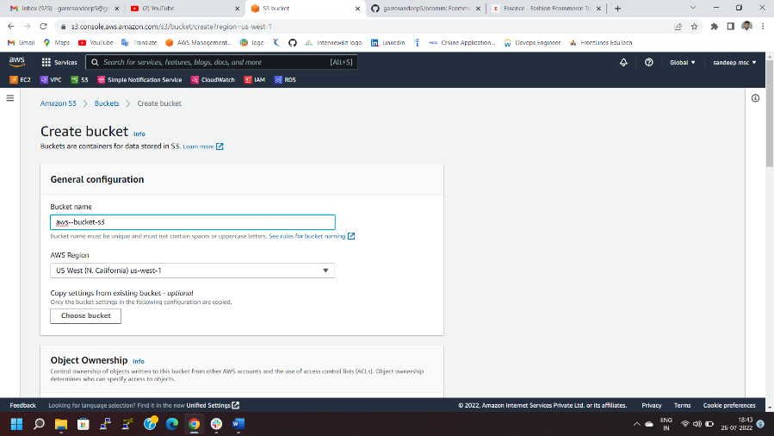

1. **Open git Gub >select ecomm repositires** And Download Zip file
2. Extract zip file in our local machine

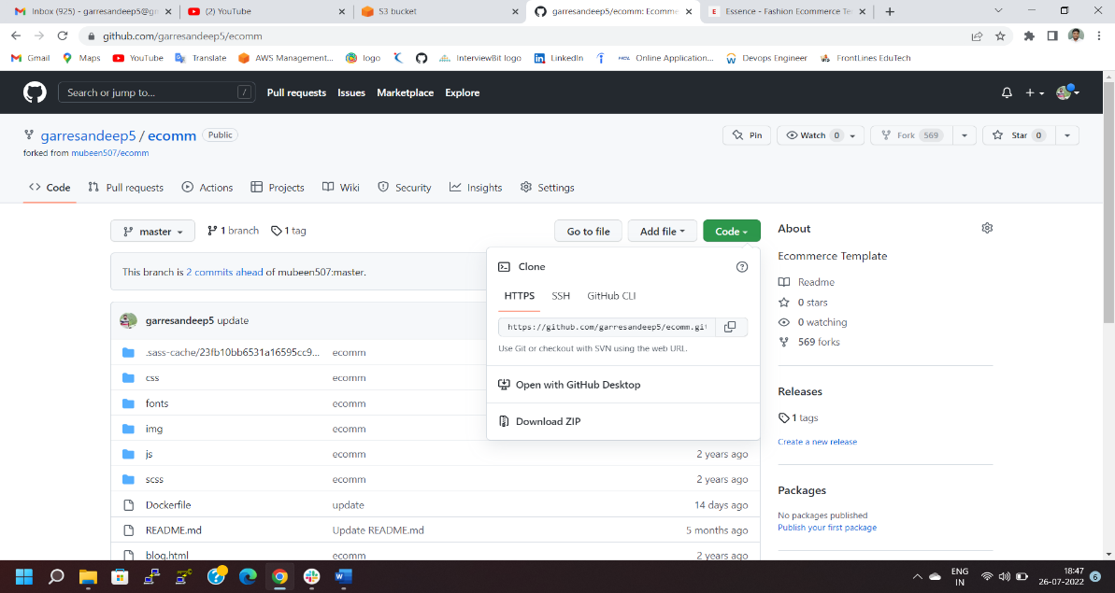



**5)**Upload all the Ecomm file in S3 bucket

**6)**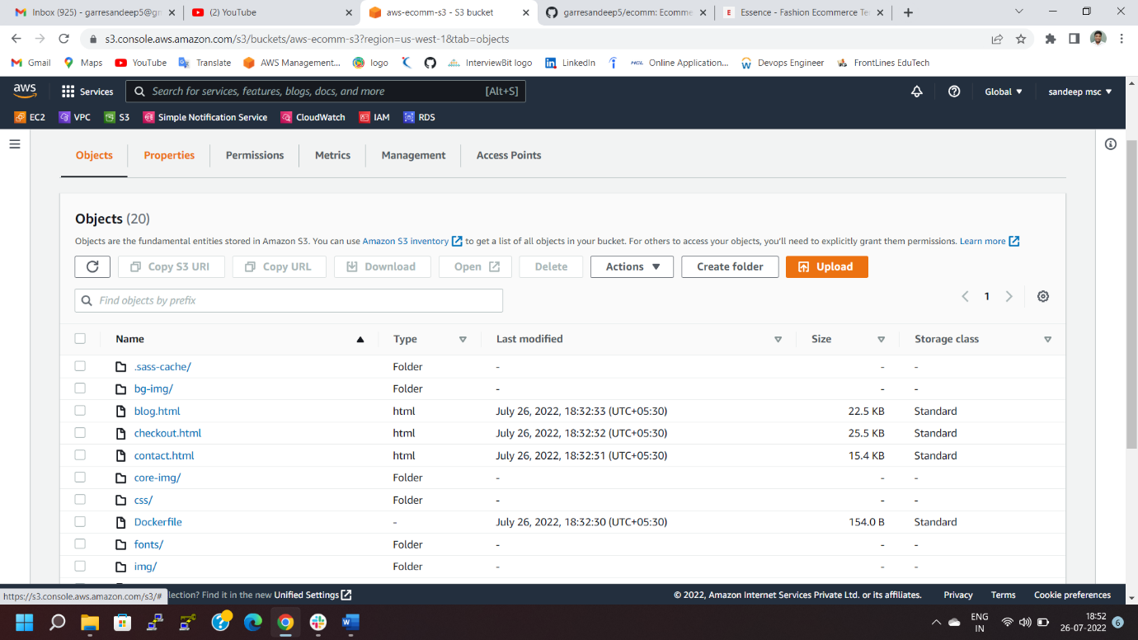

**$) Enable Give public read access policy Of Bucket**

**7)**Select the Static Website And Enable the option

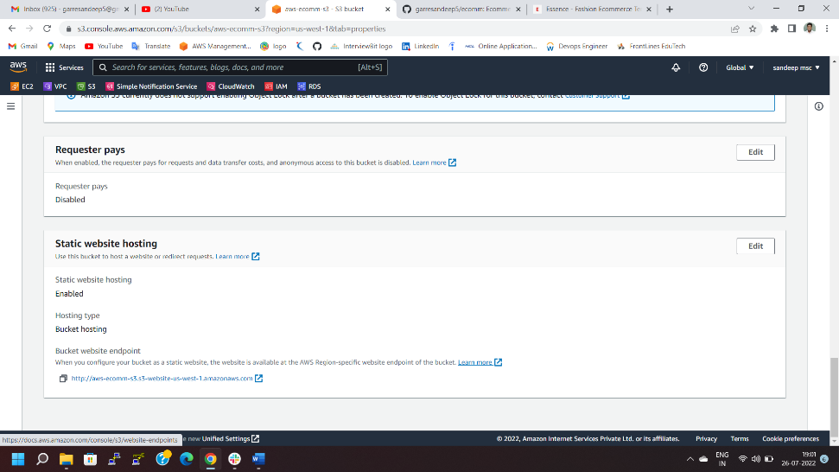

**8)Browse the the Link Statice enable website**

