PROJECT REPORT

NAME: SOUMYA JHA
REGISTRATION NUMBER: 20BCE0885

1. What is your role?
I made the entire app on my own using android studio. It is a very simple to do list app which provides the user an option to add task and we can strike them once we are done with the task.

2. What you learned while building the project?
I didn’t know much about JAVA so I learnt that a little bit. And I had no idea about Android studio so I learnt how to use it to make an app. I loved my experience and I am looking forward to work on Android Studio in future as well.
3.Did you take any courses like coursera, udemy...etc ,,while working for your project?
I initially learned how to use Android studio and how to install emulator in it for better experience from a youtube channel.
I also referred to a lot of youtube videos to clear my doubts and learn anything that was required.
4. Mention the libraries that you have installed for the project.
I made the app on android studio using list view and array adapter.
I ran my app on Pixel 3a API 26 by downloading it on android studio.

5.Also explain the work flow of the project
In this app the ‘DATA SOURCE’ will be an array list of strings. The ‘ADAPTER’ will generate text view for each item in the ‘DATA SOURCE’ and the ‘ADAPTER VIEW’ will display all the items as a scrollable ‘ListView’ to the user.
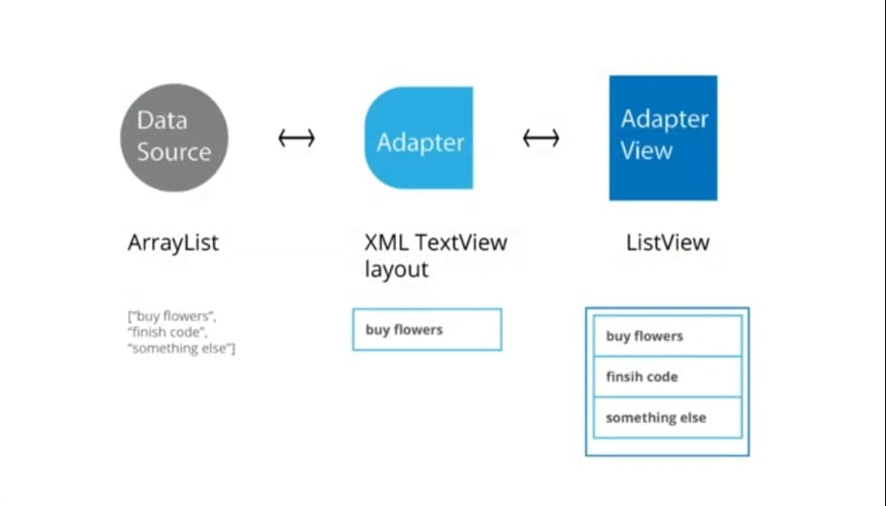

GITHUB REPO LINK:

https://github.com/soumya0204/TO_DO_LIST_APPLICATION
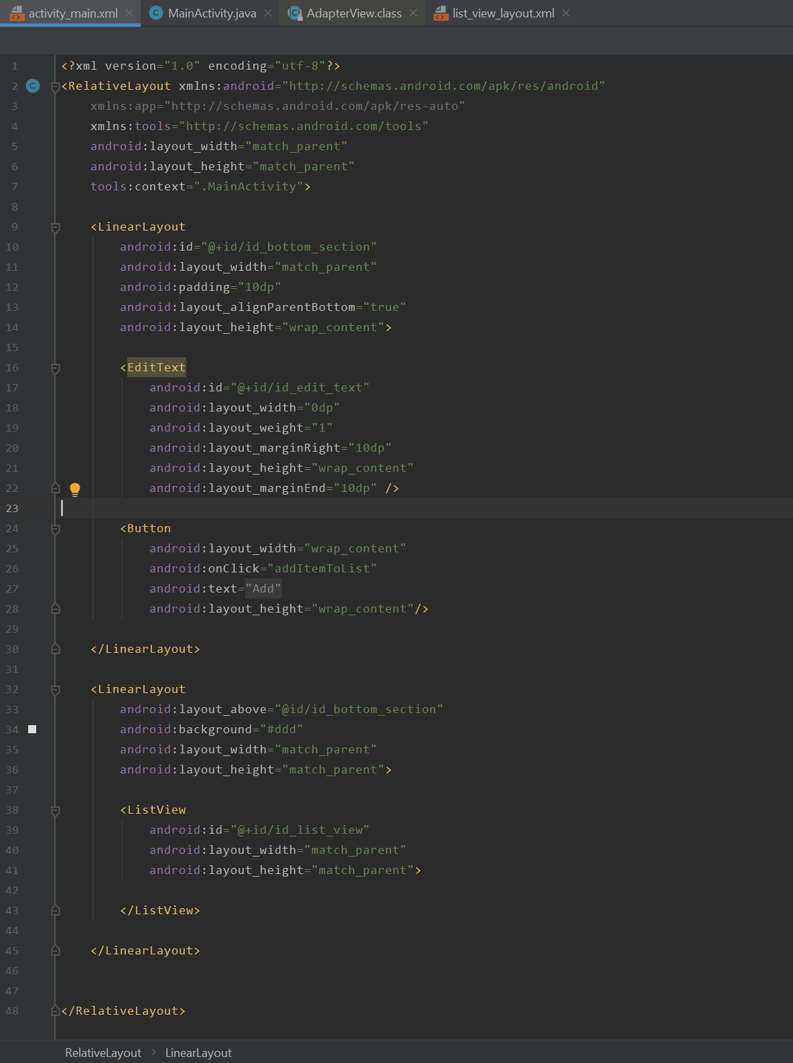
6. Screen shots

