

**SOUMYA VERMA (18MCA010)**

###### COMPUTER SCIENCE & ENGINEERING DEPARTMENT NATIONAL INSTITUTE OF TECHNOLOGY, AGARTALA

**INDIA-799046**

**March, 2020**

***Report submitted to***

***National Institute of Technology, Agartala for the award of the degree***

***of***

***Master of Computer Applications***

***by***

***SOUMYA VERMA (18MCA010)***

***Under the Guidance of***

***Dr. Moumita Majumdar Professor, CSE Department, NIT Agartala, India***



#### COMPUTER SCIENCE & ENGINEERING DEPARTMENT NATIONAL INSTITUTE OF TECHNOLOGY AGARTALA

**December, 2020**

To our Project Supervisor Dr. Moumita Majumdar, Professor, CSED, NIT Agartala for sharing her valuable knowledge, encouragement & showing confidence on us all the time. Each of the faculties of the department to contribute in our development as a professional and help us to achieve this goal.

To all those people who have somehow contributed to the creation of this project and who have supported us.

### ***“We make a living by what we get. We***[***make a life***](https://www.success.com/article/rohn-how-to-live-a-beautiful-life)***by what we give.” ―*Winston S. Churchill**

This report entitled “ ”SMILE”- A FOOD, CLOTH AND STATIONERY DONATION WEBSITE”, by SOUMYA VERMA (18MCA010), is approved for the award of ***Master of Computer Applications*** in ***Computer Science and Engineering***.

********************** (Project Supervisor)

Dr. Moumita Majumdar Professor

Computer Science and Engineering Department NIT, Agartala

*********************** (Head of the Department)

Mr. Mrinal Kanti Deb Barma Professor

Computer Science and Engineering Department NIT Agartala

Date: 19/12/2020

Place: NIT, Agartala

We declare that the work presented in this report proposal titled “”SMILE”- A FOOD, CLOTH AND STATIONERY DONATION WEBSITE”, submitted to the Computer Science and Engineering Department, National Institute of Technology, Agartala, for the award of the ***Master of Computer Applications*** degree in ***Computer Science and Engineering***, represents our ideas in our own words and where others’ ideas or words have been included, we have adequately cited and referenced the original sources. We also declare that we have adhered to all

principles of academic honesty and integrity and have not misrepresented or fabricated or falsified any idea/data/fact/source in our submission. We understand that any violation of the above will be cause for disciplinary action by the Institute and can also evoke penal action from the sources which have thus not been properly cited or from whom proper permission has not been taken when needed.

December, 2020 Agartala



SOUMYA VERMA

Candidate’s Name

It is certified that the work contained in the report titled “”SMILE”- A FOOD, CLOTH AND STATIONERY DONATION WEBSITE”, by SOUMYA VERMA(18MCA010), has been carried out under my supervision and this work has not been submitted elsewhere for a degree.

***************** (Project Supervisor)

Dr. Moumita Majumdar Professor

Computer Science and Engineering Department NIT Agartala

******************** (Head of the Department)

Mr. Mrinal Kanti Deb Barma Professor

Computer Science and Engineering Department NIT Agartala

### Acknowledgement

We would like to take this opportunity to express our deep sense of gratitude to all who helped us directly or indirectly during this thesis work.

Firstly, we would like to thank our supervisor, **Dr. Moumita Majumdar**, for being a great mentor and adviser. Her advice, encouragement and critics are source of innovative ideas, inspiration and causes behind the successful completion of this report. The confidence shown on us by her was the vital source of inspiration for us. It has been a privilege working with her.

We are highly obliged to all the faculty members of Computer Science and Engineering Department for their support and encouragement. We also thank **Prof. (Dr.) Harish Kumar Sharma**, Director, NIT Agartala and **Mr. Mrinal Kanti Deb Barma**, H.O.D, CSED for providing excellent computing and other facilities without which this work could not achieve its quality goal.

#### SOUMYA VERMA

List of Figures

1. Use Case Diagram
2. Home Page
3. Registration and Login Page
4. Welcome Page
5. Donor Details Page
6. Thank You Donor Page
7. Donated Items Page
8. Receiver Details Page
9. Thank You Receiver Page
10. Database Snapshot 1
11. Database Snapshot 2
12. Database Snapshot 3

### Abstract

“SMILE”- A FOOD, CLOTH AND STATIONERY DONATION WEBSITE, is used by donors for donating food, cloth and stationery products online and by receivers (NGOs) for collecting the donated items and further providing it to the people in need. The donors and receivers have to register and login for donating and receiving items. It is a website with database system in which data of registered users, donors, receivers and invoice of received items are being stored. We have used HTML, CSS and PHP for building this project. The interface of this website is user friendly and easy to use.

### Contents

|  |  |
| --- | --- |
| **Acknowledgement**  **Abstract**  **1 Introduction** | **ix**  **x** |
| 1.1 Motivation |  |
| 1.2 Goal |  |
| 1.3 Contribution in Dissertation  1.4 Outline of the Project |  |
| **2 SYSTEM ANALYSIS**  2.1 Existing System |  |
| 2.2 Proposed System and its features |  |

1. **REQUIREMENTS**

3.1 Hardware Requirement

3.2 Software requirement

3.3 Software Description

3.3.1 HTML

* + 1. CSS

3.3.3 PHP

3.3.4 MySQL

**4 PROPOSED SYSTEM**

* 1. What is Smile Donation Website about?
  2. Why to use Smile Donation Website?
  3. How It Works?
  4. Use Case Diagram

1. FUNCTIONALITIES OF THE SYSTEM
   1. Description
   2. Snapshots of the Website
      1. Home page
      2. Registration and Login page
      3. Welcome Page
      4. Donor Details Page
      5. Donated Item Page
      6. Thank You Donor Page
      7. Receiver Details Page
      8. Thank You Receiver Page
      9. Database Snapshots
2. Conclusion & Future Direction of Work 49
   1. Conclusion
   2. Future Direction of work
3. References

### CHAPTER 1

INTRODUCTION

“SMILE”- A FOOD, CLOTH AND STATIONERY DONATION WEBSITE, can be used mainly by donors for donating food, cloth and stationery products online and by receivers (NGOs) for collecting the donated items and further providing it to the people in need. Currently, there are very few websites and applications for donations are created and apart from that the donations have to make manually by going to different places. Using this website anyone who want to donate food, cloth or stationery can donate it online. The donors and receivers just have to register and login for donating and receiving items.

The main purpose of building this website was to provide everyone an ease to donations and collections, so that people don’t have to go places for donations.

## Motivation

Large quantity of used goods which are in usable condition lie in our households. It is deep-rooted in our psyche that old goods should not be thrown away due to the misplaced belief that someday we may need them. That day never comes and finally the items find their way either to the local Scrap collector who will pay a small amount based on weight or to the Utensil Collectors who are travelling women providing utensils in exchange for used clothes.

Now look at other side of the coin. Children playing on slum streets wear worn clothes and limited sources for studying. Underprivileged women dress up in the same saree for many days. Street-dwellers shiver in severe winter with no blanket to protect them and no food to eat.

So, thinking about the recent lockdown and pandemic during which many of the daily wage workers, rag pickers and homeless people remain helpless and don’t even get sufficient food to eat, clothes to wear and their children will not be able to get proper education they are worthy of. And this remained the biggest motivation of building this website throughout.

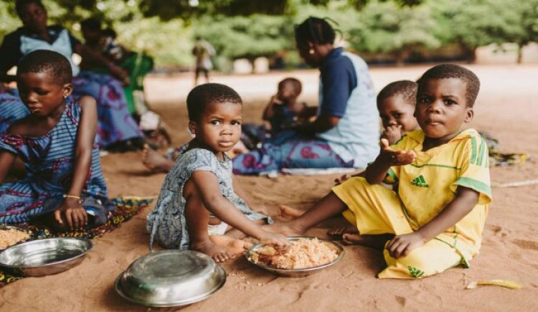

## Goal

* To help the people in need.
* To provide an ease of donating online.
* To make it easy for NGOs to collect/receive the donations online.

## Contribution in Dissertation

In my project, I have carried out all the features of this Online Donation System Some features are as follows:

* It provides an ease for donating online.
* It saves a lot of time of donors as well as receivers.
* It stores data of registered users, donors and receivers.

**1.4 Outline of the Project**

* Chapter 2, contains a small view of System Analysis of the project.
* Chapter 3, describes about the hardware requirement and software description.
* Chapter 4, describes about the design of the system.

### CHAPTER 2

SYSTEM ANALYSIS

* 1. **EXISTING SYSTEM**

Presently major donations are made manually, where donors have to find and go to different places for donating. This consumes a lot of time and sometimes due to lack of sufficient time many of the people don’t go to make donations.

Apart from that Covid-19 pandemic have made the situations even worse for people to go out and help the needy people.

* 1. **PROPOSED SYSTEM AND ITS FEATURES**

The existing system has many limitations like:

* It requires work to be done manually.
* It consumes very much time.
* The data of donors and receivers needs to be maintained manually and thus requires a lot of paperwork.

To overcome this limitation of the existing system, the idea of web-based services is proposed. It has following features:

* It is an online donation website.
* It is very easy and convenient to use.
* It has a user-friendly interface.
* It saves a lot of time and manual work.
* It keeps record of registered users, donors and receivers.

CHAPTER 3

**REQUIREMENTS**

3.1 **HARDWARE REQUIREMENT**

* Processor: Intel Pentium or higher version.
* Hard disk: 1GB free space.
* RAM minimum: 1GB or above.

3.2 **SOFTWARE REQUIREMENT**

* SERVER: Xampp Server
* OS: Windows / Linux /MacOS

3.3 **SOFTWARE DESCRIPTION**

3.3.1 **HTML**

* HTML is a markup language for describing web documents (web pages), HTML stands for Hypertext Markup Language.
* Hyper Text: Hypertext simply means “Text within Text”. A text that has a link within it, is a hypertext. Whenever you click on a link which brings you to a new webpage, you have clicked on a hypertext. Hypertext is a way to link two or more web pages (HTML documents) with each other.
* Markup language: A markup language is a computer language that is used to apply layout and formatting conventions to a text document. Markup language makes text more interactive and dynamic. It can turn text into images, tables, links, etc.
* Web Page: A web page is a document which is commonly written in HTML and translated by a web browser. A web page can be identified by entering an URL. A Web page can be of the static or dynamic type. With the help of HTML only, we can create static web pages.
* Hyper Text Markup Language, A markup language is a set of markup tag. HTML documents that are described by HTML tags. Each HTML tag describes different document content.
* HTML is the set of markup symbols or codes inserted in a file intended for display on a World Wide Web browser page.
* The markup tells the Web browser how to display a Web pages words and images for the user. Each individual markup code is referred to as an element (but many people also refer to it as a tag).
* Some elements come in pairs that indicate when some display effect is to begin and when it is to end. The current version of HTML is HTML5.

3.3.2 **CSS**

* Cascading Style Sheets, fondly referred to as CSS, is a simple design language intended to simplify the process of making web pages presentable.
* CSS handles the look and feel part of a web page. Using CSS, you can control the color of the text, the style of fonts, the spacing between paragraphs, how columns are sized and laid out, what background images or colors are used, layout designs, variations in display for different devices and screen sizes as well as a variety of other effects.
* CSS saves a lot of work. It can control the layout of multiple web pages all at once.
* CSS is easy to learn and understand but it provides powerful control over the presentation of an HTML document. Most commonly, CSS is combined with the markup languages HTML or XHTML.
* CSS is added to HTML pages to format the document according to information in the style sheet. There are three ways to insert CSS in HTML documents.
* Inline CSS: Inline CSS is used to apply CSS on a single line or element.
* Internal CSS: Internal CSS is used to apply CSS on a single document or page. It can affect all the elements of the page. It is written inside the style tag within head section of html.
* External CSS: External CSS is used to apply CSS on multiple pages or all pages. Here, we write all the CSS code in a css file. Its extension must be .css for example: style.css.

3.3.3 **PHP**

* PHP is a server-side scripting language.
* PHP is an interpreted language, i.e., there is no need for compilation.
* PHP is an object-oriented language
* PHP is an open-source scripting language.
* PHP code can be easily embedded within HTML tags and script.

3.3.4 **MySQL**

* MySQL is an open-source database so you don’t have to pay a single penny to use it.
* MySQL is customizable because it is an open-source database.
* MySQL is quicker than other databases so it can work well even with the large data set.
* MySQL is very friendly with PHP, the most popular language for web development.
* MySQL supports large databases, up to 50 million rows or more in a table. The default file size limit for a table is 4GB, but you can increase this (if your operating system can handle it) to a theoretical limit of 8 million terabytes (TB).

### CHAPTER 4

**PROPOSED SYSTEM**

## What is Smile Donation Website about?

## 

“SMILE”- A FOOD, CLOTH AND STATIONERY DONATION WEBSITE, is about donating and collecting those donations online. It is used by donors for donating food, cloth and stationery products online and by receivers (NGOs) for collecting the donated items and further providing it to the people in need. The donors and receivers have to register and login for donating and receiving items. It is a website with database system in which data of registered users, donors, receivers and invoice of received items are being stored. We have used HTML, CSS and PHP for building this project. The interface of this website is user friendly and very easy to use.

## Why to use Smile Donation Website?

These are the main reasons for using this website:

* It is an online donation website.
* It is very easy and convenient to use.
* It has a user-friendly interface.
* It saves a lot of time and manual work.
* It keeps record of registered users, donors and receivers.

## How it works?

## The working of the website is as follows:

* It is an online donation website.
* It allows user to register and login.
* The donor can select the type of donation (like: food, cloth, stationery) and the related NGO.
* The donor can add details of the items that they want to donate.
* The donor needs to provide their location and contact details.
* The receiver must be a government certified NGO.
* The receiver can search donated item by the city location.
* If found any donated item on the searched location, the receiver can select which donated item they want to collect.
* Then the receiver has to provide their details like:
* Name
* Contact details
* Preferred time for delivery
* Address.
* All the data of registered users, donors and receivers is stored in the database.

## USE CASE DIAGRAM

DONOR

Figure 1

Use Case Diagram

CHAPTER 5

**FUNCTIONALITIES OF THE SYSTEM**

## Description

“SMILE”- A FOOD, CLOTH AND STATIONERY DONATION WEBSITE, is about donating and collecting those donations online. It is used by donors for donating food, cloth and stationery products online and by receivers (NGOs) for collecting the donated items and further providing it to the people in need. The donors and receivers have to register and login for donating and receiving items.

It is a website with database system in which data of registered users, donors and receivers is stored. We have used HTML, CSS and PHP for building this project. The interface of this website is user-friendly and has an ease of access.

## SNAPSHOTS OF THE WEBSITE

## Here are some snapshots of the website and its database:

## 5.2.1 Home Page

## 

Figure 2

This is the Home Page of the website in which when user click on the Donate button they will be directed to the registration and login page.

5.2.2 **Registration and Login Page**

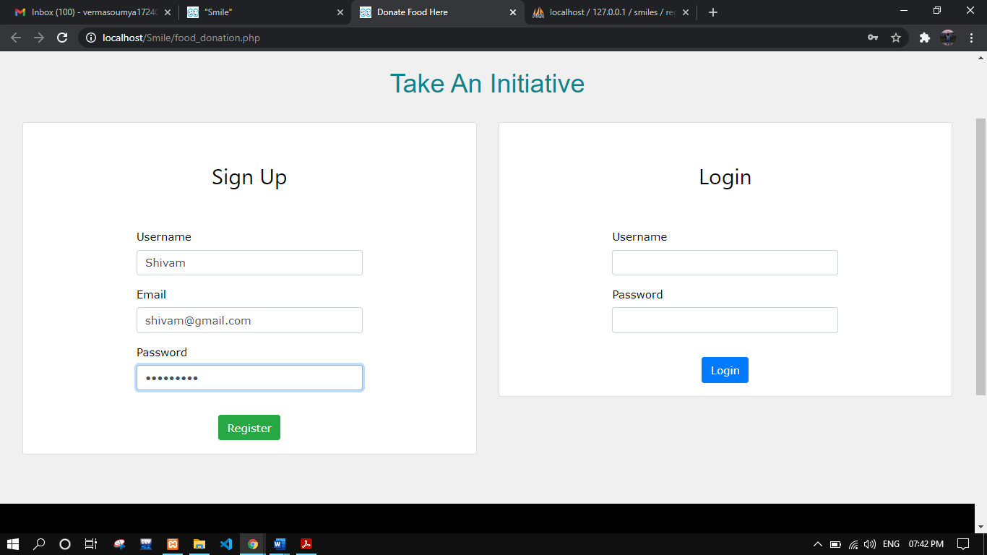

Figure 3

This is the registration and login page. In this page the users who are already registered can login and proceed for donations and collections.

5.2.3 **Welcome Page**

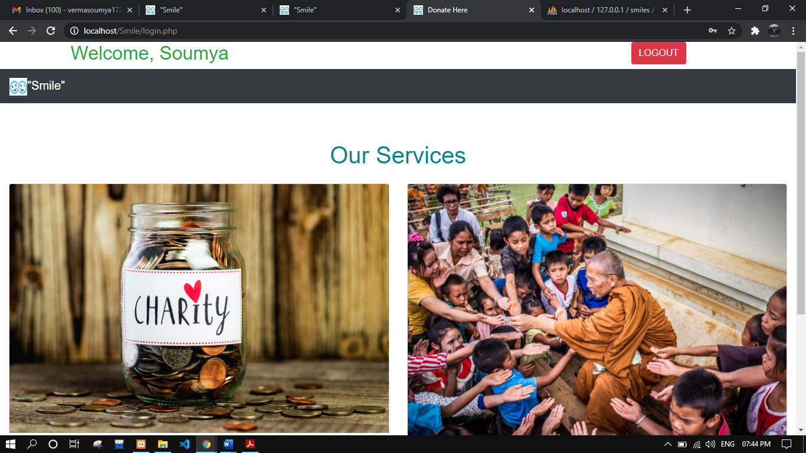

Figure 4

This is the welcome page for donors and receivers.

5.2.4 **Donor Details Page**

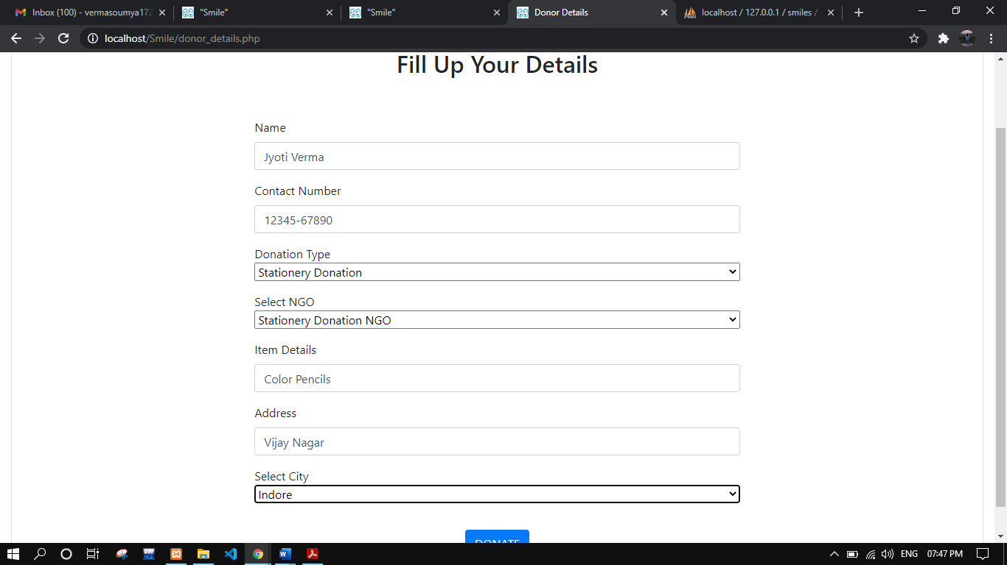

Figure 5

This is the page where donor need to enter their required details.

5.2.5 **Thank You Donor Page**

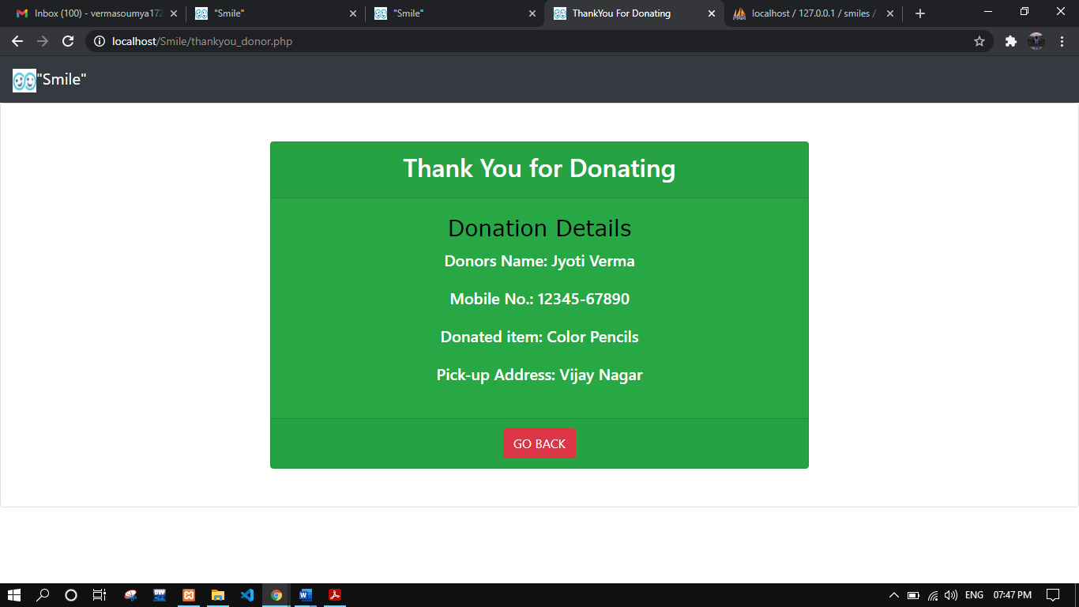

Figure 6

This is the thank you donor page that shows donor’s details.

5.2.6 **Donated Items Page**

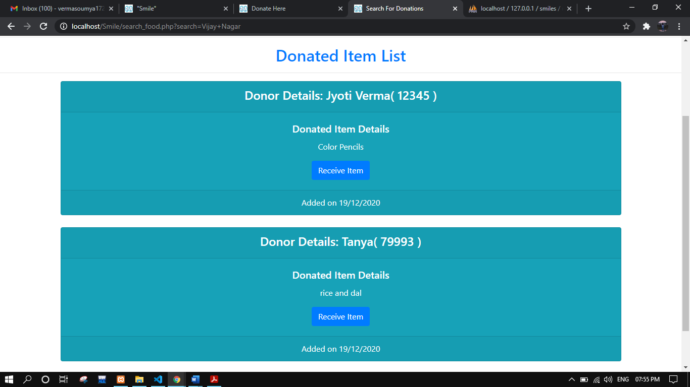

Figure 7

This page shows the item donated by the donor which is used by the receivers to collect the donated items.

5.2.7 **Receiver Details Page**

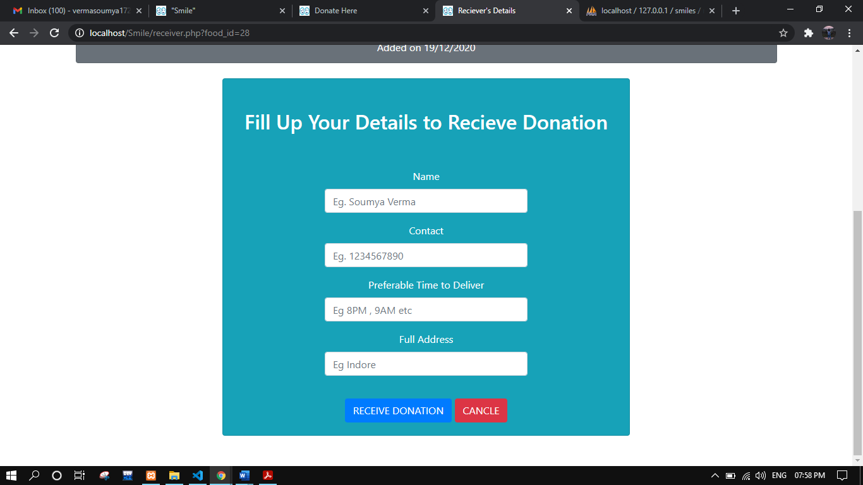

Figure 8

This is the receiver’s details page where the receiver has to fill their details for receiving the selected donation.

5.2.8 **Thank You Receiver Page**

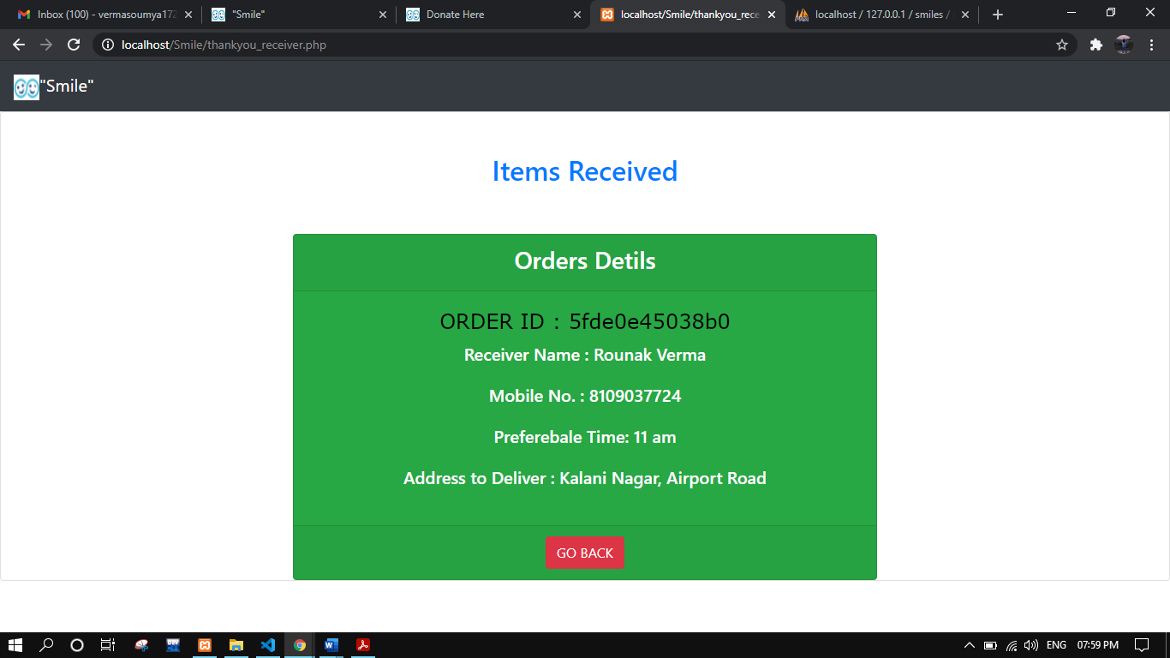

Figure 9

This page is shown to the receiver after they collects the donated items.

5.2.9 **Database Snapshots**

1. Registered Users Database:

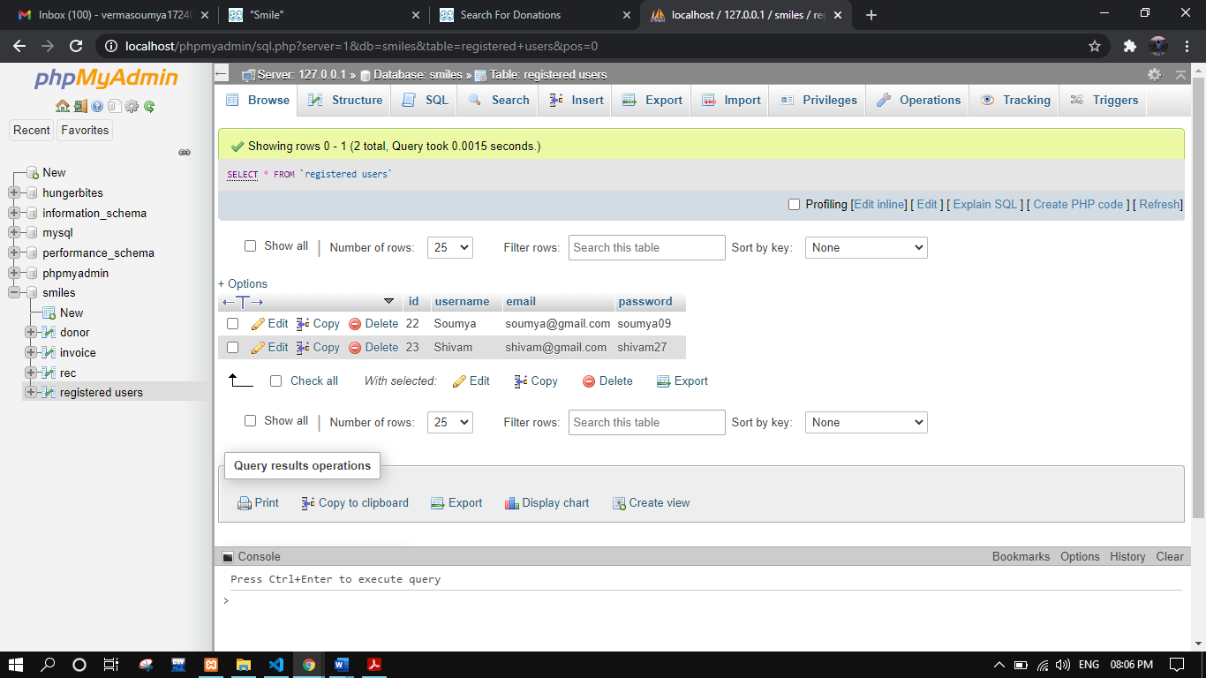

Figure 10

This image shows ‘registered users’ table in the database.

1. Donor Database:

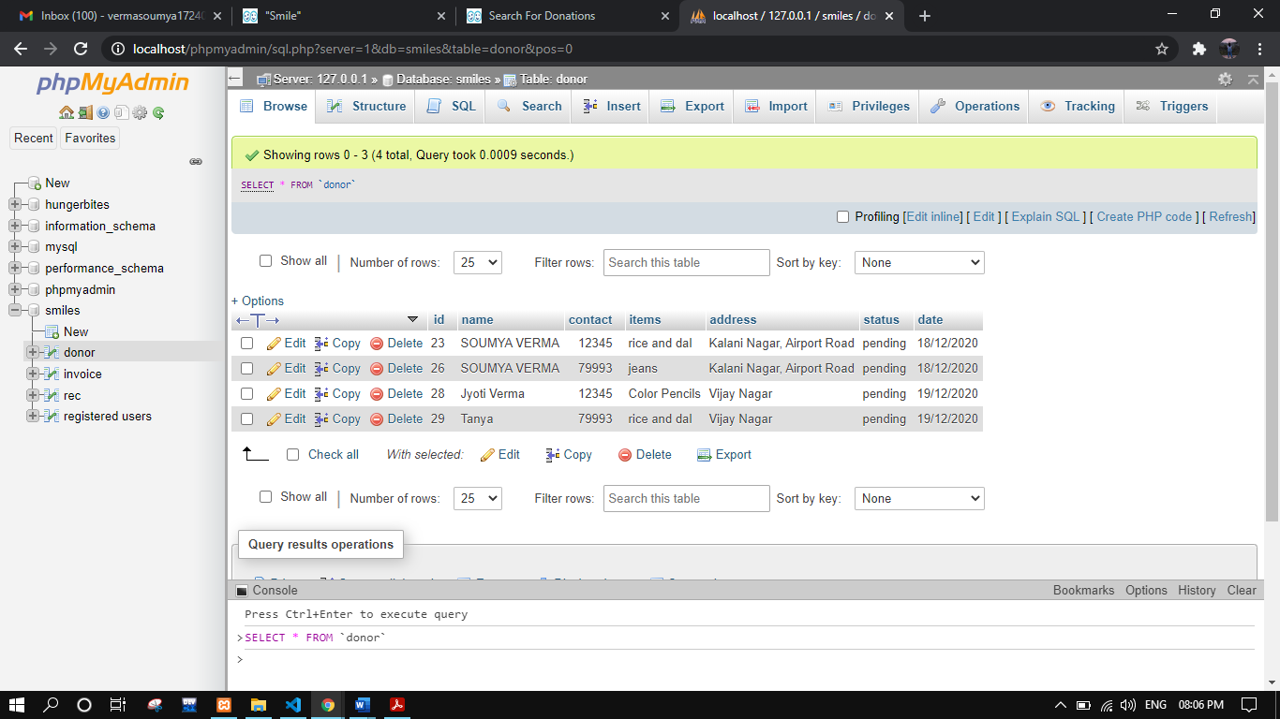

Figure 11

This image shows ‘donor’ table in the database.

1. Receiver Database:

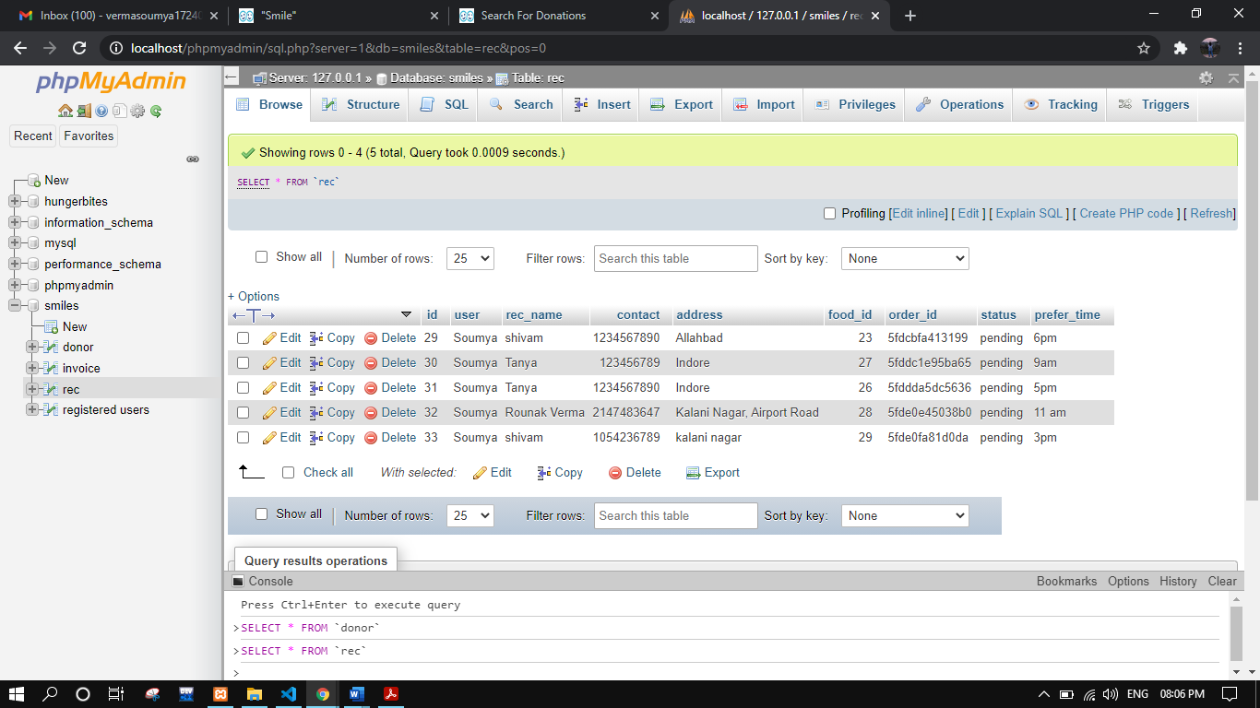

Figure 12

This image shows ‘rec’ table in the database that indicates the receivers.

CHAPTER 6

**Conclusion & Future Direction of Work**

## Conclusion

## In this era of technology many of the routine works have become a lot easier.

## And the technology advancements once again proved itself worthy during Covid-19

## pandemic situation as all over the world more than 70% of the people are working from

## home and are taking advantages of the online services. This is much required for keeping

## ourself and others safe avoiding going out of our home unnecessarily.

## In this pandemic many of the people like: daily wage workers, homeless and rag

## pickers, etc. remains helpless and might need our help for fulfilling their basic necessity

## of daily life, such as Food, Cloths, or Stationery items for their children’s education. So,

## in order to provide them with all these necessary items we can help them sitting in home

## by using the online website for donations. Thus, keeping ourself and them safe.

### **“The meaning of life is to find your gift.**[**The purpose of life**](https://www.success.com/videos/youtube/how-to-find-your-purpose)**is to give it away.” ―Pablo Picasso**

## Future Direction of the project

## In future I would like to add many more features in this project such as:

## A separate page for receiving NGOs registration and login.

## A detailed structure for each of the donation pages.

## Adding many more kind of donations like:

## Donations for animals

## Sanitary items

## Toys donation, etc.

## Adding mail system so that each user can get updates from the website about their donations and if something new is added to the site.

### References

**BOOKS:**

* PHP: The Complete Reference
* HTML and CSS: The Complete Reference
* Software-engineering: Rajib Mall

**WEBSITES:**

* <https://www.W3Schools.com>
* <https://www.tutorialspoint.com>
* <https://www.geeksforgeeks.org/>

### APPENDIX I

Biographical Sketch

**SOUMYA VERMA**

Kalani Nagar, Airport Road, Indore PIN-452005, E-Mail: [vermasoumya172409@gmail.com,](mailto:vermasoumya172409@gmail.com,%20) Contact. No. +91 7999348743

* Pursuing MCA from NIT, Agartala with current CGPA of 7.53/10.00.
* Intermediate from Vidhyanjali International School under (C.B.S.E), Indore with 55.8% in 2014.
* High School from Vidhyanjali International School under (C.B.S.E), Indore with 7.6 CGPA in 2012.