Customer Behaviour Analysis
Professional Project Report
Python | PostgreSQL SQL | Power BI
Project purpose
This report converts the project notebook, SQL analysis, dataset, and Power BI dashboard into a concise business-ready report. It documents the analytical workflow, presents key findings, and recommends practical actions for merchandising, subscription strategy, discount planning, and dashboard use.

Metric | Value | Interpretation
Customers | 3,900 | Total records in the source dataset
Total Revenue | $233,081 | Revenue represented by purchase amount
Average Purchase | $59.76 | Mean purchase value per customer
Average Rating | 3.75 | Mean review rating after median imputation

Prepared by-Soumya Ranjan Mahakud

Executive Summary
Headline finding
The dataset shows broad and stable purchasing behavior across categories, seasons, and age groups. Revenue is led by Clothing and Accessories because of order volume, while average purchase value remains tightly clustered around $60 across most customer segments.

- The project analyzes 3,900 customers, 25 products, 4 categories, and 50 locations.
- Clothing contributes the highest revenue at $104,264, followed by Accessories at $74,200.
- Subscription status does not currently show a higher average spend: subscribers average $59.49 compared with $59.87 for non-subscribers.
- Discounted purchases average $59.28, slightly below non-discounted purchases at $60.13, so discounting should be reviewed for margin impact.
- Fall is the strongest revenue season with $60,018 and the highest average purchase value at $61.56.
Business Area | Evidence | Implication
Merchandising | Clothing and Accessories generate the largest revenue pools. | Keep inventory depth and campaign focus strongest in these categories.
Customer Value | Average spend varies very little between gender, age, discount, and subscription groups. | Growth should focus on conversion, basket expansion, and frequency rather than only segment-level pricing.
Retention | 3,116 customers qualify as Loyal based on more than 10 previous purchases. | Loyalty programs can be targeted at repeat buyers who are not yet subscribed.
Analytics Delivery | PBIX contains 1 page and 18 visuals. | The dashboard is suitable for summary monitoring with slicers for category, gender, subscription, and shipping.

Project Overview
The Customer Behaviour Analysis project studies shopping patterns from a retail customer dataset. The workflow begins with Python-based data preparation, continues with PostgreSQL SQL analysis, and ends with a Power BI dashboard for interactive exploration.
Component | File | Role in Project
Dataset | customer_shopping_behavior.csv | Raw customer shopping records used for profiling and analysis.
Python Notebook | Analysis.ipynb | Data loading, cleaning, feature engineering, and database loading workflow.
SQL Script | Data_analysis_sql_file.sql | Business questions for revenue, products, subscriptions, discounts, and segments.
Power BI Report | Data_analysis.pbix | Dashboard layer with KPI cards, slicers, and charts.

Stage | Activity | Output
1. Ingest | Load CSV in pandas. | Structured dataframe with 3,900 records.
2. Prepare | Handle missing ratings, clean column names, create age and frequency features. | Analysis-ready dataset.
3. Persist | Upload cleaned dataframe to PostgreSQL. | customer table for SQL queries.
4. Analyze | Run SQL questions on revenue, products, discounts, loyalty, and age groups. | Business insights and aggregation tables.
5. Visualize | Build Power BI dashboard with KPIs, slicers, and summary charts. | Interactive executive view.

Dataset Overview
The source dataset contains customer demographics, purchased product details, transaction values, discounts, shipping type, review rating, previous purchase count, payment method, and purchase frequency.
Measure | Result
Rows | 3,900
Columns | 18
Unique Products | 25
Categories | 4
Locations | 50
Age Range | 18 to 70
Missing Values Before Cleaning | review_rating: 37

Category | Orders | Revenue | Avg Purchase
Clothing | 1,737 | $104,264 | $60.03
Accessories | 1,240 | $74,200 | $59.84
Footwear | 599 | $36,093 | $60.26
Outerwear | 324 | $18,524 | $57.17

Data quality note
The only observed missing field was Review Rating with 37 blank values. The notebook resolves this by imputing ratings with the median rating inside each product category, preserving category-level rating behavior.

Python Data Preparation
Python was used as the preparation layer. The notebook loads the CSV, profiles the dataset, fills missing ratings, standardizes column names, creates age groups, maps purchase frequency to day intervals, drops the duplicate promo-code field, and loads the result into PostgreSQL.
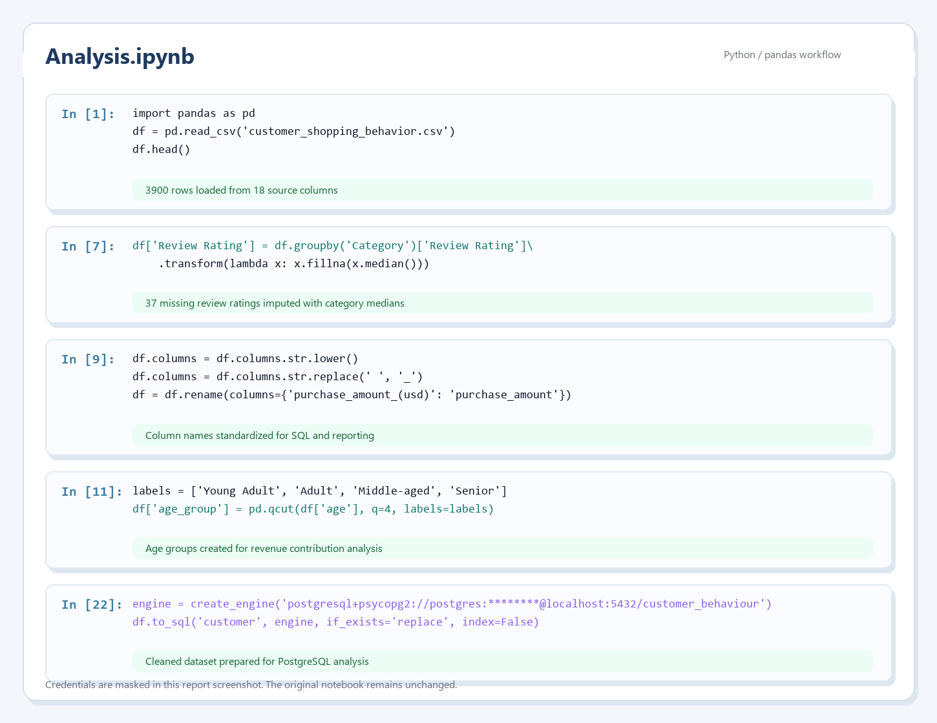
Figure 1. Python notebook workflow screenshot with credentials masked.
Preparation Step | Purpose | Report Impact
Missing rating imputation | Fill 37 missing Review Rating values using category medians. | Keeps rating analysis complete without forcing a global average.
Column normalization | Convert names to lowercase and underscores; rename purchase amount field. | Makes SQL querying consistent and readable.
Age grouping | Create Young Adult, Adult, Middle-aged, and Senior segments using quartiles. | Enables age-group revenue comparison in SQL and Power BI.
Frequency mapping | Translate purchase frequency labels into approximate day intervals. | Supports future recency/frequency modeling.
Database loading | Use SQLAlchemy and psycopg2 to load a clean customer table. | Allows repeatable PostgreSQL analysis.

SQL Analysis
The SQL file frames the analysis as practical business questions. It focuses on revenue splits, high-value discounted customers, product ratings, shipping comparisons, subscription revenue, discount rates, customer segmentation, category leaders, repeat buyers, and age-group revenue.
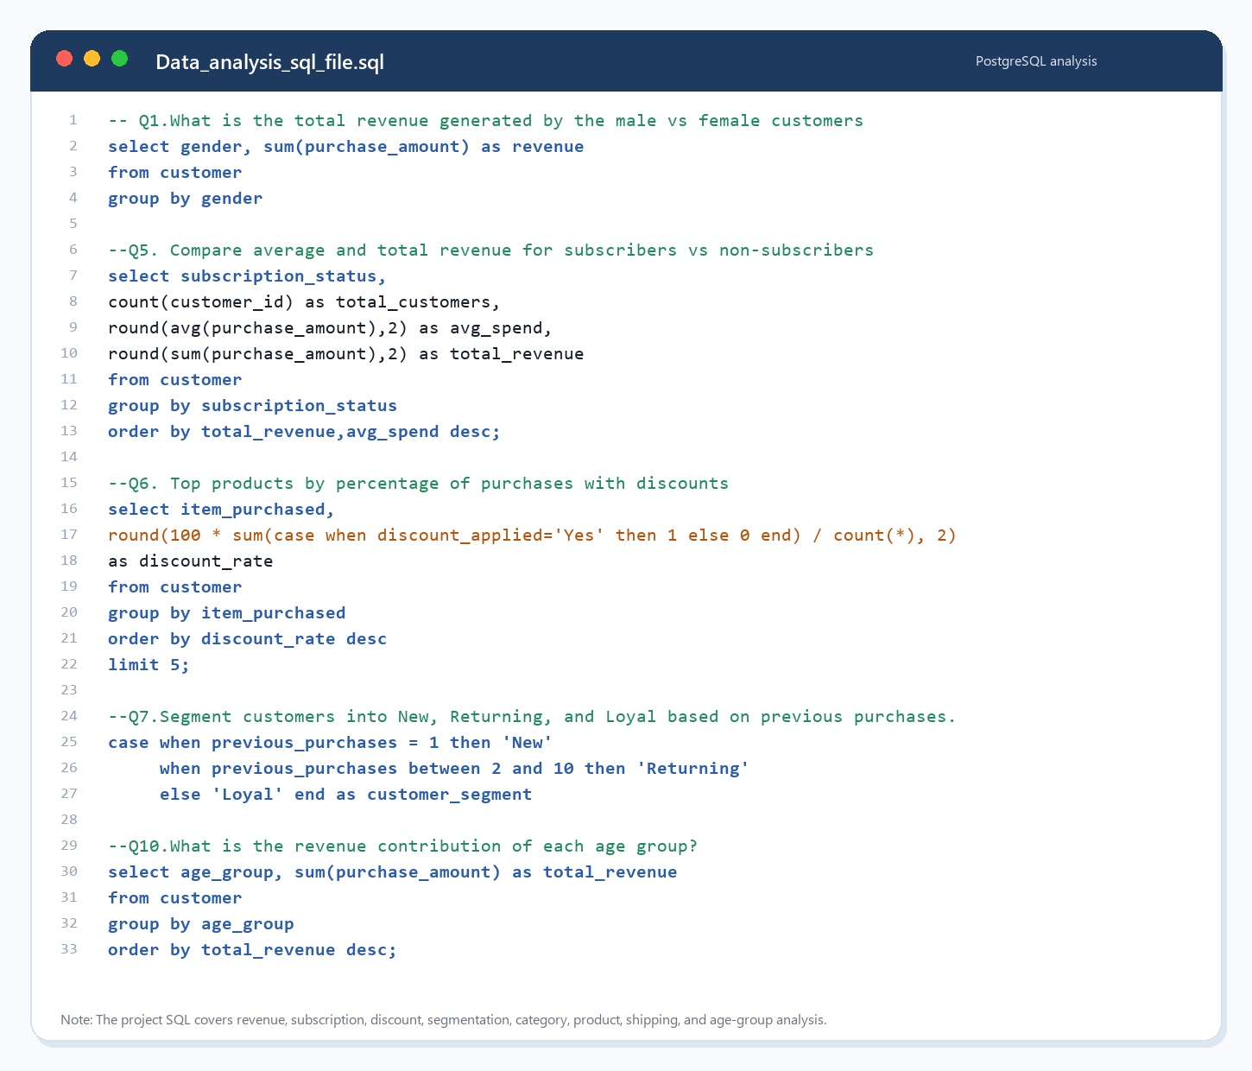
Figure 2. SQL analysis screenshot showing selected PostgreSQL queries.
SQL Question | Analytical Output | Observed Insight
Male vs female revenue | Revenue and average purchase by gender. | Male customers produce higher total revenue due to count; female average spend is slightly higher.
Subscription comparison | Customer count, average spend, and revenue by subscription status. | Subscribers are not yet spending more on average than non-subscribers.
Discount analysis | Products with highest discount usage and customers spending above average with discounts. | Discounts appear frequent but do not lift average spend in the current data.
Customer segmentation | New, Returning, and Loyal segments based on previous purchases. | The dataset is heavily repeat-customer oriented, with 3,116 Loyal customers.
Age-group revenue | Total revenue by age group. | Revenue is balanced, with Young Adult slightly leading at $62,143.

Implementation note
The SQL script contains one extra closing parenthesis after the top-products-by-category query. Removing that stray parenthesis will make the script cleaner for direct execution.

Power BI Dashboard
The Power BI file contains one report page with 18 visual containers. The dashboard combines KPI cards, slicers, a subscription donut chart, category revenue/order charts, and age-group contribution charts.
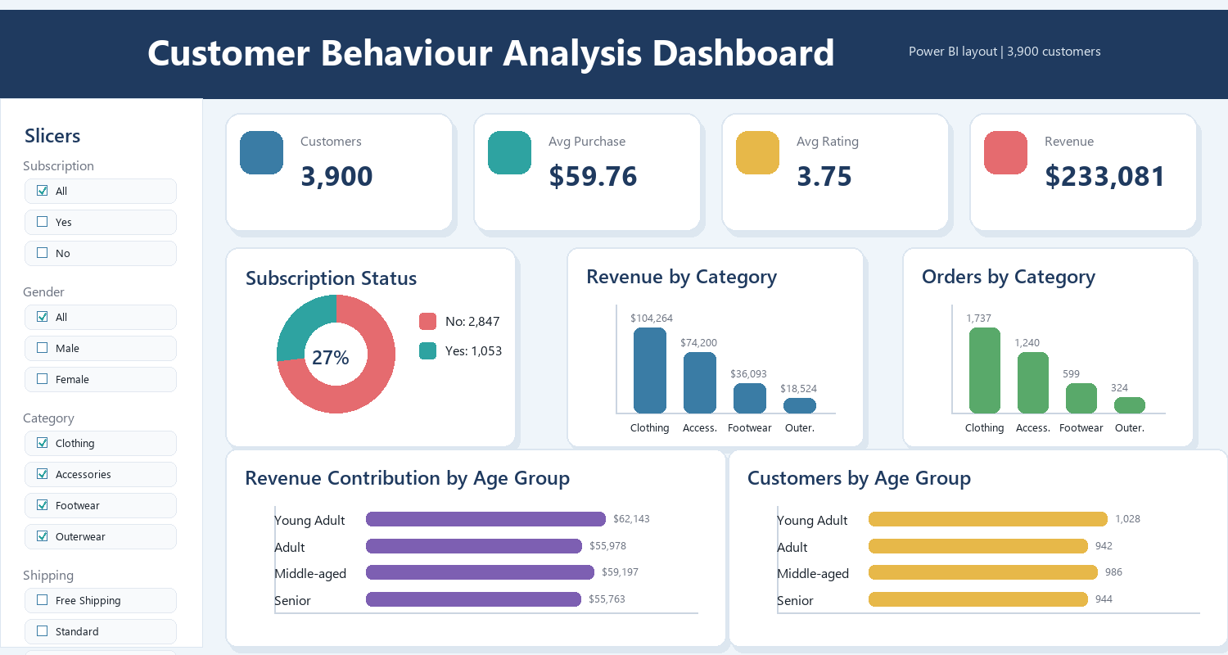
Figure 3. Report-ready dashboard view recreated from the PBIX layout and project dataset.
Dashboard Area | Visuals | Business Use
Top KPI strip | Customers, average purchase, average rating, revenue. | Quick health check of the dataset and performance baseline.
Left slicer panel | Subscription, gender, category, and shipping filters. | Interactive segmentation of customer behavior.
Subscription donut | Customer split by subscription status. | Checks adoption level and subscriber share.
Category charts | Revenue and order count by category. | Supports merchandising and inventory decisions.
Age-group charts | Revenue and customer count by age band. | Shows whether spend is concentrated in a customer age group.

Key Findings
Theme | Finding | Evidence
Revenue concentration | Clothing and Accessories dominate total revenue. | Clothing: $104,264; Accessories: $74,200.
Gender behavior | Female customers spend slightly more on average, while male customers drive larger total revenue. | Female avg: $60.25; Male revenue: $157,890.
Seasonality | Fall is the strongest revenue season. | Fall revenue: $60,018; Fall avg purchase: $61.56.
Subscription | Subscription is underperforming as a value differentiator. | Subscriber avg: $59.49; Non-subscriber avg: $59.87.
Discounting | Discounted transactions do not show higher spend. | Discounted avg purchase: $59.28; non-discounted avg purchase: $60.13.
Age groups | Revenue is stable across age groups. | Highest age-group revenue: Young Adult at $62,143.

Top-Rated Product | Average Rating
Gloves | 3.86
Sandals | 3.84
Boots | 3.82
Hat | 3.80
Handbag | 3.78

Highest Discount Product | Discount Rate
Hat | 50.00%
Sneakers | 49.66%
Coat | 49.07%

Recommendations
Recommendation | Reason | Action
Strengthen Clothing and Accessories campaigns. | These categories generate the most revenue. | Plan seasonal promotions, bundle offers, and stock planning around these categories.
Redesign subscriber benefits. | Subscribers do not currently spend more on average. | Test subscriber-only bundles, early access, or loyalty credit tied to repeat purchases.
Audit discount strategy. | Discounted purchases average slightly lower than non-discounted purchases. | Measure margin impact and reserve discounts for conversion or inventory-clearance goals.
Target loyal non-subscribers. | Most repeat buyers are not subscribed. | Use previous purchases greater than five as a trigger for subscription campaigns.
Use dashboard as an operating view. | The PBIX provides filters and summary charts. | Review monthly and extend with trend measures if a transaction date becomes available.

Next analytical upgrade
The dataset does not contain transaction dates. Adding date-level purchase history would unlock true retention, seasonality trend, cohort, and customer lifetime value analysis.

Conclusion
The Customer Behaviour Analysis project successfully demonstrates an end-to-end analytics workflow: Python prepares the customer dataset, SQL converts the data into business questions, and Power BI presents the results in an interactive dashboard. The strongest opportunity is not simply finding the highest-spend segment, because average spend is very stable. The larger opportunity is operational: improve subscription value, use discounts more selectively, protect high-performing categories, and activate loyal repeat buyers.
The report can now be used as a project submission document, portfolio artifact, or presentation companion for explaining the technical workflow and business interpretation.

