PROJECT REPORT
Breast Cancer Classification Using Machine Learning
Comparative Analysis of Classification Algorithms

Student Name: Soumya Thakur
Roll Number: 25MIB10029
Institution: VIT Bhopal

1. Abstract
Breast cancer is an important health concern, and correctly identifying whether a tumor is benign or malignant is an important part of diagnosis. Machine learning can be useful for this type of classification because it can learn patterns from different diagnostic features and use them to predict the class of a tumor.
In this project, four machine learning algorithms were implemented and compared: Logistic Regression, K-Nearest Neighbors (KNN), Decision Tree, and Random Forest. The dataset was first preprocessed, divided into training and testing sets, and scaled before training the models. The models were then compared using accuracy, precision, recall, and F1-score.
Among all the models tested, Logistic Regression performed the best. It achieved an accuracy of 98.25%, precision of 98.61%, recall of 98.61%, and F1-score of 98.61%. It also achieved a ROC-AUC score of 0.9954, showing that the model was able to distinguish very effectively between benign and malignant cases on the test dataset.

2. Introduction
Breast cancer classification mainly involves identifying whether a tumor is benign or malignant based on its diagnostic characteristics. Correct classification is important because malignant tumors may require further medical examination and treatment.
Traditional diagnosis involves medical examination and diagnostic procedures. Machine learning provides another way to analyze multiple diagnostic features together and identify patterns that can be useful for classification.
In this project, different machine learning algorithms were trained and compared to find out which one performed best for classifying breast tumors.
This is a binary classification problem with two classes:
- Class 0 – Benign
- Class 1 – Malignant
The main purpose of this project is to understand how machine learning can be applied to breast cancer classification. It is not intended to replace professional medical diagnosis.

3. Problem Statement
Breast cancer diagnosis requires accurate classification of tumors. Since diagnostic data contains several features, machine learning can be used to identify patterns in these features and classify tumors into benign or malignant categories.
The problem addressed in this project is:
To develop and compare machine learning models that can accurately classify breast tumors as benign or malignant using diagnostic features.
The project compares multiple classification algorithms and selects the model that gives the best overall performance.

4. Objectives
The main objectives of this project are:
- To build a machine learning model for classifying tumors as benign or malignant.
- To prepare and preprocess the dataset for machine learning.
- To divide the dataset into training and testing sets.
- To apply feature scaling before model training.
- To train different classification algorithms.
- To evaluate each model using suitable performance metrics.
- To compare the performance of the models.
- To select the best-performing model.
- To further evaluate the selected model using ROC-AUC and classification analysis.

5. Dataset
The project uses a breast cancer diagnostic dataset containing numerical features related to breast tumor samples.
The target variable represents the type of tumor:
Class |  | Meaning
0 |  | Benign
1 |  | Malignant
The different diagnostic features are used as inputs for the machine learning models. Since the features are numerical, they can be directly processed and used with the classification algorithms after preprocessing and scaling.

6. Methodology
The project follows a simple machine learning workflow:
Dataset → Data Preprocessing → Train/Test Split → Feature Scaling → Model Training → Model Evaluation → Best Model Selection
The same general process was followed while evaluating the different classification algorithms.
Step 1: Dataset Preparation
The dataset was first loaded and prepared for the machine learning process. The target variable was separated from the diagnostic features.
Step 2: Data Preprocessing
The data was checked and prepared so that it could be used properly by the machine learning models.
Step 3: Train-Test Split
The dataset was divided into training and testing data. The training data was used to train the models, while the testing data was used to check how well the models performed on unseen data.
Step 4: Feature Scaling
Feature scaling was applied before training. This was especially important for models such as Logistic Regression and KNN, where differences in feature scales can affect model performance.
Step 5: Model Training
Four classification algorithms were trained:
- Logistic Regression
- K-Nearest Neighbors (KNN)
- Decision Tree
- Random Forest
Step 6: Model Evaluation
The models were compared using:
- Accuracy
- Precision
- Recall
- F1-score
ROC-AUC analysis was also performed for the selected Logistic Regression model.
Step 7: Best Model Selection
After comparing the results, Logistic Regression was selected as the final model because it achieved the strongest overall performance.

7. Machine Learning Models Used
7.1 Logistic Regression
Logistic Regression is a classification algorithm that predicts the probability of an observation belonging to a particular class.
In this project, it was used to classify tumors as benign or malignant. Among the four models tested, Logistic Regression gave the best overall results.

7.2 K-Nearest Neighbors
K-Nearest Neighbors, or KNN, classifies a new observation by looking at the classes of nearby observations.
In this project, KNN achieved an accuracy of 95.61% and an F1-score of 96.55%.

7.3 Decision Tree
A Decision Tree makes predictions by following a series of decision rules based on the input features. It creates a tree-like structure to arrive at the final classification.
The Decision Tree achieved an accuracy of 91.23% and an F1-score of 92.86%.

7.4 Random Forest
Random Forest is an ensemble learning algorithm that uses multiple decision trees and combines their results to make a final prediction.
The Random Forest model achieved an accuracy of 95.61% and an F1-score of 96.55%.

8. Evaluation Metrics
To compare the models properly, four main classification metrics were used.
8.1 Accuracy
Accuracy tells us how many predictions made by the model were correct out of all the predictions.
Accuracy = (TP + TN) / (TP + TN + FP + FN)
Where:
- TP = True Positive
- TN = True Negative
- FP = False Positive
- FN = False Negative

8.2 Precision
Precision tells us how many of the cases predicted as positive were actually positive.
Precision = TP / (TP + FP)
A higher precision means the model is making fewer false-positive predictions.

8.3 Recall
Recall tells us how many of the actual positive cases were correctly identified by the model.
Recall = TP / (TP + FN)
Recall is particularly useful when missing a positive case can be important.

8.4 F1-Score
F1-score combines precision and recall into a single value. It is useful for understanding the balance between these two metrics.
F1 = 2 × (Precision × Recall) / (Precision + Recall)
A higher F1-score generally indicates a better balance between precision and recall.

8.5 ROC-AUC
ROC-AUC shows how well a classification model can distinguish between the two classes at different classification thresholds.
The selected Logistic Regression model achieved a ROC-AUC of 0.9954, which indicates excellent discrimination between the two classes on the test dataset.

9. Model Performance and Results
The final results obtained from the project are:
Model | Accuracy | Precision | Recall | F1-Score
Logistic Regression | 98.25% | 98.61% | 98.61% | 98.61%
KNN | 95.61% | 95.89% | 97.22% | 96.55%
Decision Tree | 91.23% | 95.59% | 90.28% | 92.86%
Random Forest | 95.61% | 95.89% | 97.22% | 96.55%
From the comparison, Logistic Regression achieved the highest values across the reported metrics, making it the best-performing model in this project.

10. Best Model: Logistic Regression
After comparing all four models, Logistic Regression was selected as the final model.
Its final performance was:
Metric | Result
Accuracy | 98.25%
Precision | 98.61%
Recall | 98.61%
F1-Score | 98.61%
ROC-AUC | 0.9954
The model performed better overall than KNN, Decision Tree, and Random Forest based on the evaluation carried out in this project.
Final Result
Overall, Logistic Regression gave the best results among the models tested. The model correctly classified most of the test samples and maintained a strong balance between precision and recall. Its ROC-AUC score of 0.9954 also shows that it was able to distinguish between the two classes very effectively on the test dataset.

11. Classification Report
The classification report for Logistic Regression showed strong results for both classes.
Class 0 – Benign
- Precision: 0.98
- Recall: 0.98
- F1-score: 0.98
Class 1 – Malignant
- Precision: 0.99
- Recall: 0.99
- F1-score: 0.99
The overall accuracy was approximately 0.98. This shows that the selected model performed consistently well for both benign and malignant classifications.

12. Confusion Matrix
A confusion matrix was generated for the Logistic Regression model to understand its predictions in more detail.
It helps show four types of outcomes:
- True Negatives
- False Positives
- False Negatives
- True Positives
Looking at the confusion matrix helps us understand where the model made correct predictions and where it made classification errors.
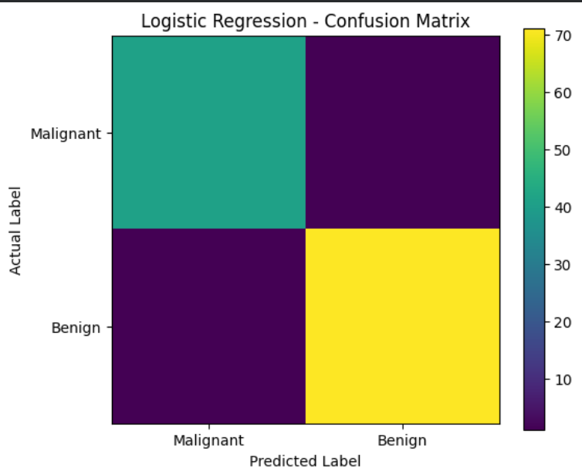
Figure 1: Confusion Matrix of Logistic Regression

The exact numerical values of the confusion matrix have not been included here because they were not available in the provided report material. The actual confusion matrix generated in the notebook should be inserted in this section.

13. ROC Curve Analysis
ROC curve analysis was performed for the selected Logistic Regression model.
The model achieved:
ROC-AUC = 0.9954
An AUC of 0.9954 indicates excellent discrimination between the benign and malignant classes on the test dataset. In simple terms, the model was able to separate the two classes very effectively across different classification thresholds.

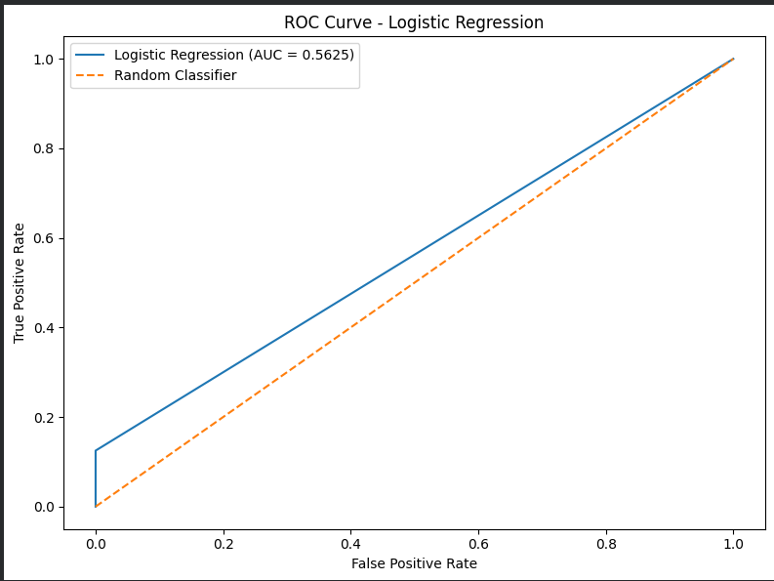
Figure 2: ROC Curve of Logistic Regression

14. Discussion
The comparison of the four models shows that all of them were able to perform the classification task, but their performance was different.
Logistic Regression performed the best, with an accuracy of 98.25% and an F1-score of 98.61%. Its precision and recall were also 98.61%, showing that the model maintained a good balance between identifying positive cases and avoiding incorrect positive predictions.
KNN and Random Forest both achieved an accuracy of 95.61% and an F1-score of 96.55%. Although their performance was good, they were still below Logistic Regression.
Decision Tree had the lowest accuracy among the four models, at 91.23%, with an F1-score of 92.86%.
The ROC-AUC score of 0.9954 further supported the strong performance of Logistic Regression. Based on the overall comparison, Logistic Regression was therefore selected as the final model.

15. Key Findings
The main findings from the project are:
- Four machine learning classification algorithms were tested.
- Logistic Regression performed the best overall.
- Logistic Regression achieved 98.25% accuracy.
- It achieved 98.61% precision, recall, and F1-score.
- It achieved a ROC-AUC of 0.9954.
- KNN and Random Forest both achieved 95.61% accuracy.
- Decision Tree achieved 91.23% accuracy.
- Logistic Regression was selected as the final model based on the overall results.
Overall, the comparison showed that Logistic Regression was the strongest-performing model among the algorithms tested.

16. Limitations
16.1 Dataset Limitation
The performance of the model depends on the dataset used for training and testing. Results may be different when the model is tested on another dataset.
16.2 Model Generalization
A strong result on the test dataset does not necessarily mean that the model will perform in exactly the same way in a real-world clinical environment.
16.3 Medical Application
This project is mainly an academic machine learning implementation. The model should not be considered a replacement for professional medical diagnosis.

16.4 Limited Model Scope
Only four machine learning algorithms were compared in this project. Other machine learning and deep learning methods could also be explored in future work.

17. Future Scope
There are several ways in which this project could be improved in the future:
- Try additional machine learning algorithms.
- Experiment with advanced ensemble methods.
- Perform more extensive hyperparameter tuning.
- Use cross-validation for more reliable performance evaluation.
- Explore feature selection and feature engineering.
- Test the model on additional datasets.
- Compare traditional machine learning models with deep learning approaches.
- Build an interactive application to demonstrate the model.
These improvements could help in understanding how well the model performs on different datasets and under different conditions.

18. Conclusion
This project explored how machine learning can be used to classify breast tumors into benign and malignant categories.
Four different algorithms—Logistic Regression, KNN, Decision Tree, and Random Forest—were trained and compared using accuracy, precision, recall, and F1-score.
Among these models, Logistic Regression achieved the best overall performance, with:
- Accuracy: 98.25%
- Precision: 98.61%
- Recall: 98.61%
- F1-Score: 98.61%
- ROC-AUC: 0.9954
The ROC-AUC result also showed that Logistic Regression was able to distinguish between the two classes very effectively on the test dataset.
Based on the results obtained in this project, Logistic Regression was selected as the final model. Overall, the project demonstrates the potential of machine learning for breast tumor classification using diagnostic features. However, this model is intended for academic purposes and should not be treated as a substitute for professional medical diagnosis.

19. Technologies Used
The project was developed using the following technologies and libraries:
- Python
- Google Colab
- Pandas
- NumPy
- Scikit-learn
- Matplotlib
These tools were used for data processing, model development, evaluation, and visualization.

20. Final Result
After comparing the four machine learning models, Logistic Regression was selected as the best-performing model for this project.
The model achieved an accuracy of 98.25%, which means it correctly classified most of the tumor samples in the test dataset. It also achieved 98.61% precision, recall, and F1-score, showing that the model performed consistently well in identifying both benign and malignant cases.
The model's ROC-AUC score of 0.9954 further shows that it was able to clearly distinguish between the two classes.
Overall, Logistic Regression gave the best results among all the models tested, making it the final model selected for this project.
Final Performance:
- Model Selected: Logistic Regression
- Accuracy: 98.25%
- Precision: 98.61%
- Recall: 98.61%
- F1-Score: 98.61%
- ROC-AUC: 0.9954

