Prepare **deliverables.** Prepare your artwork to present to your client. Your work should include all of the following components documenting your collaborative product.

1. A cover page with all of the following: ~~your group name,~~ a visual display comparing the images used as input to those produced as output by your algorithm, ~~the developers, and a link to your cloud 9 workspace~~.
2. ~~Credits for raw images used as input or as part of your algorithm~~
3. ~~Brainstorming notes and a sketch of proposed idea~~
4. ~~Visual display of raw images used in the algorithm~~
5. A daily project log that has sequence of images showing stages of manipulation reflecting intermediate stages of data during the algorithm's execution
6. Array of images showing results from a range of values for a parameter of the manipulation
7. Conclusion: Reflect on the team dynamic and on the design process. What were areas for improvement? What steps could you take next time to make those improvements?

Once you have finished inserting all of the above it must be deleted from this submission and all that should remain is your final report.

AS Productions

***Developers: Soumya Kakarlapudi and Akamai Wong***

***CSE PERIOD 4 : Mr. Brown***

<https://ide.c9.io/soumya3939/cse4-kakarlapudi-s-python>

***Problem: (chosen 3/6/18)***

Client #3 - They need a brand image that represents their product, in a memorable fashion. The purpose is to increase sales.

***Requirements: (chosen 3/6/18)***

* Be able to use it as a frame, overlay, or silhouette to a large number of images in the marketing campaign
* See geometric shapes incorporated in the image - drawn on, as a border or a mask
* Offer a range of options for the image operations being performed.

***Brainstorm: (3/6/18)***

|  |  |
| --- | --- |
| ***Product (w/ category):*** | ***Our Idea (Logo):*** |
| Alexa (AI) | * A circle with a solid blue line on the inside * has the amazon logo on top of other images that create a full collage that fit inside of the circle   *Pros:   * Interesting idea with a spin on the image of the Alexa   *Cons:   * Need to gather lots of app images that would go inside of the collage |
| Drone (Electronics) | * Circle with a drone inside, the product name would go in a straight line directly under the circle.   *Pros:  *Cons: |
| Beats Pill (Speaker) | * An image of the Beats Pill with different images of pop stars on it   *Pros:   * Easier to do   *Cons:   * Don’t really like the idea |

Sketch: (3/6/18)

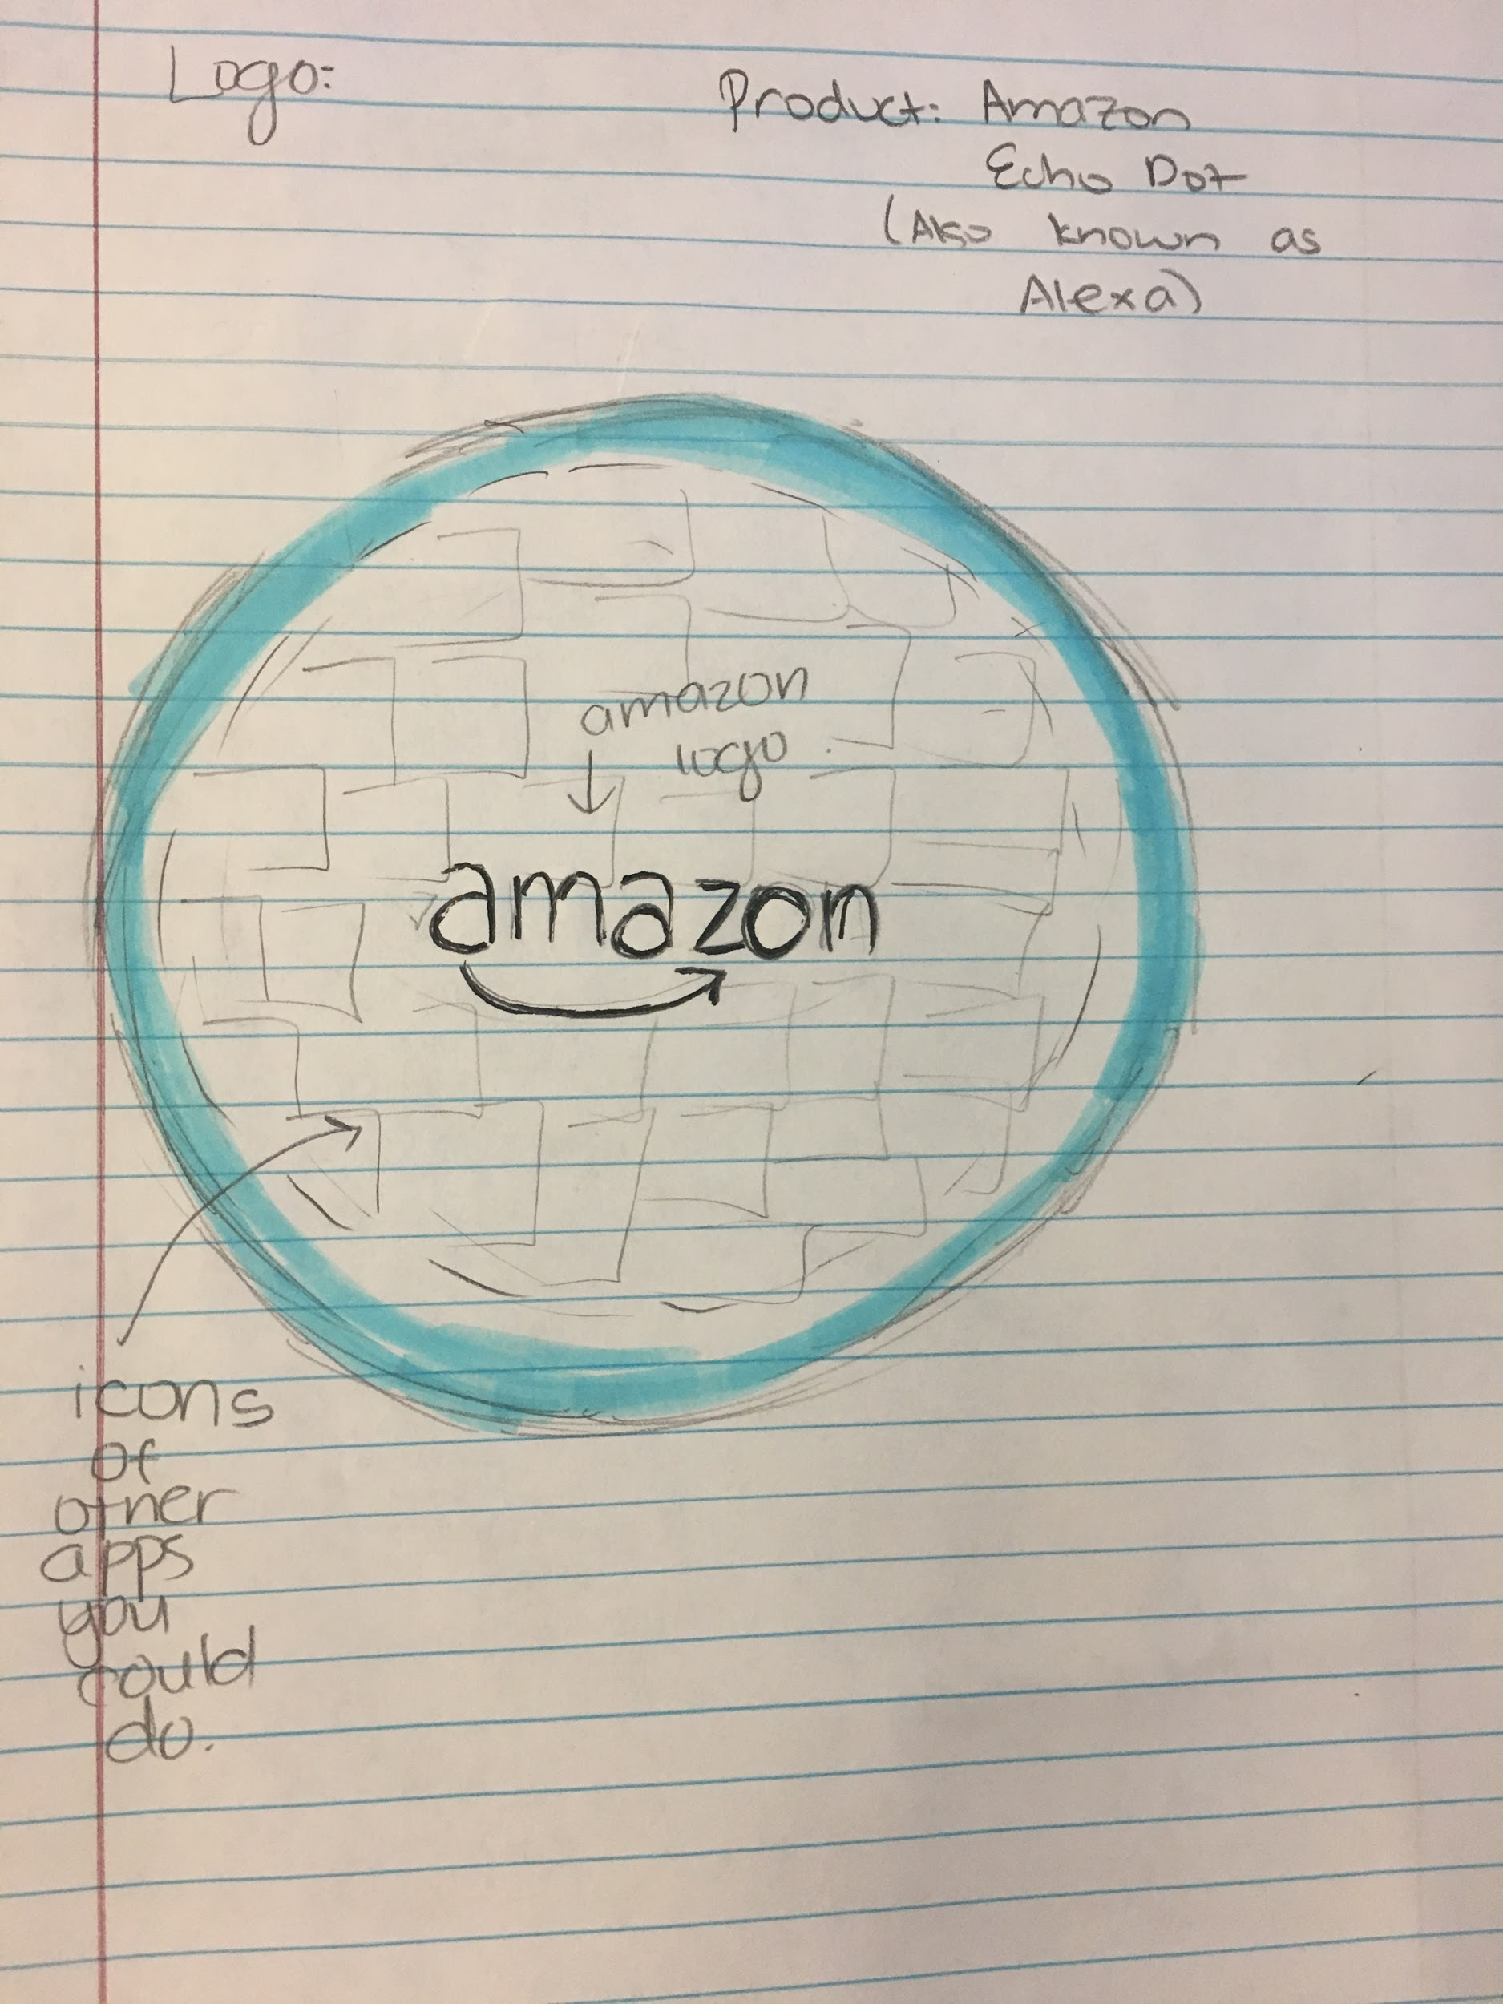

Raw Images:

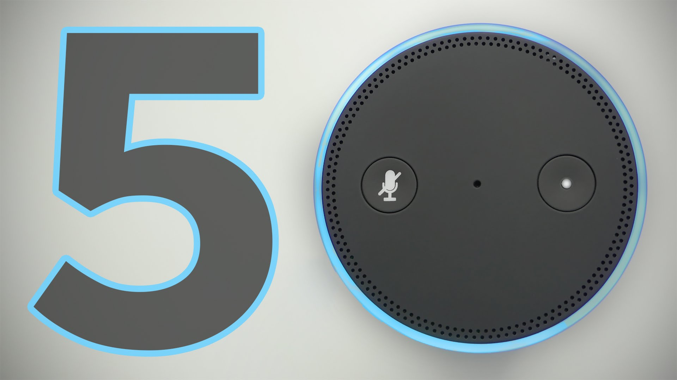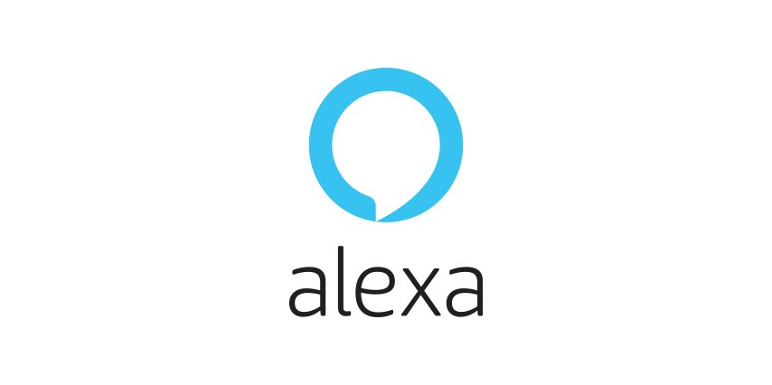

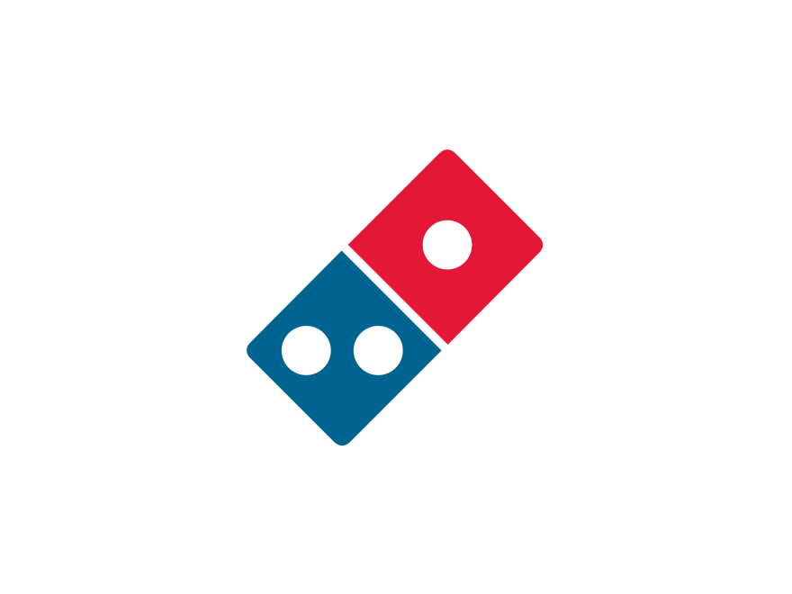

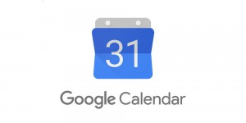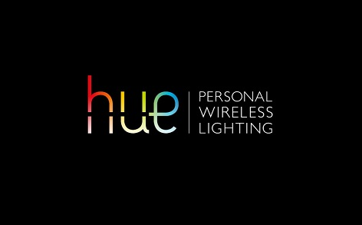





Credits (in order)

* Phone Buff - YT channel
* <http://www.hypebot.com/hypebot/2014/10/artists-confront-spotify-at-soho-house.html>
* <https://play-fi.com/news/dts-play-fi-onkyo-and-pioneer-announce-support-of-amazon-alexa-connected-sp>
* <https://twitter.com/audibleuk>
* <http://logok.org/dominos-logo/>
* <https://commons.wikimedia.org/wiki/File:Phone_Shiny_Icon.svg>
* Imagery by 1000logos.net
* <https://commons.wikimedia.org/wiki/File:Toronto-Dominion_Bank_logo.svg>
* <https://home-assistant.io/blog/2016/02/09/Smarter-Smart-Things-with-MQTT-and-Home-Assistant/>
* <https://exeo.me/2016/04/06/google-calendars-reminders-feature-now-web/google-calendar-logo/>
* <http://www.technologyintegrator.net/article/avad-adds-philips-hue-works-nest-lineup/>
* <https://mumbrella.com.au/great-northern-brewing-partners-outback-wrangler-new-campaign-celebrating-outdoors-412561>
* <http://www.sellersbuickgmc.com/UberLyftProgram>

Client Feedback:

* design is innovative, but incorporate more color to attract with looks
* make the lettering a bigger font
* make the outline of the circle thicker for the visibility
* change the lettering to say “alexa” instead of “amazon”, because you are supposed to be advertising for the product - not the company itself
* like the idea of the blue ring around it to imitate the original echo dot
* use a modified folder to create the images, then you can apply one image to other images

***Daily Project Log***

|  |  |
| --- | --- |
| Tuesday; 3/6/18 | In Class:   * Picked a client to support * Brainstormed ideas on how to help the client * Drew a sketch of our original logo idea * Found two images to modify   Home:   * None |
| Wednesday; 3/7/18 | In Class:   * Found 11 non-copyright images to use on our logo. * Read all the requirements and instructions in more depth   Home:   * Each asked parents to provide “client feedback” |
| Thursday; 3/8/18 | In Class:   * Got “client feedback” from peers * Started figuring out how to crop the images   Home:   * Started cropping the images |
| Friday & the Weekend; 3/9/18 - 3/11/18 | In Class:   * Finished cropping the images * Started resizing the images   Home:   * N/A |
| Monday; 3/12/18 | In Class:   * Continued resizing the images   Home:   * Continued resizing the images |
| Tuesday; 3/13/18 | In Class:   * Finished resizing the images individually * Tried to make a loop to resize all the images at once in an attempt to make the project less file-specific.   Home:   * Continued to try to make the loop |
| Wednesday; 3/14/18 | In Class:   * worked out the resizing loop that were were previously working on * started to work on pasting images   Home:   * watched a tutorial on how to make a function that pastes several images; tried to follow along with the process |
| Thursday; 3/15/18 | In Class:   * pasted one image of alexa logo onto the alexa circle * working on making the white pixels transparent using transparency method   Home:   * try to figure out a loop for pasting several images at once |
| Friday & the Weekend; 3/16/18 - 3/18/18 | In Class:   * N/A (no school today)   Home:   * figure out pasting all images onto alexa including the original alexa logo |
| Monday; 3/19/18 | In Class:   * made Alexa logo’s white pixels transparent to get ready to paste onto the alexa image * worked on making the images fit into the circle without going into the excess   Home:   * none (busy) |
| Tuesday; 3/20/18 | In Class:   * shrink the images to fit into the alexa circle * duplicate images to fill the circle with only minimal black space left   Home:   * finish our slideshow * made a few modifications to make the code function better |
| Wednesday; 3/21/18 | GALLERY WALK DAY ……………………... |

|  |
| --- |
| **Our Image Manipulation:**   * *Alexa* logo   **Client # 3: A Product**   * Your client is a company that manufactures or distributes a product. The client needs an image that is memorable and has a lasting impact on people to increase sales or brand loyalty to their product. This could be a real or fictitious product. * The client wants to be able to apply their brand image as a frame, overlay, or silhouette to a large number of images to be used in the marketing campaign. The client enjoys abstract art as well and would like to see geometric shape incorporated in the image—drawn on, as a border, or as a mask. * The client enjoys participating in the creative process and will appreciate being offered a range of options (as a parameter) for one of the image operations you perform. |

|  |  |
| --- | --- |
| Pros/Good things | Improvements/Missing |
| * Simple and clean design * lots of manipulations * Good * The design and integration with all the images in the background in a grid is quite complex! * I love it! * The idea is really original, and you can tell that it is meant for client #3- product. * The directory structure is very organized and put together. | * Only one sample * Not clear what function is supposed to be run to modify an image * you need four images manipulated * it would be good if you added more images * repetitive, not much variety * not clear what the client is * can it manipulate things procedurally? * There is only one image to show with all the manipulations |

Stages of Image Manipulation

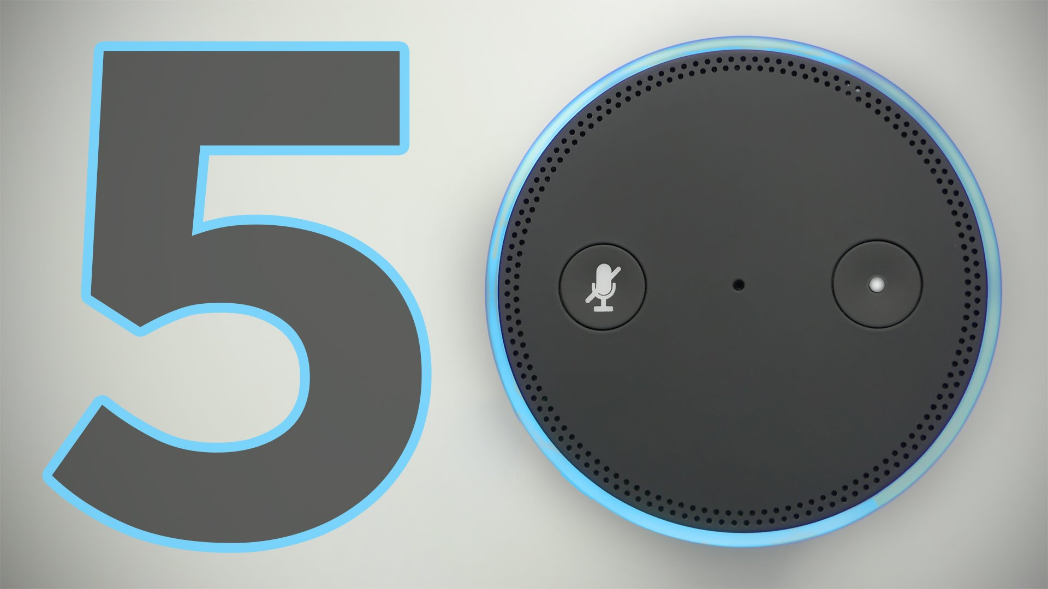

(Original)

↓

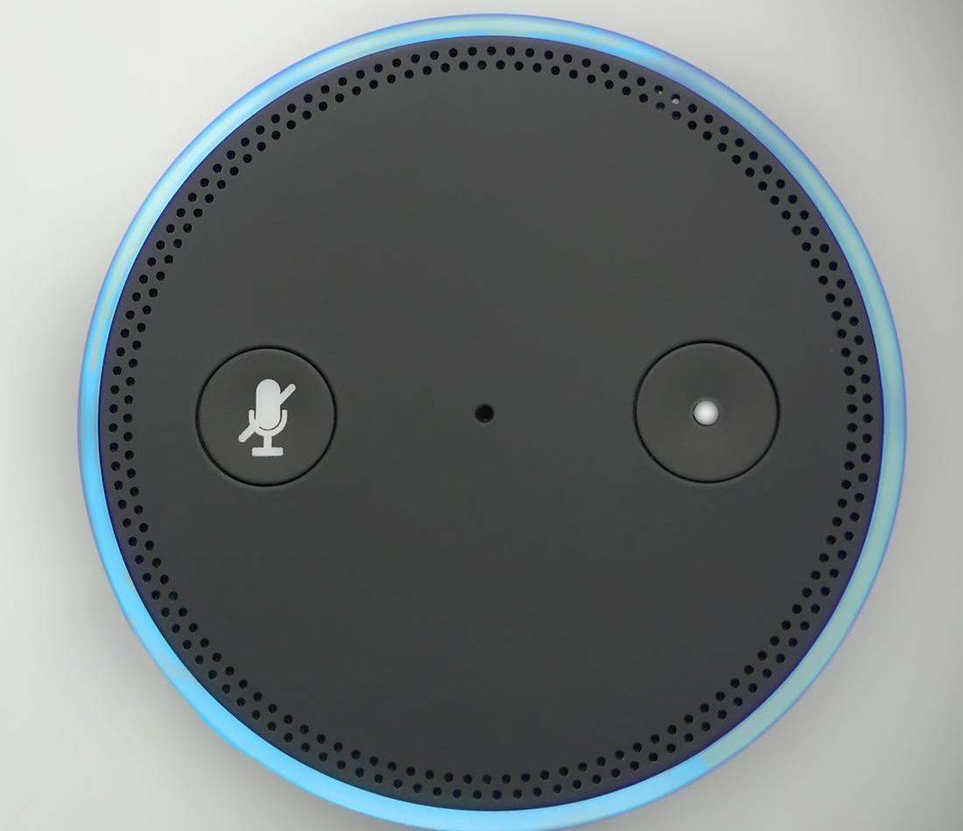

(Modified)

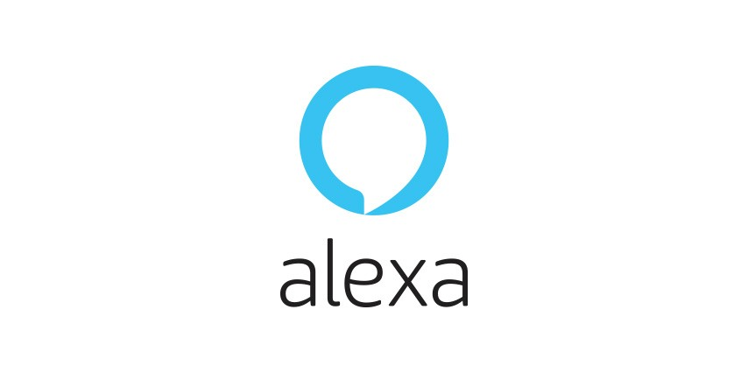

(Original)

↓

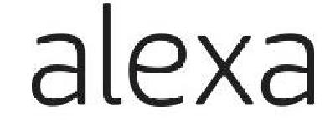

(Modified)



(Original)

↓



(Modified - alters all images[logos] in the directory)

Tiers:

Tier 1:

* cropping the images to fit onto alexa
* figuring out how to resize one image

Tier 2:

* resizing multiple images that are in one file
* paste one image

Tier 3:

* pasting several images in one file
* make the logo and other images somewhat transparent

Tier 4:

* make all of the images fit into the circle perfectly

Conclusion