MySql

1.Create Database Company

create database company; /*database company is created*/

2.Create table Employees in Company Database

create table employees(eid varchar(10),ename varchar(10),age int(2),phone varchar(10)); /*employees table will be created*/

3.DESCRIBE employees;

Field | Type | Null | Key | Default | Extra
eid | varchar(10) | NO |  | NULL
ename | varchar(10) | NO |  | NULL
age | int(2) | NO |  | NULL
phone | varchar(10) | NO |  | NULL

4.Adding values to employees table

insert into employees values("s123","soumya","21","9741518020"); /* 1 row will be inserted */
insert into employees values("s134","sushmita","22","7760391039"); /*2 row will be inserted */
insert into employees values("c1","pooja","24","9448868034"); /*3 row will be inserted */

5.Checking the deatils of the employees table

select *from employees; /*displays all the columns which are in the employees table*/

6.To get the name of the employees in employees table-

select ename from employees; /*displays only ename column*/

7.Updating the contents in the employees table-

update employees
set ename="anu"
where eid="s123"; /*the ename soumya changes to anu after executing this*/

8.Delete is used to delete the contents in the table

delete from employees
where ename="sushmita"; /*it deletes 1 row from the employees table*/

9.Snapshots

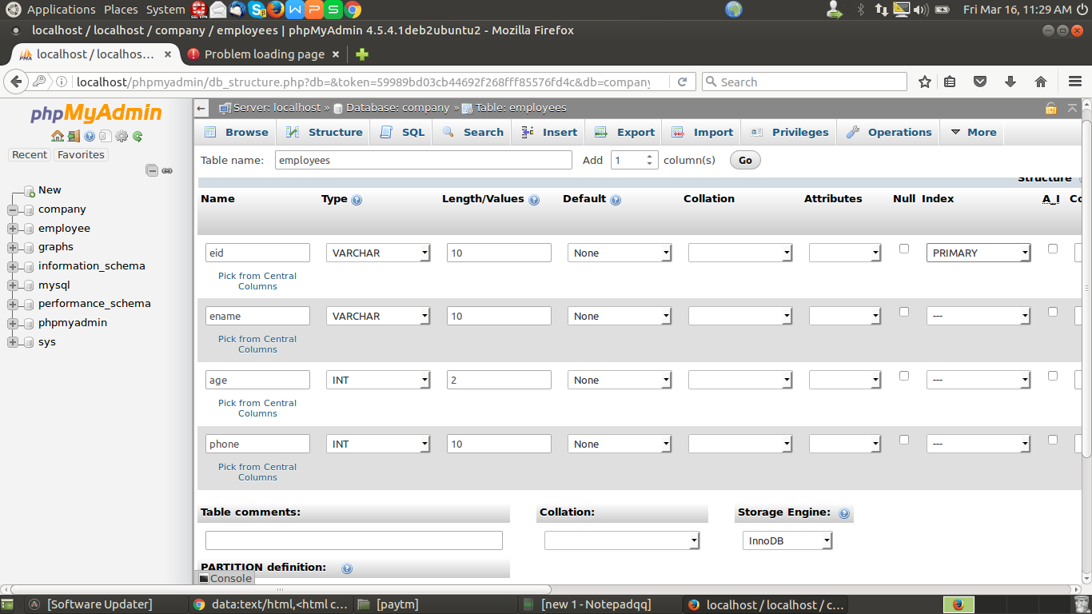
s1-creating the table employees

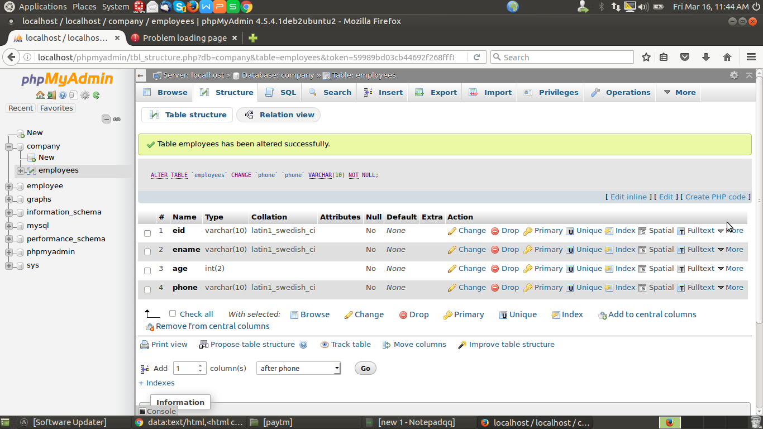
s2-table created
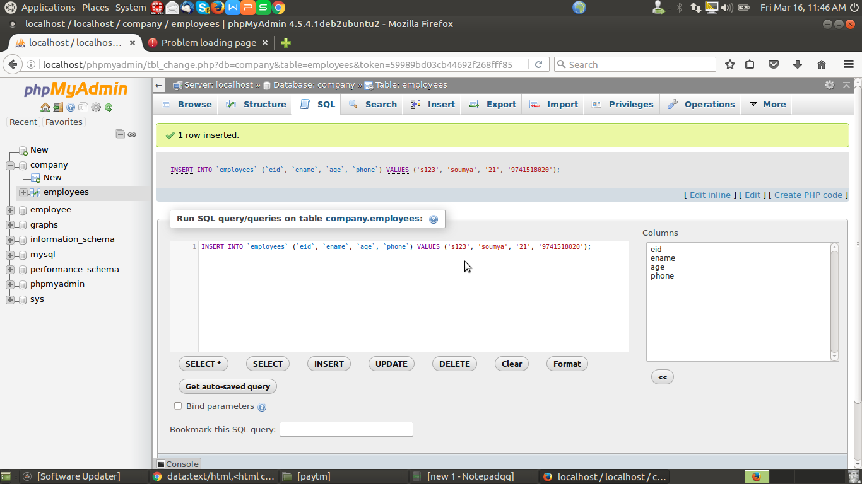

s3-inserting values to employees table
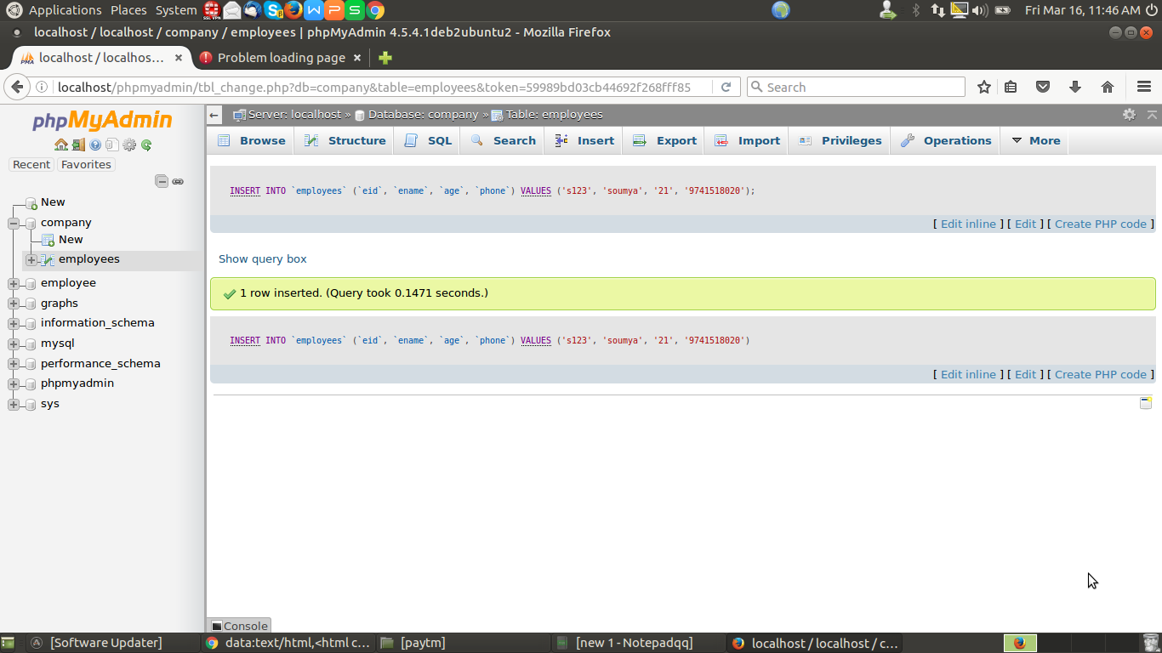
s4-row inserted successfully
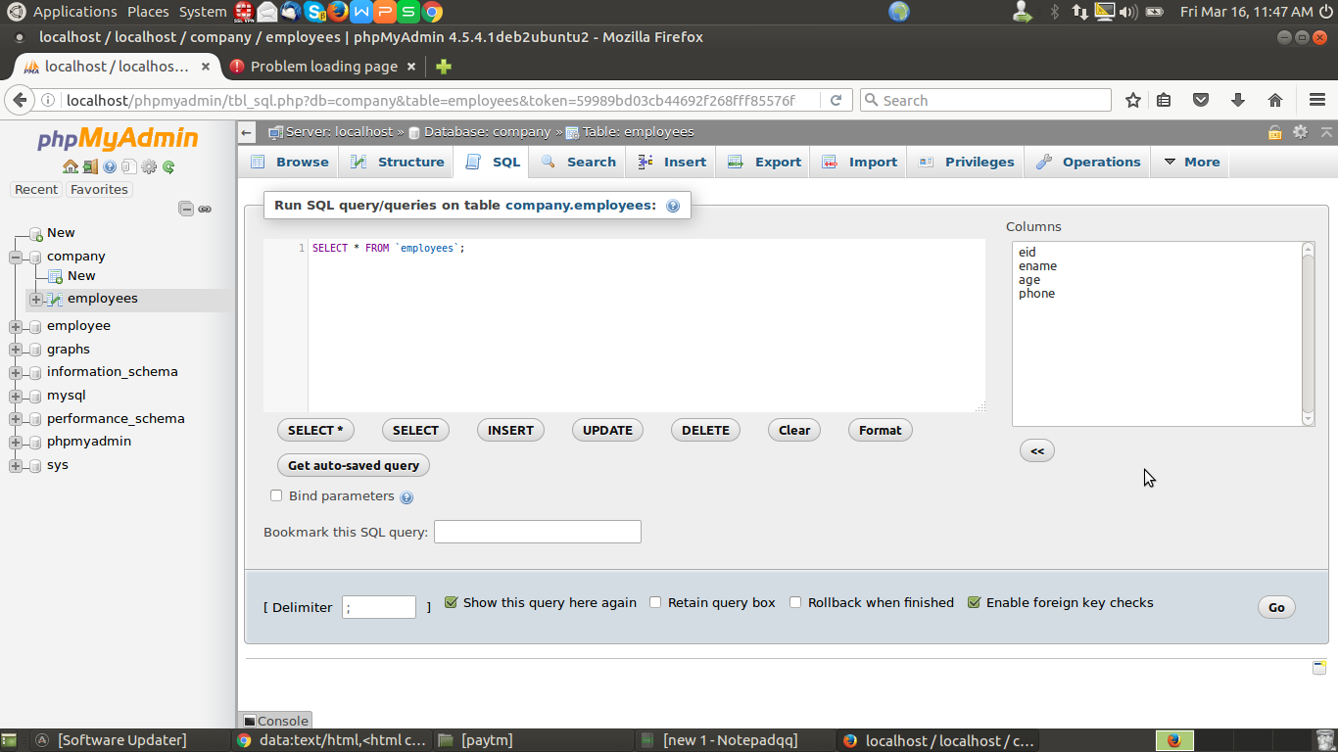
s5-getting a values from the employees table

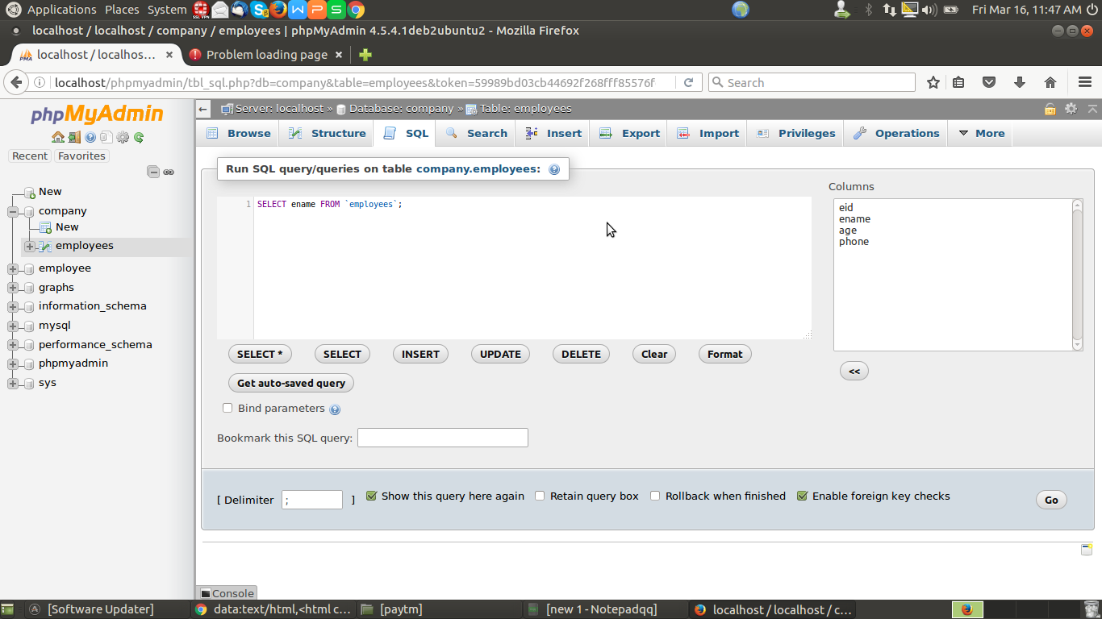
s6-only ename column will be displayed from the employees table

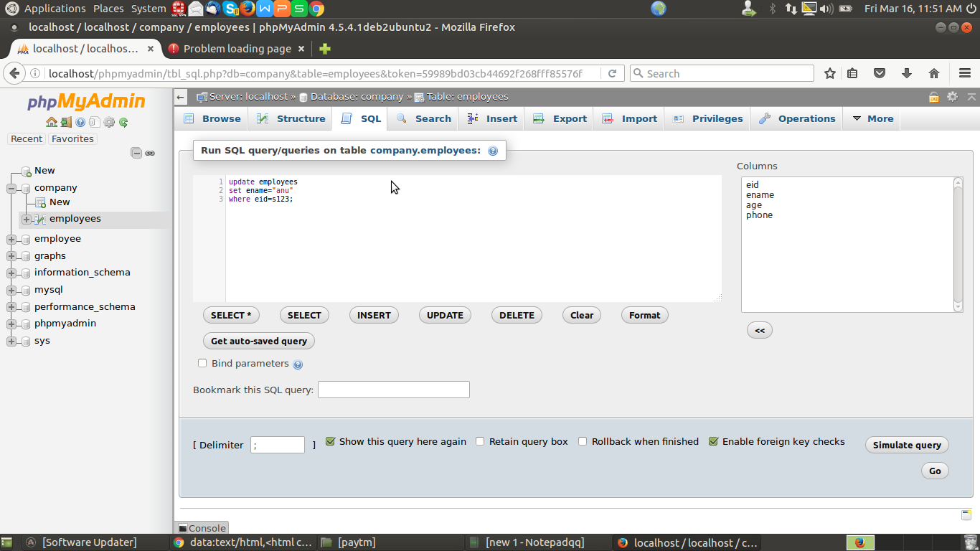
s7-updating ename value in the employees table

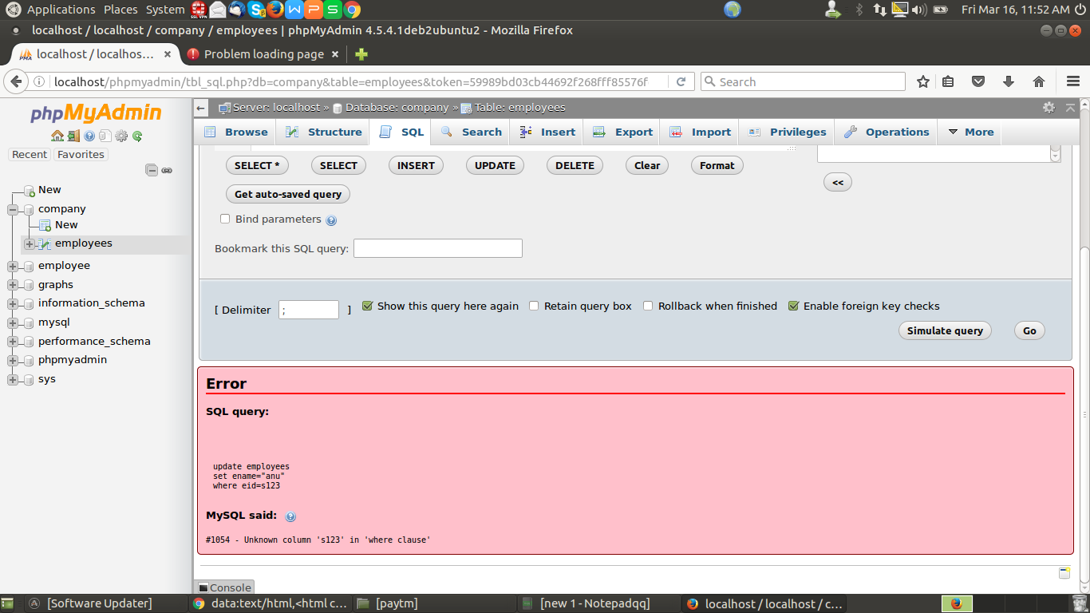
s8-error because of not giving “ in eid=s123

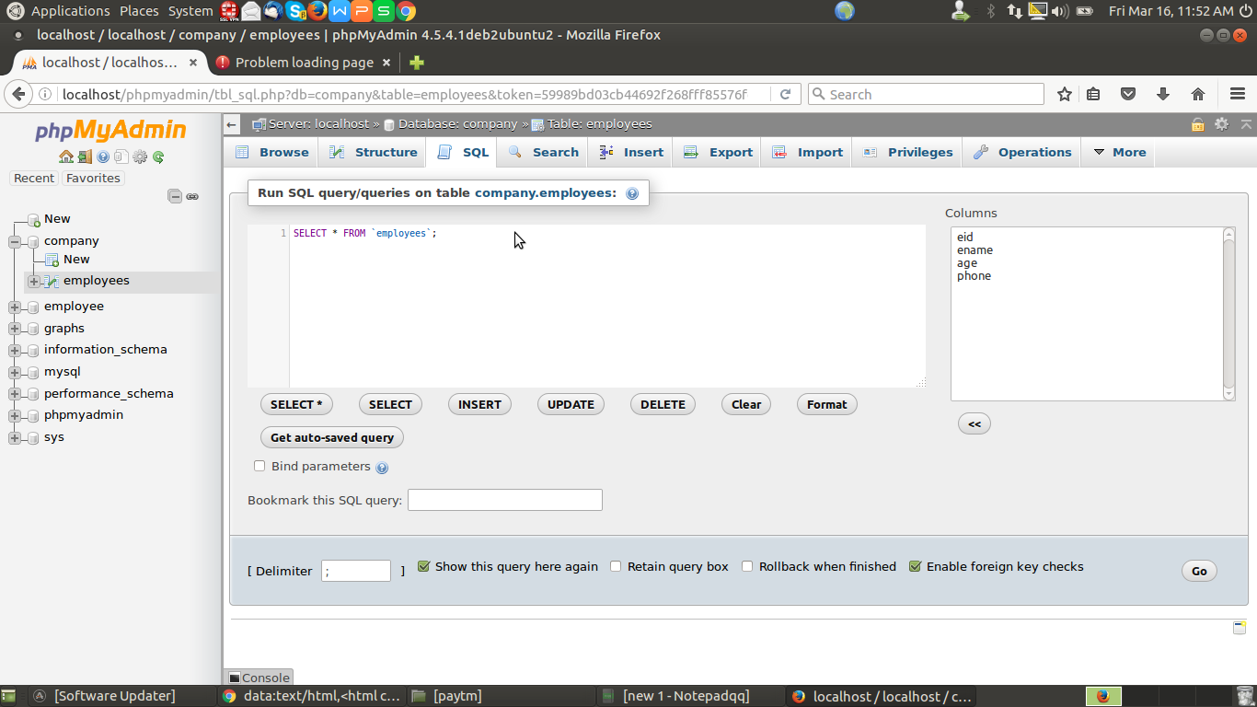
s10-for getting a details of the employees in employees table

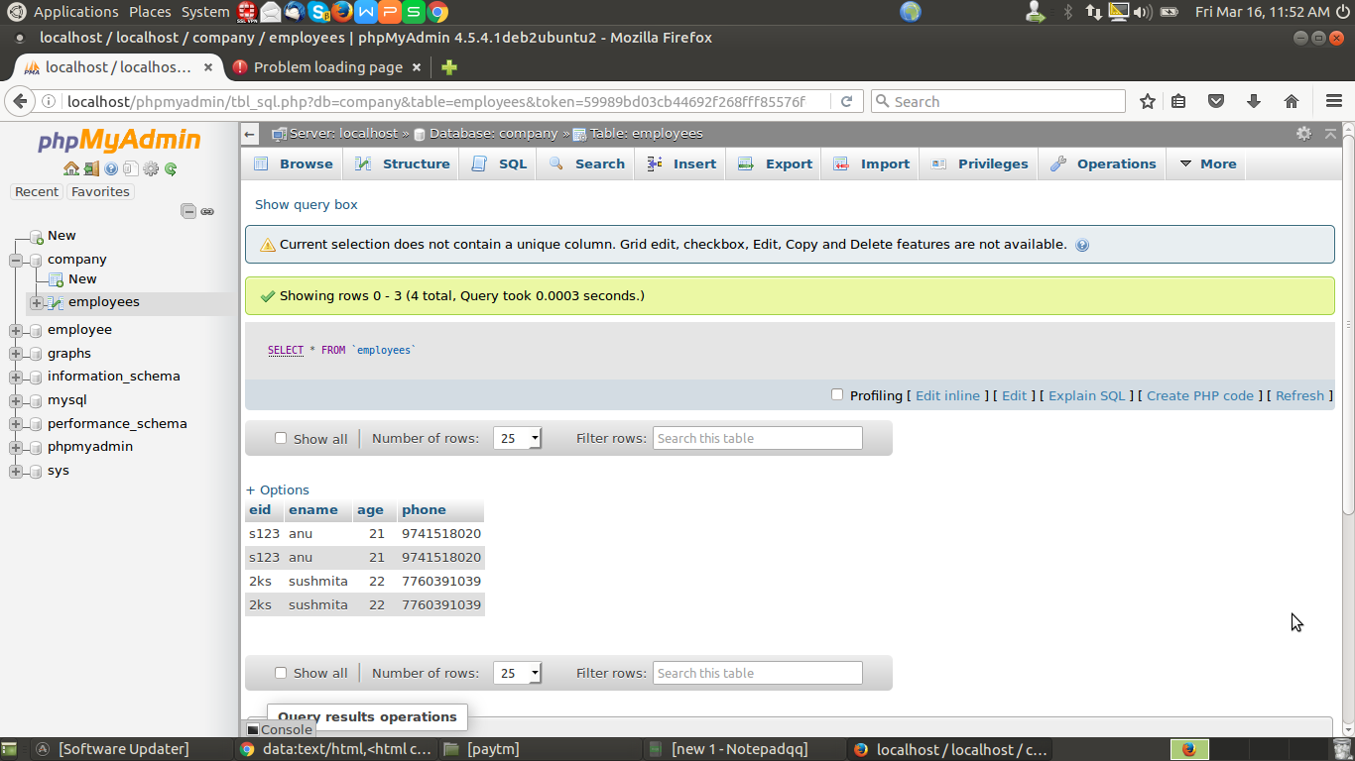
s11-details of the employees

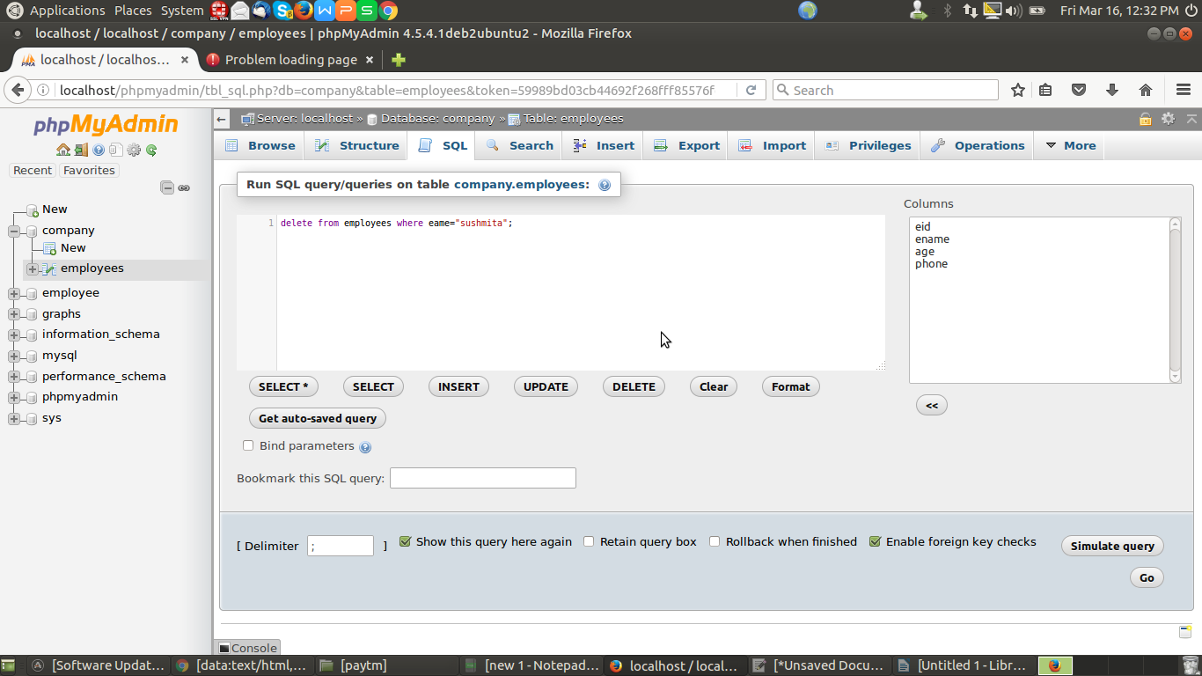
s12-deleting row from the employees table

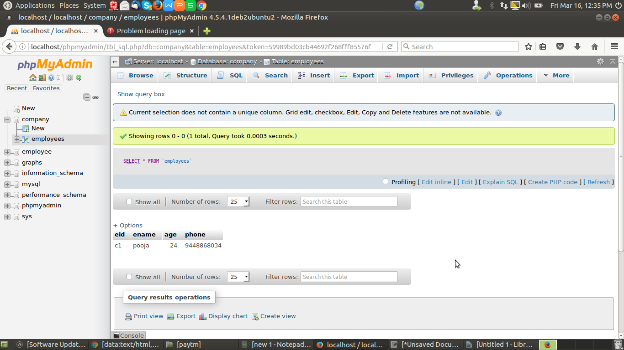
s13-table contents

