

School of Computing Science Engineering and Artificial Intelligence
(SCAI)

Practical File

Course Name: Programming in Java
(Course Code: CSE2006)
Slot: A11+A12+A13+D11+D12

Submitted By: Submitted to:
Name: Soumya Ghosh Mrs. Garima Jain
Reg. no.: 24MIM10093

PROGRAMMING IN JAVA
CSE2006

INDEX

Exp. No. | Title | Date Conducted | Remark
1 | Java Program to Check whether input character is vowel or consonant. | 20/11/25
2 | Java Program to Find Factorial of a number. | 20/11/25
3 | Java Program to Show Encapsulation in Class. | 21/11/25
4 | Java Program to Show Inheritance in Class. | 22/11/25
5 | Java Program to Show Polymorphism in Class. | 23/11/25
6 | Java Program to Show Overloading of Methods in Class. | 23/11/25
7 | Java Program to Show Overriding of Methods in Classes. | 23/11/25
8 | Java Program to Show Use of Super Keyword in Class. | 23/11/25
9 | Java Program to Show Use of This Keyword in Class. | 23/11/25
10 | Java Program to Show Usage of Static Keyword in Class. | 24/11/25
11 | Java Program to Show Usage of Access Modifier. | 24/11/25
12 | Java Program to demonstrate constructor overloading. | 24/11/25
13 | Java Program to Create Abstract Class. | 25/11/25
14 | Java Program to Create an Interface. | 25/11/25
15 | Java Program to Create Singleton Class. | 25/11/25

EXPERIMENT 1:
Aim: Write a Java Program to Check whether input character is vowel or consonant.

Code:
package SoumyaGhoshLabFile;
import java.util.Scanner;

public class Exp1 {
public static void main(String args[]){
Scanner sc = new Scanner(System.in);
System.out.println("Enter a character: ");
char ch = sc.next().charAt(0);

String vowel = "aeiouAEIOU";
if(vowel.indexOf(ch) == -1)
System.out.println("The char " + ch + " is a consonant.");
else
System.out.println("The character " + ch + " is a vowel.");
sc.close();
}
}

Output:
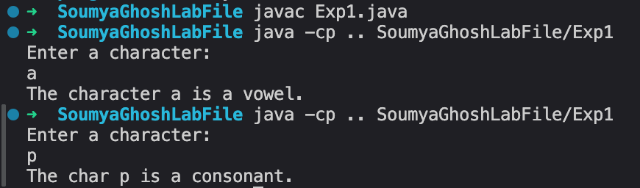

EXPERIMENT 2:
Aim: Write a Java Program to Find Factorial of a number.

Code:
//using normal method
package SoumyaGhoshLabFile;
import java.util.Scanner;

public class Exp2 {
public static void main(String args[]){
Scanner sc = new Scanner(System.in);

int fact = 1;
System.out.println("Enter an integer: ");
int num = sc.nextInt();
if (num < 0) {
System.out.println("Enter non negative integer.");
} else {
int original = num;
for (int i = 1; i <= num; i++) {
fact *= i;
}
System.out.println("The factorial of " + original + " is: " + fact);
}
sc.close();
}
}

Output:
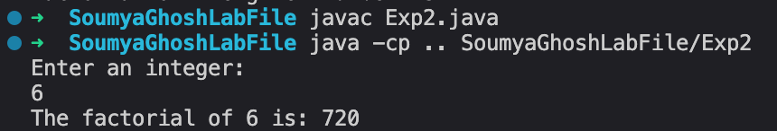

Code:
//using recursive method
Import java.util.Scanner;
public class Exp2 {

int factorial(int num){
if(num < 0 || num == 1)
return 1;
else
return num * factorial(num-1);
}

public static void main(String args[]){
Scanner sc = new Scanner(System.in);
System.out.println("Enter a number to check factorial: ");
int fact = sc.nextInt();
Exp2 exp = new Exp2();
System.out.println("Factorial of the given number is: " + exp.factorial(fact));
sc.close();
}
}

Output:
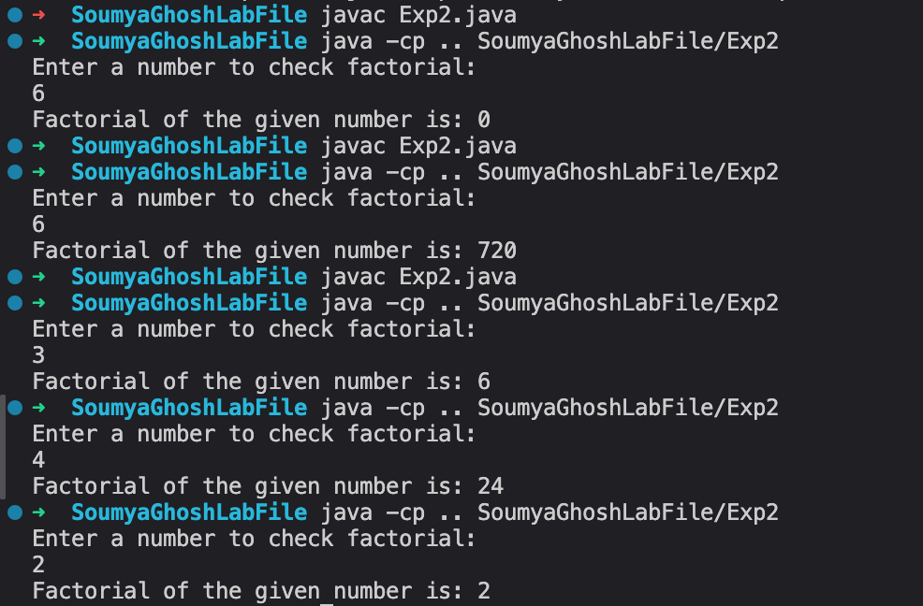

EXPERIMENT 3:
Aim: Write a Java Program to Show Encapsulation in Java class.

Code:
class Student{

//private fields
private String name;
private int age;
private double gpa;

//public constructor
Student(String name, int age, double gpa){
this.name = name;
this.age = age;
this.gpa = gpa;
}

//public getters(accessors)
public String getName(){
return name;
}
public int getAge(){
return age;
}
public double getGpa(){
return gpa;
}

//public setters(mutators)
public void setName(String name){
this.name = name;
}
public void setAge(int age){
this.age = age;
}
public void setGpa(double gpa){
this.gpa = gpa;
}

public void displayStudentInfo(){
System.out.println("Name: " + name + ", Age: " + age + ", Gpa: " + gpa);
}
}

class Exp3{
public static void main(String args[]){
Student student1 = new Student("Soumya", 20, 8.5);
student1.displayStudentInfo();

//System.out.println(student1.name); //can't directly access invisible field
System.out.println("Name: " + student1.getName()); //instead i use public getters
System.out.println("Age: " + student1.getAge());
System.out.println("Gpa: " + student1.getGpa());

//student1.name = "Rahul"; //can't directly modify invisible fields
student1.setName("Rahul"); //instead i use public setters
student1.setAge(21);
student1.setGpa(9.5);
student1.displayStudentInfo();
}
}

Output:
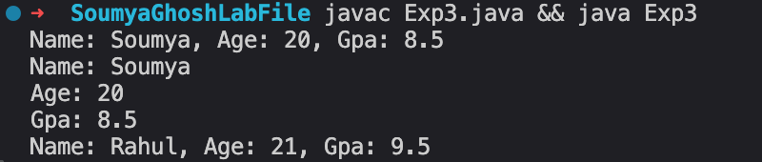

EXPERIMENT 4:
Aim:Java Program to Show Inheritance in Class

Code:
//parent class
class Animal{
protected String name;
protected int age;
public Animal(){}

public Animal(String name, int age){
this.name = name;
this.age = age;
}

void makeSound(){
System.out.println(name + " makes a generic sound!");
}
void eat(){
System.out.println(name+ " is eating food!");
}
void sleep(){
System.out.println(name + " is sleeping!");
}
void displayInfo(){
System.out.println("Name: " + name + ", Age: " + age);
}
}

//child class 1
class Dog extends Animal{
protected String breed;

public Dog(String name, int age, String breed){
super(name, age);
this.breed = breed;
}

void makeSound(){
System.out.println(name + " makes barking sound!");
}
void fetchBall(){
System.out.println(name + " fetches the ball.");
}
void displayInfo(){
System.out.println("Name: " + name + ", Age: " + age + ", Breed: " + breed);
}
}

//child class 2 for showing heirerchial inheritance
class Cat extends Animal{

private int livesLeft;

public Cat(String name, int age, int livesLeft){
super(name, age);
this.livesLeft = livesLeft;
}
void makeSound(){
System.out.println(name + " makes meowing sound!");
}
void climbTree(){
System.out.println(name + " climbing a tree");
}
void displayInfo(){
System.out.println("Nmae: " + name + ", Age: " + age + ", Lives Left: " + livesLeft);
}
}

//grandchild class for showing multilevel inheritance
class Puppy extends Dog{
private boolean isTrained;
public Puppy(String name, int age, String breed, boolean isTrained){
super(name, age, breed);
}

void play(){
System.out.println(name + "is playing happily.");
}
void displayInfo(){
System.out.println("Name: " + name + ", Age: " + age + ", Breed: " + breed + ", Istrained: "+ isTrained);
}
}

public class Exp4{
public static void main(String args[]){
Animal animal = new Animal("genericAnimal", 13);
animal.displayInfo();
animal.makeSound();
animal.eat();
animal.sleep();

Dog dog;
dog = new Dog("Kalu", 5, "desi");
dog.displayInfo();
dog.eat();
dog.makeSound();
dog.fetchBall();

Cat cat = new Cat("puchu", 3, 9);
cat.displayInfo();
cat.makeSound();
cat.sleep();
cat.climbTree();

Puppy puppy = new Puppy("bhulu", 1, "labrador", true);
puppy.displayInfo();
puppy.makeSound();
puppy.fetchBall();
puppy.play();

}
}

Output: 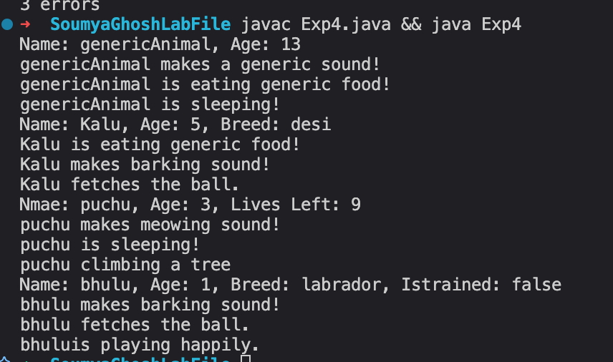

EXPERIMENT 5:
Aim:Java Program to Show Polymorphism in Class

Code:
class Shape{
protected String color;

Shape(String color){
this.color = color;
}
void calculateArea(){
System.out.println("This is a generic area.");
}
void display(){
System.out.println("This is a " + color + " shape.");
}
void describe(){
System.out.println("This is a generic shape class.");
}
}

class Circle extends Shape{
private double radius;

Circle(String color, double radius){
super(color);
this.radius = radius;
}

void calculateArea(){
double area = Math.PI * radius * radius;
System.out.println("The area of circle is: " + area);
}

void display(){
System.out.println("This is a " + color + " Circle with radius" + radius);
}
void describe(){
System.out.println("This is circle class");
}
void resize(double newRadius){
this.radius = newRadius;
System.out.println("The circle is resized to radius " + radius);
}
void resize(int scale){
this.radius *= scale * radius;
System.out.println("The circle is being scaled to of radius" + radius);
}
}

class Rectangle extends Shape{
private double length;
private double width;

Rectangle(String color, double length, double width){
super(color);
this.length = length;
this.width = width;
}
void calculateArea(){
double area = length * width; //local variables should alwawys be initialized
System.out.println("The area of the rectangle is: " + area);
}
void display(){
System.out.println("This is a " + color + " rectangle of length " + length + " width " + width);
}
void describe(){
System.out.println("This is a rectangle class");
}
}

class Triangle extends Shape{
private double base;
private double height;

Triangle(String color, double base, double height){
super(color);
this.base = base;
this.height = height;
}
void calculateArea(){
double area = 0.5 * base * height;
System.out.println("The area of the triangle is: " + area);
}
void display(){
System.out.println("This is a " + color + " triangle");
}
void describe(){
System.out.println("This is a Tirangle class.");
}
}

public class Exp5 {
public static void main(String Args[]){

//Runtime-Polymorphism(Mehtod overriding)
Shape shape1 = new Circle("Red", 8);
Shape shape2 = new Triangle("Blue", 8, 9);
Shape shape3 = new Rectangle("Green", 9, 8);

Shape[] shapes = {shape1, shape2, shape3};
for(Shape shape : shapes){
shape.calculateArea();
shape.display();
}
//shape1.resize(4);
//Parent class refernce can only access generic methods
//Compiletime-Polymorphism(Method Overloading)
Circle circle = new Circle("Yellow", 4);
circle.resize(2);

circle.describe(); //static method called compiletiime (early binding)
circle.display(); //not static method called in runtime (late binding)
}
}

Output:
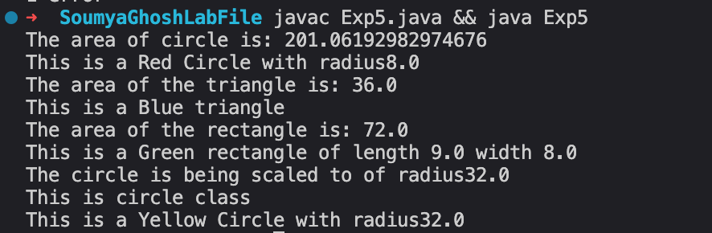

EXPERIMENT 6:
Aim: Java Program to Show Overloading of Methods in Class

Code:

class Calculator{

//add two integers
public void ladd(int a, int b){
System.out.println("Sum of two int: " + (a + b));
}
//add three integers
public void add(int a, int b, int c){
System.out.println("Sum of three int: " + (a + b + c));
}
//add two double
public void add(double a, double b){
System.out.println("Sum of tow doubles: " + (a + b));
}
//add three doubles
public void add(double a, double b, double c){
System.out.println("Sum of three doubles : " + (a + b + c));
}
//Concatenate two strings
public void add(String a, String b){
System.out.println("The two concatenated string: " + a + b);
}
//concatenate three strings
public void add(String a, String b, String c){
System.out.println("The three concatenated String: " + a + b + c);
}
//add elements of array
public void add(int[] num){
int sum = 0;
for(int a : num){
sum += a;
}
System.out.println("The sum of array elems: " + sum);
}

}

class MathUnits{
//area of square
public void calculateArea(double side){
double area = side * side;
System.out.println("The area of the square: " + area);
}
//area of rectangle
public void calculateArea(double length, double width){
double area = length * width;
System.out.println("The area of the rectangle: " + area);
}

//isCircle is redundant param passed to maintain the rules of overloading
public void calculateArea(double radius, boolean isCircle){
double area = Math.PI * radius * radius;
System.out.println("The area of the Circle: " + area);
}
}

public class Exp6 {
public static void main(String args[]){

//overloaded calculator methods
int[] arr = {3, 5, 6, 8};
Calculator calc = new Calculator();
calc.add(3, 4);
calc.add(5, 6, -9);
calc.add("Soumya", " Ghosh");
calc.add(9.6, 6.9);
calc.add("I ", "love ", "her");
calc.add(arr);

//overloaded Area methods
MathUnits area = new MathUnits();
area.calculateArea(8.9); //area of square
area.calculateArea(8.6, 9.8); //aera of rectangle
area.calculateArea(4.5, true); //area of Circle
}
}

Output:
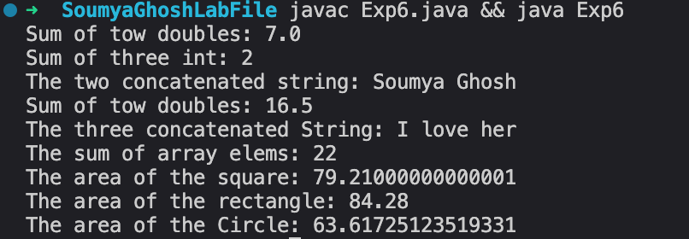

EXPERIMENT 7:
Aim:Java Program to Show Overriding in methods in Class

Code:

class BankAccount{
protected String accNumber;
protected String accHolder;
protected double accBalance;

BankAccount(String accNumber, String accHolder, double accBalance){
this.accNumber = accNumber;
this.accHolder = accHolder;
this.accBalance = accBalance;
}

void deposit(double amount){
if(amount > 0){
accBalance += amount;
System.out.println("Deposited: " + amount);
}
else System.out.println("Invalid deposit amount.");
}

void withdraw(double amount){
if(amount > 0 && accBalance >= amount){
accBalance -= amount;
System.out.println("Withdrawn: " + amount);
}
else
System.out.println("invalid amount or insufficient balance");
}

void calculateInterest(){
System.out.println("No interest for basic account");
}

void displayAccountInfo(){
System.out.println("Account No.: " + accNumber);
System.out.println("Account holer: " + accHolder);
System.out.println("Account Balance: " + accBalance);
}

//can not be overriden
final void getAccountType(){
System.out.println("Basic Bank Account");
}
}

class SavingsAccount extends BankAccount{
private double interestRate;
SavingsAccount(String accNumber, String accHolder, double accBalance, double interestRate){
super(accNumber, accHolder, accBalance);
this.interestRate = interestRate;
}

//overriden method
void withdraw(double amount){
if(amount > 0 && amount <= accBalance && (accBalance - amount) >= 1000){
accBalance -= amount;
System.out.println("Withdrawn: (maintain min 1000 rupes) " + amount);
}
else
System.out.println("Withdrawal failed! Maintain atleast 1000 rupee");
}
//overriden method
void calculateInterest(){
double interest = accBalance * interestRate /100;
accBalance += interestRate;
System.out.println("The account balacne after interest: " + accBalance);
}
void displayAccountInfo(){
super.displayAccountInfo();
System.out.println("Interest Rate: " + interestRate);
}
}

class CurrentsAccount extends BankAccount {
private double overdraftLimit;

public CurrentsAccount(String accountNumber, String accountHolder, double balance, double overdraftLimit) {
super(accountNumber, accountHolder, balance);
this.overdraftLimit = overdraftLimit;
}
//overriden method
public void withdraw(double amount) {
if (amount > 0 && amount <= (accBalance + overdraftLimit)) {
accBalance -= amount;
System.out.println("Withdrawn" + amount);
if (accBalance < 0) {
System.out.println("Overdraft used! balacne: " + Math.abs(accBalance));
}
} else {
System.out.println("Withdrawal exceeds overdraft limit.");
}
}
//overriden method
public void calculateInterest() {
System.out.println("No interest for currents account.");
}
//overriden method
public void displayAccountInfo() {
super.displayAccountInfo();
System.out.println("Overdraft limit" + overdraftLimit);
System.out.println("This is Current Account ");
}
}

public class Exp7 {
public static void main(String args[]){
BankAccount savings = new SavingsAccount("sav100", "Soumya Ghosh", 5000, 4.5);
BankAccount currents = new CurrentsAccount("curr100", "Soumya Ghosh", 5000, 400);

BankAccount[] accounts = {savings, currents};
for(BankAccount account : accounts){
account.getAccountType();
account.displayAccountInfo();
account.deposit(4000);
account.withdraw(300);
account.calculateInterest();
}
}
}

Output:
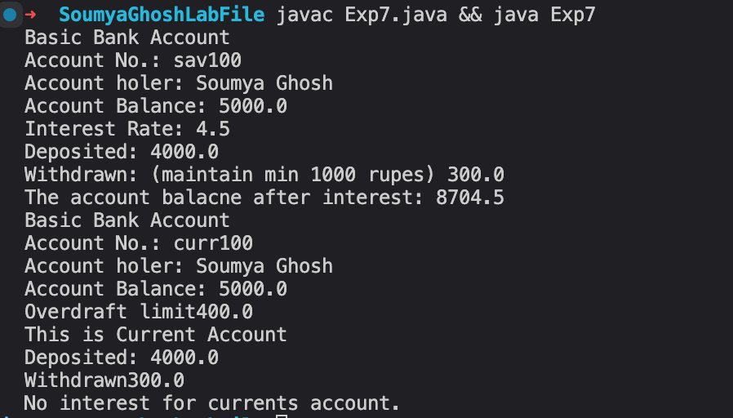

EXPERIMENT 8:
Aim: Java Program to Show Super Keyword Usage in Class.

Code:

class Person{
String name;
int age;
String nationality;

//fully initialized constructor
public Person(String name, int age, String nationality){
this.name = name;
this.age = age;
this.nationality = nationality;
}

//default person class
public Person(){
this.name = "unknown";
this.age = 25;
this.nationality = "Unknown";
}

//overriden method
public void displayInfo(){
System.out.println("Name: " + name);
System.out.println("Age: " + age);
System.out.println("Nationality: " + nationality);
introduce();
}

//super method calling
public void introduce(){
System.out.println("Hi I am "+ name + " from " + nationality);
}

//final method
public final void breathe(){
System.out.println(name + " is breathing");
}
}

//inherits person class
class Student extends Person{
private String studentId;
private String major;
private double gpa;

//unconstructed (full parameterized constructor)
public Student(String name, int age, String nationality, String studentId, String major, double gpa){
super(name, age, nationality); //super method
this.studentId = studentId;
this.major = major;
this.gpa = gpa;
}

//partially constructed constructor
public Student(String name, String studentId, String major){
super(name, 21, "Indian");
this.studentId = studentId;
this.major = major;
this.gpa = 0;
}
public void displayInfo(){
super.displayInfo();
System.out.println("Student Id: " + studentId);
System.out.println("Major in: " + major);
System.out.println("Gpa: " + gpa);
}

public void study(){
System.out.println(super.name + "(student id: " + studentId + ") is studying..");
super.breathe();
}
}

//inherits perosn class
class Employee extends Person{
private String employeeId;
private String department;
private double salary;

public Employee(String name, int age, String nationality, String employeeId, String department, double salary){
super(name, age, nationality);
this.employeeId = employeeId;
this.department = department;
this.salary = salary;
}

//constructor with partial parameters will have the other variables assigned
public Employee(String name , String employeeId, String department){
super(name, 27, "Indian");
this.employeeId = employeeId;
this.department = department;
this.salary = 20000;
}

public void displayInfo(){
super.displayInfo();
System.out.println("Employee Id: " + employeeId);
System.out.println("Department: " + department);
System.out.println("Salary: " + salary);
}

public void work(){
System.out.println(super.name + "(employee id - " + employeeId + ") is working..");
super.breathe();
}
}

//multi-level inheritance
class StarStudent extends Student{
private boolean scholarship;

public StarStudent(String name, int age, String nationality, String studentId, String major, double gpa, boolean scholarship){
super(name, age, nationality, studentId, major, gpa);
this.scholarship = scholarship;
}

public StarStudent(String name, int age, String nationality){
super(name, age, nationality, "24MIM10015", "Data Science", 9.5 );
this.scholarship = true;
}
public void displayInfo(){
super.displayInfo();
System.out.println("Scholarship status: " + scholarship);
}

//multilevel super usage
public void studyAndSleep(){
super.study();
System.out.println("Scholarship status: " + scholarship);
}
}

public class Exp8 {
public static void main(String args[]){
Person person = new Person();
Student student = new Student("Soumya", "24MIM10093", "Artificial Intelligence");
Employee employee = new Employee("Enagandula", "21MAT10093", "SASL");
Student starStudent1 = new StarStudent("Rahul", 20, "Nepali"); //parent class reference(no scholarhip)
StarStudent starStudent2 = new StarStudent("Swagata", 19, "Bangladeshi"); //child class reference(gets scholarship)

person.displayInfo();
person.introduce();
person.breathe();

student.displayInfo();
student.introduce();
student.study();

employee.displayInfo();
employee.introduce();
employee.work();

starStudent1.displayInfo();
starStudent1.introduce();
starStudent1.study();
// starStudent1.studyAndSleep(); //parent class ref obj can't have access to StarStudent specific variable (scholarship)

starStudent2.displayInfo();
starStudent2.study();
starStudent2.studyAndSleep(); //can access generic and specific as it is child class refernce object

}
}

Output:
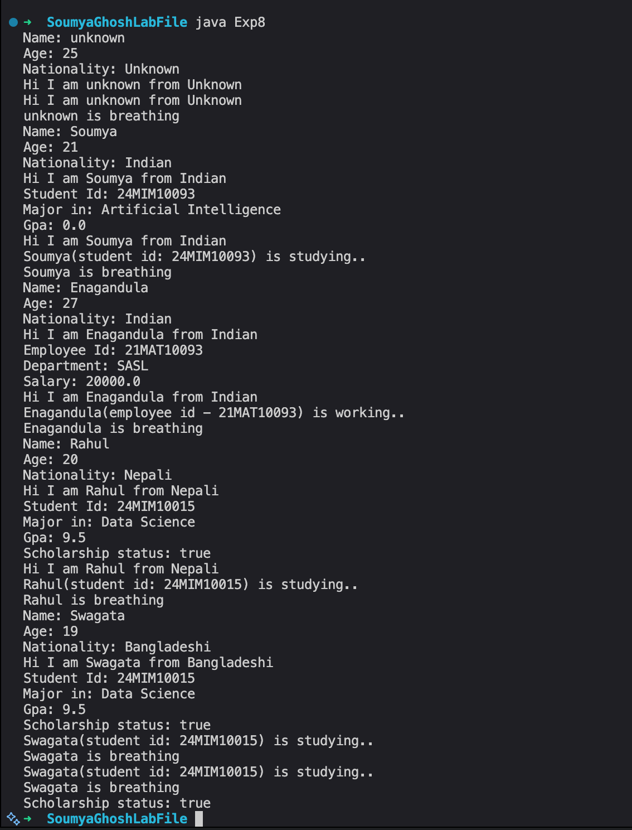

EXPERIMENT 9:
Aim: Java Program to Show ThisKeyword Usage in Class.

Code:

class Student{
// Instance variables
public String name;
public int rollNumber;
public double marks;
public String department;

public Student(String name, int rollNumber, double marks, String department) { //parameteres inside Student constructor
this.name = name;
this.rollNumber = rollNumber;
this.marks = marks;
this.department = department;
}

public Student(String name, int rollNumber){
this.name = name;
this.rollNumber = rollNumber;
this.marks = 0.0;
this.department = "Undeclared";
}

//here 'this' is optional
public void displayStudentInfo() {
System.out.println("Name: " + this.name);
System.out.println("Roll Number: " + rollNumber);
System.out.println("Marks: " + this.marks);
System.out.println("Department: " + this.department);
}

public void updateMarks(double marks){
this.marks = marks; // Assign parameter value to instance variable
}

public boolean hasHigherMarks(Student otherStudent){
return this.marks > otherStudent.marks;
}
}

public class Exp9{
public static void main(String[] args) {

Student student1 = new Student("Soumya Ghosh", 100, 88.5, "AI");
Student student2 = new Student("Rahul Behera", 102, 92.0, "AI");
Student student3 = new Student("Lakshya Kant", 103);

student1.displayStudentInfo();
student2.displayStudentInfo();
student3.displayStudentInfo();

student3.updateMarks(78.5);
student3.displayStudentInfo();

System.out.println("Does " + student2.name + " have higher marks than " + student1.name + "? "
+ student2.hasHigherMarks(student1));
System.out.println("Does " + student1.name + " have hihger marks than " + student3.name + "? "
+ student1.hasHigherMarks(student3));
}
}

Output:
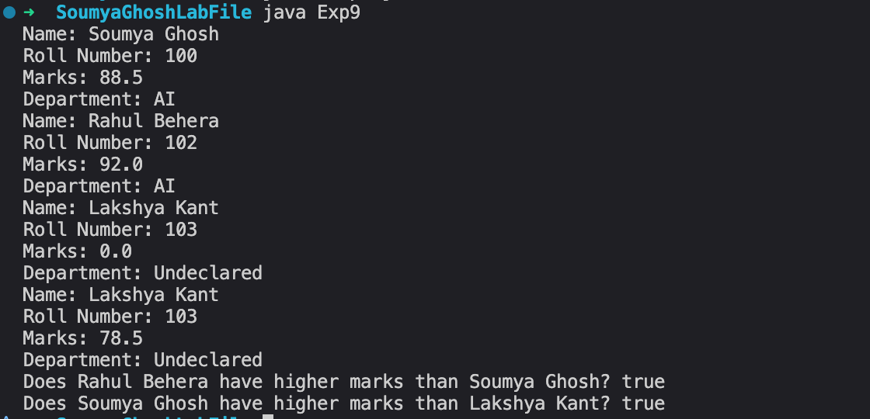

EXPERIMENT 10:
Aim: Java Program to Show Static Keyword Usage in Class.

Code:

class Counter {
static int count = 0;
int instanceCount = 0;

public Counter() {
count++;

instanceCount++;
}
static void displayTotalCount() {
System.out.println("Total objects created: " + count);
}

void displayInfo() {
System.out.println("Static count: " + count + ", Instance count: " + instanceCount);
}
}

class MathUtils {
static final double PI = 3.14159;
static int add(int a, int b) {
return a + b;
}
static double calculateCircleArea(double radius) {
return PI * radius * radius;
}
}

class Exp10 {
static {
System.out.println("Static block executed - class loaded");
}
public static void main(String[] args) {
Counter c1 = new Counter();
Counter c2 = new Counter();
Counter c3 = new Counter();

c1.displayInfo();
c2.displayInfo();
c3.displayInfo();
Counter.displayTotalCount();

System.out.println("5 + 3 = " + MathUtils.add(5, 3));
System.out.println("Circle area: " + MathUtils.calculateCircleArea(5));
System.out.println("PI value: " + MathUtils.PI);

System.out.println("Counter.count: " + Counter.count);
System.out.println("c1.count: " + c1.count);
}
}

Output:
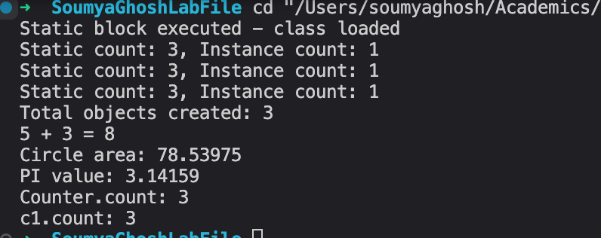

EXPERIMENT 11:
Aim: Java program to show usage of Access Modifier.

Code:
class AccessDemo{

// Different access modifiers
private String privateVar = "private";
protected String protectedVar = "protected";
public String publicVar = "public";
String defaultVar = "default";
private void privateMethod(){
System.out.println("Private method called");
}
protected void protectedMethod(){
System.out.println("Protected method called");
}
public void publicMethod() {
System.out.println("Public method called");
privateMethod();
}

void defaultMethod() {
System.out.println("Default method called");
}

public void displayAll(){
System.out.println("Private: " + privateVar);
System.out.println("Protected: " + protectedVar);
System.out.println("Public: " + publicVar);
System.out.println("Default: " + defaultVar);
}
}

class SubClass extends AccessDemo{
public void testAccess(){
System.out.println("protected:" + protectedVar);
System.out.println("Public: " + publicVar);
System.out.println("deffault: " + defaultVar);
}
}

public class Exp11{
public static void main(String[] args){
AccessDemo obj = new AccessDemo();

System.out.println("Public: " +obj.publicVar);
System.out.println("Default: " + obj.defaultVar);

obj.publicMethod();
obj.defaultMethod();
SubClass sub = new SubClass();
sub.testAccess();
}
}

Output:
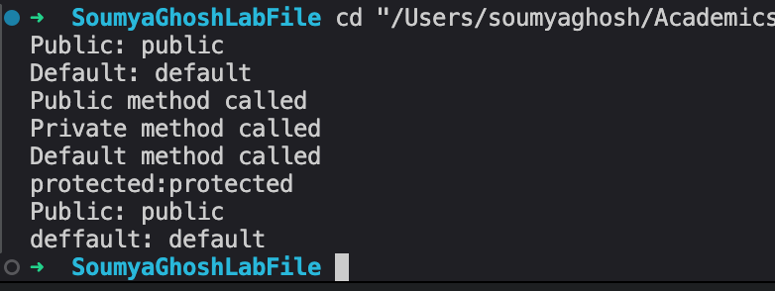

EXPERIMENT 12:
Aim: Java Program To Show Constructor Overloading

Code:
class Student{
private String name;
private int age;
private double gpa;
//default
public Student(){
this.name = "Unknown";
this.age = 0;
this.gpa = 0.0;
System.out.println("Default constructor called");
}
public Student(String name){
this.name = name;
this.age = 0;
this.gpa = 0.0;
System.out.println("nmae only constructor called");
}
public Student(String name, int age){
this.name = name;
this.age = age;
this.gpa = 0.0;
System.out.println("nmae and age constructor called");
}
public Student(String name, int age, double gpa){
this.name =name;
this.age = age;
this.gpa = gpa;
System.out.println("Full parameter constructor called");
}
public void display(){
System.out.println("Name:"+ name +", Age: " + age + ", GPA: " + gpa);
}
}

public class Exp12{
public static void main(String[] args) {
//calld based on params
Student s1 = new Student();
Student s2 = new Student("Soumya Ghosh");
Student s3 = new Student("Rahul bhera", 22);
Student s4 = new Student("Dhimant Bhardwaj", 20, 8.8);

System.out.println();
s1.display();
s2.display();
s3.display();
s4.display();
}
}

Outputs: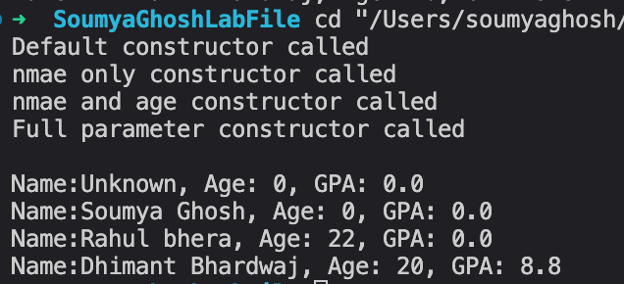

EXPERIMENT 13:
Aim: Java Program To Show Abstract Classses.

Code:
abstract class Animal {
protected String name;

public Animal(String name) {
this.name = name;
}
public abstract void makeSound();
public void sleep() {
System.out.println(name + " is sleeping");
}
}

class Dog extends Animal {
public Dog(String name) {
super(name);
}
public void makeSound() {
System.out.println(name + " says: Woof! Woof!");
}
}

class Cat extends Animal {
public Cat(String name) {
super(name);
}
public void makeSound() {
System.out.println(name + " says: Meow! Meow!");
}
}
public class Exp13{
public static void main(String[] args){
// Animal animal = new Animal();

Animal dog = new Dog("Buddy");
Animal cat = new Cat("Whiskers");

dog.makeSound();
dog.sleep();
cat.makeSound();
cat.sleep();
}
}

Output:
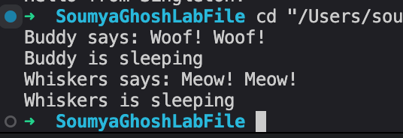

EXPERIMENT 14:
Aim: Java Program To Show Interface.

Code:
interface Vehicle {
void start();
void stop();

default void honk() {
System.out.println("Beep Beep!");
}

static void vehicleInfo() {
System.out.println("This is a vehcle interface");
}
}

class Car implements Vehicle {
private String name;

public Car(String name) {
this.name = name;
}

public void start() {
System.out.println(name + " car starting...");
}
public void stop() {
System.out.println(name + " car stopping ...");
}
}
class Bike implements Vehicle {
public void start() {
System.out.println("Bike starting with kick ...");
}
public void stop() {
System.out.println("Bike stopping...");
}
}

public class Exp14 {
public static void main(String[] args) {
Vehicle car = new Car("Toyota");
Vehicle bike = new Bike();
car.start();
car.honk();
car.stop();
bike.start();
bike.stop();
Vehicle.vehicleInfo();
}
}

Output:
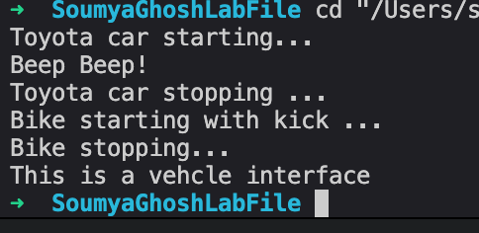

EXPERIMENT 15:
Aim: Java Program To Show Singleton Class.

Code:
class Singleton{
private static Singleton instance;
private Singleton(){
System.out.println("Singleton instance created");
}

public static Singleton getInstance() {
if (instance == null) {
instance = new Singleton();
}
return instance;
}

public void showMessage(){
System.out.println("Hello from Singleton!");
}
}
public class Exp15{
public static void main(String[] args){
Singleton s1 = Singleton.getInstance();
Singleton s2 = Singleton.getInstance();
Singleton s3 = Singleton.getInstance();

System.out.println("s1 == s2: " + (s1 == s2));
System.out.println("s2 == s3: " + (s2 == s3));
s1.showMessage();
}
}

Output:
