

Practical File Submission

Course Name: JavaScript Lab
Course Code: T-3013 / 0705210508
Submitted by
Soumya Bajirao
24070521146
Batch: 2024-28
Semester - V
Section: C

Submitted to
Dr. Shreyas Rajendra Hole

Practical 1
Experiment Title: Demonstrate inline, internal, and external JavaScript; use console methods; create a webpage showing user info and a welcome message.
Software/Tools Required: VS Code , Web Browser
Experiment Program Code:
Demo html file:
<!DOCTYPE html>
<html>
<head>
<title>CSS and JavaScript Demonstration</title>

<style>
body{
font-family: Arial, sans-serif;
text-align: center;
background-color: #f5f5f5;
}

/* Internal CSS */
.heading1{
color: blue;
font-size: 40px;
font-weight: bold;
}

/* External CSS Heading (for demo) */
.heading2{
color: red;
font-size: 40px;
font-weight: bold;
}

p{
font-size: 20px;
}

#msg{
color: darkorange;
font-size: 24px;
font-weight: bold;
margin-top: 20px;
}

button{
background-color: navy;
color: white;
font-size: 18px;
padding: 10px 20px;
border: none;
border-radius: 8px;
cursor: pointer;
margin-top: 20px;
}

button:hover{
background-color: #000066;
}
</style>
</head>

<body>

<!-- Internal CSS -->
<h1 class="heading1">WELCOME TO INTERNAL CSS</h1>
<p><b>Name:</b> Soumya Bajirao</p>
<p><b>PRN:</b> 24070521146</p>

<!-- Inline CSS -->
<h1 style="color:green;">WELCOME TO INLINE CSS</h1>
<p><b>Name:</b> Soumya Bajirao</p>
<p><b>PRN:</b> 24070521146</p>

<!-- External CSS -->
<h1 class="heading2">WELCOME TO EXTERNAL CSS</h1>
<p><b>Name:</b> Soumya Bajirao</p>
<p><b>PRN:</b> 24070521146</p>

<!-- Button -->
<button onclick="alert('Welcome Soumya!')">
Click Me
</button>

<!-- JavaScript Message -->
<h3 id="msg"></h3>

<!-- Internal JavaScript -->
<script>
document.getElementById("msg").innerHTML =
"Welcome to JavaScript Programming!";

console.log("Console Log Message");
console.info("Console Info Message");
console.warn("Console Warning Message");
console.error("Console Error Message");
</script>

<!-- External JavaScript -->
<script src="script.js"></script>

</body>
</html>
Output:
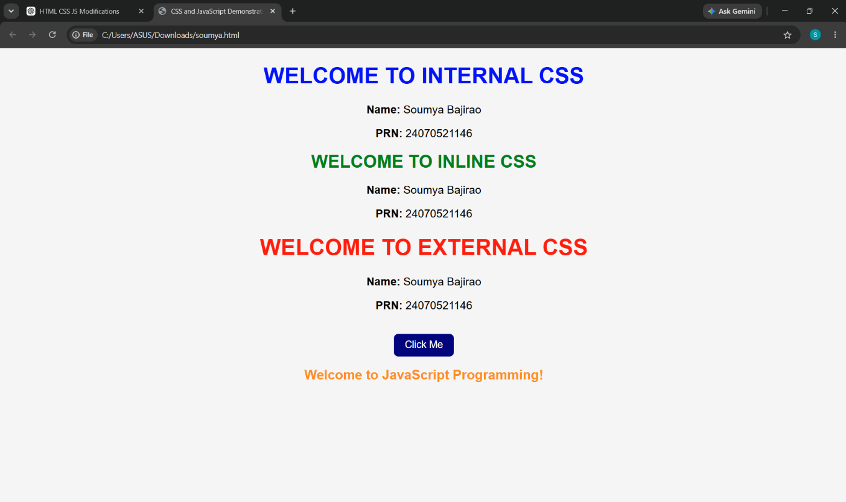

Case Study 01
Case Study Title:- Create a web page for college department and link the student information page with it and write a js program to display "Welcome to SIT Nagpur" in an alert box
Case Study Code:
Department file (HTML):-
<!DOCTYPE html>
<html lang="en">
<head>
<meta charset="UTF-8">
<meta name="viewport" content="width=device-width, initial-scale=1.0">
<title>Department of CSE - SIT Nagpur</title>
<style>
:root {
--primary: #0f172a;
--accent: #2563eb;
--accent-hover: #1d4ed8;
--bg: #f8fafc;
--card-bg: #ffffff;
--text-main: #334155;
--text-dark: #0f172a;
}

body {
font-family: 'Segoe UI', system-ui, -apple-system, sans-serif;
background-color: var(--bg);
color: var(--text-main);
margin: 0;
padding: 0;
line-height: 1.6;
}

/* Top Navbar */
.navbar {
background-color: var(--primary);
color: white;
padding: 15px 5%;
display: flex;
justify-content: space-between;
align-items: center;
box-shadow: 0 4px 6px -1px rgba(0,0,0,0.1);
}

.logo {
font-weight: 700;
font-size: 1.4rem;
letter-spacing: -0.5px;
}

/* Hero Banner Section */
.hero {
background: linear-gradient(135deg, #1e3a8a 0%, #0f172a 100%);
color: white;
padding: 60px 20px;
text-align: center;
}

.hero h1 {
font-size: 2.5rem;
margin: 0 0 10px 0;
font-weight: 800;
}

.hero p {
font-size: 1.1rem;
opacity: 0.9;
max-width: 600px;
margin: 0 auto;
}

/* Main Container */
.main-container {
max-width: 1100px;
margin: -40px auto 40px auto;
padding: 0 20px;
}

/* Stats Grid */
.stats-grid {
display: grid;
grid-template-columns: repeat(auto-fit, minmax(220px, 1fr));
gap: 20px;
margin-bottom: 40px;
}

.stat-card {
background: var(--card-bg);
padding: 25px;
border-radius: 12px;
text-align: center;
box-shadow: 0 10px 15px -3px rgba(0,0,0,0.05);
border: 1px solid #e2e8f0;
transition: transform 0.2s;
}

.stat-card:hover {
transform: translateY(-5px);
}

.stat-number {
font-size: 2rem;
font-weight: 700;
color: var(--accent);
margin-bottom: 5px;
}

.stat-label {
font-size: 0.9rem;
font-weight: 600;
color: var(--text-dark);
}

/* Content Card */
.content-card {
background: var(--card-bg);
padding: 40px;
border-radius: 16px;
box-shadow: 0 10px 15px -3px rgba(0,0,0,0.05);
border: 1px solid #e2e8f0;
text-align: center;
}

.content-card h2 {
color: var(--text-dark);
font-size: 1.8rem;
margin-top: 0;
}

/* Call to Action Button */
.cta-btn {
display: inline-flex;
align-items: center;
background-color: var(--accent);
color: white;
text-decoration: none;
padding: 14px 32px;
border-radius: 8px;
font-weight: 600;
font-size: 1rem;
margin-top: 25px;
box-shadow: 0 4px 14px rgba(37, 99, 235, 0.3);
transition: all 0.2s ease;
}

.cta-btn:hover {
background-color: var(--accent-hover);
transform: translateY(-2px);
box-shadow: 0 6px 20px rgba(37, 99, 235, 0.4);
}

.cta-btn span {
margin-left: 8px;
transition: transform 0.2s;
}

.cta-btn:hover span {
transform: translateX(4px);
}
</style>
</head>
<body onload="showAlert()">

<!-- Navbar -->
<nav class="navbar">
<div class="logo">SIT NAGPUR</div>
<div>Academic Year 2026-27</div>
</nav>

<!-- Hero Area -->
<header class="hero">
<h1>Welcome to SIT Nagpur</h1>
<p>Shaping the future through innovation, research, and excellent engineering education.</p>
</header>

<!-- Core Content Container -->
<main class="main-container">

<!-- Quick Stats Overview -->
<section class="stats-grid">
<div class="stat-card">
<div class="stat-number">1200+</div>
<div class="stat-label">Active Students</div>
</div>
<div class="stat-card">
<div class="stat-number">45+</div>
<div class="stat-label">Expert Faculty</div>
</div>
<div class="stat-card">
<div class="stat-number">94%</div>
<div class="stat-label">Placement Record</div>
</div>
</section>

<!-- Department Hub -->
<section class="content-card">
<h2>Computer Science & Engineering Portal</h2>
<p>Access your curriculum tracking tools, manage course registration profiles, review upcoming exam timetables, and securely update your academic portfolios from our unified digital hub.</p>

<a href="student_info.html" class="cta-btn">
Access Student Information Page <span>&rarr;</span>
</a>
</section>
</main>

<!-- JavaScript Alert Script -->
<script>
function showAlert() {
alert("Welcome to SIT NAGPUR");
}
</script>

</body>
</html>
Student Info (html):-
<!DOCTYPE html>
<html lang="en">
<head>
<meta charset="UTF-8">
<meta name="viewport" content="width=device-width, initial-scale=1.0">
<title>Student Profile - SIT Nagpur</title>
<style>
:root {
--primary: #0f172a;
--accent: #2563eb;
--bg: #f8fafc;
--card-bg: #ffffff;
--text-main: #334155;
--text-dark: #0f172a;
}

body {
font-family: 'Segoe UI', system-ui, -apple-system, sans-serif;
background-color: var(--bg);
color: var(--text-main);
margin: 0;
padding: 0;
line-height: 1.6;
}

.navbar {
background-color: var(--primary);
color: white;
padding: 15px 5%;
display: flex;
justify-content: space-between;
align-items: center;
}

.logo {
font-weight: 700;
font-size: 1.4rem;
}

.container {
max-width: 800px;
margin: 40px auto;
padding: 0 20px;
}

.profile-card {
background: var(--card-bg);
border-radius: 16px;
box-shadow: 0 10px 15px -3px rgba(0,0,0,0.05);
border: 1px solid #e2e8f0;
padding: 40px;
}

h1 {
color: var(--text-dark);
margin-top: 0;
font-size: 2rem;
border-bottom: 2px solid #e2e8f0;
padding-bottom: 15px;
}

/* Modern Table Styling */
.info-table {
width: 100%;
border-collapse: collapse;
margin-top: 25px;
}

.info-table th, .info-table td {
padding: 14px 16px;
text-align: left;
border-bottom: 1px solid #e2e8f0;
}

.info-table th {
background-color: #f1f5f9;
color: var(--text-dark);
font-weight: 600;
width: 30%;
}

.back-link {
display: inline-block;
margin-top: 30px;
color: var(--accent);
text-decoration: none;
font-weight: 600;
transition: transform 0.2s;
}

.back-link:hover {
text-decoration: underline;
transform: translateX(-3px);
}
</style>
</head>
<body>

<!-- Navbar -->
<nav class="navbar">
<div class="logo">SIT NAGPUR</div>
<div>Dashboard</div>
</nav>

<!-- Main Container -->
<div class="container">
<div class="profile-card">
<h1>Student Information Profile</h1>
<p>Verify your enrollment status and core registration details below. Contact the department office to modify locked fields.</p>

<!-- Sample Data Layout -->
<table class="info-table">
<tr>
<th>Institute</th>
<td>Symbiosis Institute of Technology (SIT), Nagpur</td>
</tr>
<tr>
<th>Department</th>
<td>Computer Science & Engineering</td>
</tr>
<tr>
<th>Academic Status</th>
<td>Active Enrollment</td>
</tr>
<tr>
<th>Portal Access</th>
<td>Authorized Student Profile</td>
</tr>
</table>

<a class="back-link" href="index.html">&larr; Return to Department Home</a>
</div>
</div>

</body>
</html>

Output:

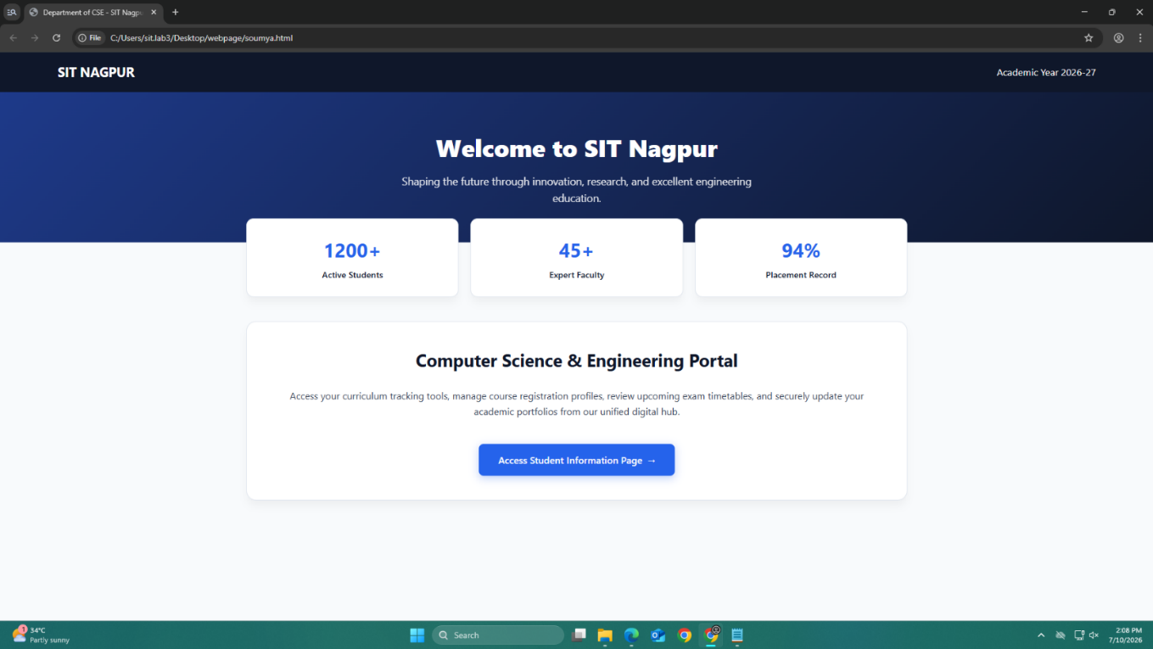
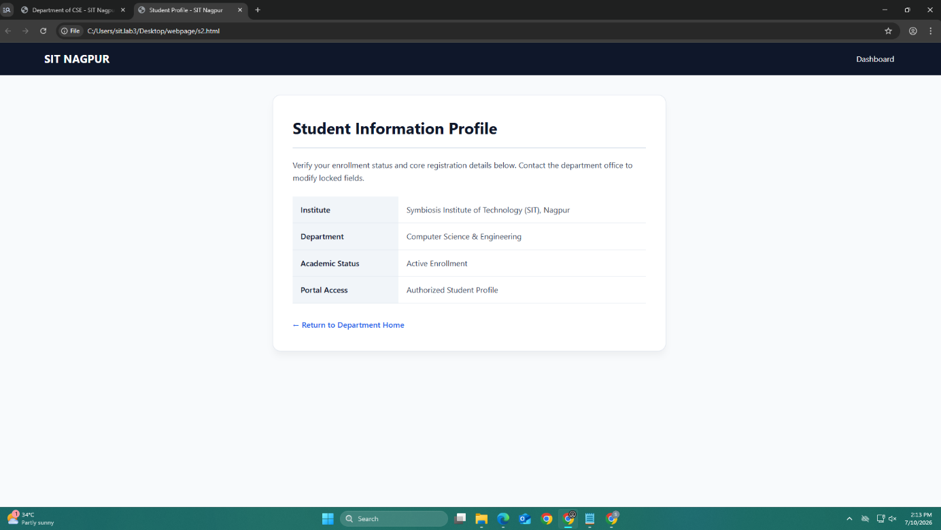

Result / Conclusion:-
Hence we have created a basic html page with javascript to show student information and and website login page.

Practical 02
Aim:- Use var, let, const, and demonstrate basic features like template literals and destructuring; build a billing calculator with user input.
Software/Tools Required: VS Code , Web Browser
Experiment program code:
Calculator.html:-
<!DOCTYPE html>
<html>
<head>
<title>Billing Calculator</title>
</head>
<body>

<h2>Soumya.Bajirao 24070521146</h2>
<script>
const GST = 0.18;
var customerName = prompt("Enter Customer Name: ");
var productName = prompt("Enter Product Name: ");
var quantity = Number(prompt("Enter quantity"));
let price = Number(prompt("Enter price per Item"));
let total = quantity * price;
let gstAmount = total * GST;
let finalBill = total + gstAmount;
const bill = {
customer: customerName,
product: productName,
quantity,
price,
total,
gstAmount,
finalBill
};

const {
customer,
product,
gstAmount: gst,
finalBill: amount
} = bill;
document.write(`<h3>Billing Receipt</h3>`);
document.write(`<p>Customer: ${customer}</p>`);
document.write(`<p>Product: ${product}</p>`);
document.write(`<p>Quantity: ${quantity}</p>`);
document.write(`<p>Price per Item: ₹${price}</p>`);
document.write(`<p>Total: ₹${total}</p>`);
document.write(`<p>GST (18%): ₹${gst.toFixed(2)}</p>`);
document.write(`<h3>Final Bill: ₹${amount.toFixed(2)}</h3>`);
</script>
</body>
</html>
Output:-
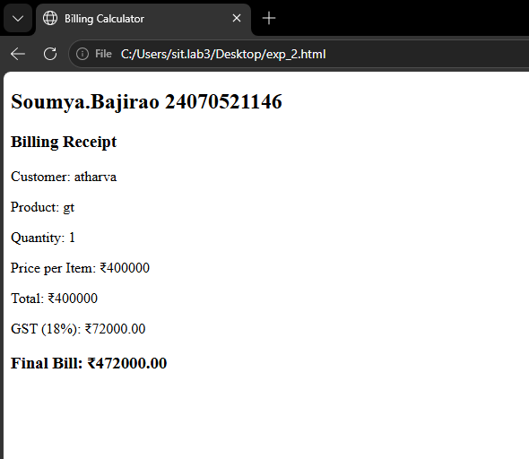

Case Study 02
Case Study Title:- Develop the webpage for an online shopping website with using HTML,CSS and HTML5 tags
Software/Tools Used:- VScode , Web Browser
Code:-
<!DOCTYPE html>
<html lang="en">
<head>
<meta charset="UTF-8">
<meta name="viewport" content="width=device-width, initial-scale=1.0">
<title>Online Shopping & Billing Portal</title>
<style>
:root {
--primary-color: #007bff;
--success-color: #28a745;
--bg-color: #f8f9fa;
--card-bg: #ffffff;
--text-color: #333333;
}

body {
font-family: Arial, sans-serif;
background-color: var(--bg-color);
color: var(--text-color);
margin: 0;
padding: 20px;
}

.container {
max-width: 800px;
margin: 0 auto;
background: var(--card-bg);
padding: 30px;
border-radius: 8px;
box-shadow: 0 4px 10px rgba(0, 0, 0, 0.1);
}

h1 {
text-align: center;
color: var(--primary-color);
margin-bottom: 25px;
}

fieldset {
border: 1px solid #ced4da;
border-radius: 6px;
padding: 20px;
margin-bottom: 20px;
}

legend {
font-weight: bold;
color: var(--primary-color);
padding: 0 10px;
}

.form-grid {
display: grid;
grid-template-columns: 1fr 1fr;
gap: 15px;
}

.form-group {
display: flex;
flex-direction: column;
}

.form-group.full-width {
grid-column: span 2;
}

label {
font-size: 14px;
font-weight: bold;
margin-bottom: 5px;
}

input, select {
padding: 10px;
border: 1px solid #ccc;
border-radius: 4px;
font-size: 14px;
}

button {
background-color: var(--success-color);
color: white;
padding: 12px;
border: none;
border-radius: 4px;
font-size: 16px;
font-weight: bold;
cursor: pointer;
width: 100%;
margin-top: 10px;
}

button:hover {
opacity: 0.9;
}

.invoice-output {
margin-top: 30px;
background: #eef2f7;
padding: 20px;
border-radius: 6px;
border-left: 5px solid var(--primary-color);
}

.invoice-output h2 {
margin-top: 0;
color: #2c3e50;
}

.bill-row {
display: flex;
justify-content: space-between;
margin-bottom: 8px;
font-size: 15px;
}

.bill-row.total {
font-weight: bold;
font-size: 18px;
border-top: 1px solid #ccc;
padding-top: 10px;
margin-top: 10px;
color: var(--success-color);
}
</style>
</head>
<body>

<div class="container">
<h1>Online Shopping Store</h1>

<form id="billingForm" onsubmit="calculateBill(event)">
<!-- Customer Details -->
<fieldset>
<legend>Customer Information</legend>
<div class="form-grid">
<div class="form-group">
<label for="custName">Customer Name:</label>

<input type="text" id="custName" required placeholder="Enter full name">
</div>
<div class="form-group">
<label for="mobileNo">Mobile Number:</label>
<input type="tel" id="mobileNo" pattern="[0-9]{10}" required placeholder="10-digit mobile number">
</div>
<div class="form-group">
<label for="invoiceNo">Invoice Number:</label>
<input type="text" id="invoiceNo" value="INV-2026-001" readonly>
</div>
<div class="form-group">
<label for="membership">Membership Type:</label>
<select id="membership">
<option value="0">None (0% Extra Off)</option>
<option value="5">Silver (5% Extra Off)</option>
<option value="10">Gold (10% Extra Off)</option>
</select>
</div>
</div>
</fieldset>

<!-- Product & Purchase Details -->
<fieldset>
<legend>Product & Charges Details</legend>
<div class="form-grid">
<div class="form-group">
<label for="productName">Product Name:</label>
<input type="text" id="productName" required placeholder="e.g. Organic Cashews">
</div>
<div class="form-group">
<label for="quantityKg">Quantity (in kg):</label>
<input type="number" id="quantityKg" step="0.1" min="0.1" required placeholder="e.g. 2.5">
</div>
<div class="form-group">
<label for="rateKg">Rate per kg (₹):</label>
<input type="number" id="rateKg" step="1" min="1" required placeholder="e.g. 500">
</div>
<div class="form-group">
<label for="gstRate">GST Rate (%):</label>
<select id="gstRate">
<option value="5">5%</option>
<option value="12">12%</option>
<option value="18">18%</option>
</select>
</div>
<div class="form-group">
<label for="packingCharges">Packing Charges (₹):</label>
<input type="number" id="packingCharges" value="30" min="0">
</div>
<div class="form-group">
<label for="paymentMode">Payment Mode:</label>
<select id="paymentMode">
<option value="UPI">UPI</option>
<option value="Credit Card">Credit Card</option>
<option value="Debit Card">Debit Card</option>
<option value="Cash on Delivery">Cash on Delivery</option>
</select>
</div>
</div>
</fieldset>

<button type="submit">Calculate and Generate Bill</button>
</form>

<!-- Computed Invoice Display Area -->
<div class="invoice-output" id="invoiceSection" style="display: none;">
<h2>Invoice Summary</h2>
<div class="bill-row"><span>Invoice No:</span> <span id="outInv"></span></div>
<div class="bill-row"><span>Customer:</span> <span id="outName"></span></div>
<div class="bill-row"><span>Mobile:</span> <span id="outMobile"></span></div>
<div class="bill-row"><span>Product:</span> <span id="outProduct"></span></div>
<div class="bill-row"><span>Qty & Rate:</span> <span id="outQtyRate"></span></div>
<div class="bill-row"><span>Base Amount:</span> <span id="outBase"></span></div>
<div class="bill-row"><span>Membership Disc:</span> <span id="outMemberDisc"></span></div>
<div class="bill-row"><span>GST Amount:</span> <span id="outGst"></span></div>
<div class="bill-row"><span>Packing Charges:</span> <span id="outPacking"></span></div>
<div class="bill-row"><span>Payment Mode:</span> <span id="outPayMode"></span></div>
<div class="bill-row total"><span>Final Payable Total:</span> <span id="outTotal"></span></div>
</div>
</div>

<script>
function calculateBill(event) {
event.preventDefault();

// Fetch inputs
const name = document.getElementById('custName').value;
const mobile = document.getElementById('mobileNo').value;
const inv = document.getElementById('invoiceNo').value;
const product = document.getElementById('productName').value;
const qty = parseFloat(document.getElementById('quantityKg').value);
const rate = parseFloat(document.getElementById('rateKg').value);
const memberDiscPercent = parseFloat(document.getElementById('membership').value);
const gstPercent = parseFloat(document.getElementById('gstRate').value);
const packing = parseFloat(document.getElementById('packingCharges').value);
const payMode = document.getElementById('paymentMode').value;

// Calculations
const baseAmount = qty * rate;
const discountAmount = (baseAmount * memberDiscPercent) / 100;
const amountAfterDiscount = baseAmount - discountAmount;
const gstAmount = (amountAfterDiscount * gstPercent) / 100;
const finalTotal = amountAfterDiscount + gstAmount + packing;

// Bind outputs
document.getElementById('outInv').innerText = inv;
document.getElementById('outName').innerText = name;
document.getElementById('outMobile').innerText = mobile;
document.getElementById('outProduct').innerText = product;
document.getElementById('outQtyRate').innerText = qty + ' kg @ ₹' + rate + '/kg';
document.getElementById('outBase').innerText = '₹' + baseAmount.toFixed(2);
document.getElementById('outMemberDisc').innerText = '- ₹' + discountAmount.toFixed(2) + ' (' + memberDiscPercent + '%)';
document.getElementById('outGst').innerText = '+ ₹' + gstAmount.toFixed(2) + ' (' + gstPercent + '%)';
document.getElementById('outPacking').innerText = '+ ₹' + packing.toFixed(2);
document.getElementById('outPayMode').innerText = payMode;
document.getElementById('outTotal').innerText = '₹' + finalTotal.toFixed(2);

// Show invoice section
document.getElementById('invoiceSection').style.display = 'block';
}
</script>

</body>
</html>

Output:-
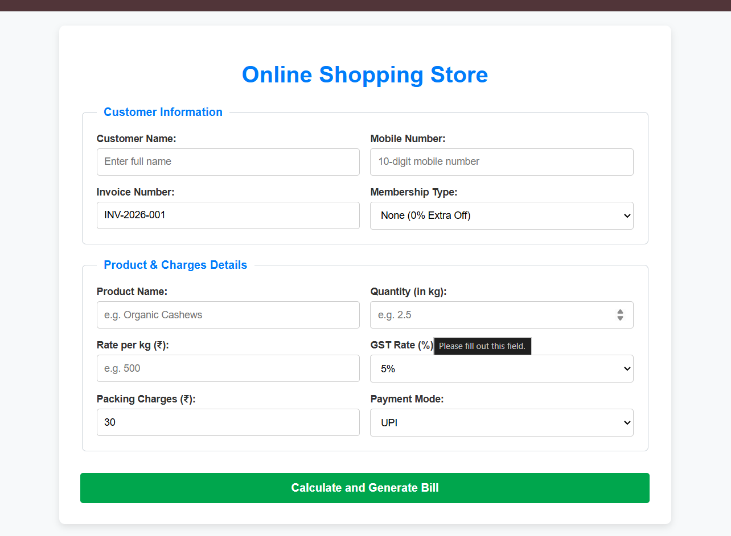

Practical 3
Aim:- Implement control structures and form validation; create a grading system based on user-entered marks.
Software/Tools Required: VS Code , Web Browser
Experiment program code:
Student Marks and grade:-
<!DOCTYPE html>
<html lang="en">
<head>
<meta charset="UTF-8">
<meta name="viewport" content="width=device-width, initial-scale=1.0">
<title>Modern Analytics Grading Dashboard</title>
<style>
/* Modern Design Tokens & Variables */
:root {
--bg-gradient: linear-gradient(135deg, #0f172a 0%, #1e1b4b 100%);
--card-bg: rgba(30, 41, 59, 0.7);
--card-border: rgba(255, 255, 255, 0.08);
--text-primary: #f8fafc;
--text-secondary: #94a3b8;

/* Dynamic Grade Colors */
--color-a: #10b981; /* Emerald */
--color-b: #3b82f6; /* Blue */
--color-c: #8b5cf6; /* Purple */
--color-d: #f59e0b; /* Amber */
--color-f: #ef4444; /* Rose */

--error-bg: rgba(239, 68, 68, 0.15);
--error-border: #ef4444;
}

/* Reset & Base Layout */
* { box-sizing: border-box; margin: 0; padding: 0; font-family: 'Segoe UI', system-ui, sans-serif; }
body {
background: var(--bg-gradient);
color: var(--text-primary);
min-height: 100vh;
display: flex;
justify-content: center;
align-items: center;
padding: 20px;
}

/* Glassmorphism Portal Card */
.portal-card {
background: var(--card-bg);
backdrop-filter: blur(16px);
-webkit-backdrop-filter: blur(16px);
border: 1px solid var(--card-border);
border-radius: 24px;
width: 100%;
max-width: 440px;
padding: 40px;
box-shadow: 0 20px 40px rgba(0, 0, 0, 0.3);
transition: transform 0.3s ease;
}

/* Typography & Headings */
.portal-header { text-align: center; margin-bottom: 32px; }
.portal-header h1 { font-size: 28px; font-weight: 700; letter-spacing: -0.5px; margin-bottom: 8px; background: linear-gradient(to right, #fff, #94a3b8); -webkit-background-clip: text; -webkit-text-fill-color: transparent; }
.portal-header p { color: var(--text-secondary); font-size: 14px; }

/* Form Controls */
.form-group { position: relative; margin-bottom: 24px; }
.input-wrapper { position: relative; display: flex; align-items: center; }

input[type="text"] {
width: 100%;
padding: 16px 20px;
background: rgba(15, 23, 42, 0.6);
border: 2px solid rgba(255, 255, 255, 0.1);
border-radius: 14px;
color: var(--text-primary);
font-size: 18px;
font-weight: 600;
outline: none;
transition: all 0.25s cubic-bezier(0.4, 0, 0.2, 1);
}
input[type="text"]:focus { border-color: #6366f1; box-shadow: 0 0 0 4px rgba(99, 102, 241, 0.2); background: rgba(15, 23, 42, 0.8); }
input[type="text"]::placeholder { color: #475569; font-weight: 400; }

/* Custom Interactive Button */
button {
width: 100%;
padding: 16px;
background: linear-gradient(135deg, #6366f1 0%, #4f46e5 100%);
border: none;
border-radius: 14px;
color: white;
font-size: 16px;
font-weight: 600;
cursor: pointer;
box-shadow: 0 4px 12px rgba(99, 102, 241, 0.3);
transition: all 0.2s ease;
}
button:hover { transform: translateY(-1px); box-shadow: 0 6px 20px rgba(99, 102, 241, 0.4); }
button:active { transform: translateY(1px); }

/* Validation Alert Message */
.error-alert {
display: none;
background: var(--error-bg);
border-left: 4px solid var(--error-border);
color: #fca5a5;
padding: 12px 16px;
border-radius: 8px;
font-size: 14px;
margin-top: 12px;
animation: shake 0.4s cubic-bezier(.36,.07,.19,.97) both;
}

/* Advanced Dynamic Result Display */
.result-panel {
display: none;
margin-top: 32px;
padding-top: 32px;
border-top: 1px solid rgba(255, 255, 255, 0.1);
text-align: center;
animation: fadeIn 0.5s ease forwards;
}
.badge-container { display: inline-flex; justify-content: center; align-items: center; width: 90px; height: 90px; border-radius: 50%; margin-bottom: 16px; box-shadow: 0 0 20px rgba(0,0,0,0.2); position: relative; }
.badge-container::after { content: ''; position: absolute; inset: -4px; border-radius: 50%; opacity: 0.2; }
.grade-badge { font-size: 42px; font-weight: 800; color: white; }

.score-display { font-size: 15px; color: var(--text-secondary); margin-bottom: 4px; }
.status-text { font-size: 20px; font-weight: 600; letter-spacing: -0.2px; }

/* System Dynamic Color Classes */
.tier-a { background: var(--color-a); }.tier-a::after { border: 4px solid var(--color-a); }
.tier-b { background: var(--color-b); }.tier-b::after { border: 4px solid var(--color-b); }
.tier-c { background: var(--color-c); }.tier-c::after { border: 4px solid var(--color-c); }
.tier-d { background: var(--color-d); }.tier-d::after { border: 4px solid var(--color-d); }
.tier-f { background: var(--color-f); }.tier-f::after { border: 4px solid var(--color-f); }

.text-tier-a { color: var(--color-a); }
.text-tier-b { color: var(--color-b); }
.text-tier-c { color: var(--color-c); }
.text-tier-d { color: var(--color-d); }
.text-tier-f { color: var(--color-f); }

/* Structural Animations */
@keyframes cubic-bezier {
0% { opacity: 0; transform: translateY(10px); }
100% { opacity: 1; transform: translateY(0); }
}
@keyframes shake {
10%, 90% { transform: translate3d(-1px, 0, 0); }
20%, 80% { transform: translate3d(2px, 0, 0); }
30%, 50%, 70% { transform: translate3d(-4px, 0, 0); }
40%, 60% { transform: translate3d(4px, 0, 0); }
}
@keyframes fadeIn { from { opacity: 0; transform: translateY(10px); } to { opacity: 1; transform: translateY(0); } }
</style>
</head>
<body>

<div class="portal-card">
<div class="portal-header">
<h1>Grading Analytics</h1>
<p>SOUMYA BAJIRAO 24070521146</p>
</div>

<form id="gradingForm" novalidate>
<div class="form-group">
<div class="input-wrapper">
<input type="text" id="marksInput" placeholder="Enter total marks (0 - 100)" autocomplete="off">
</div>
<div id="errorAlert" class="error-alert"></div>
<button type="submit">Process Evaluation</button>
</form>

<!-- Structural Result Display Component -->
<div id="resultPanel" class="result-panel">
<div id="badgeContainer" class="badge-container">
<span id="gradeBadge" class="grade-badge">A</span>
</div>
<div id="scoreDisplay" class="score-display">Calculated Score: 0%</div>
<div id="statusText" class="status-text">Excellent</div>
</div>

<script>
document.getElementById('gradingForm').addEventListener('submit', function(event) {
event.preventDefault();

const inputField = document.getElementById('marksInput');
const errorAlert = document.getElementById('errorAlert');
const resultPanel = document.getElementById('resultPanel');
const badgeContainer = document.getElementById('badgeContainer');
const gradeBadge = document.getElementById('gradeBadge');
const scoreDisplay = document.getElementById('scoreDisplay');
const statusText = document.getElementById('statusText');

const rawValue = inputField.value.trim();

// Reset structural visibility states
errorAlert.style.display = 'none';
resultPanel.style.display = 'none';

// 1. Structural Empty Validation
if (rawValue === '') {
showValidation("Input cannot be empty. Please enter a valid number.");
return;
}

// 2. Type Configuration Verification
const marks = Number(rawValue);
if (isNaN(marks)) {
showValidation("Invalid format. Character string inputs are strictly rejected.");
return;
}

// 3. Mathematical Absolute Boundary Evaluation
if (marks < 0 || marks > 100) {
showValidation("Out of bounds range. Entry must scale explicitly between 0 and 100.");
return;
}

// 4. Data Evaluation Pipeline & Theme Mapping
let grade = '';
let status = '';
let tierClass = '';

if (marks >= 90) {
grade = 'A';
status = 'Excellent Performance';
tierClass = 'tier-a';
} else if (marks >= 80) {
grade = 'B';
status = 'Very Good Standing';
tierClass = 'tier-b';
} else if (marks >= 70) {
grade = 'C';
status = 'Good / Satisfactory';
tierClass = 'tier-c';
} else if (marks >= 60) {
grade = 'D';
status = 'Passing / Marginal';
tierClass = 'tier-d';
} else {
grade = 'F';
status = 'Failing Status';
tierClass = 'tier-f';
}

// 5. Dynamic Render Pipeline Configuration
badgeContainer.className = `badge-container ${tierClass}`;
statusText.className = `status-text text-${tierClass}`;

gradeBadge.textContent = grade;
scoreDisplay.textContent = `Calculated Score: ${marks}%`;
statusText.textContent = status;

// Render Animation Trigger
resultPanel.style.display = 'block';
});

function showValidation(message) {
const errorAlert = document.getElementById('errorAlert');
errorAlert.textContent = message;
errorAlert.style.display = 'block';
}
</script>
</body>

</html>

Output:-
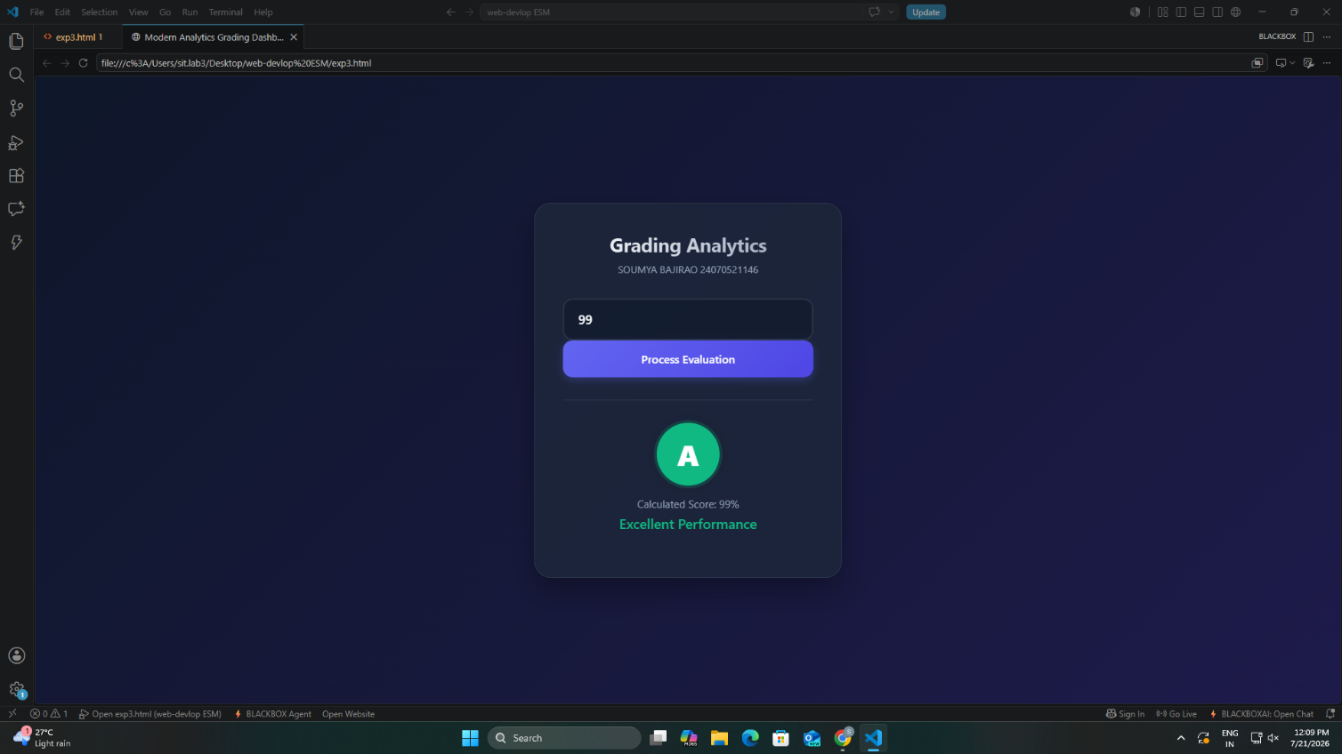

Case Study 03
Case Study Title:- Scholarship Eligibilty:
A college awards scholarship based on marks
Below 50:- Not eligible
50-69:- Bronze Scholarship
70-84:- Silver Scholarship
85-94:- Gold Scholarship
95-100:- Platinum Scholarship
Software/Tools Used:- VScode , Web Browser
Case Study Code:-
<html>
<head>
<title>Scholarship Eligibility</title>
<style>
body {
font-family: Arial, sans-serif;
background-color: #f2f2f2;
text-align: center;
padding: 40px;
}
h2 {
color: #c21321af;
margin: 5px 0;
}
input {
padding: 8px;
font-size: 15px;
margin-top: 10px;
border: 1px solid #c0e61b;
border-radius: 4px;
}
button {
display: block;
margin: 15px auto 0;
padding: 8px 20px;
font-size: 15px;
background-color: #1a5cff;
color: white;
border: none;
border-radius: 4px;
cursor: pointer;
}
button:hover {
background-color: #0d3fb0;
}
#result {
margin-top: 20px;
font-size: 17px;
color: #333;
}
</style>
</head>
<body>
<h2>Sumya bajirao 2407051146</h2>
<h2>Scholarship Eligibility System</h2>
<h3>Enter marks:</h3>
<input type='number' id='marks'></input>
<button onClick="checkScholarship()">Submit</button>
<p id='result'></p>
<script>
function checkScholarship(){
var marks = document.getElementById("marks").value;
if( marks == ""){
alert("Please Enter marks!!");
return;
}
if(marks<0 || marks> 100){
alert("Enter marks between 0 and 100");
return;
}
if(marks>=95){
scholarship = "Platinum Scholarship";
}
else if(marks>=85){
scholarship = "Gold Scholarship";
}
else if(marks>=70){
scholarship = "Silver Scholarship";
}
else if(marks>=50){
scholarship = "Bronze Scholarship";
}
else{
scholarship = "Not Eligible";
}
document.getElementById("result").innerHTML =
"Marks = " + marks + "<br>Scholarship = " + scholarship;
}
</script>
</body>
</html>

Output:-

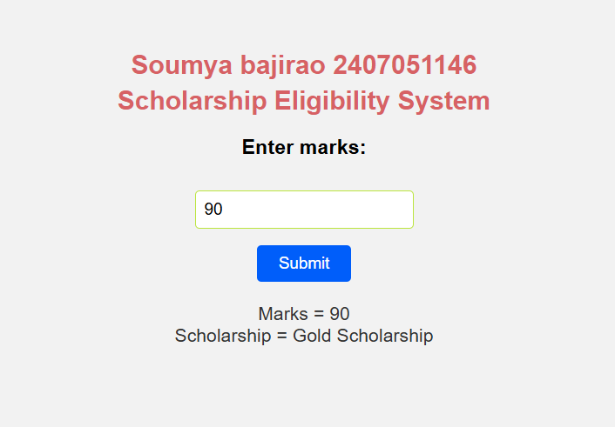

Practical 4
Aim:- Use function types ,scope , and closure; apply try catch ;build a palindrome checker
Software/Tools Required: VS Code , Web Browser
Experiment program code:
Palindrome checker:-
<!DOCTYPE html>
<html lang="en">
<head>
<meta charset="UTF-8">
<meta name="viewport" content="width=device-width, initial-scale=1.0">
<title>Palindrome Checker</title>
<style>
* {
box-sizing: border-box;
margin: 0;
padding: 0;
}
body {
font-family: 'Segoe UI', Arial, sans-serif;
background: linear-gradient(135deg, #667eea, #764ba2);
min-height: 100vh;
display: flex;
flex-direction: column;
justify-content: center;
align-items: center;
padding: 20px;
}
.student-header {
background: rgba(255, 255, 255, 0.15);
backdrop-filter: blur(6px);
border: 1px solid rgba(255, 255, 255, 0.3);
border-radius: 14px;
padding: 12px 24px;
margin-bottom: 20px;
text-align: center;
color: #fff;
box-shadow: 0 8px 24px rgba(0, 0, 0, 0.15);
}
.student-header .name {
font-size: 18px;
font-weight: 700;
letter-spacing: 1px;
}
.student-header .prn {
font-size: 13px;
opacity: 0.9;
margin-top: 3px;
}
.container {
width: 380px;
background: #ffffff;
padding: 30px;
border-radius: 18px;
box-shadow: 0 20px 50px rgba(0, 0, 0, 0.35);
text-align: center;
}
.container h2 {
font-size: 22px;
color: #333;
margin-bottom: 6px;
}
.subtitle {
font-size: 13px;
color: #8a8fa3;
margin-bottom: 20px;
}
.input-box {
background: #f4f6fb;
border: 2px solid #e3e7f0;
border-radius: 12px;
padding: 14px;
margin-bottom: 16px;
}
input {
width: 100%;
padding: 12px;
font-size: 18px;
text-align: center;
border: none;
outline: none;
background: transparent;
color: #333;
font-weight: 600;
}
input::placeholder {
color: #b0b6c8;
font-weight: 400;
font-size: 15px;
}
button {
width: 100%;
padding: 14px;
font-size: 16px;
font-weight: 600;
color: #fff;
background: linear-gradient(135deg, #667eea, #764ba2);
border: none;
border-radius: 12px;
cursor: pointer;
transition: transform 0.15s ease, box-shadow 0.15s ease;
margin-bottom: 18px;
}
button:hover {
transform: translateY(-2px);
box-shadow: 0 8px 20px rgba(102, 126, 234, 0.4);
}
button:active {
transform: translateY(0);
}
h3#result {
min-height: 50px;
display: flex;
align-items: center;
justify-content: center;
background: #f4f6fb;
border-radius: 12px;
padding: 14px;
font-size: 16px;
color: #333;
font-weight: 600;
}
.checks {
margin-top: 14px;
font-size: 13px;
color: #8a8fa3;
}
</style>
</head>
<body>

<div class="student-header">
<div class="name">Soumya Bajirao</div>

<div class="prn">PRN: 24070521146</div>
</div>

<div class="container">
<h2>Palindrome Checker</h2>
<div class="subtitle">Check if a word reads the same forward &amp; backward</div>

<div class="input-box">
<input type="text" id="word" placeholder="Enter a word">
</div>

<button onclick="checkPalindrome()">Check</button>

<h3 id="result"></h3>
<div id="checks" class="checks"></div>
</div>

<script>

// Global Scope
let appName = "Palindrome Checker";

// Function Declaration
function cleanString(str) {
return str.toLowerCase().replace(/[^a-z0-9]/g, "");
}

// Function Expression
const reverseString = function(str) {
return str.split("").reverse().join("");
};

// Closure
function counter() {
let count = 0;

return function() {
count++;
return count;
};
}

const checkCount = counter();

// Arrow Function
const isPalindrome = (str) => {
return str === reverseString(str);
};

// Main Function
function checkPalindrome() {

try {

let input = document.getElementById("word").value;

// Local Scope
let text = cleanString(input);

if (text === "") {
throw "Please enter some text.";
}

let result = isPalindrome(text)
? `"${input}" is a Palindrome ✅`
: `"${input}" is NOT a Palindrome ❌`;

document.getElementById("result").innerHTML = result;
document.getElementById("checks").innerHTML =
`Checks Performed: ${checkCount()}`;

} catch(error) {

document.getElementById("result").innerHTML =
`<span style="color:red;">Error: ${error}</span>`;

}

finally {
console.log(appName + " executed.");
}
}
</script>
</body>
</html>

Output:-

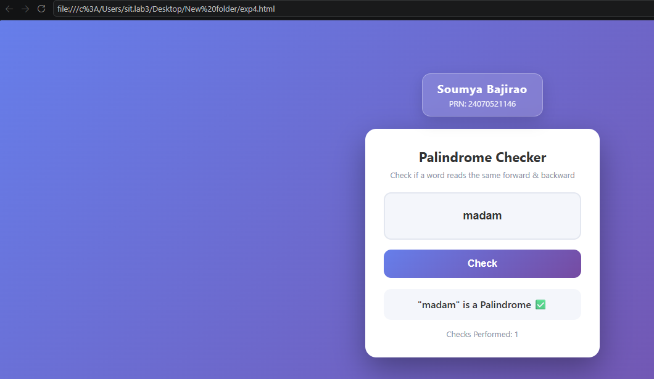

Case Study 04
Real-Time Case Study: ATM Card PIN Verification Using JavaScript Functions
Case Study An ATM system verifies whether a customer's PIN is a palindrome. If the PIN reads the same forward and backward, the bank displays a special security message. To implement this, create a function to reverse the entered PIN number and another function to check whether it is a palindrome. Use function declaration, function expression, arrow function, and demonstrate scope concepts
Software/Tools Used:- VScode , Web Browser
Case Study Code:-
﻿<!DOCTYPE html>
<html lang="en">
<head>
<meta charset="UTF-8">
<meta name="viewport" content="width=device-width, initial-scale=1.0">
<title>ATM PIN Strength Checker</title>
<style>
* {
box-sizing: border-box;
margin: 0;
padding: 0;
}
body {
font-family: 'Segoe UI', Arial, sans-serif;
background: linear-gradient(135deg, #0f2027, #203a43, #2c5364);
min-height: 100vh;
display: flex;
flex-direction: column;
justify-content: center;
align-items: center;
padding: 20px;
}
.student-header {
background: rgba(255, 255, 255, 0.15);
backdrop-filter: blur(6px);
border: 1px solid rgba(255, 255, 255, 0.3);
border-radius: 14px;
padding: 12px 24px;
margin-bottom: 20px;
text-align: center;
color: #fff;
box-shadow: 0 8px 24px rgba(0, 0, 0, 0.15);
}
.student-header .name {
font-size: 18px;
font-weight: 700;
letter-spacing: 1px;
}
.student-header .prn {
font-size: 13px;
opacity: 0.9;
margin-top: 3px;
}
.atm-card {
width: 400px;
background: #ffffff;
border-radius: 20px;
box-shadow: 0 20px 50px rgba(0, 0, 0, 0.4);
padding: 35px 30px;
text-align: center;
}
.bank-header {
display: flex;
justify-content: space-between;
align-items: center;
margin-bottom: 20px;
}
.bank-logo {
font-size: 20px;
font-weight: 700;
color: #2c5364;
letter-spacing: 1px;
}
.bank-chip {
background: linear-gradient(135deg, #d4af37, #f5d061);
width: 40px;
height: 30px;
border-radius: 6px;
box-shadow: inset 0 0 5px rgba(0,0,0,0.2);
}
.title {
font-size: 22px;
font-weight: 700;
color: #0f2027;
margin-bottom: 6px;
}
.subtitle {
font-size: 13px;
color: #7a8a99;
margin-bottom: 25px;
}
.pin-box {
background: #f4f7f9;
border: 2px solid #e2e8f0;
border-radius: 12px;
padding: 18px;
margin-bottom: 20px;
}
.pin-input {
width: 100%;
padding: 14px;
font-size: 28px;
letter-spacing: 12px;
text-align: center;
border: none;
outline: none;
background: transparent;
color: #0f2027;
font-weight: 700;
}
.pin-input::placeholder {
letter-spacing: 2px;
font-size: 16px;
color: #b0bcc6;
font-weight: 400;
}
.btn {
width: 100%;
padding: 14px;
font-size: 16px;
font-weight: 600;
color: #fff;
background: linear-gradient(135deg, #2c5364, #0f2027);
border: none;
border-radius: 12px;
cursor: pointer;
transition: transform 0.15s ease, box-shadow 0.15s ease;
margin-bottom: 20px;
}
.btn:hover {
transform: translateY(-2px);
box-shadow: 0 8px 20px rgba(15, 32, 39, 0.3);
}
.btn:active {
transform: translateY(0);
}
.result-box {
min-height: 50px;
display: flex;
align-items: center;
justify-content: center;
border-radius: 12px;
padding: 12px;
font-size: 16px;
font-weight: 600;
background: #f4f7f9;
transition: all 0.3s ease;
}
.result-box.weak {
background: #fff3e0;
color: #e65100;
}
.result-box.strong {
background: #e8f5e9;
color: #2e7d32;
}
.result-box.invalid {
background: #ffebee;
color: #c62828;
}
.result-box.empty {
background: #f4f7f9;
color: #7a8a99;
}
.hint {
margin-top: 15px;
font-size: 12px;
color: #b0bcc6;
}
</style>
</head>
<body>

<div class="student-header">
<div class="name">Soumya Bajirao</div>
<div class="prn">PRN: 24070521146</div>
</div>

<div class="atm-card">
<div class="bank-header">
<div class="bank-logo">💳 PIN Guard</div>
<div class="bank-chip"></div>
</div>

<div class="title">ATM PIN Strength Checker</div>
<div class="subtitle">Enter your PIN to check its strength</div>

<div class="pin-box">
<input type="password" id="pin" class="pin-input"
placeholder="Enter your PIN" maxlength="12"
inputmode="numeric" oninput="this.value=this.value.replace(/[^0-9]/g,'')">
</div>

<button class="btn" onclick="checkStrength()">Check PIN</button>

<div id="result" class="result-box empty">Enter a PIN to see its strength</div>

<div class="hint">🔒 Numbers only · A palindrome PIN is weak</div>
</div>

<script>
// Core validation logic
function validatePin(pin) {
// 1. Remove spaces
let cleanText = pin.replace(/\s/g, '');

// 2. Only numbers are allowed
if (cleanText === '' || !/^[0-9]+$/.test(cleanText)) {
return "Invalid: PIN must contain only numbers.";
}

// 3. Reverse the string
let reversedText = cleanText.split('').reverse().join('');

// 4. Evaluate strength
if (cleanText === reversedText) {
return "Weak PIN";
}

return "Strong PIN";
}

// Wire the logic to the UI
function checkStrength() {
let input = document.getElementById("pin").value;
let result = validatePin(input);
let box = document.getElementById("result");

box.className = "result-box";

if (result.startsWith("Invalid")) {
box.classList.add("invalid");
box.innerText = result;
} else if (result === "Weak PIN") {
box.classList.add("weak");
box.innerText = "⚠️ " + result + " — A palindrome PIN is easy to guess!";
} else {
box.classList.add("strong");
box.innerText = "✅ " + result + " — Your PIN is secure!";
}
}

// --- Test Cases (console) ---
console.log(validatePin("12321")); // Output: Weak PIN (palindrome)
console.log(validatePin("12345")); // Output: Strong PIN
console.log(validatePin("Secret123")); // Output: Invalid (not numbers only)
console.log(validatePin("Racecar")); // Output: Invalid (not numbers only)
</script>

</body>
</html>
Output:-
