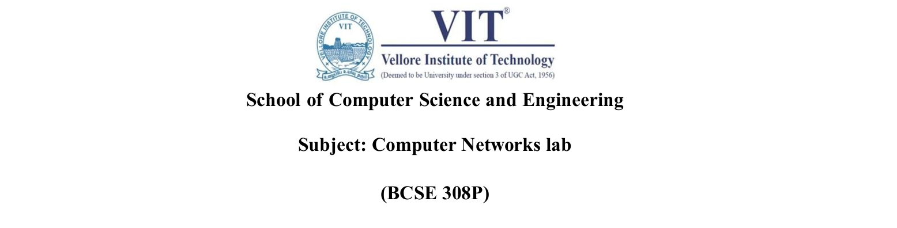
Assessment 6
1)Name- Soumya Bhardwaj
Reg.No.- 23BCE0294
2)Name-Chirayu Singla
Reg.No.- 23BCE0249
ABSTRACT
Title: QoS-Aware Adaptive Routing for Improved Network Performance under Congestion

Abstract:
Conventional shortest-path routing primarily selects routes based on static path costs and may not account for changing network conditions such as congestion, packet loss and delay. This project proposes a QoS-aware adaptive routing approach that dynamically evaluates network paths using delay, packet loss, link utilization and hop count. Normalized link metrics are combined into a weighted path cost, and Dijkstra's algorithm selects the path with the lowest QoS cost. The proposed approach is evaluated against conventional shortest-path routing under normal, moderate and high congestion conditions. Performance is measured using end-to-end delay, packet loss, throughput and packet delivery ratio. The final system provides a comparative simulation and visualizes selected routes and performance trade-offs.

Existing work:
Apostolopoulos et al., "QoS Routing Mechanisms and OSPF Extensions," RFC 2676, 1999, provides the reference framework for QoS-aware routing and resource-aware path computation.

Gap identified:
Static shortest-path costs may not adequately reflect changing congestion, delay and packet loss, even when a healthier alternative path exists.

Work proposed:
Use Dijkstra's algorithm with a weighted cost based on normalized delay, packet loss, link utilization and hop count. Compare it with conventional shortest-path routing under normal, moderate and high congestion.

Metrics to be improved:
End-to-end delay, packet loss, throughput and packet delivery ratio, with hop count and path cost assessed as routing trade-offs.

Final output:
A Python-based comparative network simulation with route visualizations and performance graphs/tables comparing conventional shortest-path and QoS-aware adaptive routing under different congestion conditions.

