Design patterns represent the best practices used by experienced object-oriented software developers. Design patterns are solutions to general problems that software developers faced during software development. These solutions were obtained by trial and error by numerous software developers over quite a substantial period of time.

OO - Java

Singleton

Factory

Strategy

MSA Design Patterns

----------------------------------

Aggregator

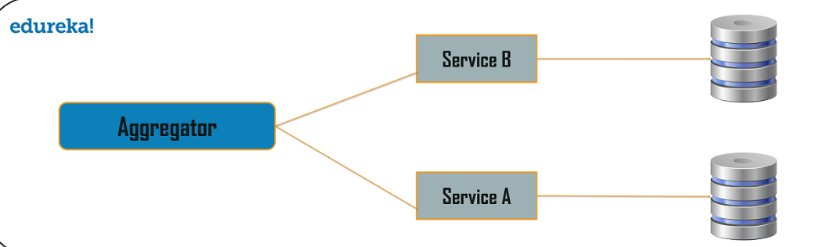

API Gateway Design Pattern

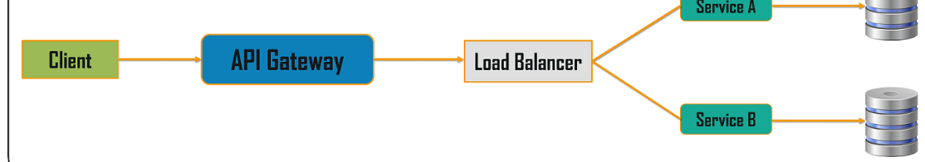

Chain Responsibility

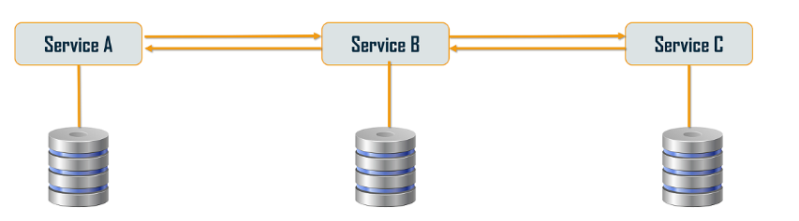

**Asynchronous Messaging Design Pattern**

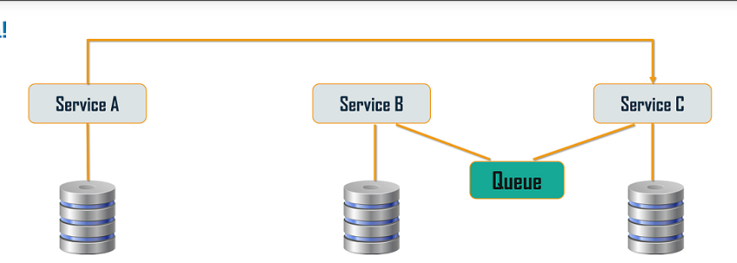

### ****Database or Shared Data Pattern****

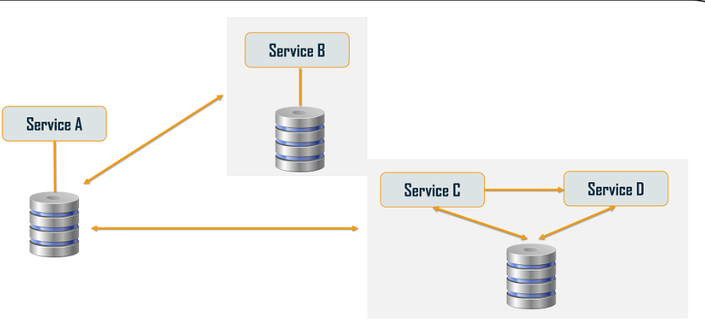

Event Sourcing

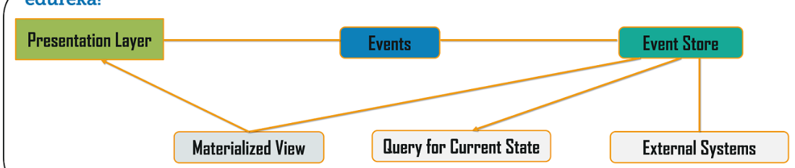

### ****Command Query Responsibility Segregator (CQRS) Design Pattern****

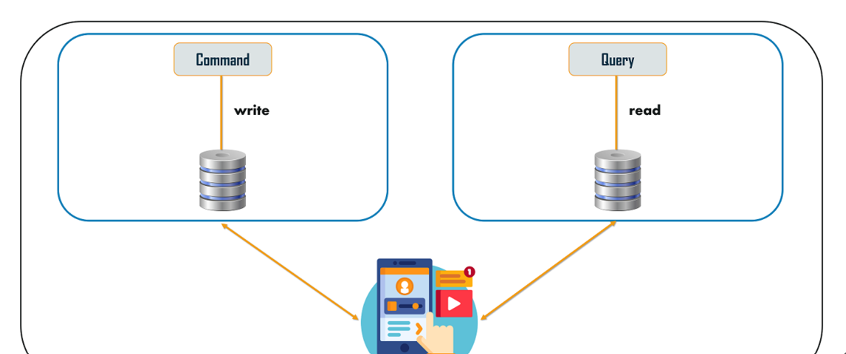

Circuit Breaker

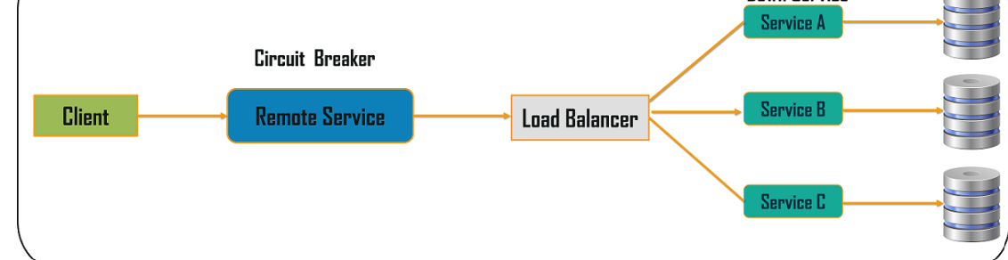

### ****Decomposition Design Pattern****