Django tutorials

https://youtube.com/playlist?list=PLu0W_9lII9ah7DDtYtflgwMwpT3xmjXY9

Summary of <v1-v3>

1. Install 🡪 pip install Django
2. Check 🡪 python –m Django –version
3. To check stable or not 🡪 Django-admin
4. To start a project 🡪 Django-admin startproject <nameof project>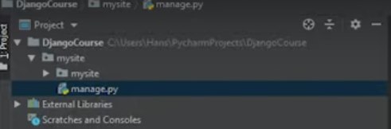 this project will be created a. mysite folder and the manage.py

Mysite folder -> main file

Init.py

Settings.py 🡪 high level settings

Urls.py 🡪urls and mapping

Wsgi.py (webserverinterface.py)

1. Now to start a local dev server 🡪 python manage.py runserver

Summary of <v4-v>