**MS Excel:**

1. Sum Function : =
2. 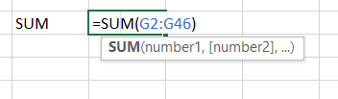

‘G’ column : G2-G46

1. Sum + Avg + Min + Max : (Syntax : **=Fun(start col : End_Col) )**

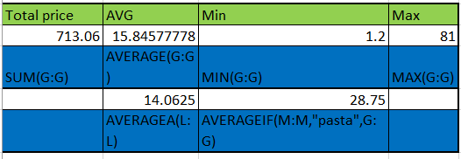

For AVERAGEA(A:A) : It will add text +num and give the avg

AVERAGEIF(RANGE,CRITERIA,AVG RANGE) 🡪 to find the avg(g col) if it is pasta in M col

**NOTE: In excel function depends on a few things

1. Its Inbuilt Formulas
2. Numbers
3. True or False
4. Its Cell Reference
5. SUMIF – to check the sum of specific for a given condition

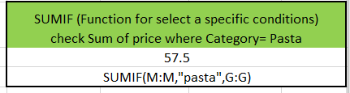

1. SUMIF – to change greater than and less than condition

Here no [] range is given which is optional . if [] is not specified then it will give sum of conditional column

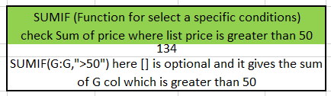

1. SUMIFS : for multiple conditions

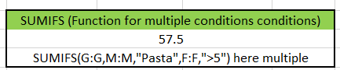

1. COUNT COUNTA:

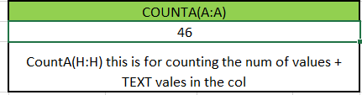

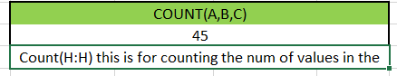

1. Countif and countifs

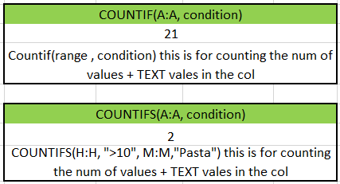

1. Round +roundup +rounddown

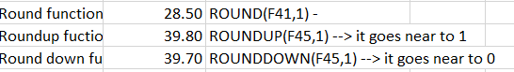

1. CONCAT function

=CONCATENATE(C12," -",D12) it will add C12 cell and D12 cell with “-“ as a seperator

Short Cut

1. Ctrl + shift + down arrow = select the datas present in the excel
2. Ctrl + shift + left arrow = After 1st one it will select the all the table which have values(doesn’t include empty cols)
3. Press ALT -> it will show the all other short cut keys in the screen

Link: https://www.youtube.com/watch?v=RdTozKPY_OQ&t=2852s