Viral polymerases：
Protein Name | HIV reverse transcriptase
Gene Name | pol
Uniprot ID | P03366
PDB ID | 6OTZ
Function in the virus life cycle | HIV reverse transcriptase is an RNA-dependent DNA polymerase that produces the complementary DNA from an RNA template – a key process called reverse transcription in the HIV life cycle
Targeted drugs | Approved drugs:  NRTIs: zidovudine, didanosine, stavudine, lamivudine, abacavir, emtricitabine, tenofovir, tenofovir alafenamide  NNRTIs: nevirapine, efavirenz, delavirdine, elsulfavirine, rilpivirine, etravirine, doravirine  Novel inhibitors:  NRTIs: MK-8591(phase 2), GS-9131(phase 2)  NNRTIs: MK-1650 (phase 2)
Host protein interaction | SAMHD1, TBP, TAF, TFIIA
2D or 3D Structure | 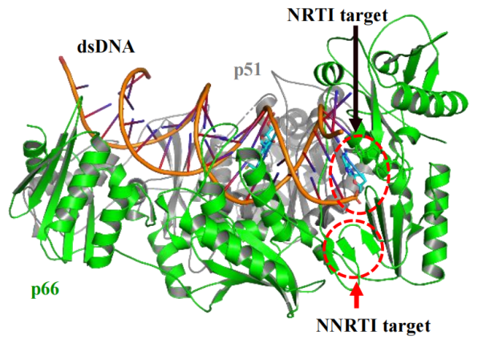

Protein Name | HBV polymerase
Gene Name | P
Uniprot ID | Q9QMN7
PDB ID
Function in the virus life cycle | the active site of reverse transcriptase in the HBV polymerase is critical for protein priming and viral DNA synthesis
Targeted drugs | Approved drugs: Adefovir, besifovir, clevudine  entecavir, telbivudine, tenofovir alafenamide, tenofovir  Novel inhibitors: Tenofovir exalidex
Host protein interaction | HSP90, Histone, PML
2D or 3D Structure

Protein Name | HCV NS5B polymerase
Gene Name | NS5B
Uniprot ID | P26664
PDB ID | 5UJ2
Function in the virus life cycle | HCV NS5B polymerase is an RNA-dependent RNA polymerase that plays an essential role in the HCV RNA synthesis and genome replication
Targeted drugs | Approved drugs: Sofosbuvir, dasabuvir  Novel inhibitors: Adafosbuvir, deleobuvir, Lomibuvir, mericitabine, Radalbuvir, radalbuvir
Host protein interaction | Cyclophilins, hnRNP, AUF1, HuR
2D or 3D Structure | 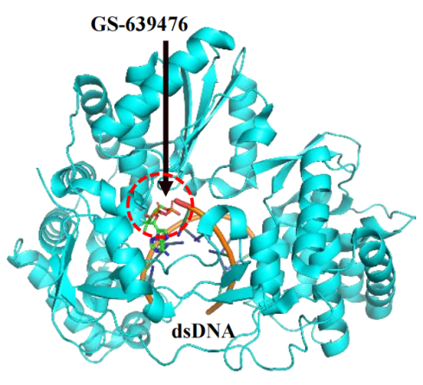

Protein Name | HCMV polymerase
Gene Name | UL54
Uniprot ID
PDB ID | 3KD5
Function in the virus life cycle | HCMV DNA polymerase is a multiprotein complex that contains a catalytic subunit UL54 and a processivity factor UL44 to synthesize long stretches of viral DNA during viral replication
Targeted drugs | Approved drugs: Cidofovir, fomivirsen, foscarnet, ganciclovir, valganciclovir  Novel inhibitors: Filociclovir
Host protein interaction | HMG-I/Y, LEF1, NFIC, Cytochrome P450
2D or 3D Structure | 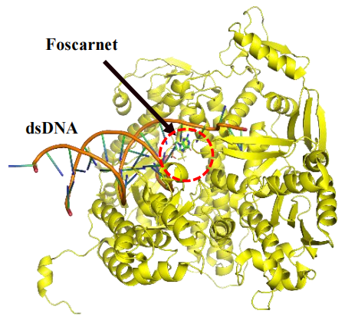

Protein Name | Influenza polymerase
Gene Name | PA/PB1/PB2
Uniprot ID | P03433, P0C0U1, P03428
PDB ID | 6QCT
Function in the virus life cycle | Influenza polymerase is a viral RNA-dependent RNA polymerase that conducts viral transcription and replication using one single-stranded negative-sense genomic RNA 1
Targeted drugs | Approved drugs: Baloxavir marboxil, favipiravir  Novel inhibitors: Pimodivir (VX-787)
Host protein interaction | TFIID, TBP, TAF, hnRNP, Nop58, Nop56
2D or 3D Structure | 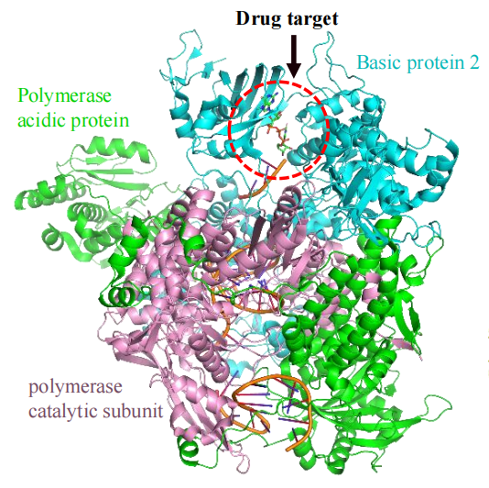

Protein Name | HSV polymerase
Gene Name | UL30/UL42
Uniprot ID | A0A1D8RFC8, P10226
PDB ID | 2GV9, 4M3R
Function in the virus life cycle | HSV-1 DNA polymerase, encoded by the UL30 gene, takes part in the proof-reading and polymerization activities during the viral DNA replication
Targeted drugs | Approved drugs: Aciclovir, brivudine, famciclovir,  foscarnet, idoxuridine, penciclovir, trifluridine, valaciclovir  Novel inhibitors: Synguanol, filociclovir, MBX-2168, mitoxantrone dihydrochloride, PHA767491
Host protein interaction | TFIID, TBP, TAF, LEF1, Coxsackie
2D or 3D Structure | 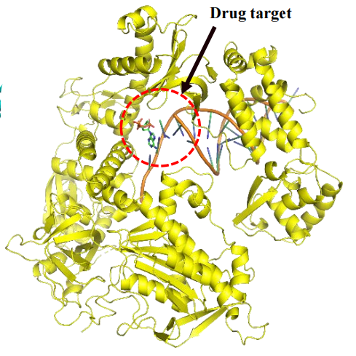

Protein Name | RSV polymerase
Gene Name | P/L
Uniprot ID | P03421, P28887
PDB ID
Function in the virus life cycle | RSV polymerase is an RNA-dependent RNA polymerase for RSV replication and transcription
Targeted drugs | Approved drugs: Ribavirin  Novel inhibitors: Lumicitabine (ALS-8176)
Host protein interaction
2D or 3D Structure | p38 MAPK, PI3K, caspase-8, L9, L22

Protein Name | VZV polymerase
Gene Name | ORF28/ORF29
Uniprot ID | Q6QCM7, Q6QCM6
PDB ID
Function in the virus life cycle | VZV polymerase belongs to the DNA polymerase type-B family. As the essential component of VZV replication complex, DNA polymerase is encoded by the open reading frame 28 (ORF28)
Targeted drugs | Approved drugs: Aciclovir, brivudine, famciclovir,  valaciclovir, vidarabine  Novel inhibitors:
Host protein interaction | hnRNP, TBP, TAFⅠ/Ⅱ, Oct-1/2
2D or 3D Structure

Viral proteases：
Protein Name | HIV protease
Gene Name | Gag-Pol
Uniprot ID | P12497
PDB ID | 3OY4
Function in the virus life cycle | HIV protease plays an indispensable role in the proteolytic processing of Gag and Gagpol polyproteins to release key structural proteins (matrix, capsid, nucleocapsid, p6) and viral enzymes (reverse transcriptase, integrase, protease)
Targeted drugs | Approved drugs: Amprenavir, atazanavir, darunavir, fosamprenavir, indinavir, lopinavir,  nelfinavir, ritonavir, saquinavir, tipranavir  Novel inhibitors: TMB-607, TMC-310911, GRL-09510
Host protein interaction | TNF, p38, JNK, ERK
2D or 3D Structure | 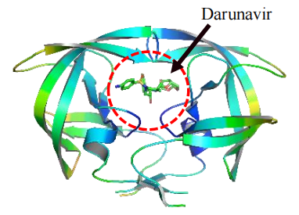

Protein Name | HCV NS3/4A protease
Gene Name | NS3/4A
Uniprot ID | P26663, P27958
PDB ID | 5EQQ
Function in the virus life cycle | The non-covalent formation of HCV NS3/4A complex is essential for the proteolytic cleavage at four junction sites in the polyprotein to produce nonstructural proteins 4
Targeted drugs | Approved drugs: Danoprevir, glecaprevir, grazoprevir, paritaprevir, paritaprevir, Simeprevir  Novel inhibitors: Asunaprevir, faldaprevir, furaprevir, narlaprevir, Seraprevir, vaniprevir, vedroprevir
Host protein interaction | STAT1, STAT3, STAT6, Akt, PI3K, Raf, ERK
2D or 3D Structure | 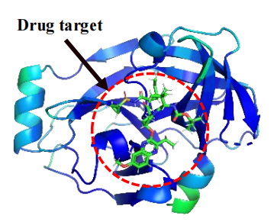

Viral integrase：
Protein Name | HIV integrase
Gene Name | Pol
Uniprot ID | P12497
PDB ID | 5U1C, 3L2V
Function in the virus life cycle | HIV integrase is essential for integrating the full-length linear HIV DNA genome into the host chromatin
Targeted drugs | Approved drugs: Bictegravir, dolutegravir, elvitegravir, raltegravir  Novel inhibitors: Cabotegravir
Host protein interaction | LEDGF/p75, INI1/hSNF5, Ku70/Ku80, HMGA1, INI4
2D or 3D Structure | 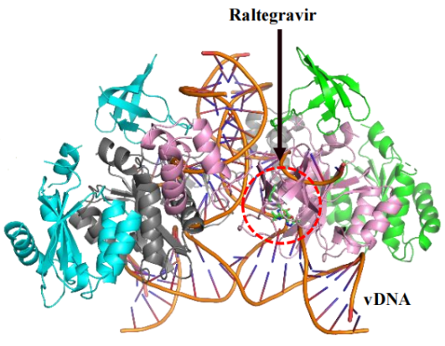

Structural proteins:
Protein Name | HIV gp120 and gp41
Gene Name | gp120 /gp41 (Env)
Uniprot ID | P04578
PDB ID | 6OT1
Function in the virus life cycle | HIV envelope glycoproteins, gp120 and gp41, are critical for the viral entry. HIV Env spikes on the viral surface have a trimeric structure formed by two noncovalently bound subunits: the receptor-binding protein gp120 and the transmembrane protein gp41
Targeted drugs | Approved drugs: Albuvirtide (gp41), enfuvirtide (gp41), Fostemsavir (gp120)  Novel inhibitors: GSK373239 (gp41)
Host protein interaction | CCR5, CXCR4, CD4
2D or 3D Structure | 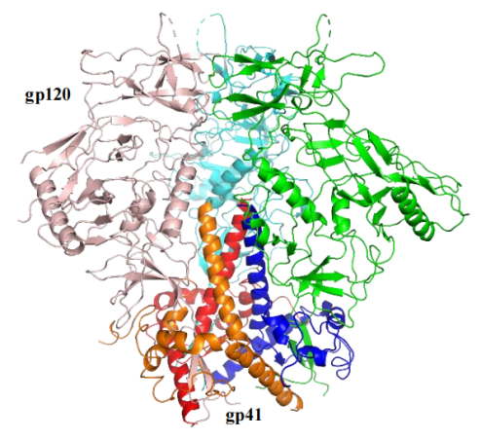

Protein Name | Influenza hemagglutinin
Gene Name | HA
Uniprot ID | P03436
PDB ID | 5T6N
Function in the virus life cycle | To initiate the viral entry, influenza hemagglutinin binds to sialic acids expressed by the cellular receptors on the extracellular membranes of host cells, thereby triggering endocytosis or micropinocytosis
Targeted drugs | Approved drugs:  Novel inhibitors:
Host protein interaction | CAM2, CSF1, ST6GAL1, HSP90, LAMP1
2D or 3D Structure | 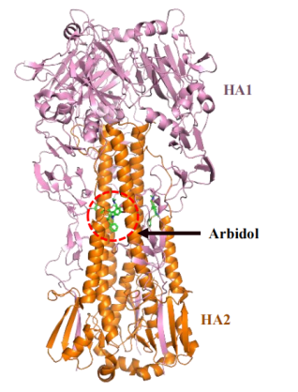

Protein Name | Influenza neuraminidase
Gene Name | NA
Uniprot ID | P03474
PDB ID | 4MWV
Function in the virus life cycle | To complete the viral budding, influenza neuraminidase cleaves sialic acids from both viral and host glycoproteins, therefore releasing influenza progenies from influenza-infected cells
Targeted drugs | Approved drugs: Laninamivir, oseltamivir, peramivir, zanamivir  Novel inhibitors: Isocorilagin
Host protein interaction | rsCD4, CD44, AcHSPG
2D or 3D Structure | 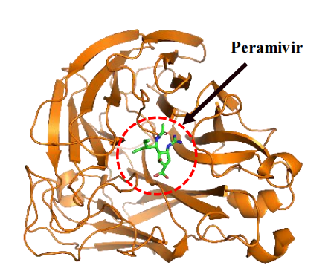

Protein Name | RSV fusion glycoprotein
Gene Name | F
Uniprot ID | P03420
PDB ID
Function in the virus life cycle | RSV fusion (F) glycoproteins on the viral surface facilitate the viral attachment to host cells and actively mediate the fusion between the viral and host membranes during the viral entry
Targeted drugs | Approved drugs: Palivizumab  Novel inhibitors: Presatovir (GS-5806), ziresovir (RO-0529, AK0529), MDT-637, JNJ-53718678, sisunatovir, ALX-0171
Host protein interaction | CX3CR1, glycophorin G, DRF2, VEGF
2D or 3D Structure

Protein Name | Smallpox VP37 envelope wrapping protein
Gene Name | VP37 (A27L)
Uniprot ID
PDB ID
Function in the virus life cycle | Smallpox VP37 envelope wrapping protein, encoded by the gene F13L, interacts with cellular proteins (e.g. Rab9 GTPase, TIP47) in the trans-Golgi membranes to wrap the intracellular viral particles into the triple-wrapped form
Targeted drugs | Approved drugs: Tecovirimat  Novel inhibitors:
Host protein interaction | GRP78, SMURF2, NF-Y
2D or 3D Structure

Other viral proteins:
Protein Name | HCV NS5A phosphoprotein
Gene Name | NS5A
Uniprot ID | P26664
PDB ID | 4CL1
Function in the virus life cycle | it can interact with NS5B for HCV RNA replication, trigger the formation of nucleocapsids, and interact with numerous cellular factors (e.g. apolipoprotein E) to regulate HCV replication and assembly
Targeted drugs | Approved drugs: Daclatasvir, ledipasvir, ombitasvir, elbasvir, velpatasvir, pibrentasvir  Novel inhibitors: Ravidasvir, ruzasvir，odalasvir
Host protein interaction | STAT3, Bcl-2, IKKα/β, RIG-I, IRF-3
2D or 3D Structure | 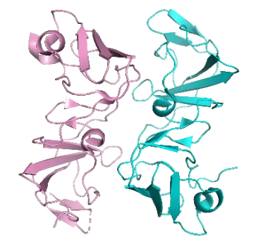

Protein Name | Influenza matrix protein 2
Gene Name | M2
Uniprot ID | A3DRP1
PDB ID | 6BKL
Function in the virus life cycle | Influenza matrix protein 2 (M2) is an integral membrane protein with multiple functions during the viral entry, assembly, and budding
Targeted drugs | Approved drugs: Amantadine, rimantadine  Novel inhibitors:
Host protein interaction | TSG101, VPS28, VPS37, VPS4, Hemagglutinin (HA)
2D or 3D Structure | 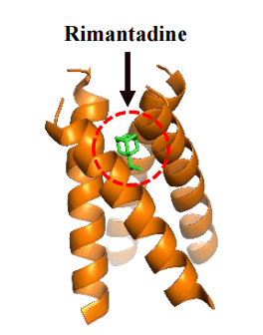

Protein Name | HCMV terminase
Gene Name | UL89/UL56
Uniprot ID | P16732, P16724
PDB ID
Function in the virus life cycle | HCMV DNA terminase complex is a hetero-oligomer composed of UL56, UL89, and additional viral subunits (UL51, UL52, UL77, UL93). This terminase complex cleaves HCMV DNA concatemers and packages the genome into the capsid for the DNA-packing process during the viral maturation and packaging
Targeted drugs | Approved drugs: Letermovir  Novel inhibitors:
Host protein interaction | DNA-PK, IRF-1, Proteasome regulator subunit 2, p53
2D or 3D Structure

Host proteins:
Protein Name | CCR5
Gene Name | CCR5
Uniprot ID | P51681
PDB ID | 4MBS
Function in the virus life cycle | C-C chemokine receptor type 5 (CCR5) from the beta chemokine receptor family is expressed as an integral membrane protein on the surface of various immune cells such as CD4+ T cells, dendritic cells, macrophages, monocytes, and microglia
Targeted drugs | Maraviroc
Host protein interaction | HIV gp120, HCV NS5A
2D or 3D Structure | 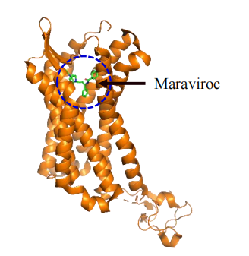

Protein Name | CXCR4
Gene Name | CXCR4
Uniprot ID | P61073
PDB ID | 3ODU
Function in the virus life cycle | HIV gp120 on the viral surface binds to the chemokine receptor CCR5 or CXCR4, thereby triggering the viral entry
Targeted drugs | NF279
Host protein interaction | HIV gp120, HCV E2
2D or 3D Structure | 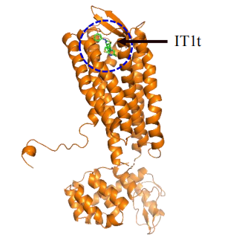

Protein Name | CD4
Gene Name | CD4
Uniprot ID | P01730
PDB ID | 3O2D, 6MET
Function in the virus life cycle | Cluster of differentiation 4 (CD4), a member of the immunoglobulin supergene family, is a membrane glycoprotein highly expressed on the surface of immune cells (e.g. T-helper cells, dendritic cells, macrophages). CD4 mainly acts as a co-receptor of T-cell receptors to mediate the communication between T-cell receptors and antigen-presenting cells
Targeted drugs | Ibalizumab
Host protein interaction | HIV gp120, HSV gD, HBV LHBs
2D or 3D Structure | 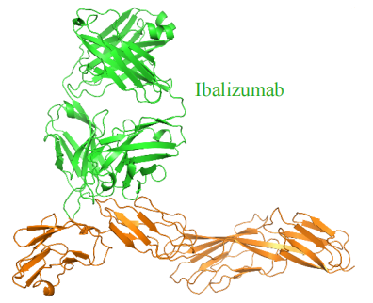

Protein Name | NTCP
Gene Name | SLC10A1
Uniprot ID | Q14973
PDB ID
Function in the virus life cycle | Sodium taurocholate cotransporting polypeptide (NTCP), encoded by the SLC10A1 gene, is a transmembrane glycoprotein that mediates the transport of liver-specific bile acids
Targeted drugs | Myrcludex B
Host protein interaction | HBV LHBs, HCV E1/E2
2D or 3D Structure

Protein Name | LAMP1
Gene Name | LAMP1
Uniprot ID | P11279
PDB ID | 5GV0
Function in the virus life cycle | Lysosomal-associated membrane protein 1 (LAMP1) is a glycoprotein expressed primarily across lysosomal membranes to maintain lysosome integrity, but a basal level of LAMP1 is also expressed on plasma membranes.
Targeted drugs | Candidate 3.3
Host protein interaction | HSV gB, HSV gD, Influenza Hemagglutinin
2D or 3D Structure | 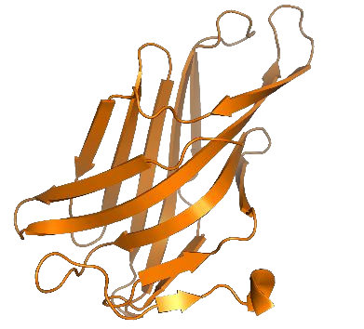

Protein Name | VCP/p97
Gene Name | VCP
Uniprot ID | P55072
PDB ID | 5FTJ
Function in the virus life cycle | Valosin-containing protein (VCP or p97) is a type II AAA (ATPase-associated with various activities) ATPase. VCP participates in many cellular pathways such as vesicular trafficking, proteasomal degradation, and membrane fusion
Targeted drugs | Sorafenib, NMS-873
Host protein interaction | HSV UL56, HBX, HCV NS4A, HCV NS4B
2D or 3D Structure | 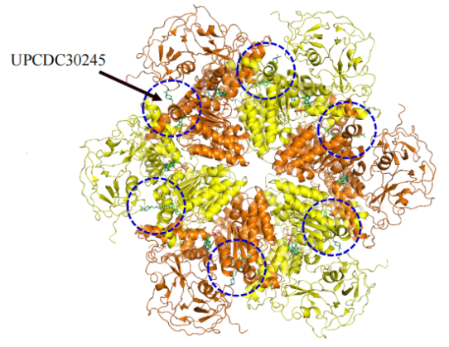

Protein Name | AMPK
Gene Name | PRKAA1/PRKAA2
Uniprot ID | Q13131, P54646
PDB ID | 4QFR
Function in the virus life cycle | Adenosine monophosphate-activated protein kinase (AMPK) is an intracellular serine/threonine kinase activated by metabolic stresses to promote catabolic pathways or suppress biosynthetic pathways
Targeted drugs | PF-06409577, Metformin, AICAR
Host protein interaction | HBx, Influenza NS1
2D or 3D Structure | 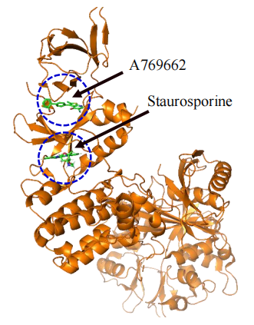

Protein Name | AAK1
Gene Name | AAK1
Uniprot ID | Q2M2I8
PDB ID | 5L4Q
Function in the virus life cycle | Adaptor-associated kinase 1 (AAK1) and cyclin G-associated kinase (GAK) are cellular kinases that regulate trans-Golgi network (TGN) transport and clathrin-mediated endocytosis. Both AAK1 and GAK are serine/threonine kinases that phosphorylate specific threonine residues in the clathrin-associated adaptor protein complexes, thereby enhancing their binding to tyrosine signals in cargo proteins and stimulating vesicle assembly and internalization
Targeted drugs | Sunitinib, erlotinib
Host protein interaction | HBx, HPV E7
2D or 3D Structure | 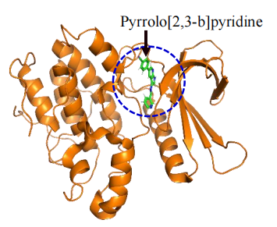

Protein Name | GAK
Gene Name | GAK
Uniprot ID | O14976
PDB ID | 5Y7Z
Function in the virus life cycle | Adaptor-associated kinase 1 (AAK1) and cyclin G-associated kinase (GAK) are cellular kinases that regulate trans-Golgi network (TGN) transport and clathrin-mediated endocytosis. Both AAK1 and GAK are serine/threonine kinases that phosphorylate specific threonine residues in the clathrin-associated adaptor protein complexes, thereby enhancing their binding to tyrosine signals in cargo proteins and stimulating vesicle assembly and internalization
Targeted drugs | Sunitinib, erlotinib
Host protein interaction | HBx, HIV Vpr
2D or 3D Structure | 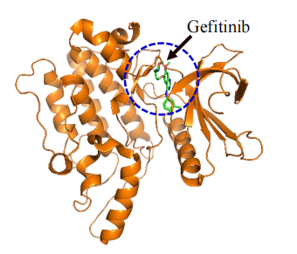

Protein Name | BRD4
Gene Name | BRD4
Uniprot ID | O60885
PDB ID | 3MXF
Function in the virus life cycle | The Bromodomain and Extra-Terminal Domain (BET) family includes five proteins (BRD1, BRD2, BRD3, BRD4, BRDT) that target acetylated lysine in histones and other proteins to coordinate the recruitment of transcriptional complexes to human chromatin. BET proteins play a key role in regulating the gene expression of many viruses (e.g. HIV, HPV, murine leukemia virus, Kaposi sarcoma-associated herpesvirus)
Targeted drugs | I-BET762, JQ1, ZL0580
Host protein interaction | HPV E2, HIV Tat, HCV NS5A
2D or 3D Structure | 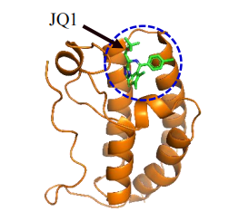

Protein Name | RACK1
Gene Name | Gnb2l1 (RACK1)
Uniprot ID | P63244
PDB ID | 4AOW
Function in the virus life cycle | Receptor for activated C kinase 1 (RACK1), a member of the WD40 protein family, acts as a scaffolding protein to recruit other effector proteins (e.g. protein kinase C) in many cellular processes and pathways
Targeted drugs | SD-29, SD-29-14
Host protein interaction | Influenza NS1, HBx
2D or 3D Structure | 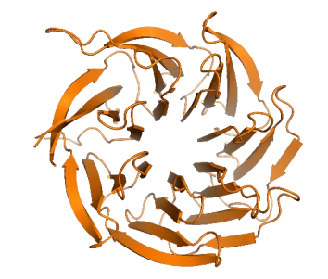

Protein Name | Hsp27
Gene Name | HSPB1
Uniprot ID | P04792
PDB ID | 6DV5
Function in the virus life cycle | Heat shock protein 27 (Hsp27), encoded by the HSPB1 gene, is an intracellular chaperone with multiple functions in many pathophysiological pathways. HSP27 in its oligomeric structure (Figure 2I) not only promotes cancers 118 , but also takes part in the life cycle of human viruses such as HCMV119 , Enterovirus 71 120 , and HIV
Targeted drugs | TDP
Host protein interaction | HIV Tat, Influenza NS1, HPV E5
2D or 3D Structure | 