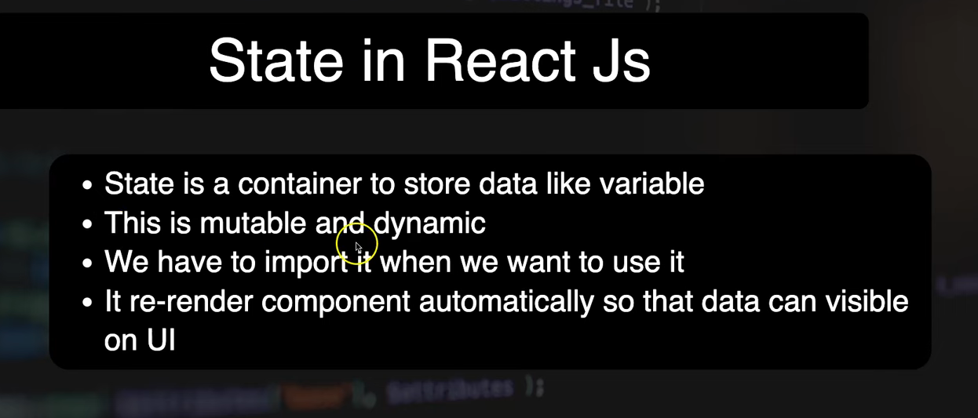
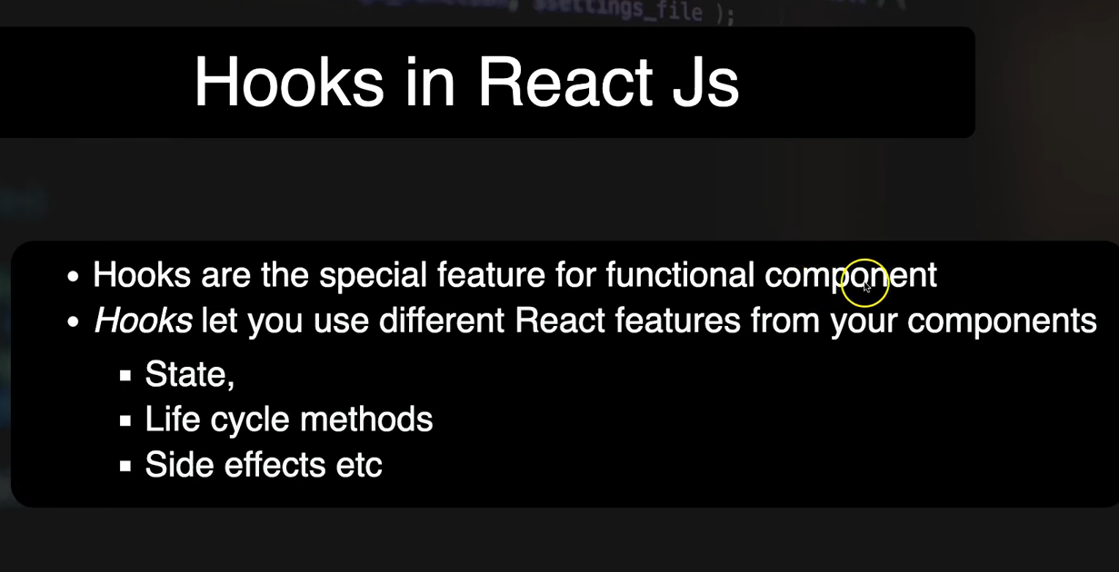

Hooks in React JS
React Hooks were introduced in version 16.8 of React and provide a way to use state and other React features in functional components without writing a class. They allow developers to "hook" into React features such as state and lifecycle methods, making the code more concise and easier to understand.
Key Principles
Hooks can only be called inside React function components and at the top level of a component. They cannot be conditional and are not compatible with class components.
Common Hooks
useState
The useState hook allows you to add state to a functional component. It returns a state variable and a function to update it.
import React, { useState } from "react";

function FavoriteColor() {
const [color, setColor] = useState("red");

return (
<>
<h1>My favorite color is {color}!</h1>
<button onClick={() => setColor("blue")}>Blue</button>
<button onClick={() => setColor("red")}>Red</button>
<button onClick={() => setColor("pink")}>Pink</button>
<button onClick={() => setColor("green")}>Green</button>
</>
);
}

useEffect
The useEffect hook allows you to perform side effects in your components, such as fetching data or directly manipulating the DOM.
import React, { useEffect, useState } from "react";

function DataFetcher() {
const [data, setData] = useState(null);

useEffect(() => {
fetch("https://api.example.com/data")
.then(response => response.json())
.then(data => setData(data));
}, []);

return <div>{data ? JSON.stringify(data) : "Loading..."}</div>;
}

useContext
The useContext hook allows you to access context values without passing props down manually at every level.
import React, { useContext } from "react";
import { ThemeContext } from "./ThemeContext";

function ThemedButton() {
const theme = useContext(ThemeContext);

return <button style={{ background: theme.background, color: theme.color }}>Themed Button</button>;
}

Custom Hooks
Custom hooks allow you to extract and reuse stateful logic across multiple components. They are regular JavaScript functions whose names start with "use" and can call other hooks.
import { useState, useEffect } from "react";

function useFetch(url) {
const [data, setData] = useState(null);

useEffect(() => {
fetch(url)
.then(response => response.json())
.then(data => setData(data));
}, [url]);

return data;
}

Benefits of Using Hooks
- Simpler Code: Functional components with hooks are often more concise and easier to understand than class components.
- Reusability: Hooks make it easier to reuse stateful logic without changing the component hierarchy.
- Improved Maintainability: Code using hooks is often easier to test and debug.
Important Considerations
- Hooks are optional and backward-compatible, allowing partial or full project adoption without rewriting existing code.
- React has no plans to eliminate classes; hooks and class components can coexist.
By using hooks, developers can create more efficient and maintainable React applications, leveraging the power of functional components and stateful logic.

