**Image_data_preprocessing**

**Introduction**

* Python code for some preprocessing of IMAGE data.

**Quick start**

* Required python packages:
* pandas 0.19.2
* opencv 3.4.2

**crop_bbox_from_xml.py- overview**

In deep learning model training we prepare a data which includes image and corresponding xml files which contains bounding box(bbox) of object and label. This data can be prepared using labelimg tool(https://github.com/qaprosoft/labelImg) or other tools. In this repository I uploaded 2 example image and xml files for review. Sometimes we need only exact croped object out of image to prepare dataset. So this code helps you to do that.

Example:

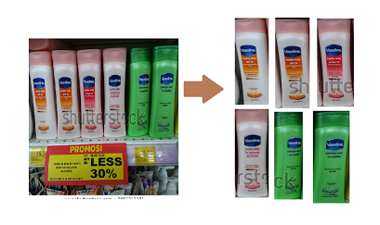

* To run the file open spyder or Anaconda prompt and type below command:

Python **crop_bbox_from_xml.py**

It will ask for path, provide your system path where image and corresponding xml files are stored.