Vrinda Store Sales Analysis Report (2022)
Data Analysis Project using Excel
Prepared By: Soumya Jain
DATASET
https://bit.ly/3X381ok

PROJECT OBJECTIVE
Vrinda Store wanted to analyze their 2022 sales data to understand customer purchasing behavior and identify opportunities to increase sales in 2023.
Goals
- Understand customer demographics
- Identify top-performing states
- Analyze sales channels
- Discover key buying patterns

SAMPLE QUESTIONS
• Which customer segment contributes the most to total sales?
• What is the purchasing distribution between men and women?
• Which age group generates the highest revenue?
• Which states contribute the most to overall sales?
• Which sales channels drive the majority of orders?
• What are the monthly sales trends and seasonal patterns?
• What percentage of orders are successfully delivered?
• How can customer targeting improve sales in the coming year?

DATASET INCLUDES
- Order ID & Sales Amount
- Customer Gender & Age
- State & Location
- Order Status
- Sales Channel

STEP 01: DATA CLEANING
To ensure the accuracy and reliability of the analysis, the dataset was carefully cleaned and standardized before processing.
Steps performed:
• Removed duplicate records to prevent double counting of sales.
• Identified and handled missing (null) values. Blank entries were reviewed and either corrected or excluded from calculations where necessary.
• Standardized categorical values by correcting inconsistencies (e.g., “M” and “Male” unified as Male, similar corrections applied to gender and state names).
• Filtered irrelevant records such as cancelled or returned orders to maintain accurate sales insights.
• Corrected data formats by:
- converting date fields into proper date format
- ensuring sales values were numeric
- removing extra spaces and formatting inconsistencies
• Verified data consistency to ensure totals and categories were accurate.
Outcome:
The dataset was cleaned, standardized, and prepared for accurate and reliable analysis.

STEP 02: DATA PROCESSING
After cleaning, the dataset was transformed to make it suitable for structured analysis and dashboard creation.
Steps performed:
• Created a Month column from the order date to analyze monthly sales trends.
• Generated an Age Group column to categorize customers into meaningful segments for demographic analysis.
• Used Excel formulas to derive and organize data, including:
- extracting months from dates
- grouping age ranges
- calculating totals where required
• Structured the dataset to support Pivot Table analysis.
• Grouped and summarized data by:
- gender
- age group
- state
- sales channel
- order status
• Prepared aggregated values to support charts and dashboard visuals.
Outcome:
The raw data was transformed into structured, analysis-ready information, enabling efficient trend analysis and dashboard visualization.

STEP 03: DATA ANALYSIS
The processed data was analyzed using Pivot Tables and visualizations to identify patterns, trends, and customer behavior.
Analysis performed:
• Examined monthly sales and order trends to understand seasonal performance and growth patterns.
• Analyzed gender-based purchasing behavior to identify the primary customer segment.
• Evaluated age group contribution to determine which demographic generates the most sales.
• Assessed state-wise sales performance to identify top-performing regions.
• An analyzed sales channel contribution to understand which platforms drive the highest revenue.
• Reviewed order status distribution to monitor delivery success and returns.
• Compared sales vs. order volume to understand purchasing patterns and demand trends.
Outcome:
The analysis revealed meaningful customer and sales patterns, enabling data-driven business recommendations.

DASHBOARD

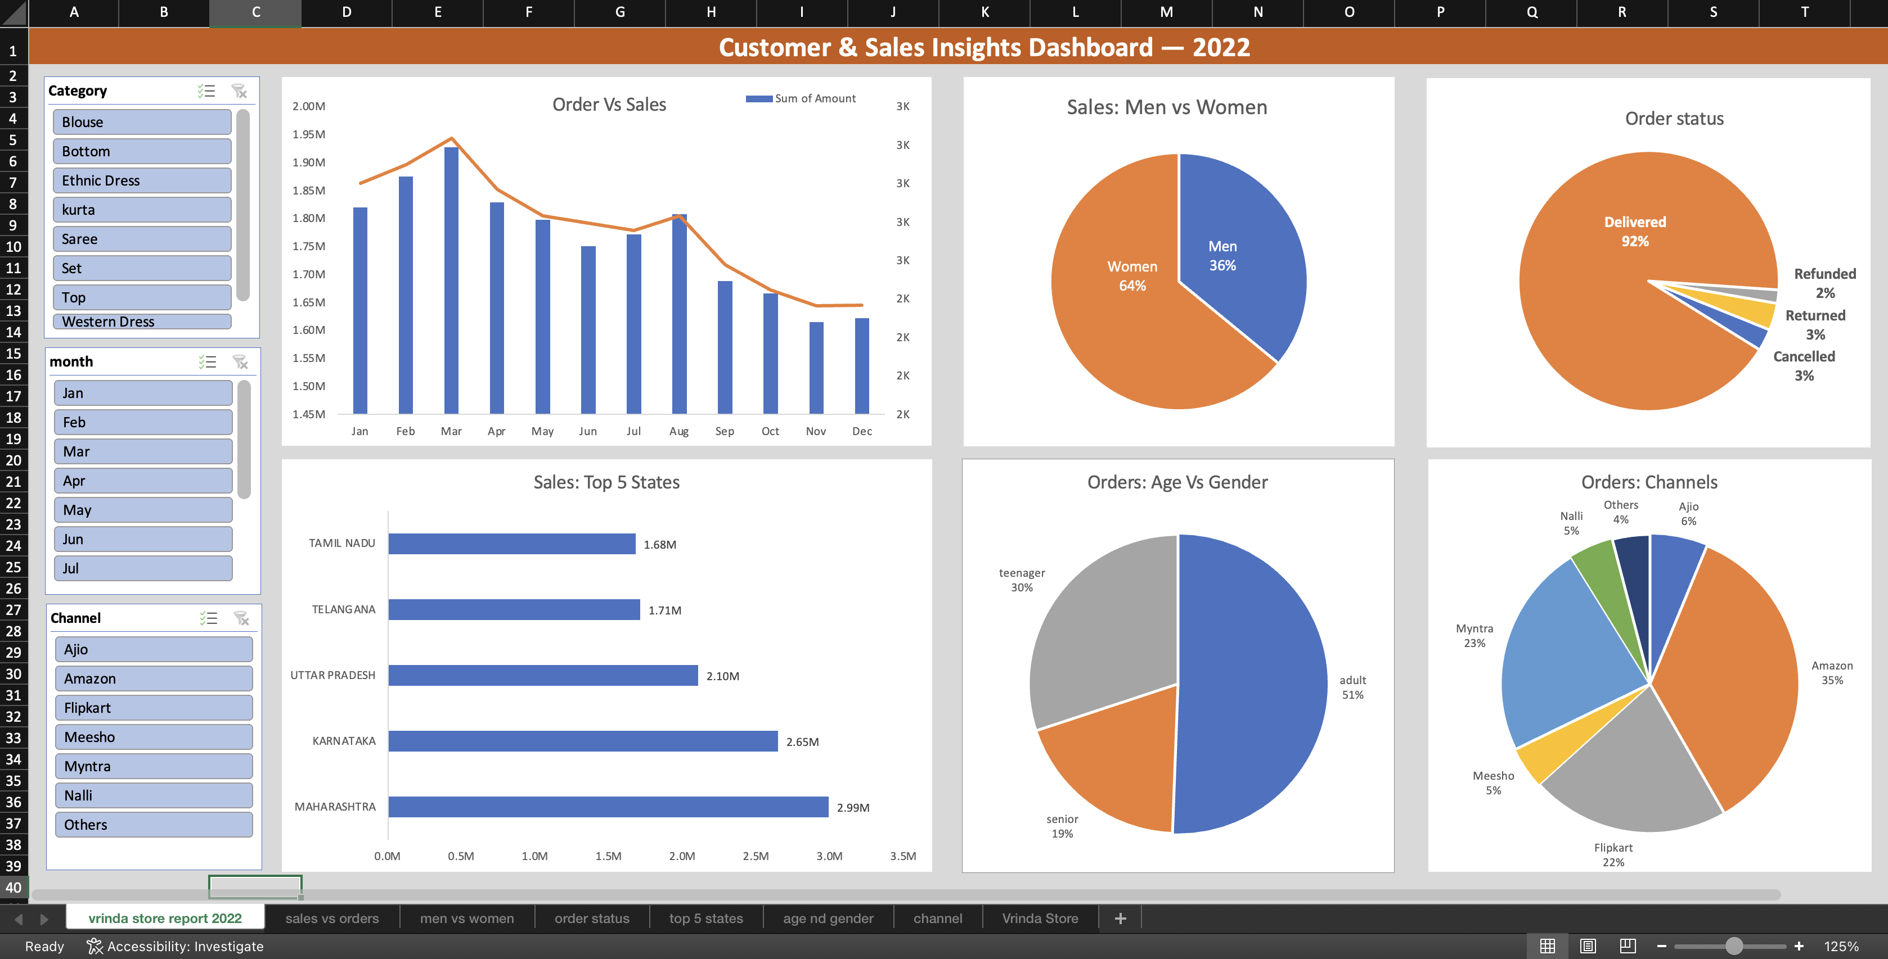

STEP 04: KEY INSIGHTS
The analysis revealed clear customer and sales patterns:
• Women customers contribute approximately 65% of total purchases, making them the primary buyer segment.
• The 30–49 age group generates nearly 50% of total sales, indicating the highest purchasing power among all age groups.
• The top-performing states in terms of sales are:
- Maharashtra
- Karnataka
- Uttar Pradesh
• E-commerce platforms drive the majority of sales, with Amazon, Flipkart, and Myntra contributing nearly 80% of total orders.
• Monthly trend analysis shows consistent demand with peak performance during festive and high-discount periods.
• Most orders are successfully delivered, indicating efficient order fulfillment and customer satisfaction.

Insight Summary
The store’s core customer base consists of women aged 30–49, primarily located in key metropolitan states, with online marketplaces serving as the dominant sales channels.

Recommendations for NEXT YEAR
Based on the analysis of 2022 sales data, the following strategic actions are recommended to improve sales performance and customer engagement:
Target the Core Customer Segment
Focus marketing efforts on women aged 30–49, as this group contributes the highest share of total purchases. Tailored promotions and personalized offers can improve conversion and retention.
Strengthen Presence in High-Performing States
Increase regional marketing initiatives and targeted campaigns in the top-performing states:
- Maharashtra
- Karnataka
- Uttar Pradesh
Localized promotions can help strengthen market penetration.
Optimize Online Sales Channels
Prioritize promotional strategies on major e-commerce platforms such as Amazon, Flipkart, and Myntra, which account for the majority of sales. Platform-specific campaigns and discount strategies can further improve performance.

Leverage Seasonal Demand
Plan targeted campaigns during festive periods and major sale events to maximize revenue. Limited-time offers and bundled deals can help increase order volume.
Enhance Customer Experience
Maintain high delivery success rates and minimize returns by improving fulfillment efficiency. Encouraging customer feedback and reviews can strengthen trust and drive repeat purchases.

