**Online Grievance Redressal Portal**

**Bachelor of Technology**

**Computer Science and Engineering**

Submitted By

SOUMYAJIT DEY SARKAR (13000221080)

NOVEMBER 2023



**Techno Main**

**EM-4/1, Sector-V, Salt Lake**

**Kolkata- 700091**

**West Bengal**

**India**

**Table of Contents**

1. Introduction 3

I. Project Overview 3

II. Project Deliverables 3

III. Evolution of this document 4

IV. References 4

V. Definitions, Acronyms, and Abbreviations 4

2. Project Organization 5

I. Process Model 5

II. Organizational Structure 6

III. Organizational Boundaries and Interfaces 6

IV. Project Responsibilities 6

3. Managerial Process 8

I. Management Objectives and Priorities 8

II. Assumptions, Dependencies, and Constraints 8

III. Risk Management 8

IV. Monitoring and Controlling Mechanisms: 9

4. Technical Process 10

I. Methods, Tools, and Techniques 10

II. Software Documentation 10

III. Project Support Functions 10

5. Work Elements, Schedule, and Budget 10

6. Conclusion 12

7. References 12

**Software Project Management Plan for “Online**

**Grievance Redressal Portal”**

# 1. Introduction

This document will serve as the foundation for the development of a comprehensive and efficient online grievance redress portal, appropriately called "Report It". Throughout this SPMP, we will outline the strategy, methodologies, and key considerations for the successful implementation of the "Report It" project, designed to enhance both user and official experiences with grievance submissions.

The goal of this project is to revolutionize grievance management and streamline the process for all stakeholders involved. From inception to implementation, it will provide a comprehensive framework that ensures the project adheres to defined objectives, meets best practices, and meets stakeholder expectations.

The entire system has to be developed (in JAVA) in a way that it is easy to maintain and extend.

## I. Project Overview

The Online Grievance Redressal Portal is a pivotal digital platform designed to streamline and modernize the grievance handling process within an organization or government entity. This portal serves as a centralized system for individuals, citizens, or employees to submit grievances, complaints, or concerns related to various administrative, operational, or service-related matters. The primary objective is to provide an efficient, transparent, and user-friendly channel for users to voice their grievances and track their progress toward resolution.

## II. Project Deliverables

1. Preliminary Project Plan 15.11.2023
2. Requirements Specification 28.11.2023 - 25.12.2023
3. Analysis [Object model, Dynamic model, and User interface] 08.01.2024
4. Architecture Specification 05.02.2024
5. Component/Object Specification 26.02.2024
6. Source Code 27.02.2024 - 05.06.2024
7. Test Plan 06.06.2024 - 30.10.2024
8. Final Product Demo 31.10.2024

## III. Evolution of this document

This document will be updated as the project progresses. Updates should be expected in the following sections:

1. ***References*** - updated as necessary.
2. ***Definitions, acronyms, and abbreviations*** - updated as necessary.
3. ***Organizational Structure*** will be updated as the team leaders are assigned for each phase.
4. ***Technical Process -*** this section will be revised appropriately as the requirements and design decisions become clearer.
5. ***Schedule –*** as the project progresses, the schedule will be updated accordingly.

### Revision History

|  |  |  |  |
| --- | --- | --- | --- |
| **Revision** | **Date** | **Updated By** | **Update Comments** |
| 0.1 | 05.09.2023 | Soumyajit Dey Sarkar | First Draft |
| 0.2 | 15.11.2020 | Soumyajit Dey Sarkar | Final Draft |

## IV. References

1. Team Website

<https://13000221080.000webhostapp.com/>

1. Project Scope

Mentioned in the Software Requirements Specification.

1. Case Studies

* [https:/www.tandfonline.com/doi/full/10.1080/01442872.2023.2193387](https://www.tandfonline.com/doi/full/10.1080/01442872.2023.2193387)
* [https://www.ijraset.com/research-paper/student-grievance-redressalsystem](https://www.ijraset.com/research-paper/student-grievance-redressal-system)

## V. Definitions, Acronyms, and Abbreviations

1. UML - Unified Modeling Language
2. AD - Architectural Design
3. ADD - Architectural Design Document
4. CM - Configuration Management
5. DD - Detailed Design ix. DDD - Detailed Design Document
6. PM - Project Manager
7. QAM - Quality Assurance Manager
8. SCMP - Software Configuration Management Plan
9. SM - Senior Management SPMP Software Project Management Plan
   * 1. (this document)
10. SR - Software Requirements
11. SRS - Software Requirements Specification
12. SUM - Software User Manual
13. TBD – To Be Decided
14. UR - User Requirements

# 2. Project Organization

## I. Process Model

The **Iterative Waterfall Model** is well-suited for this project as it is well-defined and has stable requirements, where changes are unlikely to occur during the development process. If the project requirements are clear from the outset and do not change significantly, this model can work effectively. For a grievance redressal portal, where user needs might evolve, Iterative Waterfall Model allows for iterative development and frequent stakeholder feedback, making it a flexible choice.

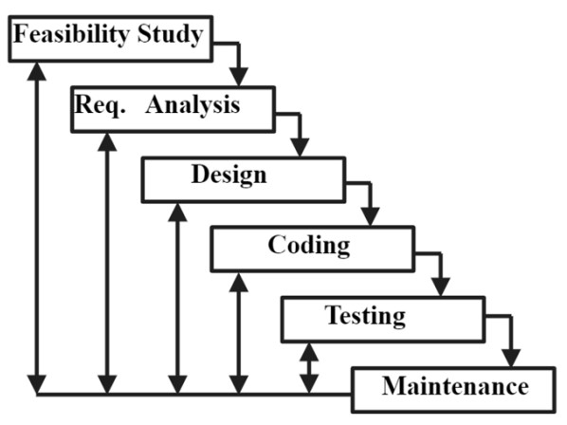

## II. Organizational Structure

Team Members –

1. Soumyajit Dey Sarkar
2. Sagnik Mukhopadhyay
3. Arkapratim Ghosh

|  |  |  |
| --- | --- | --- |
| **Name** | **Organization/**  **Position** | **Contact Information** |
| Soumyajit Dey Sarkar | Project Manager | soumyajitdeysarkar@gmail.com  +91 7980032335 |
| Sagnik Mukhopadhyay | Designer | [m.sagnik.2003@gmail.com](mailto:m.sagnik.2003@gmail.com)  +91 8420180813 |
| Arkapratim Ghosh | Tester | [arkapratimghosh1264@gmail.com](mailto:arkapratimghosh1264@gmail.com)  +91 9330450430 |

|  |  |  |  |
| --- | --- | --- | --- |
| **Days** | **Deliverable** | **Team Leader** | **Deliverable Description** |
| 9 | 1 | Soumyajit Dey Sarkar | Project Plan |
| 7 | 2 | Soumyajit Dey Sarkar | Requirements Specification |
| 9 | 3 | Soumyajit Dey Sarkar | Analysis |
| 13 | 4 | Sagnik Mukhopadhyay | Architecture Specification |
| 9 | 5 | Sagnik Mukhopadhyay | Component/Object Specification |
| 14 | 6 | Soumyajit Dey Sarkar | Source Code |
| 7 | 7 | Arkapratim Ghosh | Test Plan |
| 5 | 8 | Soumyajit Dey Sarkar | Final Deliverable |

## III. Organizational Boundaries and Interfaces

Team leaders throughout each development of the phases will be responsible for coordinating team meetings, updates, communications, and team deliverables.

## IV. Project Responsibilities

For the most vital responsibilities per phase of each team members, please refer to segment 2.2. Ultimately the project team is responsible for the successful delivery of the product. The team member tasks per deliverable according to expertise and the phases are as given below:

1. Project Plan – Whole Team
2. Requirements Specification – Sagnik Mukhpadhyay
3. Analysis – Soumyajt Dey Sarkar
4. Architecture Specification – Sagnik Mukhpadhya
5. Component/Object Specification – Sagnik Mukhpadhyay
6. Source Code – Soumyajt Dey Sarkar
7. Test Plan – Arkapratim Ghosh
8. Final Deliverable – Entire Team

|  |  |  |
| --- | --- | --- |
| **Name** | **Organization/**  **Position** | **Role/Responsibilities** |
| Soumyajit Dey Sarkar | Project Manager | * Managing and leading the project team. * Developing and maintaining a detailed project plan. * Monitoring project progress and performance. * Managing project evaluation and dissemination activities. * Develop corrective actions when necessary. |
| Sagnik Mukhopadhyay | Designer | * Creating wireframes to outline the basic structure and flow of the project. * Organizing and structuring information to enhance user understanding and navigation. * Developing and maintaining design documentation, including style guides and design systems. |
| Arkapratim Ghosh | Tester | * Developing a test plan that outlines the testing strategy, scope, resources, schedule, and deliverables * Executing test cases to identify defects, bugs, or issues in the project. * Conducting various types of testing, such as functional, regression, performance, and security testing. |

# 3. Managerial Process

## I. Management Objectives and Priorities

The management objective is to deliver the product in time and of high quality. The PM and QAM work together to achieve this by respectively checking that progress is made as planned and monitoring the quality of the product at various stages.

## II. Assumptions, Dependencies, and Constraints

In this project plan, a number of factors are taken into account. The following list shows the way milestones on various project phases have been scheduled:

* The team budget of 3 persons x 365 hours = 1095 hours
* The project deadline of November 5th, 2024.
* The final presentation is on October 31st, 2024.
* The peer evaluation deadline is on October 31st, 2024.
* During weekends, state and national holidays the project will remain paused. NOTE: Due to the deadline of November 5th, 2024, running out of time will have its reflection on the product, and not on the duration of the project. By assigning a priority to every user requirement, a selection can be made of user requirements that may be dropped out if time runs out.

## III. Risk Management

This section mentions any potential risks for the project. Also, schedules or methods are defined to prevent or to reduce the risks as below:

1. Technology risk
2. People risk
3. Financial risk
4. Market risk
5. Structure/process risk

The following are the possible risks to be encountered during the development of the project and how they can be prevented.

* 1. Miscommunication *Prevention*: Team members should not hesitate to ask and re‐ask questions if things are unclear. Team members should have a written copy of the tasks assigned to them every meeting. *Correction*: When it becomes clear that miscommunication is causing problems, the team members should gather in a meeting to clear things up.

* 1. Time shortage

*Prevention*: Care is taken to plan enough spare time.

*Correction*: When tasks fail to be finished in time or when they are finished earlier than planned the project planning is adjusted 3. Illness or absence of team members

*Prevention*: Team members should warn their team leader or the PM timely before a planned period of absence.

*Correction*: Work can be taken over quickly by someone else or be distributed among the team members if a person gets ill.

## IV. Monitoring and Controlling Mechanisms:

The monitoring of progress is done by the PM using the following means:

### 1. Project Kick-off Meetings

The project group meetings take place within the class room or through chat. These meetings are meant to inform each other of the progress made on various tasks and to assign new tasks.

### 2. Progress Report

Progress report is done every Friday. This is meant to inform and show the progress in the development of the project and how things are going.

The monitoring of progress is done by the PM using the following means:

i. Weekly project status meetings ii. Shared document repository

1. Project tracking by MS project plan
2. Tracking utilizing baselines in MS project

# 4. Technical Process

## I. Methods, Tools, and Techniques

The project will be implemented utilizing V-model methodology, and tools such as Dreamweaver, Microsoft Project, Star UML, Java, MySQL, QTP, and Load Runner will be utilized. The risks for each category are listed to complete the project successfully. For each risk, a description, a probability of occurrence, the associated action and the impact of the risk are given.

## II. Software Documentation

Documentation such as Project Charter, Business Requirement Document, Functional Specification document, Cost Benefit Analysis, Technical Specification document, Detail Design Document, Test Plan, Implementation Plan, Detailed Project Report, and Benefit Realization document.

## III. Project Support Functions

All project support documents will be completed in applicable phases.

# 5. Work Elements, Schedule, and Budget

1. The project is accounted for project resources, technologies and tools required to whole analysis, implementation, and test of the application.
2. The document for all phases will be revised in subsequent phases if applicable.

Budget and Resource Allocation

Salary 400,000.00

Office Operations/Supplies/Equipment/Consumables 15,000.00

Miscellaneous 3,875.450

**Total**  **Rs. 418875.45**

### Schedule

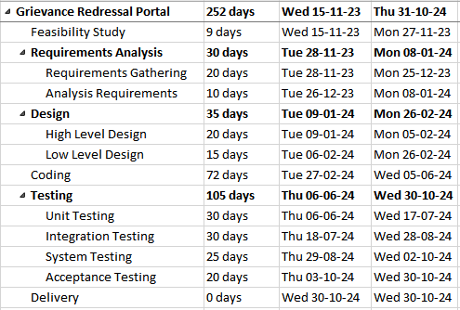

# 6. Conclusion

In conclusion, the development and implementation of an Online Grievance Redressal Portal represent a transformative step towards achieving greater transparency, accountability, and efficiency in the grievance resolution process. This digital platform empowers citizens and organizations by providing them with a user-friendly interface to submit grievances, track their progress, and ultimately, find resolutions. By fostering better communication between stakeholders and streamlining administrative workflows, the portal stands as a cornerstone for improving public service delivery. Furthermore, the successful deployment of an Online Grievance Redressal Portal not only enhances citizen engagement but also provides valuable data insights for decision-makers. It can help identify systemic issues, allocate resources effectively, and make informed policy decisions, thus contributing to better governance.

# 7. References

* <https://pgportal.gov.in/>
* <https://consumerhelpline.gov.in/>
* <https://darpg.gov.in/>
* <https://chat.openai.com/>