# Software Requirements

**Specification**

**for**

# Online Grievance Redressal Portal

**Version 1.1 approved**

**Prepared by Soumyajit Dey Sarkar**

**Techno Main Salt Lake (CSE Dept.)**

**16.11.2023**

**Table of Contents**

1. Introduction 3

1.1. Purpose/Objective 3

1.2. Document Conventions 3

1.3. Scope 3

1.4. References 4

2. History/Background Study 4

2.1. Technical Literature 4

2.2. Existing Application 4

2.3. Customer Surveys 5

2.4. Expert Advice 8

2.5. Current/Future Requirements 8

3. Overall Description 8

3.1. Product Functions 8

3.1.1. Hardware Requirement 8

3.1.2. Software Requirement 9

3.2. Functional Requirements 9

3.2.1. Language and Accessibility 9

3.2.1.1. Multi-language Support 9

3.2.2. User Registration and Authentication 9

3.2.2.1. Sign up 9

3.2.2.2. Login In 9

3.2.2.3. Change Password 9

3.2.2.4. Forget Password 10

3.2.3. Grievance Submission and Tracking 10

3.2.3.1. Grievance Submission 10

3.2.3.2. Grievance Tracking and Monitoring 10

3.2.3.3. Feedback and Ratings 10

3.2.4. Admin 10

3.2.4.1. Admin Login 10

3.2.4.2. Delete Account 11

3.2.4.3. Grievance Assigning 11

3.2.4.4. Feedback and Review 11

3.2.4.5. Grievance Handling 11

3.3. Non-Functional Requirements 11

3.3.1. Correctness Requirement 11

3.3.2. Portability Requirement 12

3.3.3. Efficiency Requirement 12

3.3.4. Usability Requirement 12

3.3.5. Reusability Requirement 13

3.3.6. Reliability Requirement 13

3.3.7. Maintainability Requirement 13

3.4. User Characteristics 14

3.5. Design & Implementation Constraints 14

3.6. Assumptions & Dependencies 15

3.6.1. Assumptions 15

3.6.2. Dependencies 15

4. Interface Requirements 15

4.1. User Interfaces 15

4.2. Hardware Interfaces 15

4.3. Software Interfaces 16

4.4. Communication Interfaces 16

5. Conclusion 16

# Introduction

## Purpose/Objective

The Online Grievance Redressal Portal, as specified in the Software Requirements Specification (SRS), serves as a comprehensive platform designed to streamline the resolution process for user-submitted complaints or grievances. The system encompasses user registration and authentication functionalities to ensure secure access. It provides an intuitive interface for users to submit grievances, capturing pertinent details and supporting documents. The portal incorporates a robust categorization mechanism to efficiently classify grievances based on their nature or severity. Additionally, a defined workflow is established to guide the grievance resolution process, outlining steps from submission to final resolution. Through these features, the Online Grievance Redressal Portal aims to enhance transparency, accountability, and responsiveness in handling and resolving grievances within an organized and user-friendly digital environment.

## Document Conventions

* SRS -> Software Requirements Analysis

## Scope

The scope of the Online Grievance Redressal Portal outlined in the Software Requirements Specification (SRS) encompasses a comprehensive system designed to facilitate the efficient resolution of user grievances. This includes user management functionalities for secure registration and authentication, as well as the establishment of user profiles. The portal provides an intuitive interface for users to submit grievances, with robust mechanisms to capture and validate essential details and supporting documents. Additionally, the system defines a structured workflow to guide the processing and resolution of grievances, ensuring transparency and accountability throughout the entire lifecycle of each case. Overall, the scope aims to create a user-friendly and organized digital platform that enhances the effectiveness of grievance handling and resolution processes.

## References

* [Centralised Public Grievance Redress and Monitoring System (CPGRAMS)](https://pgportal.gov.in/)
* [Intregrated Grievance Redressal Mechanism (INGRAM)](https://consumerhelpline.gov.in/)
* [Department of Administrative Reforms and Public Grievances (DARPG)](https://darpg.gov.in/)
* [ChatGPT](https://chat.openai.com/)

# History/Background Study

## Technical Literature

The technical literature guiding the development of the Online Grievance Redressal Portal, as outlined in the Software Requirements Specification (SRS), encompasses a synthesis of contemporary web technologies and frameworks. Leveraging robust back-end technologies such as Django or Node.js for server-side operations and a responsive front-end framework like React or Angular, the portal aims to deliver a seamless and dynamic user experience. The SRS refers to database management systems like MySQL or MongoDB to ensure efficient data storage and retrieval. Security considerations are paramount, and the literature draws on cryptographic protocols, secure socket layers (SSL), and industry best practices for user authentication and data encryption. Integration with third-party services, if required, follows RESTful API standards for interoperability. Moreover, the SRS incorporates performance optimization techniques and scalability considerations using cloud services like AWS or Azure, aligning with current technical trends to guarantee a reliable and scalable grievance redressal system.

## Existing Application

* Centralised Public Grievance Redress and Monitoring System (CPGRAMS)
* Intregrated Grievance Redressal Mechanism (INGRAM)
* Department of Administrative Reforms and Public Grievances (DARPG)

## Customer Surveys

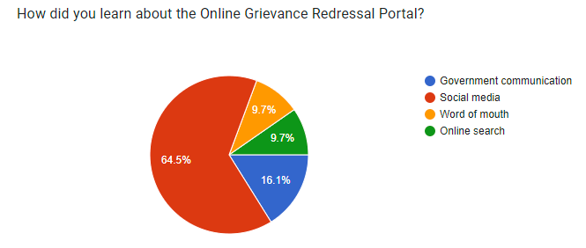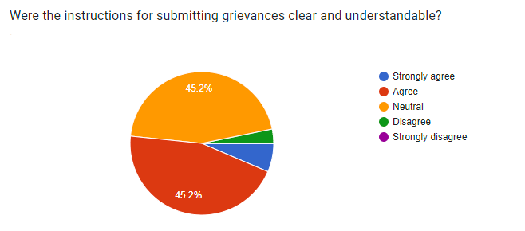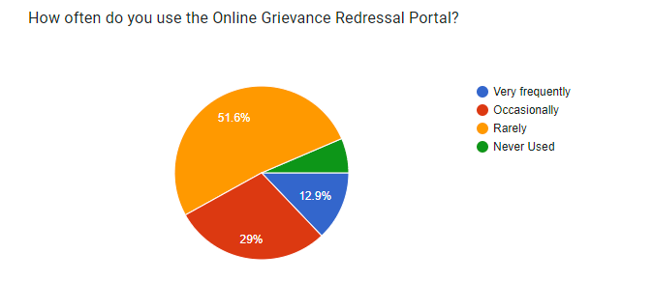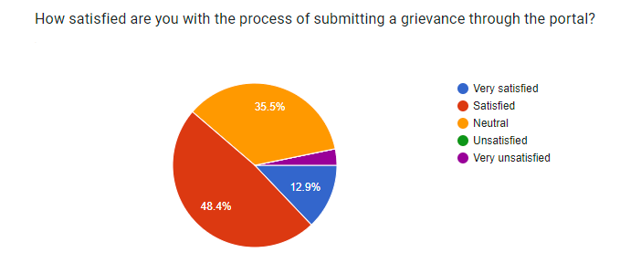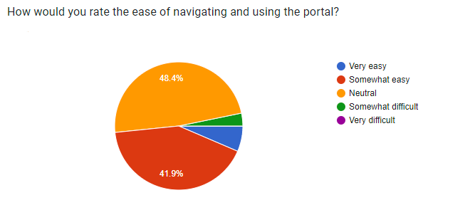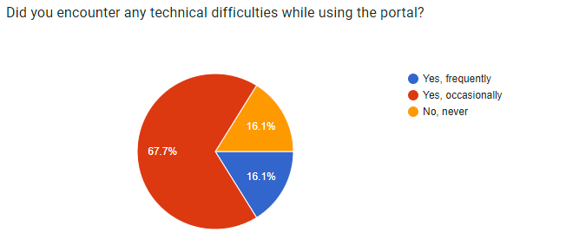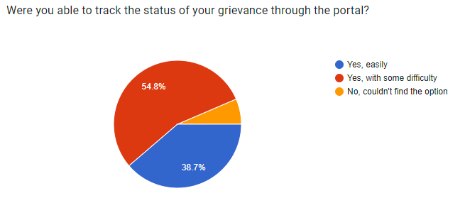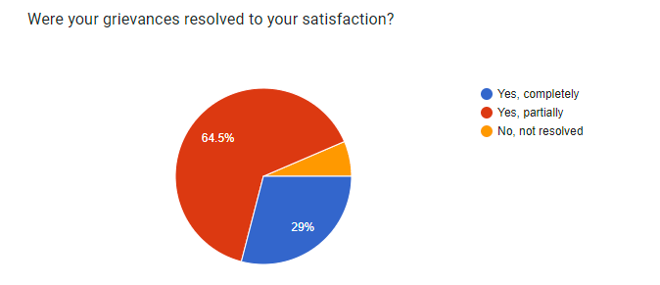

## Expert Advice

In crafting the Software Requirements Specification (SRS) for an Online Grievance Redressal Portal, it is crucial to prioritize user-centric design, ensuring an intuitive and accessible interface for individuals submitting grievances. Focus on robust security measures, adopting industry-standard protocols and encryption techniques to safeguard user data and maintain trust. Leverage successful models of existing grievance redressal systems for inspiration, incorporating features like transparent workflows, efficient categorization, and user feedback mechanisms. Additionally, emphasize scalability, performance optimization, and integration standards to ensure the portal's adaptability and interoperability with relevant systems. Regularly consult with stakeholders, including end-users, to refine and enhance the SRS based on real-world feedback, fostering a dynamic and responsive development process.

## Current/Future Requirements

In formulating the Software Requirements Specification (SRS) for the Online Grievance Redressal Portal, it is essential to consider both current and future requirements. Present-day needs demand a seamless and user-friendly interface, robust security protocols, and efficient workflows for grievance resolution. The SRS should account for scalability and performance optimization to accommodate potential increases in user volume. Future-proofing the portal requires incorporating emerging technologies, such as advanced analytics for data-driven decision-making, and integrating with evolving standards to ensure interoperability with new systems or services. Additionally, as regulatory landscapes change, the SRS should remain flexible to adapt and comply with updated legal and privacy requirements. Regular feedback loops and iterative development methodologies should be emphasized to continuously refine the portal and meet evolving user expectations and technological advancements.

# Overall Description

## Product Functions

### Hardware Requirement

* A Device (Computer/Laptop/Android/ iOS) with at least 2 GB RAM.
* Hard disk space required - 250 MB.
* Minimum Snapdragon 600 series/ i3 13th Gen/ Apple A12 Bionic.

### Software Requirement

* A Database like DBMS (MySQL) to store the details.
* A Web Browser like Chrome, Mozilla, Firefox, etc.
* Operating System - At least Windows 7 64 bit, Mac 10.11, Android Oreo (8).

## Functional Requirements

### Language and Accessibility

* + - 1. Multi-language Support **:** The Online Portal provides language-specific features, interfaces, and content to cater to users who speak different languages.
* **Input:** The user gets to choose the language from the drop down menu. (Hindi/English/Bengali).
* **Output:** The default language will be changed according to the user’s choice.

### User Registration and Authentication

* + - 1. Sign up **:** The User is supposed to create a personalised account for Grievance submission and other activities
* **Input :** The User enters his/her name, date of birth, address, phone number and email address.
* **Output :** The user will get a verification mail to the registered email address. On correctly verifying the email address the User gets to set his password. The user also gets an OTP in his/her phone what the user needs to enter to add the phone number to his/her account.
  + - 1. Login In **:** The user needs to login in to his/her account to use the services.
* **Input :** The user enters the email address and the password.
* **Output :** The user is logged into his/her account if the email address and password are both correct.
  + - 1. Change Password **:** The user can change his/her password if they think that their password has been compromised.
* **Input :** The user enter the current password along with the new password.
* **Output :** If the current password is correct, then the password is changed to the new password.
  + - 1. Forget Password **:** The user can reset his/her password if they have forgotten their current password.
* **Input :** Enter the registered email address and the registered phone no.
* **Output :** A verification mail is sent to the email address and an OTP is sent to the registered phone number if the entered email address and phone no. were correct. The user needs to verify both and then set his/her new password.

### Grievance Submission and Tracking

* + - 1. Grievance Submission **:** The user can submit his/her grievance with the help of the portal, which remains the main objective of creating this portal.
* **Input :** The user chooses the category of the grievance (workplace, safety, discrimination, etc), then writes a detailed description of the grievance and the choice of attaching any attachments if required.
* **Output :** The grievance is submitted for the higher bodies to look forward.
  + - 1. Grievance Tracking and Monitoring **:** The user can track his/her submitted grievances and check the status of them.
* **Input :** The user can see all his/her past grievances that were submitted. The user gets to select any specific grievances and study its status.
* **Output :** The current status of the selected grievance is displayed i.e.
* Received/Acknowledged.
* Under Review/Investigation.
* In Progress/Resolution.
* On Hold/Pending.
* Resolved/Closed with the final decision**.**
  + - 1. Feedback and Ratings **:** The users are allowed to rate their experience using the portal for a particular grievance they submitted.
* **Input :** The user gets to choose no. of stars he/she wants to give, with 1 Star as the minimum and 5 Star as the maximum rating allowed.
* **Output :** The user’s rating is stored.

### Admin

* + - 1. Admin Login **:** The admins are responsible for the proper working of the portal by screening out unnecessary things and take proper action on things that need attention. The admins are provided with their own IDs and password that is required to log into the portal.
* **Input :** The Admin need to enter the following details :
* Admin ID
* Password
* **Output :** The Admin Home Page appears.
  + - 1. Delete Account **:** The admin has the power to delete user accounts if required.
* **Input :** The admin can delete an account if the account as the following condition against it:
* Fake Accounts
* False Claims
* Vulgarity in Complaints
* **Output :** Account is deleted.
  + - 1. Grievance Assigning **:** Receive, review, and assign grievances to relevant departments or personnel.
* **Input :** Assign grievances to target individuals or a department.
* **Output :** Grievances is assigned to the selected personnel for investigation and action.
  + - 1. Feedback and Review**:** The admin has the power to review user feedback on the grievance resolution process and use the feedback to make improvements and enhance user satisfaction.
      2. Grievance Handling **:** The admin gets to set the grievance status according to the need.
* **Input :** The Admin can set the status of the submitted grievance by selection the available options from the drop down menu. The options are :
* Received/Acknowledged.
* Under Review/Investigation.
* In Progress/Resolution.
* On Hold/Pending.
* Resolved/Closed with the final decision.
* **Output :** The grievance’s status is changed.

## Non-Functional Requirements

### Correctness Requirement

The Online Grievance Redressal portal shall uphold a high standard of correctness in its functionality, data processing, and user interactions. The system must accurately capture, categorize, and store user grievances without data loss or corruption. User inputs, including personal information and grievance details, should be validated to ensure accuracy and compliance with established standards. The portal must adhere to legal and regulatory guidelines, ensuring that the handling and resolution of grievances align with applicable laws. Error handling mechanisms shall be implemented to promptly identify and rectify any discrepancies, providing users with reliable and precise information regarding the status and resolution of their grievances. Regular audits and quality assurance processes shall be conducted to maintain the correctness of the system throughout its lifecycle.

### Portability Requirement

The Online Grievance Redressal portal shall demonstrate a high degree of portability to ensure seamless accessibility and functionality across diverse platforms and devices. The system should be compatible with popular web browsers, including but not limited to Chrome, Firefox, Safari, and Edge, and support various operating systems such as Windows, macOS, and Linux. Furthermore, the portal must be responsive and adaptive to different screen sizes, ensuring an optimal user experience on desktops, laptops, tablets, and mobile devices. This portability requirement aims to enhance user accessibility and usability while allowing for efficient deployment and integration across a wide range of technology environments.

### Efficiency Requirement

The Online Grievance Redressal portal shall be designed and implemented to ensure optimal performance and responsiveness throughout its operation. The system must efficiently handle a potentially high volume of user submissions, employing streamlined database queries, and minimizing response times. Navigation within the portal should be intuitive, providing users with a swift and seamless experience. Resource utilization, including server capacity and bandwidth, must be optimized to support concurrent users effectively. The system should incorporate caching mechanisms and other performance-enhancing techniques to reduce latency and enhance user experience. Regular performance monitoring and testing shall be conducted, and scalability features should be implemented to accommodate increasing loads. This efficiency requirement aims to provide users with a responsive and reliable platform for the prompt resolution of grievances while ensuring efficient use of computational resources.

### Usability Requirement

The Online Grievance Redressal portal shall prioritize a user-centric design to ensure a highly usable and intuitive interface. The system must be accessible to users with diverse technical proficiencies and disabilities. Navigation within the portal should be straightforward, with clear and consistent labeling of features and functionalities. The user interface (UI) shall be aesthetically pleasing and responsive across various devices and screen sizes. To enhance user engagement, the portal should provide informative feedback, guiding users through the grievance submission and resolution process. Additionally, the system shall offer multi-language support, enabling users to interact with the portal in their preferred language. Usability testing with representatives from the target user base shall be conducted to refine the interface and overall user experience, ensuring that the Online Grievance Redressal portal is user-friendly, efficient, and accommodating of diverse user needs.

### Reusability Requirement

The Online Grievance Redressal portal shall be designed with a focus on reusability to facilitate the incorporation of its components and functionalities into other systems or future modules. Software modules, code libraries, and UI components shall be modularized and documented in a manner that supports easy integration with other applications. The system architecture should follow industry best practices, promoting the use of standardized protocols and interfaces for seamless interoperability with external systems. Additionally, the portal's codebase shall be well-commented and documented, providing clear guidelines for developers seeking to reuse or extend the functionality. The goal is to maximize the potential for future expansion, integration, and the development of related systems by ensuring that the Online Grievance Redressal portal is inherently reusable and adaptable.

### Reliability Requirement

The Online Grievance Redressal portal shall prioritize reliability to ensure consistent and dependable performance under varying conditions. The system must be designed to minimize downtime, with a target for high availability to users. To achieve this, robust error-handling mechanisms shall be implemented, promptly identifying and addressing any issues that may arise during user interactions or backend processes. Data integrity measures, such as regular backups and secure storage practices, will be implemented to safeguard against data loss or corruption. The portal shall adhere to industry-standard security protocols to protect user information and prevent unauthorized access. Furthermore, the system should be resilient to unexpected surges in user traffic, with load balancing and failover mechanisms in place to maintain operational stability. Regular reliability testing and monitoring shall be conducted to identify and address potential vulnerabilities, ensuring a trustworthy and resilient Online Grievance Redressal portal throughout its lifecycle.

### Maintainability Requirement

The Online Grievance Redressal portal shall be designed with a focus on maintainability, allowing for efficient updates, enhancements, and modifications throughout its lifecycle. The codebase shall adhere to industry best practices, utilizing a modular and well-documented structure to facilitate ease of understanding and modification by developers. The system architecture shall support scalability, enabling the addition of new features or modules with minimal disruption to existing functionalities. Regular software updates, patches, and improvements shall be seamlessly deployable, with an emphasis on minimizing system downtime. Comprehensive documentation, including technical specifications and user manuals, shall be maintained and updated to aid system administrators, developers, and end-users in understanding and utilizing the system effectively. Additionally, the use of version control systems and coding standards shall be enforced to ensure consistency and traceability in the development process. These measures collectively contribute to the maintainability of the Online Grievance Redressal portal, supporting its adaptability and longevity.

## User Characteristics

The Online Grievance Redressal portal is designed to accommodate a diverse user base, each with unique characteristics and requirements. The primary user categories include:

* **Grievance Submitters**: These are individuals or entities filing grievances through the portal. Users may vary in technical proficiency, and the portal should provide an intuitive interface to facilitate easy submission of complaints. The system should support users with different linguistic preferences and varying levels of digital literacy.
* **Administrators:** Responsible for managing and resolving grievances. Require access to an administrative dashboard for monitoring and responding to grievances efficiently. May need advanced functionalities for data analysis, reporting, and system configuration.

## Design & Implementation Constraints

The Online Grievance Redressal portal shall be developed within the framework of specified design and implementation constraints, including adherence to the organization's approved technology stack, compliance with legal and regulatory requirements, robust security measures, budgetary limitations, scalability considerations, adherence to accessibility standards, integration compatibility with existing systems, adherence to user experience guidelines, performance criteria, and a focus on ease of maintenance and support. These constraints collectively guide the design and implementation of the portal, ensuring a secure, scalable, and user-friendly platform for effective grievance resolution while aligning with organizational and industry standards.

## Assumptions & Dependencies

### Assumptions

* Coding is error free.
* The system should have apt storage capacity and provide fast access.
* Users must use their user names and correct passwords.

### Dependencies

* Web Browser
* Internet Connectivity

# Interface Requirements

## User Interfaces

The Online Grievance Redressal portal will feature an intuitive and user-friendly interface designed to facilitate seamless interaction for diverse users. The interface will include a straightforward grievance submission form with clear instructions, ensuring ease of use for grievance submitters. Administrators will have access to a comprehensive dashboard, providing real-time analytics, and efficient management tools. End users checking grievance status will experience an easily navigable portal, offering clear and concise updates. The design will prioritize accessibility, ensuring a responsive and visually consistent experience across various devices and screen sizes. Multilingual support will be integrated to accommodate users' language preferences, enhancing inclusivity in the user interface. Overall, the interface will prioritize simplicity, clarity, and accessibility to optimize user engagement and satisfaction.

## Hardware Interfaces

The Online Grievance Redressal portal's hardware interfaces are designed to operate seamlessly with standard web servers, databases, and networking components. The portal will be compatible with widely used web browsers, such as Chrome, Firefox, Safari, and Edge, ensuring accessibility across diverse platforms. The hardware infrastructure should support secure data transmission through encryption protocols to safeguard sensitive user information. Scalability considerations will guide the portal's ability to efficiently utilize available server resources, ensuring optimal performance even under varying loads. The hardware interfaces must adhere to industry best practices, promoting reliability, and minimizing downtime for both administrators and users. Compatibility with cloud services may also be considered for enhanced flexibility and resource management.

## Software Interfaces

The Online Grievance Redressal portal's software interfaces encompass compatibility with standard web browsers (e.g., Chrome, Firefox, Safari, Edge) for user interaction. The portal will integrate with backend servers, supporting HTTP/HTTPS protocols, and interact with a relational database management system for data storage and retrieval. Additionally, APIs or middleware may be employed for seamless integration with external systems or services. The software architecture will adhere to industry standards, promoting interoperability and facilitating future enhancements. Compliance with security protocols, such as SSL/TLS for secure data transmission, will be maintained to ensure data integrity and user privacy. The software interfaces will be designed for efficiency, reliability, and ease of maintenance throughout the portal's lifecycle.

## Communication Interfaces

The communication interfaces for the Online Grievance Redressal portal will encompass secure data exchange between users and the system via standard HTTP/HTTPS protocols. User notifications and updates will be communicated through email notifications and, where applicable, SMS services to ensure timely feedback. The portal may utilize API integrations or messaging protocols for seamless communication with external systems, facilitating real-time data synchronization. Security measures such as encryption will be implemented to protect sensitive information during communication. The communication interfaces will be designed to provide a reliable and transparent channel for users, administrators, and other integrated systems, enhancing the overall responsiveness and effectiveness of the grievance redressal process.

# Conclusion

In conclusion, the Online Grievance Redressal portal outlined in this Software Requirements Specification (SRS) is envisioned as a comprehensive and user-centric platform dedicated to efficient and secure grievance resolution. Through a carefully designed user interface, the portal aims to provide an intuitive and accessible experience for grievance submitters, administrators, and end users, ensuring clarity and ease of interaction. The adherence to design and implementation constraints, compatibility with diverse hardware and software interfaces, and robust communication mechanisms collectively contribute to a reliable, scalable, and maintainable system. By prioritizing security, compliance, and user experience, the Online Grievance Redressal portal is poised to facilitate transparent and effective grievance resolution while accommodating future enhancements and technological advancements.