Infosys Springboard Virtual Internship 6.0 Completion Report

Team Details
Batch Number: Batch-5
Start date: 13-Oct-2025
Names:
- Soumyajit Rout
- Sri Sai Prasanna Chinnam
- Swaranthi Balamurugan
- V Veeresh
- Vaishnavi Ambhore
- Yamini Gottapu
Internship Duration: 8 Weeks

1. Project Title
NeuroFleetX – Smart Fleet Management System.

2. Project Objective
The objective of this project is to develop a Smart Fleet Management System that digitizes vehicle booking, monitoring, and management. The system enables fleet managers and customers to efficiently track, book, and manage vehicles in real time, reducing manual effort and increasing operational accuracy.

3. Project description in detail
The NeuroFleetX project is a Smart Fleet Management System built using the MVC (Model–View–Controller) architecture to streamline vehicle management, route optimization, and operational analytics for fleet-based organizations.
This web-based application connects Admins, Fleet Managers, Drivers, and Customers on a single platform, providing real-time insights into vehicle status, bookings, and performance. The system ensures efficient vehicle utilization, reduces downtime, and enhances decision-making through intelligent data processing.
The architecture is divided into three main layers:
- Model: Built with Spring Boot and MySQL, handling data, business logic, and persistence.
- View: Designed using React.js, offering an interactive, responsive, and user-friendly interface.
- Controller: Managed through Spring Boot REST APIs, which connect frontend and backend modules for seamless data flow.
The project is structured into six modules:
- Authentication & Role Management – Secure login and access control for Admin, Fleet Manager, Driver, and Customer.
- Fleet Inventory & Vehicle Telemetry – Real-time tracking of vehicles, inventory management, and telemetry data visualization.
- AI Route & Load Optimization Engine – Smart algorithms to plan optimal routes and vehicle loading.
- Predictive Maintenance & Health Analytics – Predict maintenance schedules and detect potential faults using analytics.
- Customer Booking & Smart Recommendations – Allow customers to book vehicles with intelligent suggestions based on usage patterns.
- Admin Dashboard & Urban Mobility Insights – Comprehensive analytics and reports for monitoring fleet performance and mobility trends.
Technologies Used:
- Frontend: React.js, HTML, CSS, JavaScript, Tailwind CSS
- Backend: Spring Boot (Java)
- Database: MySQL
- Architecture: MVC Model
- Tools: GitHub, Postman, IntelliJ IDEA, VS Code
Impact:
The system helps transportation and logistics companies automate their operations, monitor fleet health in real time, and make data-driven decisions. It improves efficiency, safety, and customer satisfaction by integrating technology with modern fleet management practices.

4. Timeline Overview
Week | Activities Planned | Activities Completed
Week 1 | Design login & registration pages. | Completed
Week 2 | Implement role-based access for Admin, Fleet Manager, Driver, and Customer.  Integrate backend authentication using Spring Boot & MySQL. | Completed
Week 3 | Design database for vehicles & telemetry data.  Create REST APIs for vehicle management. | Completed
Week 4 | Develop frontend dashboard for vehicle tracking and details.
Week 5 | Research and plan AI-based route optimization logic.
Week 6 | Implement algorithms for route & load balancing.  Integrate with fleet data for dynamic route suggestions.
Week 7 | Design maintenance prediction model and dashboard.
Week 8 | Integrate vehicle health analytics into system.  Conduct overall testing & documentation.

5a. Key Milestones
Milestone | Description | Date Achieved
Project Kickoff | Team formation, project selection, and understanding requirements. Initial setup of GitHub repository and environment. | Week 1
Prototype/First Draft | Completion of Module 1: Authentication & Role Management with working login and role-based access system. | Week 2
Mid-Term Review
Final Submission
Presentation

5b. Project execution details
The project is being executed following a module-based agile development approach, where each milestone is completed within a two-week sprint. The team divided responsibilities among members for frontend, backend, database, and documentation tasks to ensure smooth collaboration and consistent progress.
Planning & Setup:
During the initial phase, the team finalized the project scope, identified the six core modules, and designed the overall system architecture using the MVC (Model-View-Controller) model.
The GitHub repository was created for version control, and development environments were configured using VS Code and IntelliJ IDEA.
Backend Development:
The backend was developed using Spring Boot, implementing RESTful APIs to handle authentication, vehicle data, and telemetry information.
The database schema was created in MySQL, and connectivity was established through Spring Data JPA.
Frontend Development:
The frontend was built using React.js, HTML, CSS, JavaScript, and Bootstrap to ensure a modern and responsive interface.
UI components were designed for login, registration, dashboard, and vehicle listing, providing smooth interaction with backend APIs.
Module 1 – Authentication & Role Management (Completed):
This module focused on secure user authentication and role-based access for Admin, Fleet Manager, Driver, and Customer roles.
JWT-based authentication and validation were successfully implemented and tested through REST APIs.
Module 2 – Fleet Inventory & Vehicle Telemetry (Ongoing):
Currently, the team is developing the Fleet Inventory & Vehicle Telemetry module.
Database tables for vehicles and telemetry data have been designed, and REST APIs for vehicle management are being integrated with the frontend dashboard to visualize fleet data in real time.
Integration, Testing & Collaboration:
The team uses Postman for API testing and GitHub for version control. Regular reviews and meetings are conducted to discuss progress, resolve issues, and ensure alignment with project goals.
Overall, the project execution so far demonstrates a strong foundation in architecture, teamwork, and technical implementation. The team is currently progressing toward completing Module 2 and integrating telemetry visualization features.

6. Snapshots / Screenshots
Module 1: Authentication & Role Management

1. Sign Up Page
This page allows new users to create an account by providing their full name, email, password, confirming password, and selecting a user role (Customer, Driver, Fleet Manager, Admin).
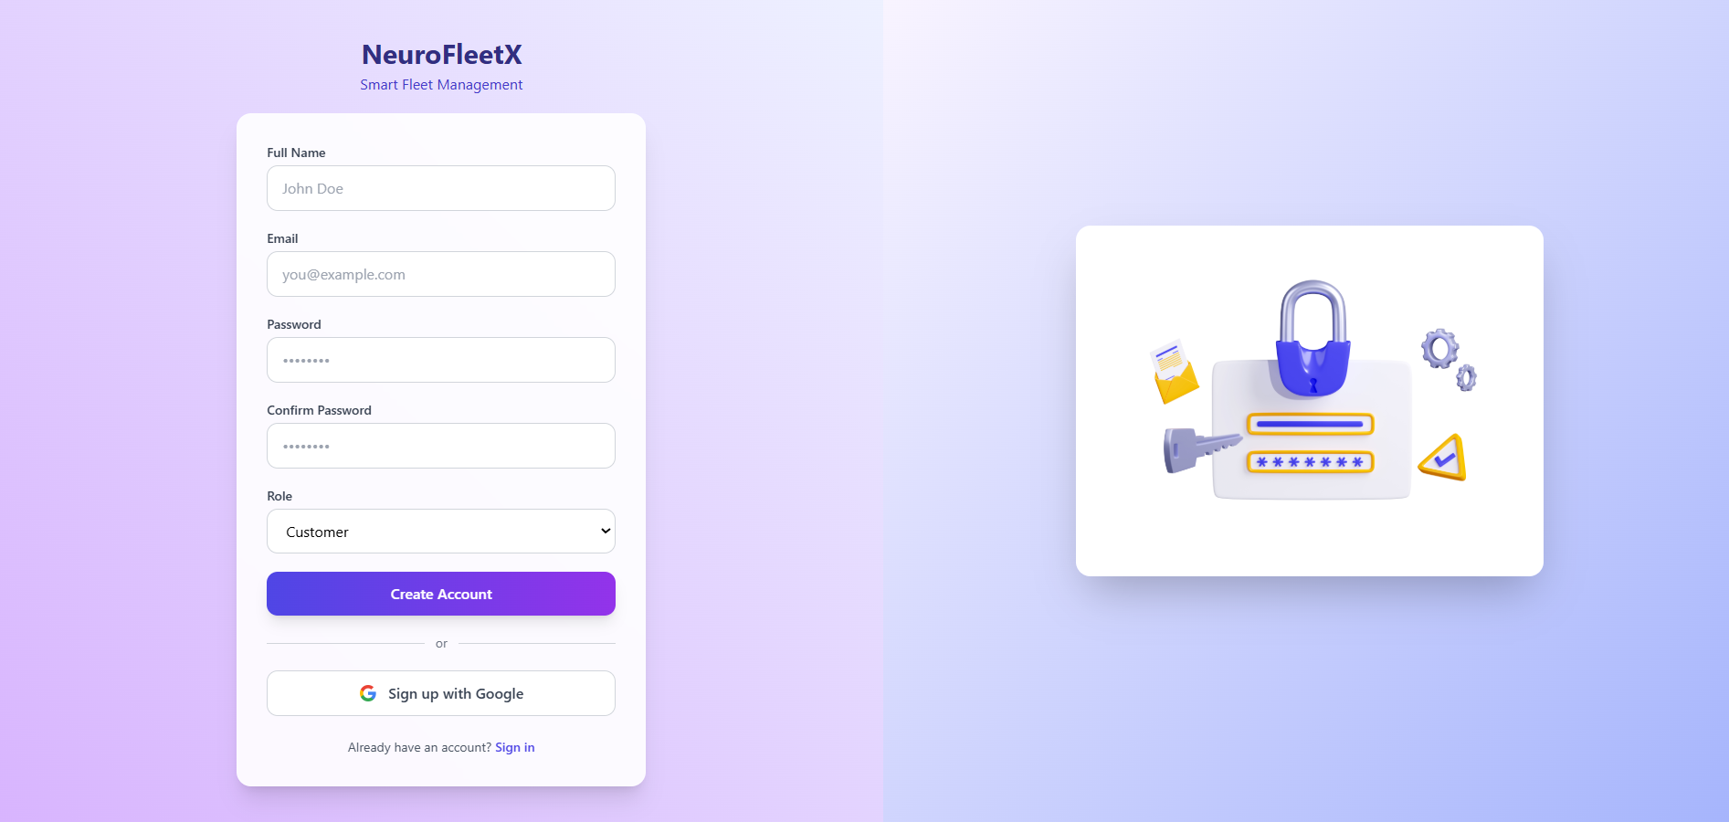
2. Sign In Page
This page enables registered users to securely log into the system. It also includes a “Sign in with Google” feature for faster authentication.
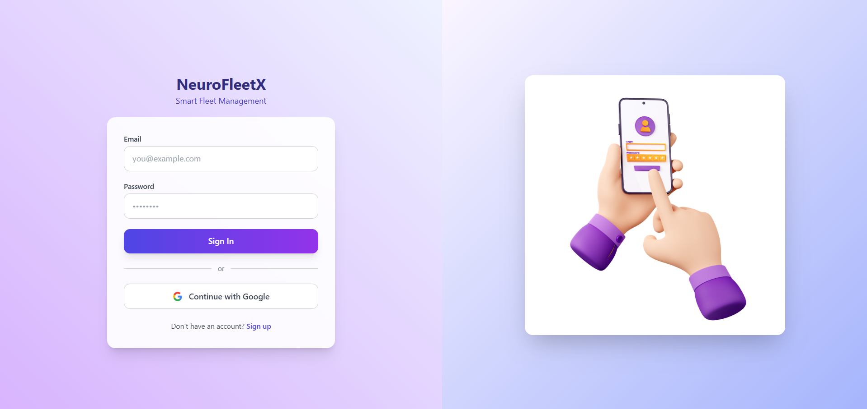

7. Challenges Faced
While working on the NeuroFleetX project, I faced some challenges during both backend and frontend development.
- Backend Integration Errors:
At first, I had some issues while connecting the Spring Boot backend with the MySQL database. The problem was mainly in the application.properties file, like wrong port and credentials. After checking the configurations properly, I was able to fix it.

- API Communication Issues:
When I started integrating the frontend with the backend, the APIs were not working properly. This happened because of wrong endpoint URLs and CORS errors. I solved it by correcting the routes and adding proper CORS setup in Spring Boot.

- Authentication Functionality:
While building the login and registration pages, it was a bit tough to manage password validation, role handling, and secure login. I went through a few debugging sessions and made changes in the code to fix the logic. I’m also working on improving JWT-based authentication.

- UI Design Consistency:
Designing the Sign In and Sign Up pages took some time to get the perfect look. I had to adjust the layout, spacing, and responsiveness several times. Using Bootstrap and CSS Flexbox helped me make the design cleaner and well-aligned.

- Time Management:
It was a bit difficult to manage project work along with college studies. I planned my tasks properly and completed Module 1 first (Authentication) before starting Module 2 (Fleet Inventory & Vehicle Telemetry).

8. Learnings & Skills Acquired
While working on the NeuroFleetX project, I learned and improved many technical as well as soft skills.
- Technical Skills:
  - Gained hands-on experience with Spring Boot, React.js, MySQL, and RESTful APIs.
  - Learned how to integrate frontend and backend smoothly using APIs.
  - Improved my understanding of authentication systems, role management, and database connectivity.
  - Enhanced my skills in HTML, CSS, JavaScript, and Bootstrap for creating responsive UI designs.
- Tools & Technologies:
  - Used GitHub for version control and team collaboration.
  - Worked with Postman for API testing and debugging.
  - Used VS Code and IntelliJ IDEA as main development environments.
- Soft Skills:
  - Improved time management and project planning by following a module-wise workflow.
  - Learned to debug issues efficiently and find solutions through research and testing.
  - Enhanced team communication and collaboration while discussing project progress and resolving errors.
- Domain Knowledge:
  - Understood how fleet management systems work in real-world scenarios.
  - Learned about vehicle tracking, telemetry, and role-based access systems.
Overall, this phase of the project helped me strengthen my full-stack development skills and understand how different technologies connect to build a complete web application.
.

9. Testimonials from team
Share your experience / success points

10. Conclusion
Summarize the overall experience, impact of the internship, and how it aligns with your academic or career goals.

11. Acknowledgements
Thank the organization, mentor, and any team members who supported your internship journey.

