QA Portal
Architecture, Data Model & Implementation Reference
System | QualityShield QA Portal
Scope | Frontend, API, database, storage, cache, security and workflows
Source baseline | Repository implementation as of 12 August 2026
Audience | Engineering, QA governance, DBA, operations and auditors

Document purpose
This document explains how the portal is assembled, how data moves through it, which database tables own each business capability, and which implementation constraints are significant for support, change control and production operation.
Important: This is a code-derived architecture baseline. Physical Oracle column types, constraints and execution plans should be confirmed against the deployed schema before production DDL or capacity decisions.

1. Executive architecture summary
QualityShield is a modular monolithic QA governance and test-management platform. The browser client is a single React application; FastAPI exposes domain-oriented REST routes; Oracle is the source of truth; Redis is an optional shared cache; uploaded evidence is stored on a persistent filesystem volume with metadata in Oracle.
- Primary business chain: QA intake → linked delivery workflow(s) → test project/repository → execution → defects → sign-off and reporting.
- Authorization combines JWT authentication, role checks, department scope, record ownership, assignment and workflow status.
- Business traceability is stored in ApprovalAction; platform/security activity is stored separately in AuditLog.
- Testcase identity is separated from version snapshots. TestCase is the stable key; TestCaseVersion and TestCaseVersionStep preserve revision history.
- The runtime is horizontally scalable at the API layer, but Oracle and the upload volume remain shared state; Redis coordinates cache consistency and selected startup work.
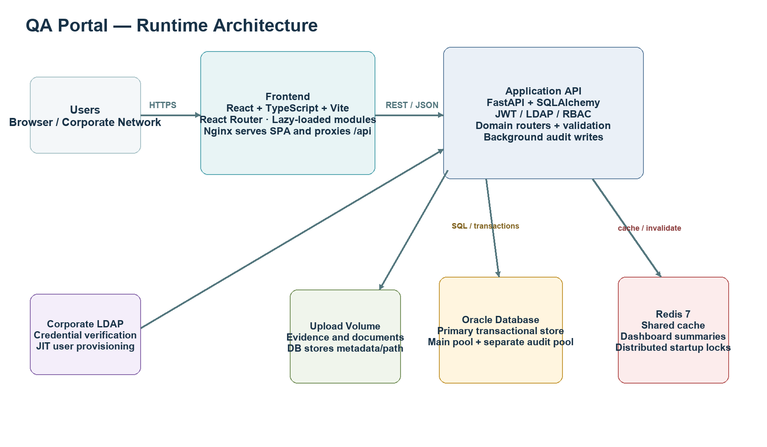
Figure 1. Runtime architecture and primary dependency flow.

2. Technology and deployment stack
Layer | Implementation | Responsibility | Significant behavior
Browser UI | React, TypeScript, Vite, React Router | Navigation, forms, dashboards, client validation | Lazy-loaded domain chunks; one protected layout persists across route changes.
Web edge | Nginx container | Serves built SPA; proxies /api | Frontend and API remain same-origin in Docker deployment.
Application API | FastAPI, Pydantic, SQLAlchemy | Business validation, workflow state, serialization | Multiple worker processes; synchronous DB sessions per request.
Primary data | Oracle via python-oracledb thin mode | Transactional system of record | Application refuses non-Oracle URLs; NUMBER(1) boolean semantics matter.
Cache | Redis 7 | Dashboard/reference caching and locks | Best-effort; requests continue when unavailable.
Files | Persistent upload volume | Evidence, attachments, comment images | DB contains metadata/path; backup must include both DB and volume.
Identity | Local users + optional corporate LDAP | Credential validation and JIT provisioning | JWT bearer token carries identity; DB provides current role/department state.

3. Component architecture and data flow

3.1 Frontend boundaries
App.tsx defines one authenticated shell and lazy-loads Functional, SAST, DAST, Suppression, Performance, Governance and Test Management modules. Shared components provide tables, badges, evidence, activity, identity signing and workflow decision panels. AuthContext owns session state; api.ts centralizes HTTP behavior.

3.2 API boundaries
Router / prefix | Primary responsibility | Principal tables
/api/auth | Login, LDAP JIT provisioning, users, roles | qap_users, qap_user_roles, qap_user_departments
/api/qa-requests | Gateway intake and linked workflow creation | qap_requests, qap_request_documents
/api/functional-requests | Functional lifecycle and tester assignment | qap_functional_requests, qap_readiness_checklist_items
/api/sast, /api/dast | Security workflows, targets/components/findings | qap_sast_*, qap_dast_*
/api/performance-requests | Performance lifecycle and tester assignment | qap_performance_requests, qap_performance_checklist_items
/api/suppressions | False-positive governance | qap_suppression_requests, qap_suppression_items
/api/test-projects | Project lifecycle and access | qap_test_projects, members, grants
/api/test-repository | Folders, cases, versions and approval | qap_test_folders, qap_test_cases, qap_test_case_versions
/api/test-execution | Cycles, assignments, runs and links | qap_test_cycles, qap_test_executions, qap_test_execution_runs
/api/defects | Defect workflow and traceability | qap_defects, qap_defect_case_links
/api/dashboard, reports | Cross-domain read models | Queries multiple domain tables; Redis cache
/api/approvals, audit, notifications | History, audit and user alerts | qap_approval_actions, qap_audit_logs, qap_notifications

3.3 Request transaction sequence
1. React sends bearer-authenticated REST request.
2. FastAPI middleware assigns/carries X-Request-ID and starts timing.
3. Dependency resolves JWT identity and eagerly loads role/department memberships.
4. Router enforces role, department, ownership, assignment and valid status transition.
5. SQLAlchemy writes domain records plus ApprovalAction/Notification in a transaction.
6. Response returns; middleware invalidates affected dashboard cache prefixes.
7. Background audit task writes AuditLog using the separate audit connection pool.
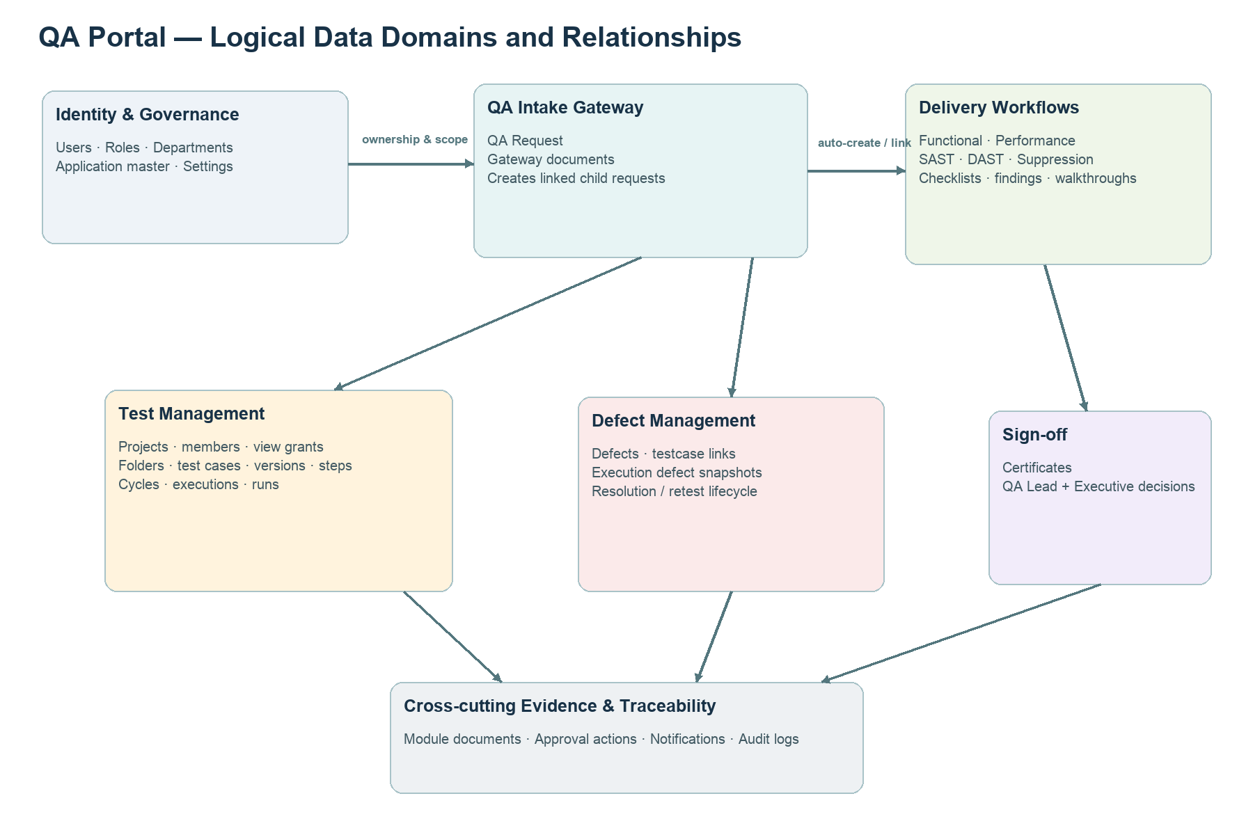
Figure 2. Logical data domains and major relationship directions.

4. Core business workflows

QA intake gateway
Draft request captures application/change context and requested service types. On raise, linked Functional, SAST, DAST and/or Performance child requests are synchronized. Application-name governance can block or return downstream approval.

Functional delivery
SM and Department Head approval → QA lead readiness → planning/tester assignment → design/execution → defect/retest → QA completion/sign-off → requester verification.

Security testing
SM and Department Head approval → Security Lead readiness → analyst configuration/scanning → finding validation/remediation/rescan → report ready/closed. SAST components and DAST targets/findings remain child records.

Performance testing
Business approvals → QA readiness/feasibility → planning and tester assignment → environment/script/baseline/load execution → analysis → defect-fix-retest → report/sign-off/requester verification.

Test repository
Stable TestCase owns project/folder identity. Each edit/review cycle occurs on TestCaseVersion. Reviewer and QA management decisions are stored on the version and mirrored to TestCase for list compatibility.

Execution and defects
TestCycle contains TestExecution slots. TestExecutionRun preserves attempts. Failed/blocked outcomes link to Defect; governed defect statuses control retest and lifecycle gates.

5. Database design principles
- Oracle identity-safe primary keys are used through a shared pk helper; business IDs are generated separately.
- Foreign keys express core ownership, while selected cross-module records use module/entity identifiers for polymorphic activity and documents.
- Testcase revision data is immutable after governance decisions; a new draft is created from an approved or rejected baseline.
- Current assignment fields are retained on completed requests and support workload/history reporting, but explicit reassignment history is carried by ApprovalAction rather than a dedicated assignment-history table.
- Shared document bytes are not BLOBs. qap_module_documents stores metadata and relative paths into the persistent upload volume.
- Oracle schema evolution is not Alembic-managed. create_all creates missing objects only; existing deployments require reviewed manual ALTER/INDEX scripts.

6. Complete table catalog

Identity & configuration
Table | ORM model | How it is used | Significant columns | Foreign-key targets
qap_id_counters | IdCounter | IdCounter domain record. | prefix, counter_date, next_value | —
qap_users | User | Local identity/profile, login type, activation and provisioning state. | id, username, full_name, email, department, login_type, hashed_password, is_active … | —
qap_user_roles | UserRole | Many-to-one role assignments used by RBAC checks. | id, user_id, role | qap_users.id
qap_user_departments | UserDepartment | Multi-department membership used for visibility and approval scope. | id, user_id, department, created_at | qap_users.id
qap_departments | Department | Canonical department master and active-state control. | id, name, is_active, created_at | —
qap_system_settings | SystemSetting | SystemSetting domain record. | id, key, value, updated_at | —
qap_application_master | ApplicationMaster | Governed application-name registry and owner/SM approval state. | id, name, status, department, requested_by_id, qa_request_id, app_owner_decided_by_id, app_owner_decided_at … | qap_users.id, qap_requests.id, qap_users.id, qap_users.id

QA intake & functional
Table | ORM model | How it is used | Significant columns | Foreign-key targets
qap_requests | QARequest | QA intake gateway; request types, requester context, and parent for child workflows. | id, request_id, request_date, department, application_name, application_owner, cr_number, epic_number … | qap_users.id, qap_application_master.id
qap_request_documents | QARequestDocument | Legacy/dedicated QA gateway evidence metadata. | id, qa_request_id, file_name, stored_path, content_type, file_size, uploaded_by_id, uploaded_at | qap_requests.id, qap_users.id
qap_functional_requests | FunctionalRequest | Functional/Sanity/Regression/UAT child workflow and tester assignment. | id, request_id, status, needs_dept_head_reapproval, priority, risk_rating, requester_id, department_head_id … | qap_users.id, qap_users.id, qap_users.id, qap_signoffs.id, qap_requests.id
qap_readiness_checklist_items | ReadinessChecklistItem | ReadinessChecklistItem domain record. | id, functional_request_id, item, owner, is_mandatory, requester_checked, is_complete, approved_by_id … | qap_functional_requests.id, qap_users.id
qap_walkthrough_sessions | WalkthroughSession | WalkthroughSession domain record. | id, functional_request_id, session_date, conducted_by, participants, recording_path, document_path, qa_acknowledged_by_id … | qap_functional_requests.id, qap_users.id

Security & performance
Table | ORM model | How it is used | Significant columns | Foreign-key targets
qap_sast_requests | SASTRequest | Static security request, security lead/analyst ownership and lifecycle. | id, request_id, application_name, epic_number, cr_number, risk_category, priority, source_code_path … | qap_users.id, qap_users.id, qap_users.id, qap_requests.id
qap_sast_components | SASTComponent | SASTComponent domain record. | id, sast_request_id, repository_url, git_branch, commit_id, technology_stack, build_number | qap_sast_requests.id
qap_sast_findings | SASTFinding | SASTFinding domain record. | id, sast_request_id, issue_id, severity, description, status | qap_sast_requests.id
qap_sast_checklist_items | SASTChecklistItem | SASTChecklistItem domain record. | id, sast_request_id, item, owner, is_mandatory, requester_checked, is_complete, approved_by_id … | qap_sast_requests.id, qap_users.id
qap_sast_walkthroughs | SASTWalkthrough | SASTWalkthrough domain record. | id, sast_request_id, session_date, conducted_by, participants, recording_path, document_path, qa_acknowledged_by_id … | qap_sast_requests.id, qap_users.id
qap_dast_requests | DASTRequest | Dynamic security request, security lead/analyst ownership and lifecycle. | id, request_id, risk_category, priority, supporting_docs_path, status, needs_dept_head_reapproval, requester_id … | qap_users.id, qap_users.id, qap_users.id, qap_requests.id
qap_dast_targets | DASTTarget | DASTTarget domain record. | id, dast_request_id, application_url, environment, authentication_required, test_credentials | qap_dast_requests.id
qap_dast_checklist_items | DASTChecklistItem | DASTChecklistItem domain record. | id, dast_request_id, item, owner, is_mandatory, requester_checked, is_complete, approved_by_id … | qap_dast_requests.id, qap_users.id
qap_dast_findings | DASTFinding | DASTFinding domain record. | id, dast_request_id, issue_id, severity, description, status | qap_dast_requests.id
qap_dast_walkthroughs | DASTWalkthrough | DASTWalkthrough domain record. | id, dast_request_id, session_date, conducted_by, participants, recording_path, document_path, qa_acknowledged_by_id … | qap_dast_requests.id, qap_users.id
qap_performance_requests | PerformanceRequest | Performance-testing workflow and multi-tester assignment. | id, request_id, application_name, epic_number, cr_number, tool_used, target_load, environment … | qap_users.id, qap_users.id, qap_requests.id
qap_performance_checklist_items | PerformanceChecklistItem | PerformanceChecklistItem domain record. | id, performance_request_id, item, data_required, is_mandatory, requester_checked, is_complete, approved_by_id … | qap_performance_requests.id, qap_users.id
qap_checklist_template_items | ChecklistTemplateItem | ChecklistTemplateItem domain record. | id, module, item, detail, is_mandatory, sort_order, active, created_at … | —
qap_performance_walkthroughs | PerformanceWalkthrough | PerformanceWalkthrough domain record. | id, performance_request_id, session_date, conducted_by, participants, recording_path, document_path, qa_acknowledged_by_id … | qap_performance_requests.id, qap_users.id
qap_suppression_requests | SuppressionRequest | False-positive/suppression approval workflow. | id, suppression_id, application_name, scan_type, department, application_owner, sast_request_id, dast_request_id … | qap_sast_requests.id, qap_dast_requests.id, qap_users.id, qap_users.id, qap_users.id
qap_suppression_items | SuppressionItem | SuppressionItem domain record. | id, suppression_request_id, issue_id, severity, description, justification | qap_suppression_requests.id
qap_suppression_walkthroughs | SuppressionWalkthrough | SuppressionWalkthrough domain record. | id, suppression_request_id, session_date, conducted_by, participants, recording_path, document_path, qa_acknowledged_by_id … | qap_suppression_requests.id, qap_users.id

Governance & evidence
Table | ORM model | How it is used | Significant columns | Foreign-key targets
qap_approval_actions | ApprovalAction | Entity-neutral business activity timeline: decisions, comments, documents and state transitions. | id, entity_type, entity_id, step_name, actor_id, actor_role, decision, comments … | qap_users.id
qap_notifications | Notification | Per-user in-app notification queue and read state. | id, recipient_id, event_type, entity_type, entity_id, entity_key, message, created_by_id … | qap_users.id, qap_users.id
qap_audit_logs | AuditLog | Request/security audit record written through the dedicated audit pool. | id, event_type, action, outcome, actor_id, actor_username, actor_name, actor_roles … | qap_users.id
qap_module_documents | RequestDocument | Shared document metadata keyed by module and entity/item ID; file bytes live on upload volume. | id, module, request_id, file_name, stored_path, content_type, file_size, uploaded_by_id … | qap_users.id
qap_signoffs | QASignOff | QA sign-off certificate and two-stage governance decisions. | id, certificate_id, certificate_date, certificate_type, testing_type, testing_request_id, change_request_ids, application_name … | qap_users.id, qap_users.id, qap_users.id, qap_users.id, qap_users.id

Test management
Table | ORM model | How it is used | Significant columns | Foreign-key targets
qap_test_projects | TestProject | Test-management container, defaults, lifecycle and access policy. | id, project_key, name, application_master_id, department, description, is_active, owner_id … | qap_application_master.id, qap_users.id, qap_users.id, qap_users.id, qap_users.id
qap_test_project_members | TestProjectMember | Project membership/role mapping. | id, project_id, user_id, project_role, added_by_id, added_at | qap_test_projects.id, qap_users.id, qap_users.id
qap_test_project_view_grants | TestProjectViewGrant | Additional read-only project access. | id, project_id, department, user_id, granted_by_id, created_at | qap_test_projects.id, qap_users.id, qap_users.id
qap_test_folders | TestFolder | Repository hierarchy within a test project. | id, project_id, parent_id, name, created_by_id, created_at | qap_test_projects.id, qap_test_folders.id, qap_users.id
qap_test_cases | TestCase | Stable testcase identity and mirror of the current draft/approved snapshot. | id, test_case_key, project_id, folder_id, epic_id, cr_number, feature_id, user_story_id … | qap_test_projects.id, qap_test_folders.id, qap_test_case_versions.id, qap_test_case_versions.id, qap_users.id
qap_test_case_tags | TestCaseTag | TestCaseTag domain record. | id, test_case_id, tag | qap_test_cases.id
qap_test_steps | TestStep | Current/legacy testcase step representation. | id, test_case_id, step_no, step_text, expected_result | qap_test_cases.id
qap_test_case_versions | TestCaseVersion | Immutable/versioned testcase content and approval state. | id, test_case_id, version_major, version_minor, status, epic_id, cr_number, feature_id … | qap_test_cases.id, qap_users.id, qap_users.id, qap_users.id, qap_users.id
qap_test_case_version_steps | TestCaseVersionStep | Version-specific immutable test steps. | id, version_id, step_no, step_text, expected_result | qap_test_case_versions.id
qap_test_cycles | TestCycle | Execution cycle header linked to a project. | id, cycle_key, project_id, name, description, status, start_date, end_date … | qap_test_projects.id, qap_users.id, qap_users.id
qap_test_cycle_child_links | TestCycleChildRequestLink | Links a cycle to Functional/SAST/DAST/Performance child requests. | id, cycle_id, child_type, child_id, child_key | qap_test_cycles.id
qap_test_executions | TestExecution | One testcase slot in a cycle, assignment and current execution result. | id, cycle_id, test_case_id, pinned_version_id, status, actual_result, test_run_artifacts, defect_id … | qap_test_cycles.id, qap_test_cases.id, qap_test_case_versions.id, qap_users.id, qap_users.id
qap_test_execution_runs | TestExecutionRun | Append-only execution attempts and evidence context. | id, execution_id, attempt_no, status, actual_result, test_run_artifacts, defect_id, executed_by_id … | qap_test_executions.id, qap_users.id

Defects
Table | ORM model | How it is used | Significant columns | Foreign-key targets
qap_test_run_defects | TestRunDefect | Execution-facing defect snapshot/link for run-level gates and reporting. | id, run_id, defect_key, defect_url, title, defect_status, notes, linked_by_id … | qap_test_execution_runs.id, qap_users.id
qap_defects | Defect | Governed defect identity, ownership, resolution/retest and terminal outcomes. | id, defect_key, title, description, status, qa_request_id, cycle_id, primary_test_case_id … | qap_requests.id, qap_test_cycles.id, qap_test_cases.id, qap_test_executions.id, qap_users.id
qap_defect_case_links | DefectTestCaseLink | Many-to-many defect-to-testcase traceability. | id, defect_id, test_case_id | qap_defects.id, qap_test_cases.id

7. High-significance table relationships
Parent / anchor | Child / dependent | Relationship and usage
qap_requests | functional/sast/dast/performance requests | One gateway may create one or more specialized child workflows; qa_request_id preserves traceability.
qap_test_projects | folders, cases, cycles, members, view grants | Project is the access and organizational boundary for test management.
qap_test_cases | test_case_versions | Stable logical identity to many version snapshots; current draft/approved pointers select active content.
qap_test_case_versions | test_case_version_steps | Each snapshot owns its own ordered steps; comparison is version-to-version.
qap_test_cycles | qap_test_executions | A cycle contains testcase execution slots and assignment/result state.
qap_test_executions | qap_test_execution_runs | Current slot to append-only attempts; supports evidence and historical outcomes.
qap_defects | qap_defect_case_links / qap_test_run_defects | Defect traces to cases and execution context; snapshot table supports execution gates/reporting.
Any governed entity | qap_approval_actions | Polymorphic entity_type/entity_id activity timeline; no database FK by design.
Any module/item | qap_module_documents | Polymorphic module/request_id metadata; physical file stored outside Oracle.
qap_users | roles, departments, assignments, actions | User identity is referenced by governance, ownership, assignments, audit and notifications.

8. Testcase versioning in detail
TestCase is the durable record and human-readable key. TestCaseVersion stores the governed content snapshot, version numbers, review decisions and author/approver assignments. TestCaseVersionStep stores the steps belonging to that exact snapshot.
- Minor approval increments the minor component: 1.9 → 1.10.
- Major approval is explicitly selected at final QA approval and requires justification: 1.9 → 2.0.
- Only the newest version is current in the UI; older history is displayed as Superseded without destroying its original decision metadata.
- Version comparison reads two snapshots and returns changed content fields plus added, removed or modified steps.
- Approved/rejected history is governed and cannot be hard-deleted through normal repository operations.

9. Security and authorization model
Control | Implementation | Important consequence
Authentication | JWT bearer token; local password or LDAP verification | API reloads the active user, roles and departments; disabling a user takes effect independently of token claims.
Authorization | Role constants plus endpoint dependencies and inline business checks | UI gating is advisory; backend remains authoritative.
Department scope | Multi-department membership and dashboard_department_scope | Business users see their departments; QA/executive roles have deliberate organization-wide review visibility.
Self-approval prevention | Requester/author identity checked at decision points | Prevents a person approving their own governed record unless explicit admin bypass applies.
Assignment control | Current assignee/lead/tester plus lifecycle status | Who can act changes with workflow stage and assignment.
Confidential roles | Redacted from non-admin user-list serialization | Sensitive access role is not exposed in ordinary pickers/API responses.
Request audit | Correlation ID, status, duration, actor snapshot | Supports operational investigation without mixing with business workflow activity.

10. Documents, evidence and rich content
Gateway evidence uses qap_request_documents. Most other modules use qap_module_documents through shared helpers. The module value distinguishes request-level, checklist-item, defect and comment-image records. Files are written below the configured upload root using request-first folders and collision-safe names.
- Database backup alone is insufficient; restore requires a consistent upload-volume backup.
- Deleting metadata without deleting bytes creates orphans; deleting bytes without metadata produces broken downloads.
- Document authorization is workflow-stage-specific and enforced by each router before shared storage helpers are invoked.
- Uploads/removals may append ApprovalAction entries so evidence changes are visible in the business timeline.

11. Audit, notifications, cache and observability
Facility | Data/store | Behavior
Business activity | qap_approval_actions | Human-readable workflow decisions, state changes, comments and document events.
Platform audit | qap_audit_logs via AuditSessionLocal | Background request/security audit using a separate Oracle pool.
Notifications | qap_notifications | Per-recipient events linked to entity type/id and read state.
Cache | Redis qa_portal:* namespace | JSON caches and prefix invalidation; cache failure becomes a miss, not a request failure.
Health | /api/health | Checks Oracle live and reports last-known Redis availability.
Correlation | X-Request-ID / X-Audit-Request-ID | Connects client-visible failures to persisted request audit and logs.
Timing | Server-Timing header | Returns application duration for browser/edge diagnosis.

12. Deployment and capacity considerations
- Docker Compose runs Nginx frontend, multi-worker FastAPI backend and Redis. Oracle is external/reachable through DATABASE_URL.
- Connection pools are per worker. Maximum potential sessions are approximately workers × (pool_size + max_overflow), plus the separate audit pools. Tune against Oracle PROCESSES/SESSIONS limits.
- The upload volume must be shared by every API replica. A node-local volume is unsafe for horizontal scaling unless requests remain sticky and failover limitations are accepted.
- Redis is optional for correctness but required for cross-worker cache coherence and reliable distributed startup locks.
- DB_QUERY_TIMEOUT_MS sets python-oracledb call_timeout. Validate reporting workloads before reducing it.
- Trusted proxy CIDRs must match the actual reverse-proxy network so client IP audit data cannot be spoofed.

13. Significant risks and recommended controls
Priority | Risk / limitation | Why significant | Recommended control
High | Manual Oracle migrations | create_all does not alter existing tables; code/schema drift can cause runtime failures. | Maintain ordered migration scripts, schema-version table, pre-deploy diff and rollback plan.
High | DB and file backup consistency | Evidence bytes and metadata are separate stores. | Snapshot Oracle and upload volume under one recoverable backup procedure; test restores.
High | Pool multiplication by workers | Default pool settings can exceed Oracle session limits. | Capacity-test and calculate aggregate main + audit sessions before scaling workers.
Medium | Assignment history is indirect | Current assignment fields identify the latest roster; reassignment history is encoded in ApprovalAction text/events. | Introduce a normalized assignment-history table if contractual time-on-task or precise historical reporting is required.
Medium | Polymorphic entity references | ApprovalAction and RequestDocument cannot use conventional FKs across many entity types. | Centralize module/entity constants; add integrity audit jobs for orphan detection.
Medium | Status strings across modules | Many workflows use string states and mirrored frontend constants. | Add automated parity/state-machine tests and consider database check constraints where safe.
Medium | Redis degradation is silent by design | Correctness remains, but latency and duplicate startup work may rise. | Alert on cache availability and cache miss rates; document degraded mode.
Low | TestCase mirror duplication | TestCase mirrors current version content for compatibility. | Keep all mutations through repository helpers and add consistency checks.

14. Change-impact guide
Change type | Inspect first | Also verify
Add workflow status | backend constants/router transitions | Frontend constants, badges, filters, dashboards, terminal-state logic, notifications.
Add database column | ORM model + Oracle migration script | Pydantic schema, TypeScript type, create/edit/detail UI, exports, audit snapshots.
Add attachment category | documents.py module key and authorization | Upload path, qap_module_documents, activity logging, backup/retention.
Change assignment | Domain assignment endpoint | Reassignment authorization, change detection, ApprovalAction, workload dashboard.
Change testcase versioning | TestCaseVersion creation/approval helpers | Mirror synchronization, compare API, cycle pinning, deletion governance.
Add dashboard metric | Scoped query and cache key | Department scope, invalidation module list, date filter semantics, index needs.
Scale API workers | WEB_CONCURRENCY | Aggregate Oracle sessions, Redis locks, shared uploads, background audit pool.

15. Operational verification checklist
- Health endpoint reports Oracle reachable and expected Redis state.
- Schema migration scripts have been applied and verified against the target Oracle schema.
- Aggregate main/audit connection ceiling is within Oracle capacity.
- Upload volume is mounted, writable, backed up and shared across replicas.
- LDAP, local login, disabled-user and JIT department-selection paths are tested.
- Role/department/self-approval scenarios are validated with representative users.
- Core state transitions are tested for Functional, SAST, DAST, Performance, Test Repository, Execution and Defects.
- Audit correlation ID can be traced from response header to application log and qap_audit_logs.
- Dashboard cache invalidates after successful domain writes.
- Testcase version history, Superseded display and two-version comparison are verified.

Appendix A. Source map
Area | Primary source files
Application composition | frontend/src/App.tsx, frontend/src/components/Layout.tsx
Shared UI/workflow controls | frontend/src/components/Common.tsx
API composition and middleware | backend/app/main.py
Database engines and pools | backend/app/database.py
ORM/data model | backend/app/models.py
Schemas/contracts | backend/app/schemas.py, frontend/src/types.ts
Authentication and scope | backend/app/auth.py, backend/app/deps.py, backend/app/routers/auth.py
Caching | backend/app/cache.py
Evidence storage | backend/app/documents.py, backend/app/storage_config.py
Domain routes | backend/app/routers/*.py
Deployment | docker-compose.yml, frontend/nginx.conf, backend/Dockerfile, frontend/Dockerfile
Oracle change history | backend/ORACLE_MIGRATION_2026-07.md and backend/*.sql

Appendix B. Interpretation notes
“Uses” in the table catalog means application ownership inferred from ORM definitions and route behavior, not observed production query frequency. The repository contains extensive migration commentary; this document summarizes the current implementation rather than reproducing historical change notes. Generated on 12 August 2026.

