**Drupal 8 Custom Module Development**

**June, 2018**

|  |  |  |  |
| --- | --- | --- | --- |
| Document No. | 1 | Ver. Rev. : | 1.0 |
| Authorized by: | Soumyajit Banerjee | Signature/:  Date: | 12th June 2018 |

**Author(s):** Soumyajit Banerjee

**Date written (MM/DD/YY):** 05/06/2018

**Project Details**

•         S/W Environment: Drupal 8, MySQL, PHP

•         Application Type: CMS

•         Project Type: Custom Module Development

**Target readers**

Drupal developers

**Keywords**

Drupal, Drupal 8, Custom Module, Block, Form, Page

Custom Form, Block & page creation using Drupal 8

**Introduction**

In the fast – moving world, the complicated things are made simple for the ease of access and maintenance, be it, a mobile communication to the robotic assembly of auto – mobiles.

Drupal is one such thing that makes the development and maintenance of the websites handy. Having its first official release on **18, May, 2000**, by Dries Buytaert, Drupal, (previously called Druppel), was used to develop light – weight portals for forums where people could communicate mainly on social issues in the US. However, it gained its popularity by 2013.

This document helps to custom module creation in Drupal 8

**Why Needed?**

It’s time to start learning D8 module development. Module development in Drupal 8 represents a major shift from Drupal 7. The module that we create in this tutorial is as simple as it can be and is aimed at helping you get a feel for the module structure.

***What’s new in Drupal 8:***

Before started, let’s touch on some of the major differences with Drupal 7 module development. Below is a list of concepts:

* Drupal 8 is object oriented and Drupal 7 is primarily procedural. That means a lot of your code will now be in classes rather than simple functions. This is going to be overwhelming for many, but will certainly make module development more flexible and you will upgrade your skills to modern programming practice in the process
* Drupal 8 uses **Symfony** framework meeting out the main purpose of OO Programming, **reusability**. With the help of the tools provided by Symfony, the most common functionalities can be reused. The use of Symfony framework has enforced the architecture to be in the **MVC format**. The Model – View – Control pattern helps the architecture to have the HTTP framework that has the optimized way of responses.
* Each class will need a namespace. Name spacing ensures that your class does not conflict with another class of the same name. You can think of it like a directory in a file system. You can have two files with the same name in different directories.
* Drupal 8 uses .yml files instead .info files. .yml files are also used to define menu items, tabs etc.
* You don’t need to use hook_menu() to map a URL to a callback function. This is now taken care of by a menu class and a route.
* Drupal 8 uses PHP annotations. Annotations are included in PHP comments and hold vital information about a class. The Drupal 8 plugin system uses them to describe plugins and they are used by Drupal to discover your plugin.

**Methodology:**

1. **Basic step custom module creation**:
2. Need to create module folder: In Drupal7, core modules go in the /modules directory and you should put your custom and contrib modules in the sites/all/modules directory or sites/sitename/modules directory. In D8, core modules go into the /core directory so you can put your contrib and custom modules in the /modules directory.

Create the directory called “development” inside the /modules directory.

D:\drupal doc\Capture.PNG

1. Need to create .info.yml file inside our module directory. It’s like drupal 7 info file. We need to mentioned module name, description, core version.

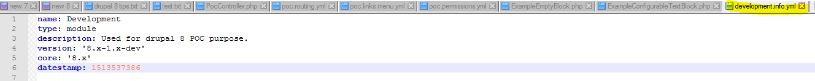

1. Need to create development.module file. But in this case leave it blank.
2. Then goto drupal 8 backend & open the module listing page(/admin/modules). Then you can see our custom module.

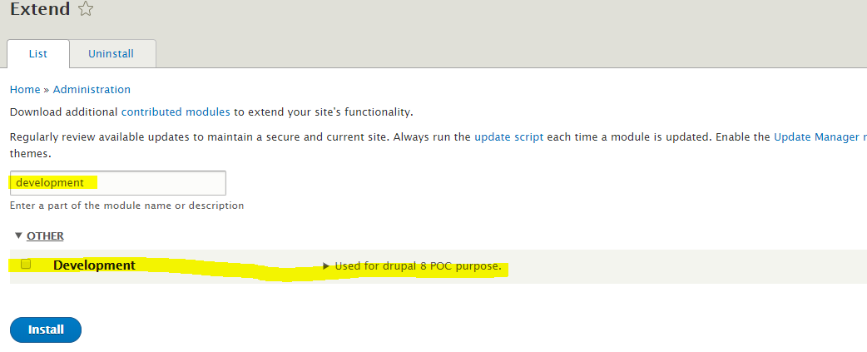

Those are the basic steps for custom module creation.

1. **Create Custom pages**:

Now we will describe how to create pages. In drupal 8 we don’t need to use hook_menu.

1. Create “src” folder into your module, then create “controller” under the src.

D:\drupal doc\Capture4.PNG

1. We need to create controller class. For this module we have created controller “DevelopmentController.php”.

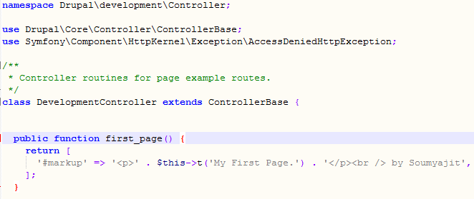

**Namespace** : This declares the prefix needed to fully qualify the name of the class we are defining.

\Drupal\development\Controller\DevelopmentController, it should look for the file modules/development/src/Controller/DevelopmentController.php

**Use** : This allows us to use ControllerBase instead of the fully qualified name

**first_page** : The method specified in the YAML file must be public. It should return a renderable array.

1. We need to create routing.yml into our custom module directory and then define page alias using routing.yml. It’s like hook_menu in D7. In our example we have created “development.routing.yml”, looks like that.

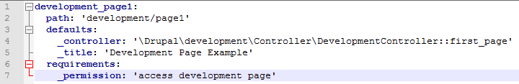

In this example development_page1 is machine name, path are using for page alias. Controller area we need to define method using controller name space::method name. Permission are used for page restriction pupose.

1. If you want to restrict this page permission wise, then you need to create “development.permissions.yml” in your custom module directory. Permission file like that :

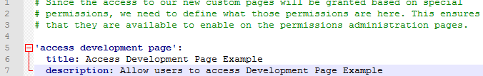

When you goto “admin/people/permissions”, then you can see page permission



1. After enable module you can see the page like that(“/development/page1”)

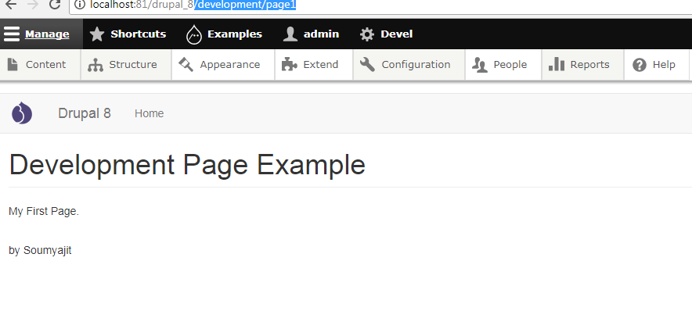

Our custom module directory like that :

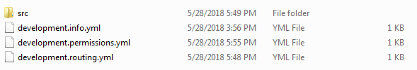

1. **Create Custom block**:

Now we will describe how to create custom block with form.

1. Before starting custom block creation you need to add dependency into the .info.yml

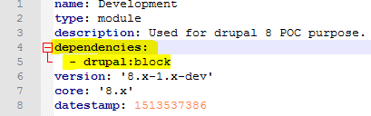

1. Need to create folder into the “src” directory, like that (/src/Plugin/Block/)
2. Create class into the “Block” directory. The class name and the file name must be the same ( class DevelopmentBlock and /src/Plugin/Block/ DevelopmentBlock.php). If the class name is different, the block will appear in the list of available blocks. It looks like that

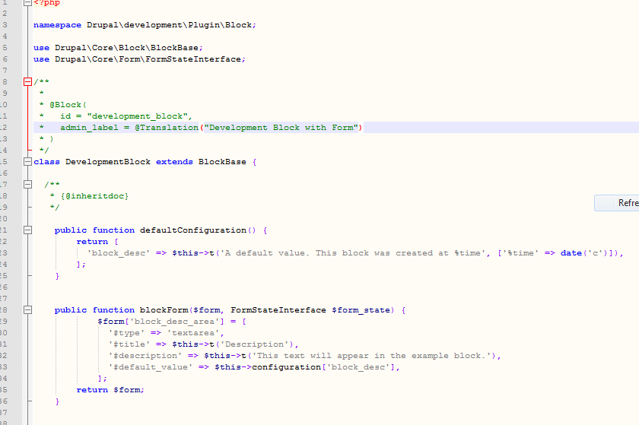

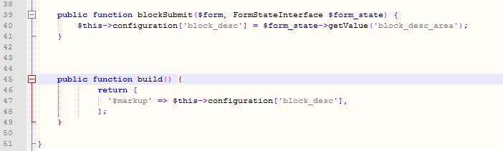

As usual we need to define namespace, then need to define blockbase & form using the “use” keyword. After that we need to define our custom block id & label. In this example we set *id = "development_block" & admin_label = @Translation("Development Block with Form")*. After that we need to define class name “DevelopmentBlock”.

**defaultConfiguration** function: It’s used for set default value. It’s looks like D7 variable set.

**blockForm** function: Used for create custom configuration form for block configuration. In this example we have define one text area field for setting block display value.

**build** function: This function used for set & display value into the block.

1. After saving block class file we need to clear cache(If module already enable otherwise we need to just enable) & goto “admin/structure/block”.

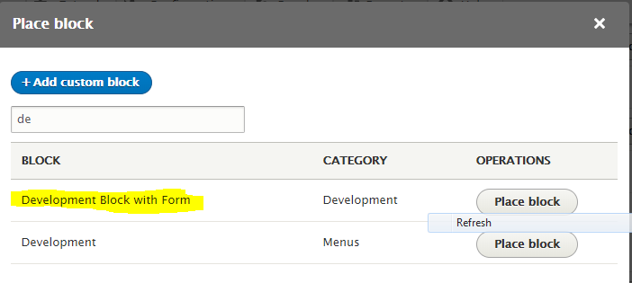

After clicking place block, form will be open. It looks like that.

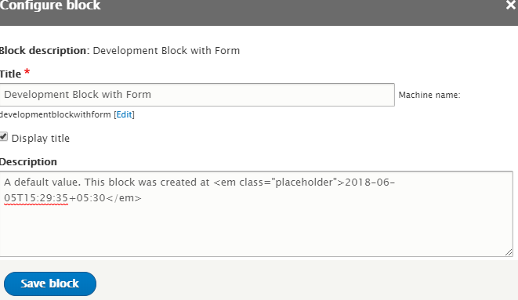

In this way you can create your own custom drupal 8 module.

**Reference(s)**

*http://www.drupal.org*

*https://www.drupal.org/docs/8/creating-custom-modules*