Software Requirements Specification
for
Cook This Not That !!
Version 1.0 approved
Prepared by IMT2016057, IMT2016053

IIITB CTNT

30th November 2018
Table of Contents
Table of Content
Revision History
1. Introduction
1.1 Purpose
1.2 Document Conventions
1.3 Intended Audience and Reading Suggestions
1.4 Product Scope
2. Overall Description
2.1 Product Perspective
2.2 Product Functions
2.3 User Classes and Characteristics
2.4 Operating Environment
2.5 Design and Implementation Constraints
2.6 User Documentation
2.7 Assumptions and Dependencies
3. External Interface Requirements
3.1 User Interfaces
3.2 Hardware Interfaces
3.3 Software Interfaces
3.4 Communications Interfaces
4. Other Nonfunctional Requirements
4.1 Performance Requirements
4.2 Safety Requirements
4.3 Security Requirements
4.4 Software Quality Attributes
4.5 Business Rules
5. Future Scope

Appendix A: User Stories
Appendix B: Analysis of models

Revision History
Name | Date | Reason For Changes | Version

1 Introduction

Purpose
The purpose of the document is to provide an overall description of the software application, as well as it will illustrate the complete declaration for development of the system. It also explains, system constraints, interface, and interactions with other external applications. This document detail the system's specific requirements, functional and non-functional requirements, database design, standard compliance, system attributes such as reliability, availability, security, maintainability, etc.
This document should act as a foundation for efficient and well-managed project completion and further serve as an accurate reference in the future.

Document Conventions
Customer/ User: Person who visits and uses the website.
CookThisNotThat Admin: Person who manages the website.
Ingredient checkbox: For selecting ingredients among given ingredients.
Submit Ingredients: This is a button used for stating you are done with ingredient selection.
Recipe checkbox: For selecting recipe among displayed recipes.
Submit recipe: This is a button used for stating you are done with recipe selection.

Intended Audience and Reading Suggestions
This SRS document is intended for stakeholders and the systems engineers, analysts, designers, testers, maintenance and the users themselves in particular. Also to the development team who manage and develop the software.

Product Scope
At home and feeling hungry, many of times we have limited ingredients but don't what you can make out of them. So our website will come in handy such situations. It will suggest with the recipes using what you ALREADY have in your kitchen.

This application will maintain a list of ingredients where you can select them and there will display the list of all possible recipes with those ingredients. Once you select a recipe, all related information regarding that recipe like direction, time etc will be displayed.

Overall Description

Product Perspective
This system is based on a web application. This application consists of the user(customer) interface.
The customer interface consists of all the ingredients to select, once the ingredients are selected it redirects to another page displaying all possible recipes with the selected ingredients. After selecting a specific recipe from those it again redirects to page showing recipe details.
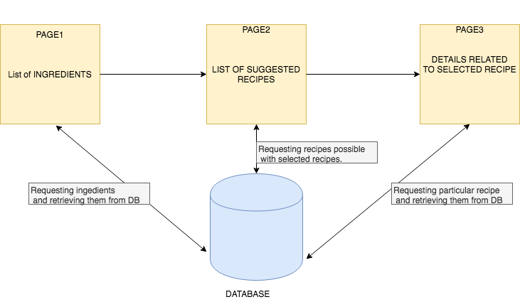

2.2 Product Functions
- Display Ingredients.
- Select ingredient.
- Display Recipes with selected ingredients.
- Select a particular ingredient.
- Display ingredient details

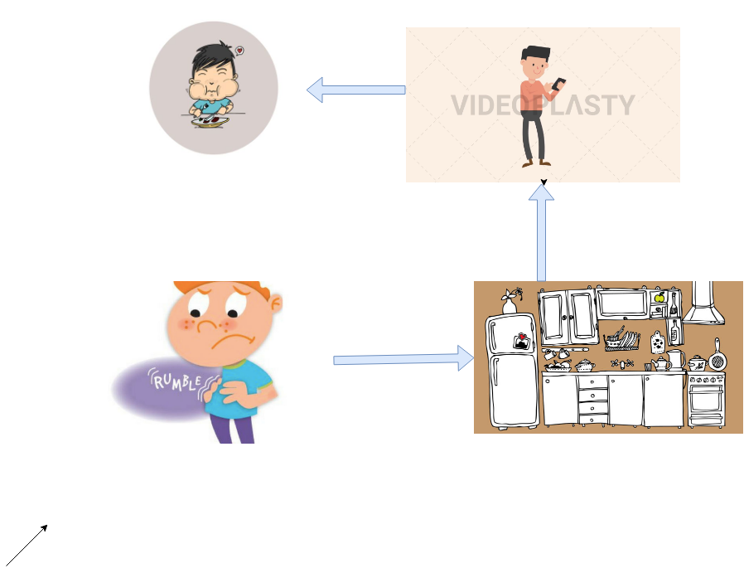

2.3 Operating Environment
Software: A browser with the internet.
This Application is a web-based application. The user should have a computer or a mobile with a browser installed on their devices.

2.4 Design and Implementation Constraints
- Must have a browser to access this web application.
- Memory Requirements: Sufficient memory to manage the browser application.
- Tools: Should have installed Apache Server, MySQL, PHP.
- Database: Accessed using MySQL language.
- Interface To other Apps: Browser.
- Language Requirements: Knowledge of MySQL, PHP.
- Connectivity: Should be able to connect to the Internet.

2.5 User Documentation
It will provide the user about specific guidelines for using the application.

External Interface Requirements

3.1 User Interfaces
This interface will be user-friendly.
- Display of ingredients will be seen as soon as the website is opened.

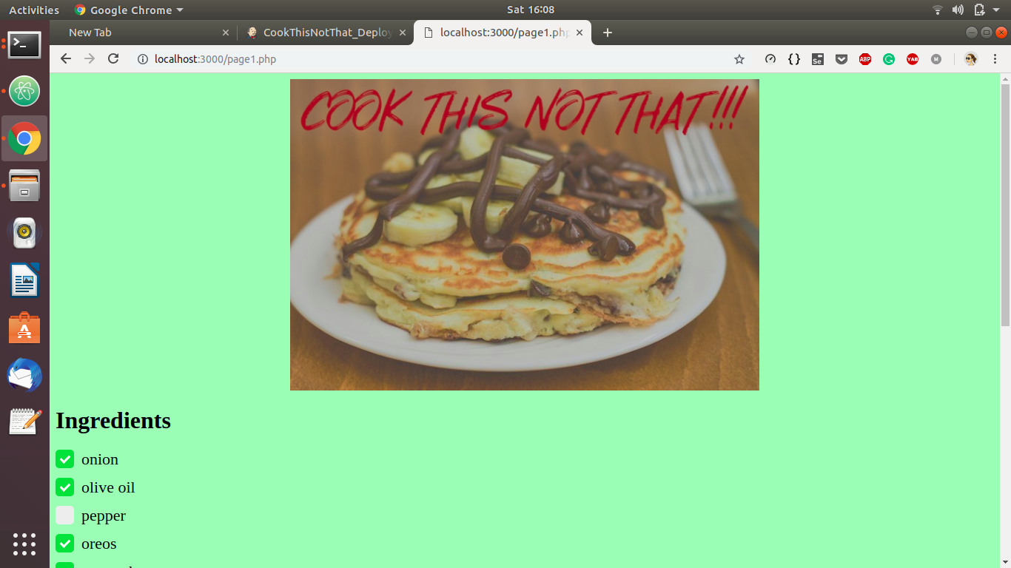
- After selecting the ingredients you can find the recipe by clicking the button at the bottom of the page.
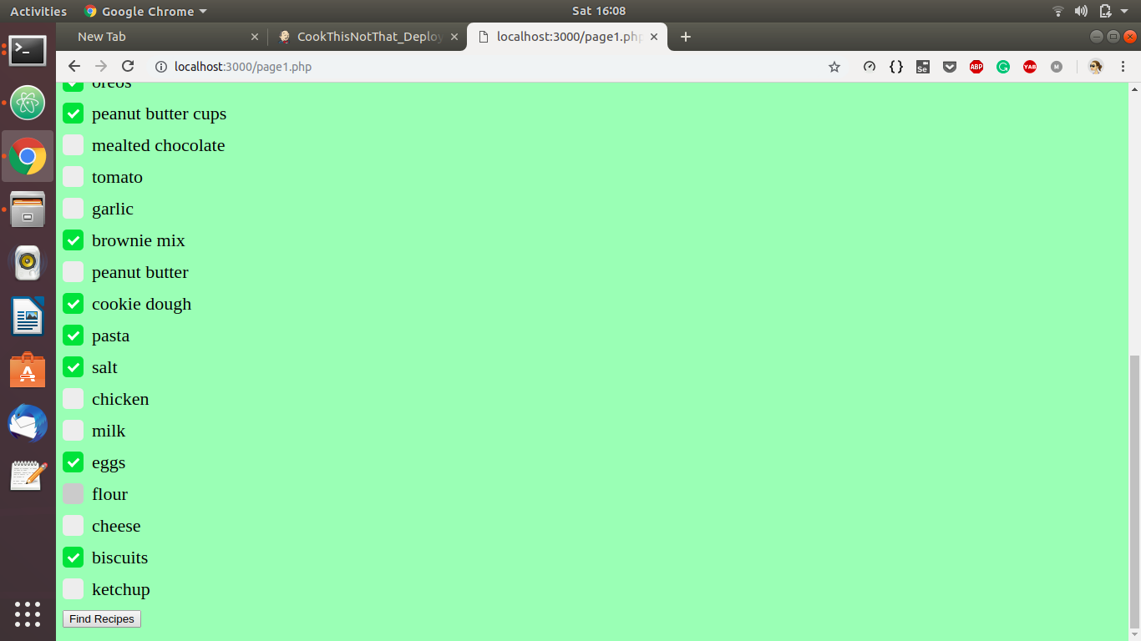

- Page redirected to a page having of suggested recipes
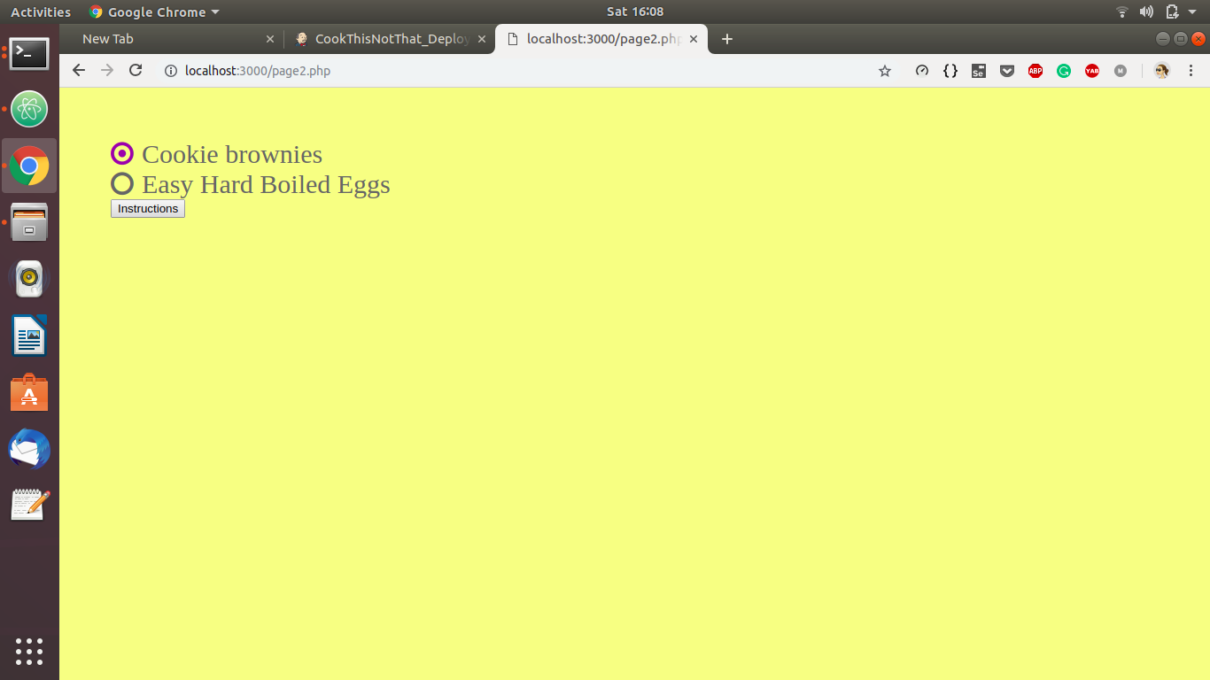

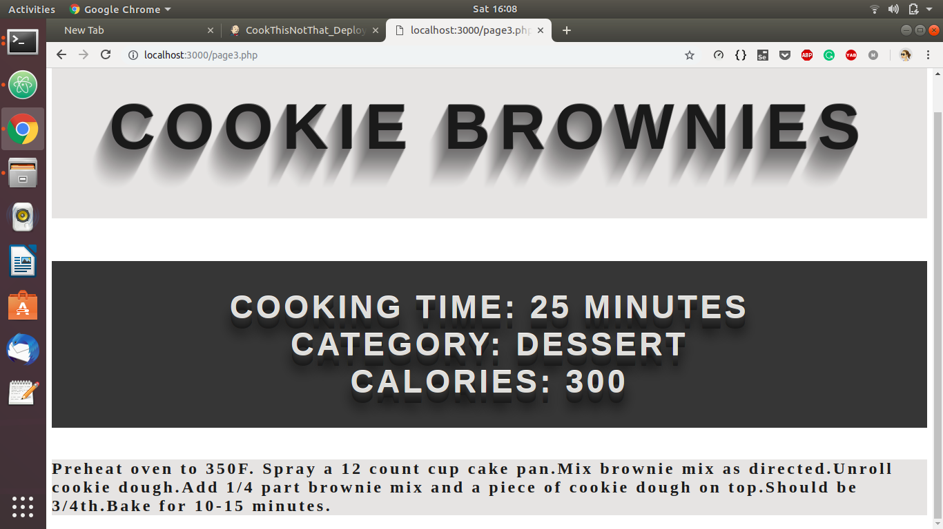
- Information related to the selected recipe after selection of a particular recipe.

3.2 Software Interfaces
The communication between the database and the web portal consists of operation concerning reading for the user.

Other Nonfunctional Requirements

Performance Requirements
- The product will be based on a local server.
- The performance will depend upon hardware components.

Software Quality Attributes
As the customers are not bound with a particular device or operating system to use the mobile application, adaptability becomes an important requirement. The design should work on multiple smartphone devices such as iOS, Android, Windows or Symbian with different screen sizes and resolution.

USER STORIES :

Users Involved:
- General User
- Admin

User Stories of General user :
- As a general user, I want to view general list of ingredients.
- As a general user, I want to select ingredients.
- As a general user, I want to search for a specific ingredient.
- As a general user, I want to see recipes with selected ingredients.
- As a general user, I want to filter recipes based on categories like cooking time, category (like dessert, beverages).
- As a general user, I want to select a particular recipe among all possible
recipes which can be prepared from the selected ingredients.
- As a general user, I want to comment for a particular recipe.
- As a general user, I want to see directions of preparation, cooking time,
calories.
- As a general user, I want to upload my own recipes.

User stories of Admin :
- As a admin, I should be able to remove a recipe.
- As a admin, I should be able to monitor the uploaded recipes.
- As a admin, only I should have the authority to add the recipe uploaded
by anyone.
- As a admin, I should be able to maintain ingredients.
- As a admin, I should be able to monitor the comments.
- As a admin, I should be able to add a recipe.

5. Future Scope :
- Recipe names will be displayed along with their images.
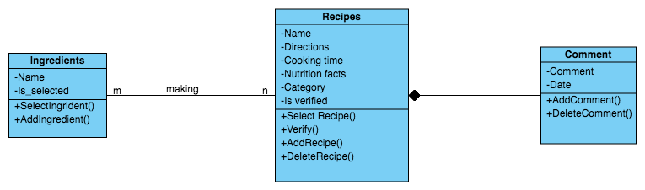
- Many of the times you might not know the name of the ingredient in your kitchen or you might feel lazy to search it in the list of ingredients in our website, so it would be really easy for the user if we could enhance this application where one could scan the ingredient.

UML DIAGRAM :

USE-CASE DIAGRAM:
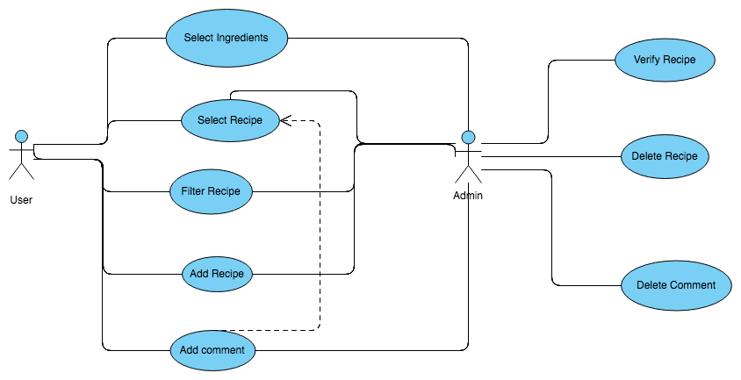

SEQUENCE DIAGRAM :
