**Purpose**

The purpose of this project is to allow the candidate to demonstrate:

- Proficiency in the skills (Html5, Css3, JavaScript)

- Problem solving approach

- Good design and documentation

Specifications

The following sections describe the specifications of the project.

Screenshot

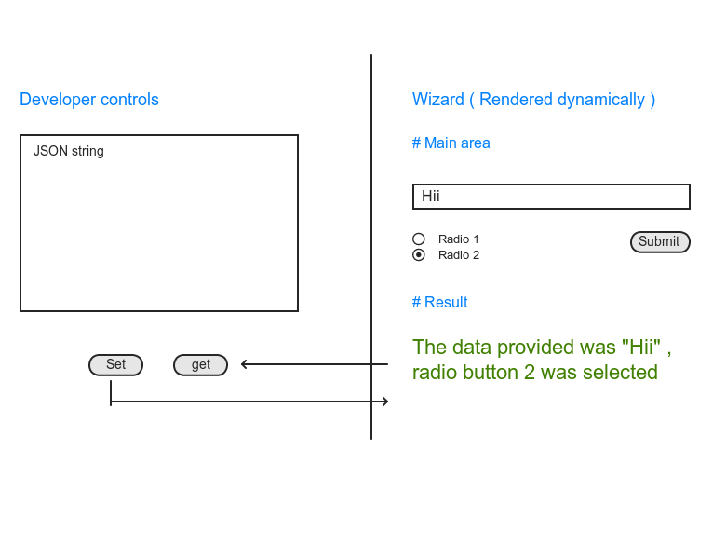

Overview

The diagram contains a **developer control area** and a **wizard control area**. When you click on the **set button**, the JSON string present in the Developer control text area should be parsed and inserted into the respective input elements in the wizard control area and when you click on the get button the data in the input wizard control area should be updated in the developer control area.

A suitable JSON representation can be used for storing the user’s provided data (this can be in any format)

Implementation

The namespace called bwizard will be used to host all of the functionality of the bwizard library. The bwizard library is a single.js file named bwizard.js

The project’s index.html should contain:

* A multi-line edit box
* Get and Set buttons which call the corresponding getData and setData functions on the wizard.
* A div for where the wizard is to be created.
* Template for wizard area (<http://en.wikipedia.org/wiki/JavaScript_templating> )

The wizard area is initialized in index.html

var wizard = bwizard.init(selector);

Here, selector represents the div to create the wizard control in:

The wizard can be configured using the setData method and passing in json string. If the passed in string is null or empty then the wizard is populated with default settings.

wizard.setData(json);

Similarly at any point the JSON configuration can be obtained as follows:

var json = wizard.getData();

Preferred skill sets

* Responsive design **without using** any third part libraries like boostrap
* **Use native Javascript, avoid using any kind of libraries**.
* Keep your code compliant to HTML5, CSS3 standards

**We would like to get followings**

* A zip library contains js file, index.html, css file
* A structured coding style or pattern