PHONE BOOK

[Projected submitted in partial fulfillment for the award of the Degree of CHSE Examination ]

Submitted By:

Sumitra Behera(IS-18-070)

Under The Guidance Of:

Soumya Prasad Rana(KIIT)



**CHRIST COLLEGE,CUTTACK**

CERTIFICATE

This is to certify that the project work entitled “PHONE BOOK” Submitted by Name:”Sumitra Behera” bearing roll no:”IS-18-070”,is an authentic and original work.

Signature:

(Internal Examiner)

Date:

DECLARATION

“SUMITRA SAHOO”,Roll no-IS-18-070 do hereby declare that the project report entitled “PHONE BOOK”submitted to CHRIST COLLEGE,CUTTACK for the award of the degree of CHSE Examination,is an authentic and original work carried out by me from 16th of November 2019 at “CHRIST COLLEGE”under the guidance of “SOUMYA PRASAD RANA” and Internal Guide Name.

Signature of the student:

Date:

ACKNOWLEDGEMENT

I,”SUMITRA BEHERA” express my sincere thanks to “SOUMYA PRASAD RANA”for guiding me with all facilities to complete this project successfully.

Date: Signature of the student

Place Name of the student:

SUMITRA BEHERA

Roll no: IS-18-070

CONTENTS

* INTRODUCTION
* OBJECTIVE
* H/W & S/W REQUIRMENT
* CLASS DIAGRAM
* DFD
* SNAPSHOPT
* REFERENCES
* INTRODUCTION

* This is a command line java application developed to help the user to add,view,search and update his contacts information easily.
* Application contains Modules:-
  + - Load Application
    - Authentication
    - ENCODER
    - View Contacts List
    - Add Contact
    - Update Contact
    - Search Contact
    - Update DB
    - BOT(Automatic Random Contacts Generator)
* **Load Application**
* This module fetches all your previously saved contact from the file named”db.xyz” .
* It uses File Reading and Writing functions to store your saved contact to a file.It helps to make the application more reliable.
* **Authentication**
* This module helps to make your data private and protect fro unauthorized access.
* It also helped to change your password you you are authorized to do so.
* **ENCODER**
* This module helps to to encrypt your data and to save it into file in encrypted format.
* This module is used at the time of file operation to save or update your data to the main source and the time of loading to decrypt the data gained from the main source.
* It has two functions 1)encode, 2)decode.Encode takes a plain string as input/parameter and return a encrypted cipher,Decode takes a cipher text as input/parameter and return a plain text after decryption.
* **View Contact List**
* This module shows the entire contact List present in the file.
* This module also contains another sub module:-View alphabetically.
* Function of sub-module shows all the contact list in alphabetical order according to their names.
* **Add Contact**
* This module contains functionality such as:
* Name Entry
* Mobile No Entry
* Email Entry
* Successful execution of the module add the entered information into your phone book and then will call the update db module to add the newly saved contact information to the file.
* **Search Contact**
* This module helps to search any specific contact from the whole phone book.
* This uses contact’s name as a key-ward to search the specific contact .
* Returns the contact information if found else returns error message “No such contact in your phone book”.
* **Update Existing Contact**
* This module helps to select the specific contact that needs to be updated.
* It takes the help of the search module to select the specific contact,if found next it will ask you what do you want to update and will update the existing contact.
* **Update DB**
* This module helps to write all your managed data to the file “db.xyz” to help the load module to load your existing contacts each time you open the application.
* It uses File Writer function to write into the file.
* This module always called when you choose exit on the application.
* **BOT**
* This module helps to test your program and to calculate the speed reliability of the application by generating random contacts and storing into the main source.
* OBJECTIVE
* Our objective is to manipulate the contact list of persons in easiest possible way.
* Objective also includes performing basic operations such as view existing contacts,adding new contact,update an existing contact and search.
* H/W & S/W REQUIRMENT
* HARDWARE SPECIFICATION:-

Processor : Pentium

RAM : 2GB

Hard disk : 20GB

* SOFTWARE SPECIFICATION:-

OS : WINDOWS

PROGAMMING

LANGUAGE : JAVA

DB : FILE SYSTEM

* CLASS DIAGRAM

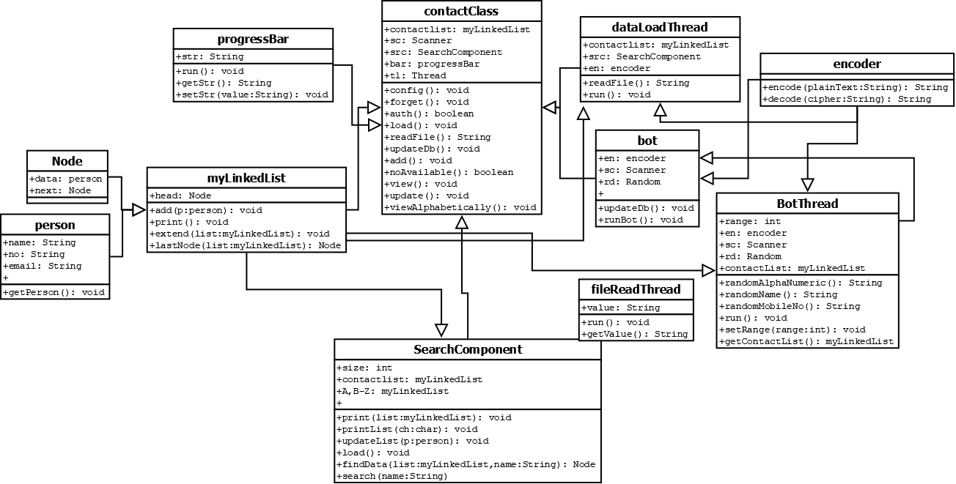

* DFD-Level-0

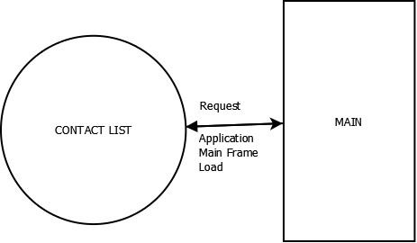

* DFD( LEVEL-1)

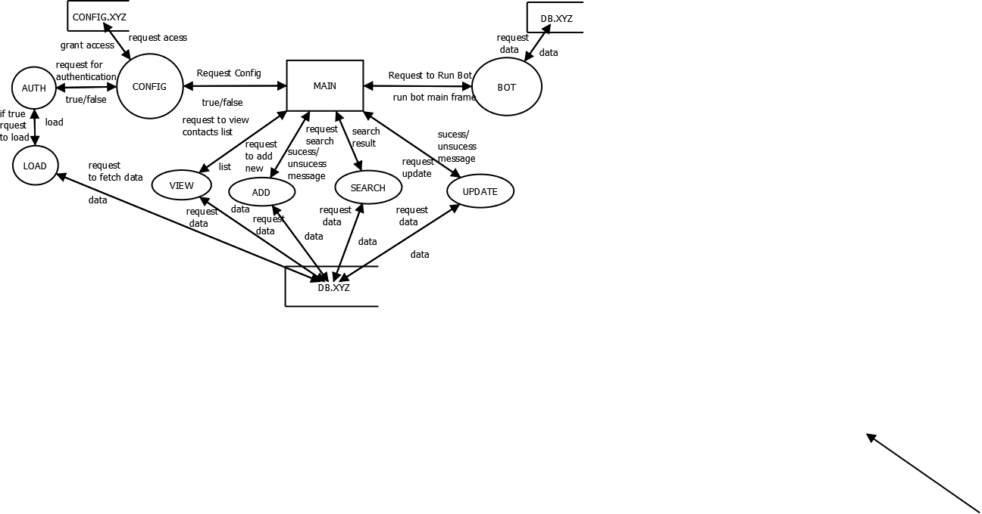

* DFD(LEVEL-2):-

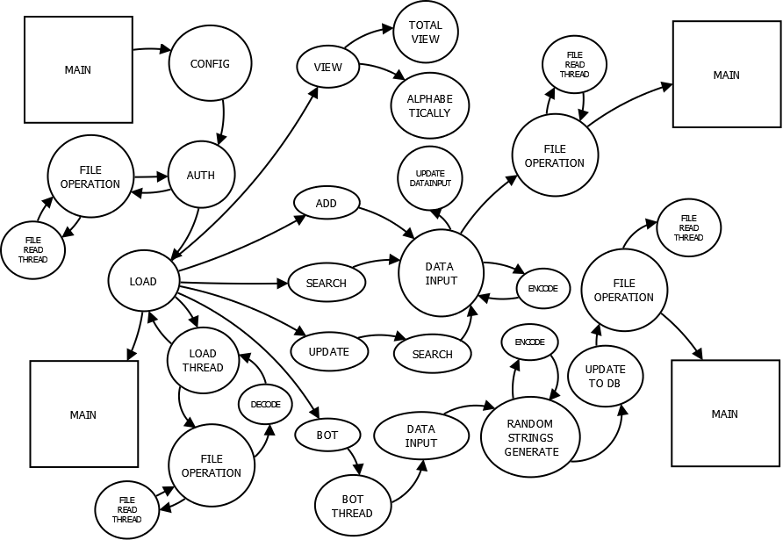

* SNAPSHOTS
* (View All Contacts):-

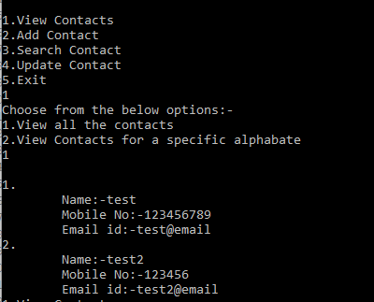

* (View For Specific Alphabetic):-

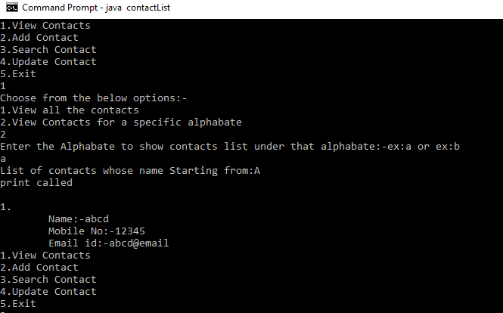

* SNAPSHOTS
* (Search):-

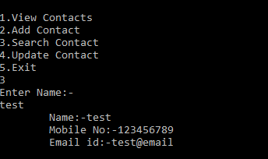

* (Update Contact):-

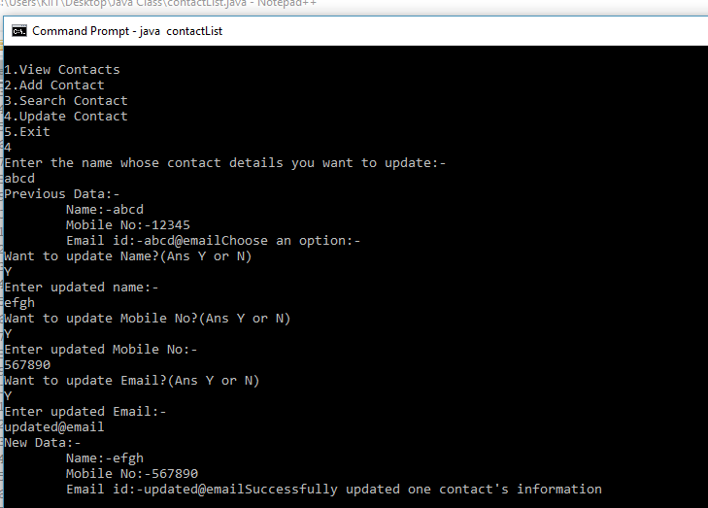

* (Add New Contact):-

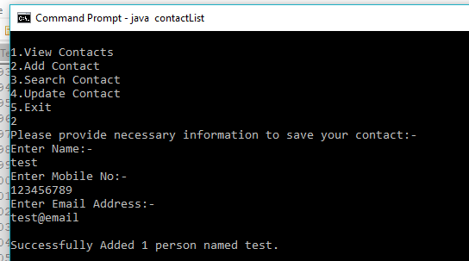

* DB.XYZ(ENCRYPTED):-

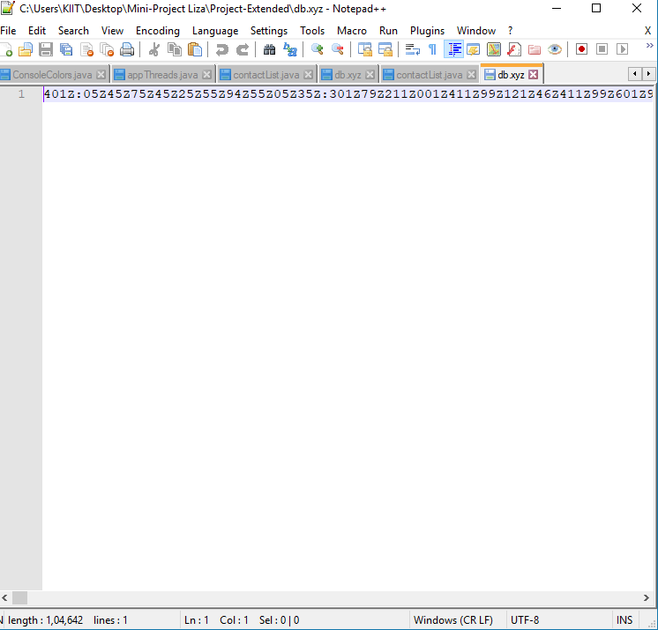

* BOT:-

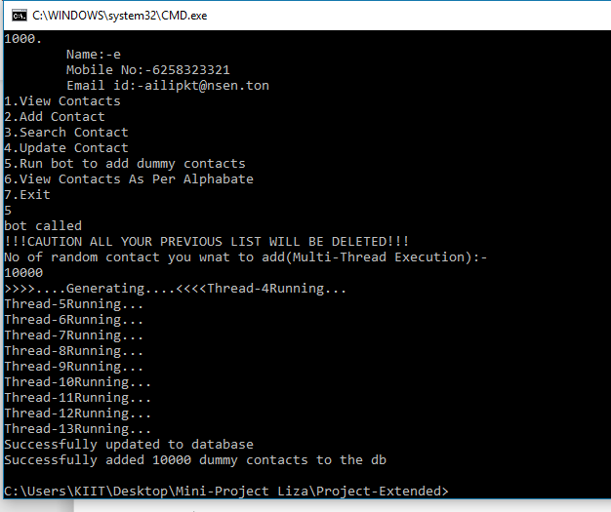

* REFERENCE
* **[www.google.com](http://www.google.com)**
* **[www.wikipedia.com](http://www.wikipedia.com)**
* **[www.w3school.com](http://www.w3school.com)**
* **[www.youtube.com](http://www.youtube.com)**