SOFTWARE REQUIREMENTS SPECIFICATION
Department Loan Management System

Version 1.1 | March 2026
Prepared for: Development Team

1. Project Overview
This document outlines the functional requirements for the Department Loan Management System (DLMS). The system enables department employees (AE/AEE) to apply for loans and advances, route applications through the organizational hierarchy, and receive approvals or rejections at the appropriate authority level.

2. Loan & Advance Types — Processing Authority
There are three primary loan/advance categories, each with a different processing authority:

Loan / Advance Type | Processing Unit | Notes
Motor Loan (Car / Cycle / Scooter) | Corporate Office only | Exclusively processed at Corporate Office. Sanctioned by Joint Secretary/AS (Car) or Superintending Engineer (Cycle/Scooter).
Marriage Advance | Drawing Unit (Corporate / Circular / Division Office) | Any one of the three offices can act as drawing unit. Sanctioned by Superintending Engineer.
Educational Advance | Drawing Unit (Corporate / Circular / Division Office) | Any one of the three offices can act as drawing unit.

Note: A Drawing Unit can be Corporate Office, Circular Office, or Division Office. Whichever unit processes the loan is designated as the drawing unit.

2A. Marriage Advance — Eligibility & Ceiling (Revised Pay Scales 2022)

Employee Category | Purpose of Advance | Enhanced Ceiling | Recovery (Principal + Interest Instalments) | Rate of Interest | Sanctioning Authority
Class-IV Employees | Marriage of male employee or sons of male/female employees | Rs. 2.00 lakhs or 15x basic pay, whichever is less | 70 + 10 | 5% p.a. | Superintending Engineer
Others (Non-Class-IV) | Same as above | Rs. 3.00 lakhs or 15x basic pay, whichever is less | 70 + 10 | 5.5% p.a. | Superintending Engineer
Class-IV Employees | Marriage of female employees themselves or daughters of male/female employees | Rs. 2.50 lakhs or 15x basic pay, whichever is less | 70 + 10 | 5% p.a. | Superintending Engineer
Others (Non-Class-IV) | Same as above | Rs. 4.00 lakhs or 15x basic pay, whichever is less | 70 + 10 | 5.5% p.a. | Superintending Engineer

2B. Motor Loan — Eligibility & Ceiling (Revised Pay Scales 2022)

S.No | Loan Name | Pay Eligibility | Enhanced Ceiling | Eligible Amount | Recovery (P + I) | Interest Rate | Sanctioning Authority
1 | Motor Car Advance | Basic pay Rs. 91,945/- p.m. and above | Rs. 9,00,000/- | Rs. 9 lakhs or 15x basic pay or actual cost, whichever is less | 135 + 65 | Class-IV: 5% p.a. Others: 5.5% p.a. | Joint Secretary / AS
2 | Motor Cycle / Scooter | Basic pay Rs. 81,430/- p.m. and above | Rs. 1,00,000/- | Rs. 1 lakh or 7x basic pay or actual cost, whichever is less | 80 + 16 | Class-IV: 5% p.a. Others: 5.5% p.a. | Superintending Engineer

2C. Other Advances (Per Official Circular — Reference)

S.No | Advance | Eligibility | Ceiling (Rs.) | Recovery Instalments | Interest | Sanctioning Authority
4 | Personal Computer Advance | Basic pay Rs. 34,955/- p.m. and above | 50,000/- | 135 principal + 65 interest | Class-IV: 5% Others: 5.5% p.a. | Superintending Engineer
5 | Festival Advance | Class-IV employees only | 6,000/- | 10 | Interest free (once per financial year) | Divisional Engineer
6 | Special Festival Advance (Gazetted) | Gazetted Officers | 8,500/- | 10 | Interest free | Divisional Engineer
6 | Special Festival Advance (Non-Gazetted) | Non-Gazetted Officers incl. Class-IV | 15,500/- | 10 | Interest free | Divisional Engineer
7 | Education Advance | Non-Gazetted Officers incl. Class-IV | 15,500/- | — | — | —

2D. House Building Advance — Reference

Slab | Pay Range (Basic, Revised Pay 2022) | Enhanced Ceiling | Eligible Amount | Interest Rate | Sanctioning Authority
a | Upto Rs. 65,600/- p.m. | Rs. 20.00 lakhs | Rs. 20 lakhs or 72x basic pay, whichever is less | Class-IV: 5% Others: 5.5% p.a. | —
b | Rs. 65,600/- to Rs. 1,04,230/- p.m. | Rs. 25.00 lakhs | Rs. 25 lakhs or 72x basic pay, whichever is less | Class-IV: 5% Others: 5.5% p.a. | —
c | Above Rs. 1,04,230/- p.m. | Rs. 30.00 lakhs | Rs. 30 lakhs or 72x basic pay, whichever is less | Class-IV: 5% Others: 5.5% p.a. | Joint Secretary

Recovery Pattern — House Building Advance:
- House Building Advance: 300 monthly instalments (240 principal + 60 interest)
- House Repairs: 90 monthly instalments (75 principal + 15 interest)
- House Site: 72 monthly instalments (60 principal + 12 interest)
- Repair/Extension ceiling: 20x basic pay or Rs. 6.00 lakhs, whichever is less
- House Site Purchase: 15x basic pay or Rs. 10.00 lakhs, whichever is less

3. Employee Loan Application Flow

3.1 Employee Actions
- Employee (AE/AEE) logs into the system.
- Navigates to the Loans/Advances section.
- Selects desired loan/advance type.
- System displays eligibility conditions for that loan type.
- Employee verifies conditions are met and submits application.
- System sends consent reminder (email/SMS) with application page URL.
- Employee clicks URL and confirms by clicking 'Yes, I Accept'.
- Application is routed forward through the hierarchy.

3.2 Application Routing
Step | Level | Action
1 | Sub-Division (Employee's section) | Application initiated by AE/AEE
2 | Division Office | Forwarded by AD (Assistant Director)
3 | Circle Office | Forwarded for review
4 | Corporate Office (if applicable) | Final processing — Motor Loans only

4. Organizational Hierarchy & Approval Roles

4.1 Corporate Office Hierarchy
Role | Level | Responsibilities
GS (General Secretary) | Highest | FINAL AUTHORITY — Accept or Reject. Rejection reason is mandatory.
GM (General Manager) | 2 | Reviews and monitors application status
AS (Assistant Secretary) | 3 | Reviews and monitors application status
PO (Processing Officer) | 4 | Receives all applications; assigns to JPOs
JPO (Junior Processing Officer) — R1/R2/R3/R4 | Lowest | Processes assigned applications

Workflow: Application arrives -> PO assigns to JPO (R1/R2/R3/R4) -> JPO processes -> PO -> AS -> GM -> GS (Final Decision)
Visibility: GS, GM, AS can view real-time status of all applications at any time.

4.2 Circle (Circular) Office Hierarchy
Role | Level | Responsibilities
AC (Assistant Commissioner) | Highest | Supervises circle office workflow
SAO (Senior Accounts Officer) | 2 | Reviews applications
AO (Accounts Officer) | 3 | Reviews applications
AAO (Assistant Accounts Officer) | 4 | Reviews applications
JAO / PRS | Lowest | Initial processing

4.3 Division Office Hierarchy
Role | Level | Responsibilities
DE (Divisional Engineer) | Highest | Oversees division loans
JAO (Junior Accounts Officer) | Middle | Processing and review
SAO / J | Lowest | Initial processing

5. Consent Reminder Feature
- System shall send automated Email and/or SMS reminder to employee when consent is required.
- The reminder must contain the URL of the exact loan application page.
- Employee clicks URL, is directed to the application page, and clicks 'Yes, I Accept / I Consent'.
- Application cannot proceed without the employee's explicit consent.

6. Loan Allocation Logic (FIFO-Based)

6.1 Circle Budget & Allocation
- There are 16 circles in the system.
- Each circle has a sanctioned loan budget that can be granted to employees.
- Loan grants are processed on a First-In, First-Out (FIFO) basis.

6.2 FIFO Bypass Rule
- If an employee next in queue is ineligible or fails to claim the loan, that employee is skipped.
- The next eligible employee in the queue becomes eligible for the loan.
- System must track and maintain FIFO status and position for all employees.

7. Employee Recovery Status
- System must check and display the recovery status (outstanding dues) of each employee.
- Recovery status must be visible to approvers in the loan processing view.
- Employees with poor recovery status may be flagged or restricted per business rules.

8. Approval & Rejection Rules
Action | Authority | Requirement
Accept Loan | GS (Corporate) / Respective Head at Circle or Division | Only final authority can accept
Reject Loan | GS (Corporate) / Respective Head at Circle or Division | Rejection reason is MANDATORY
Monitor Status | GS, GM, AS; equivalent at other levels | Read-only view of status
Assign JPO | PO (Corporate) | PO assigns to R1/R2/R3/R4 JPOs

9. Functional Requirements Summary

ID | Module | Requirement
FR-01 | Loan Types | System shall support: Motor Car Advance, Motor Cycle/Scooter Advance, Marriage Advance, Educational Advance, and other advances per official circular
FR-02 | Loan Conditions | System shall display eligibility conditions per loan type before submission
FR-03 | Application Routing | System shall auto-route: Sub-division -> Division -> Circle -> Corporate (where applicable)
FR-04 | Consent Reminder | System shall send email/SMS reminder with application URL for employee consent
FR-05 | FIFO Allocation | System shall allocate loans on FIFO order per circle budget
FR-06 | FIFO Bypass | System shall skip ineligible employees and promote next-in-line
FR-07 | Circle Budget | System shall track loan budget per circle (16 circles total)
FR-08 | Recovery Status | System shall display employee recovery/repayment status in loan view
FR-09 | Role-Based Access | System shall enforce role-based access per hierarchy at each office level
FR-10 | JPO Assignment | PO shall assign incoming requests to one of 4 JPOs (R1-R4)
FR-11 | Status Visibility | GS/GM/AS shall have real-time read-only status view
FR-12 | Rejection Reason | System shall require a rejection reason when a loan is rejected
FR-13 | Final Authority | Only GS (or equivalent head) shall have Accept/Reject rights
FR-14 | Marriage Advance Ceiling | System shall validate Marriage Advance ceiling per employee category (Class-IV vs others) and purpose (self/son/daughter marriage)
FR-15 | Interest Calculation | System shall calculate interest at 5% (Class-IV) or 5.5% (others) for applicable loans
FR-16 | Recovery Schedule | System shall generate and track recovery schedules per loan type as per circular

10. Process Flow Diagram
Step | Actor / Level | Action / Decision
1 | Employee (AE/AEE) | Selects loan type -> Reviews conditions -> Submits application
2 | System | Sends consent reminder (Email/SMS with application URL)
3 | Employee | Clicks URL -> Clicks 'I Accept' to confirm consent
4 | Sub-Division / AD | Application forwarded to Division Office
5 | Division Office | Application forwarded to Circle Office
6 | Circle Office | Forward to Corporate if Motor Loan; else process as Drawing Unit
7 | PO (Corporate) | Assigns application to JPO (R1/R2/R3/R4)
8 | JPO | Processes -> Routes back to PO
9 | PO -> AS -> GM -> GS | Application traverses hierarchy for review
10 | GS (Final Authority) | Accept (Loan Granted) OR Reject (with Reason)
11 | System | Notifies employee; updates FIFO queue and circle budget

Processing Authority Decision Tree
Loan Type = Motor Car / Cycle / Scooter -> Corporate Office ONLY
Loan Type = Marriage Advance -> Drawing Unit (Corporate OR Circle OR Division)
Loan Type = Educational / Other Advances -> Drawing Unit (Corporate OR Circle OR Division)

11. Reference — Official Loan Ceiling Circulars (Client-Provided)
The following images are official reference documents provided by the client. They contain the sanctioned ceiling limits for various loans and advances as per Revised Pay Scales 2022. Developers must use these as the source of truth when implementing validation rules, eligibility checks, and interest/recovery calculations.

Reference Image 1: Motor Car Advance (#1), Motor Cycle/Scooter Advance (#2) & Marriage Advance (#3) — Ceiling Limits
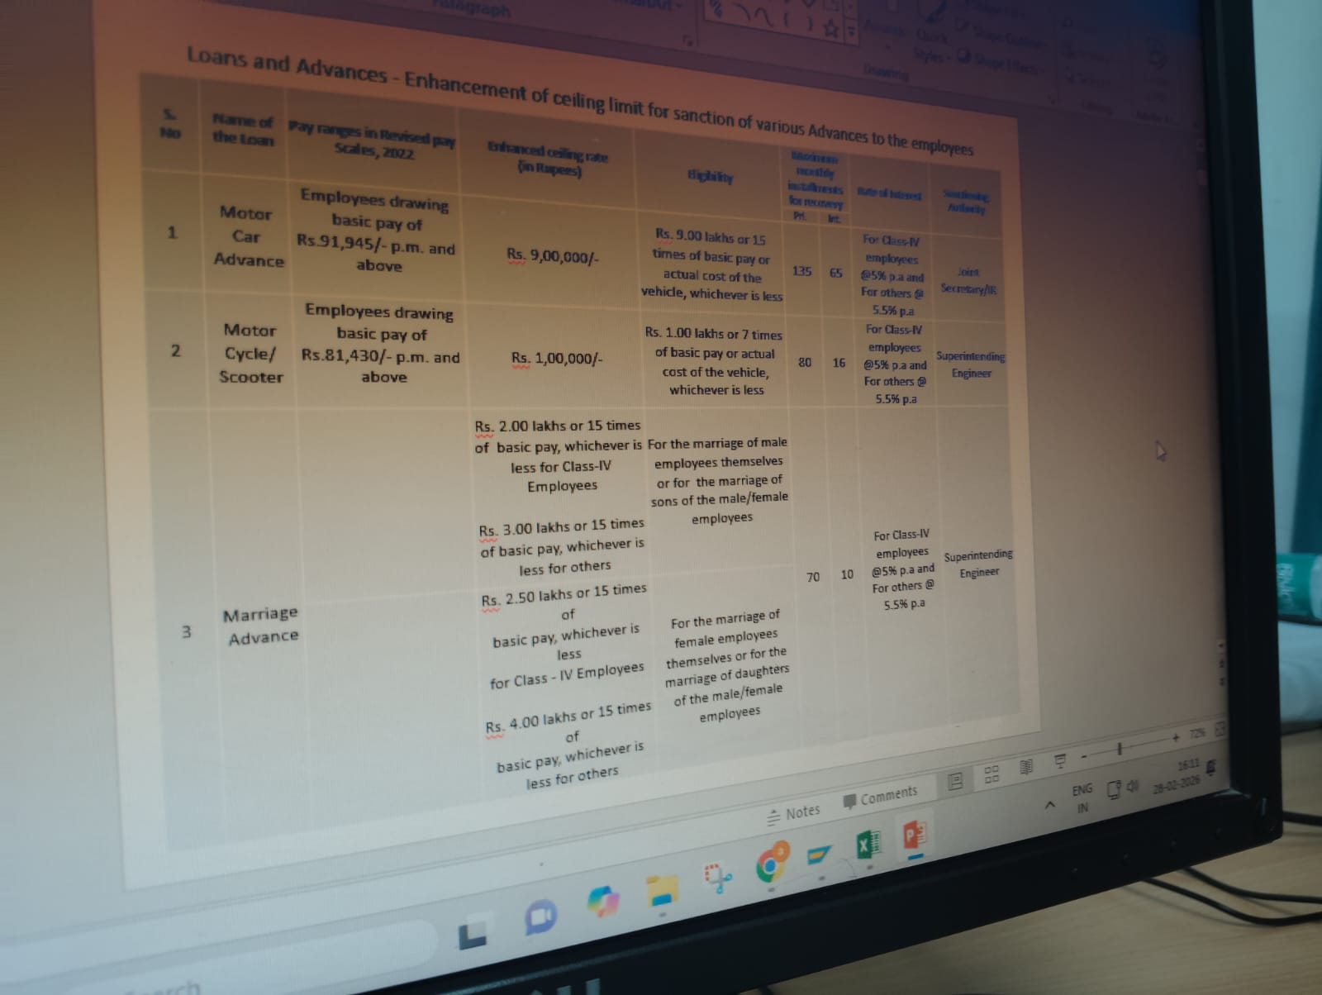

Reference Image 2: Personal Computer Advance (#4), Festival Advance (#5), Special Festival Advance (#6) & Education Advance (#7) — Ceiling Limits
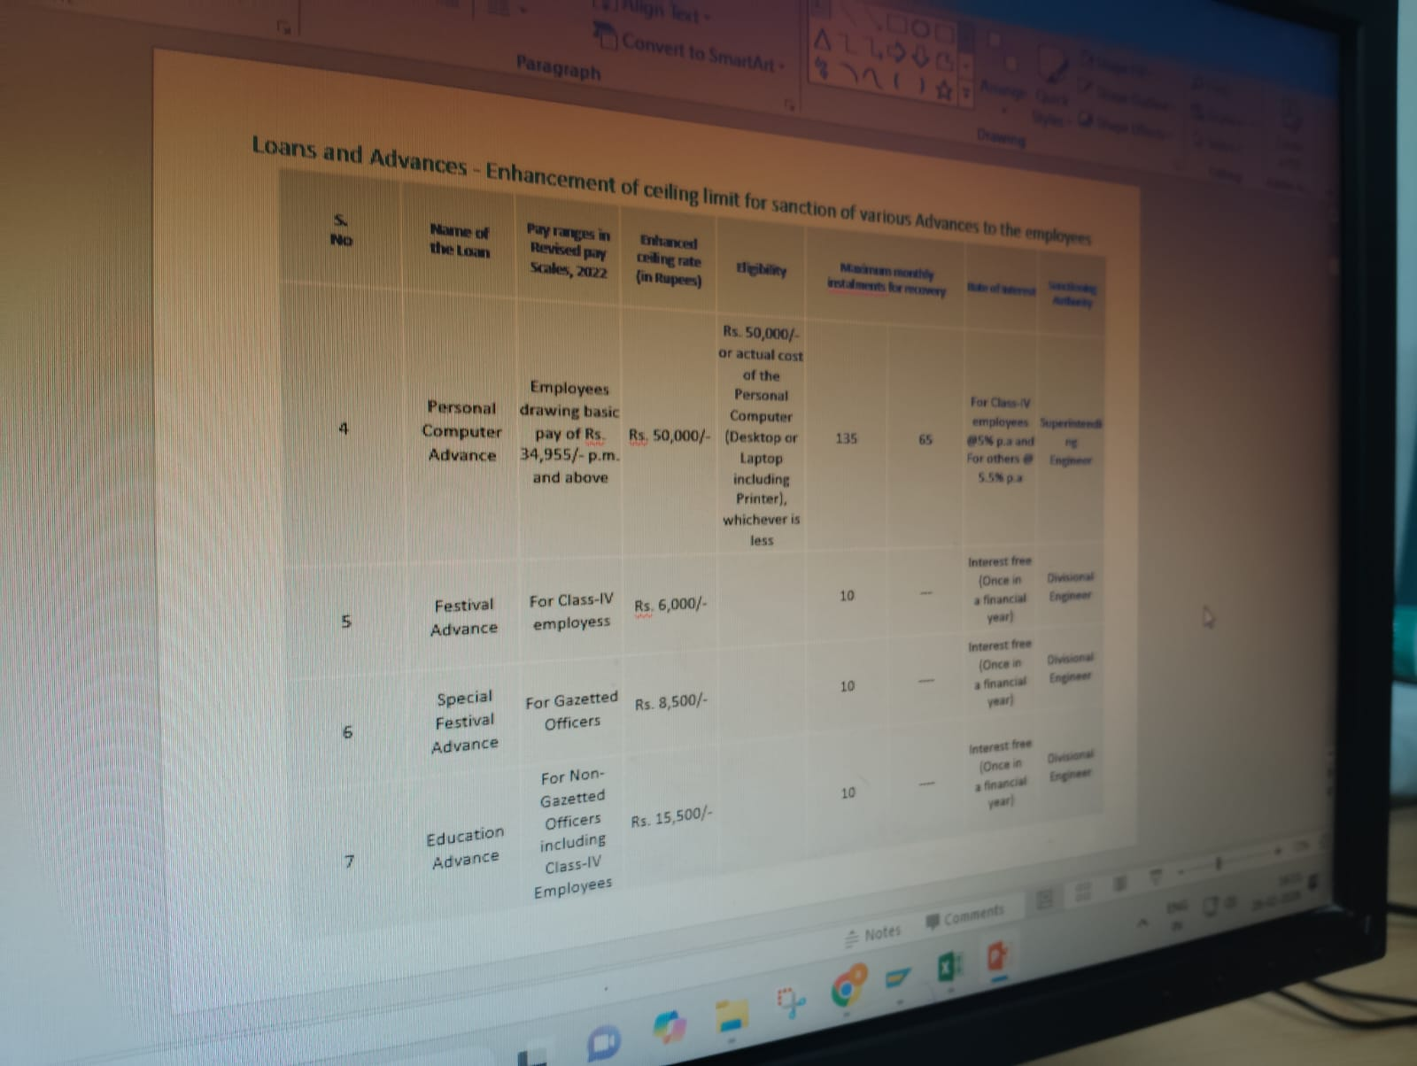

Reference Image 3: House Building Advance — Pay Slabs, Ceiling Limits & Recovery Pattern
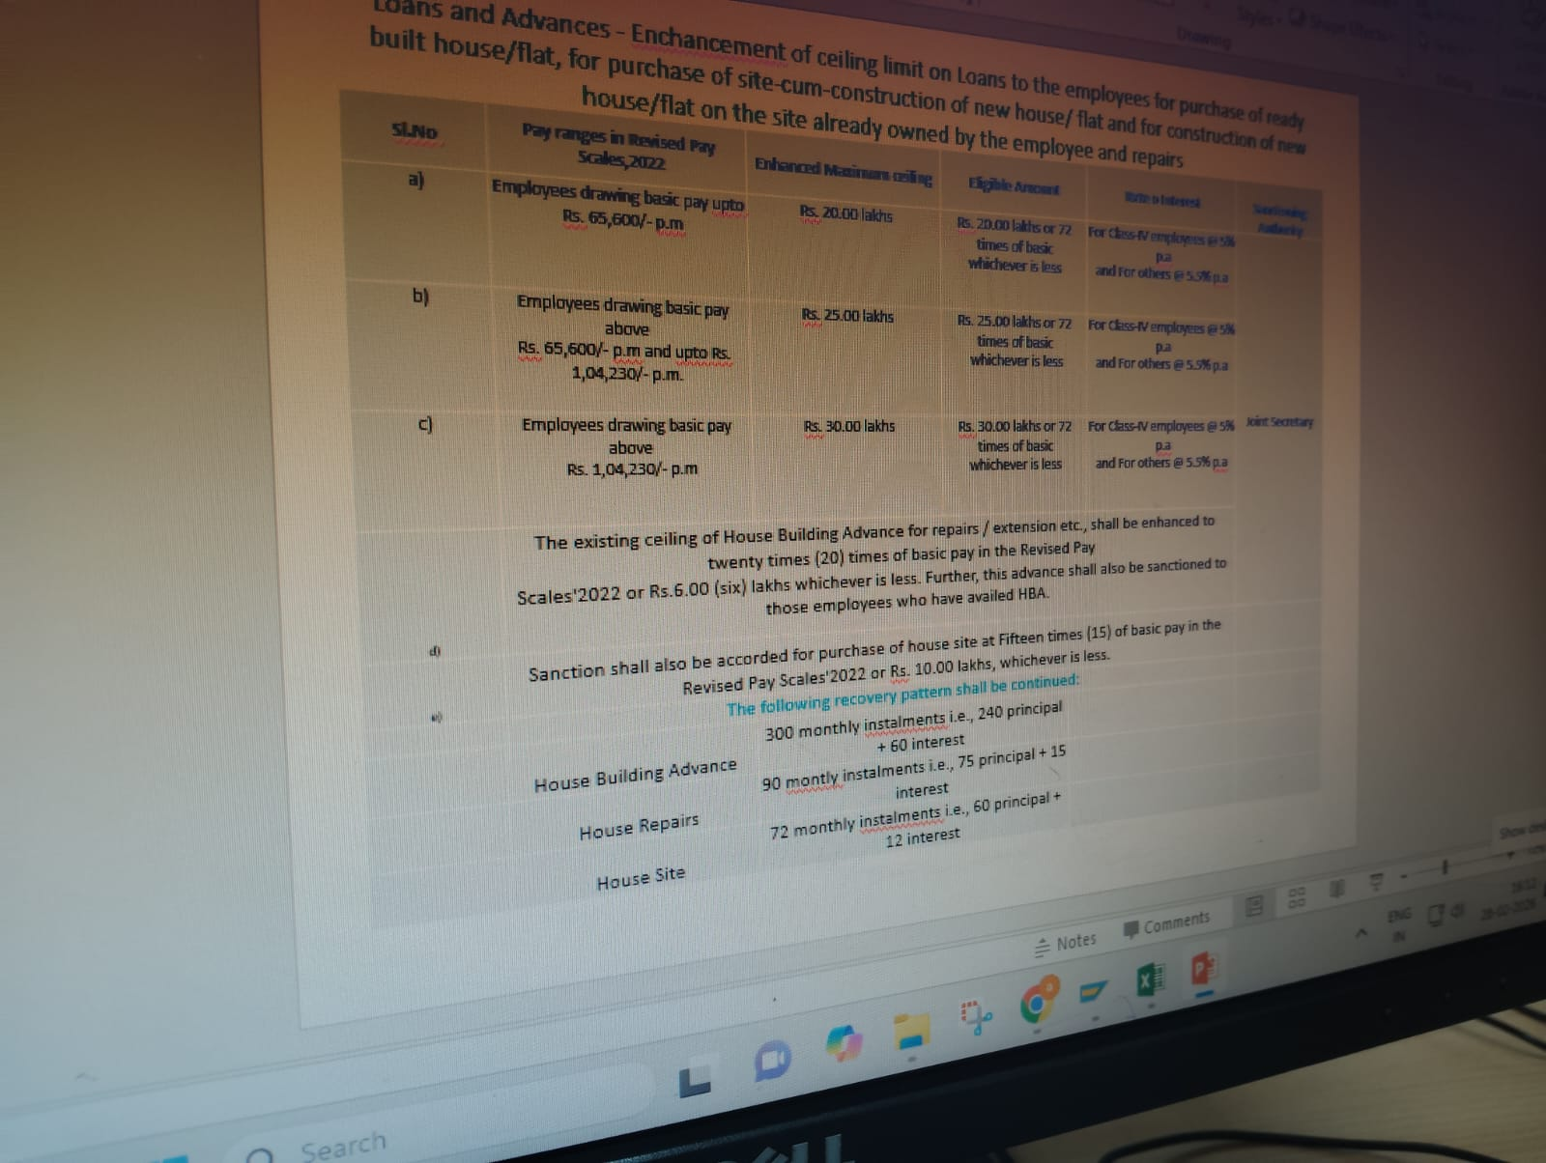

12. Glossary
Term | Full Form / Meaning
AE | Assistant Engineer
AEE | Assistant Executive Engineer
AD | Assistant Director
JPO | Junior Processing Officer
PO | Processing Officer
AS | Assistant Secretary
GM | General Manager
GS | General Secretary
AC | Assistant Commissioner
SAO | Senior Accounts Officer
AO | Accounts Officer
AAO | Assistant Accounts Officer
JAO | Junior Accounts Officer
DE | Divisional Engineer
PRS | Processing Staff (at JPO-equivalent level)
FIFO | First In, First Out — queue/allocation method
Drawing Unit | The office authorized to process and disburse a particular loan/advance
CMD | Chairman and Managing Director (highest authority above Corporate Office)
HBA | House Building Advance

--- End of Document ---

