|  |
| --- |
| Digital System Design SS2024 |
|  |
| Lab 1: Design and Test of VHDL IP |
| Report submitted by:  **Soumya Ranjan Sabat**  Matrikelnr: 1127993  **Azaz Hassan Khan**  Matrikelnr: 1128032 |
|  |
| **May/22/2024** |

Content

1 Introduction 3

1.1 Part-1: Study top level RTL design 3

1.1.1 Task-1 3

1.1.2 Task-2 4

1.2 Part-2: Design of camera emulator 5

1.2.1 Task-1 5

1.2.2 Task-2 6

1.3 Part-3: Simulation of camera emulator 7

1.3.1 Task-1 7

1.3.2 Task-2 8

1.4 Part-4: Test of HDMI Display Controller on ZedBoard 8

1.4.1 Task-1 8

1.4.2 Task-2 9

1.4.3 Task-3 10

2 References 11

# Introduction

Test a HDMI display controller, designed to display images captured by a camera. Data of the HDMI display controller is finally sent to the on-board HDMI transmitter chip. The camera is getting emulated by another VHDL model.

Objectives:

* Study of the top-level RTL design
* VHDL design of the Camera Emulator
* Simulation of the Camera Emulator
* Test of HDMI Display Controller on ZedBoard

## Part-1: Study top level RTL design

### Task-1

Q1. Describe the meaning of all output signals of HDMI_V1!! Consider that those output signals are inputs to the HDMI transmitter ADV7511. Do research on ADV7511 of ZedBoard. Use a table format with two columns: signal name and description!

Elaboration:

|  |  |
| --- | --- |
| **Signal Name** | **Description** |
| Data_out [15:0] | * 16-bit Data output of frame buffer |
| HDMI_CLK | * A clock of 25MHz from vga_pll_zedboard |
| config_done | * CEC data signal. Supports CMOS logic levels from 1.8V to 5V * One of the outputs of ov7670_controller * A LED to show when config is finished |
| PwDn | * Power saver mode. One of the outputs of ov7670_controller (transfers registers to the camera over an I2C like bus) * A LED shows if it is at the power saver mode |
| de | * Data Enable signal input for Digital Video. Supports typical CMOS logic levels from 1.8V up to 3.3V * One of the outputs of vga_controller and acts as input to Video data capture of the HDMI transmitter ADV7511 * Display enables where '1' is the display time and '0' is the blanking time |
| h_sync | * Horizontal Sync Pulse input. Supports typical CMOS logic levels from 1.8V up to 3.3V * One of the outputs of vga_controller and acts as input to Video data capture of the HDMI transmitter ADV7511 |
| v_sync | * Vertical Sync Pulse input. Supports typical CMOS logic levels from 1.8V up to 3.3V * One of the outputs of vga_controller and acts as input to Video data capture of the HDMI transmitter ADV7511 |
| siod_hdmi | * Serial Port Data I/O. Supports CMOS logic levels from 1.8V to 3.3V * This pin serves as the serial port data I/O slave for register access |
| sioc_hdmi | * Serial Port Data Clock input. Supports CMOS logic levels from 1.8V to 3.3V * Can write to the registers |
| xClk | * Clk Driver for OV7670 camera * One of the outputs of ov7670_controller |
| Reset | * Always '1' for normal mode * One of the outputs of ov7670_controller |

### Task-2

Q1. The component IMG_GENERATOR emulates the camera. Do research on OV7670 camera (data sheet). Describe each signal provided by the camera (assume a resolution setting of 640x480 and an output format of Y/Cb/Cr 4:2:2) and compare with the output ports of IMG_GENERATOR! Use a table format with two columns: signal name and description!

Elaboration:

|  |  |
| --- | --- |
| **Signal Name** | **Description** |
| cam_pwdn | * Power Down Mode Selection * 0: Normal mode 1: Power down mode |
| cam_reset | * Clears all registers and resets them to their default values. * 0: Normal mode 1: Reset mode |
| cam_sioc | * SCCB serial interface clock input |
| cam_xclk | * System clock input |
| cam_data[7:0] | * 8-bit output of Pixel_Generator * YUV video component output |
| cam_href | * HREF output * It is responsible for synchronizing each line of the image frame |
| cam_pclk | * Pixel clock output |
| cam_siod | * SCCB serial interface data I/O |
| cam_vsync | * Vertical sync output * It is responsible for synchronizing an entire image frame on the screen |

## Part-2: Design of camera emulator

### Task-1

Q1. In *Camera_Clock_Generator.vhd* we need to generate both, VSYNC and HREF in order to emulate the camera.

|  |
| --- |
| library IEEE;  use IEEE.STD_LOGIC_1164.ALL;  -- Uncomment the following library declaration if using  -- arithmetic functions with Signed or Unsigned values  use IEEE.NUMERIC_STD.ALL;  -- Uncomment the following library declaration if instantiating  -- any Xilinx leaf cells in this code.  -- library UNISIM;  -- use UNISIM.VComponents.all;  entity Camera_Clock_Generator is  Port (  pclk : in STD_LOGIC;  href : out STD_LOGIC;  vsync : out STD_LOGIC  );  end Camera_Clock_Generator;  architecture Behavioral of Camera_Clock_Generator is  signal tick_timer: integer := 0;  begin  generate_tick_timer: process(pclk)  begin  if rising_edge(pclk) then  tick_timer <= (tick_timer + 1) mod 799680;  end if;  end process;  generate_href: process(pclk)  variable count: integer := 0;  begin  if rising_edge(pclk) then  if ((tick_timer >= 31360) and (tick_timer < 784000)) then  if ((count >= 0) and (count < 1280)) then  href <= '1';  else  href <= '0';  end if;  count := (count + 1) mod 1568;  else  href <= '0';  end if;  end if;  end process;  generate_vsync: process(pclk)  begin  if rising_edge(pclk) then  if ((tick_timer >= 0) and (tick_timer < 4704)) then  vsync <= '1';  else  vsync <= '0';  end if;  end if;  end process;  end Behavioral; |

### Task-2

Q1. In Pixel_Generator.vhd we need to specify Y, CB and CR. Use VHDL constant with data type STD_LOGIC_VECTOR (7 downto 0)! Generate blue pixels!

Elaboration:

|  |
| --- |
| library IEEE;  use IEEE.STD_LOGIC_1164.ALL;  use IEEE.NUMERIC_STD.ALL;  entity Pixel_Generator is  Port (  pclk : in STD_LOGIC;  href : in STD_LOGIC;  vsync : in STD_LOGIC;  data : out STD_LOGIC_VECTOR (7 downto 0)  );  end Pixel_Generator;  architecture Behavioral of Pixel_Generator is  -- Blue pixel: Y: 41 (29), Cb: 240 (F0), Cr: 110 (6E)  constant Y_BLUE : STD_LOGIC_VECTOR (7 downto 0) := x"4C";  constant CB_BLUE : STD_LOGIC_VECTOR (7 downto 0) := x"54";  constant CR_BLUE : STD_LOGIC_VECTOR (7 downto 0) := x"FF";    signal cnt_col_pixel : integer range 0 to 1279 := 0; -- Column pixel counter  begin  -- Pixel generation process  pixel_gen_yCbCr : process(pclk)  begin  if rising_edge(pclk) then  if (href = '1') and (vsync = '0') then -- Generate data only during active video line  if (cnt_col_pixel mod 4 = 0) then  data <= CB_BLUE; -- Cb component  elsif (cnt_col_pixel mod 4 = 1) then  data <= Y_BLUE; -- Y component  elsif (cnt_col_pixel mod 4 = 2) then  data <= CR_BLUE; -- Cr component  else  data <= Y_BLUE; -- Y component  end if;  end if;    -- Reset the column pixel counter at the end of the line  if (cnt_col_pixel = 1279) then  cnt_col_pixel <= 0;  else  cnt_col_pixel <= cnt_col_pixel + 1;  end if;  end if;  end process;  end Behavioral; |

|  |  |
| --- | --- |
| **Colors** | **Y-Cb-Cr Value** |
| Black | (16,128,128) |
| White | (235,128,128) |
| Red | (82,90,240) |
| Green | (145,54,34) |
| Blue | (41,240,110) |
| Yellow | (210,16,146) |
| Cyan | (170,166,16) |
| Magenta | (107,202,222) |

## Part-3: Simulation of camera emulator

### Task-1

Q1. Run simulation of *Camera_Clock_Generator.vhd* using ModelSim (Copy code to a ModelSim project). No test bench required, because one input signal only. Compare your output with fig.2 and fig.3!

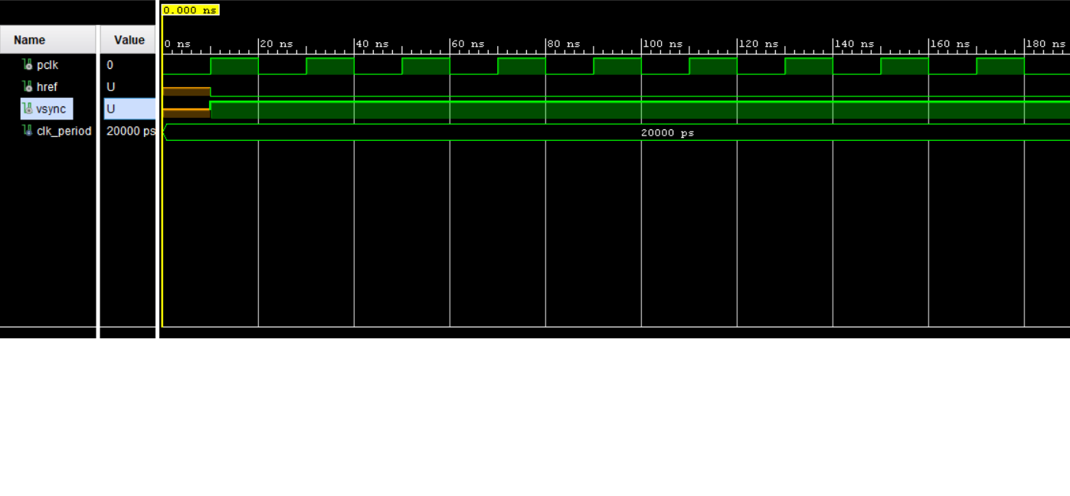

### Task-2

Q1. Run simulation of *Pixel_Generator.vhd* using ModelSim (Copy code to a ModelSim project). No test bench required, because three input signals only. Check 8-bit output data on expected CB,Y,CR,Y,CB,Y,CR sequence for blue pixel!

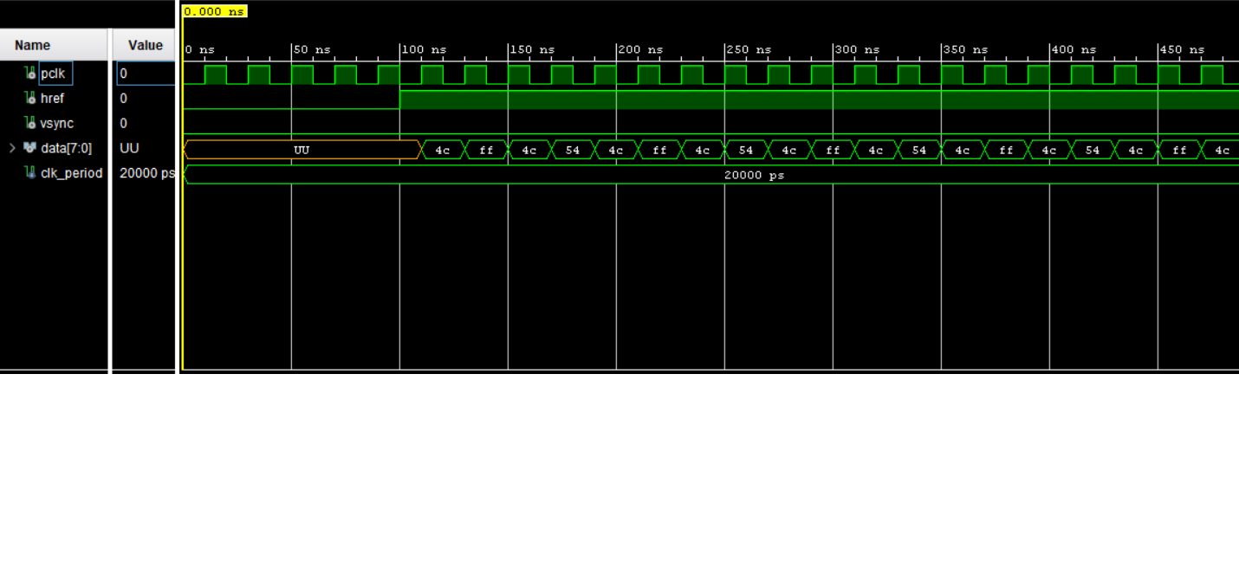

## Part-4: Test of HDMI Display Controller on ZedBoard

### Task-1

Q1. First check on file *video_project_constraints.xdc* if all the pins are set correctly. Provide a table for all I/O pins and their respective signal names!

|  |  |
| --- | --- |
| **Signal Name** | **Port** |
| HDMI_CLK | W18 |
| Data_out[15] | V14 |
| Data_out[13] | U17 |
| Data_out[12] | V15 |
| Data_out[11] | W15 |
| Data_out[10] | W13 |
| Data_out[9] | Y15 |
| Data_out[8] | AA17 |
| Data_out[7] | AB17 |
| Data_out[6] | AA16 |
| Data_out[5] | AB16 |
| Data_out[4] | AB15 |
| Data_out[3] | Y14 |
| Data_out[2] | AA14 |
| Data_out[1] | AA12 |
| Data_out[0] | Y13 |
| cam_resend | T18 |
| Clk_100M | Y9 |
| Config_done | T22 |
| De | U16 |
| h_sync | V17 |
| Resend | P16 |
| Sloc_hdmi | AA18 |
| Slod_hdmi | Y16 |
| Switch | F22 |
| V_sync | W17 |

### Task-2

Q2. Synthesize your VHDL design and implement it on the ZedBoard. For this you **Run Synthesis**, then **Run Implementation**, finally click on **Generate Bitstream**.

|  |
| --- |
| library IEEE;  use IEEE.std_logic_1164.all;  entity Pixel_Generator is  port(  pclk : in STD_LOGIC;  href : in STD_LOGIC;  vsync : in STD_LOGIC;  data : out STD_LOGIC_VECTOR (7 downto 0)  );  end Pixel_Generator;  architecture Behavioral of Pixel_Generator is  constant y_red : STD_LOGIC_VECTOR (7 downto 0) := x"52";  constant cb_red : STD_LOGIC_VECTOR (7 downto 0) := x"5A";  constant cr_red : STD_LOGIC_VECTOR (7 downto 0) := x"F0";  constant y_blue : STD_LOGIC_VECTOR (7 downto 0) := x"29";  constant cb_blue : STD_LOGIC_VECTOR (7 downto 0) := x"F0";  constant cr_blue : STD_LOGIC_VECTOR (7 downto 0) := x"6E";  constant y_green : STD_LOGIC_VECTOR (7 downto 0) := x"91";  constant cb_green : STD_LOGIC_VECTOR (7 downto 0) := x"36";  constant cr_green : STD_LOGIC_VECTOR (7 downto 0) := x"22";  constant y_yellow : STD_LOGIC_VECTOR (7 downto 0) := x"D2";  constant cb_yellow: STD_LOGIC_VECTOR (7 downto 0) := x"F0";  constant cr_yellow: STD_LOGIC_VECTOR (7 downto 0) := x"6E";    signal cnt : integer range 0 to 1279 := 0;  begin  pixel_gen: process(pclk)  begin  if falling_edge(pclk) then  if (href = '1') and (vsync = '0') then  if (cnt >= 0 and cnt < 320) then  if ((cnt rem 4) = 0) then  data <= cb_blue;  elsif ((cnt rem 4) = 1) then  data <= y_blue;  elsif ((cnt rem 4) = 2) then  data <= cr_blue;  elsif ((cnt rem 4) = 3) then  data <= y_blue;  end if;  elsif (cnt >= 320 and cnt < 640) then  if ((cnt rem 4) = 0) then  data <= cb_red;  elsif ((cnt rem 4) = 1) then  data <= y_red;  elsif ((cnt rem 4) = 2) then  data <= cr_red;  elsif ((cnt rem 4) = 3) then  data <= y_red;  end if;  elsif (cnt >= 640 and cnt < 960) then  if ((cnt rem 4) = 0) then  data <= cb_green;  elsif ((cnt rem 4) = 1) then  data <= y_green;  elsif ((cnt rem 4) = 2) then  data <= cr_green;  elsif ((cnt rem 4) = 3) then  data <= y_green;  end if;  elsif (cnt >= 640 and cnt < 960) then  if ((cnt rem 4) = 0) then  data <= cb_yellow;  elsif ((cnt rem 4) = 1) then  data <= y_yellow;  elsif ((cnt rem 4) = 2) then  data <= cr_yellow;  elsif ((cnt rem 4) = 3) then  data <= y_yellow;  end if;  end if;    if (cnt = 639) then  cnt <= 0;  else  cnt <= cnt + 1;  end if;    end if;    end if;    end process;  end Behavioral; |

### Task-3

Q3. Change *Pixel_Generator.vhd* in a way that you get color strips on your screen as shown in fig.4! Take photo of screen output

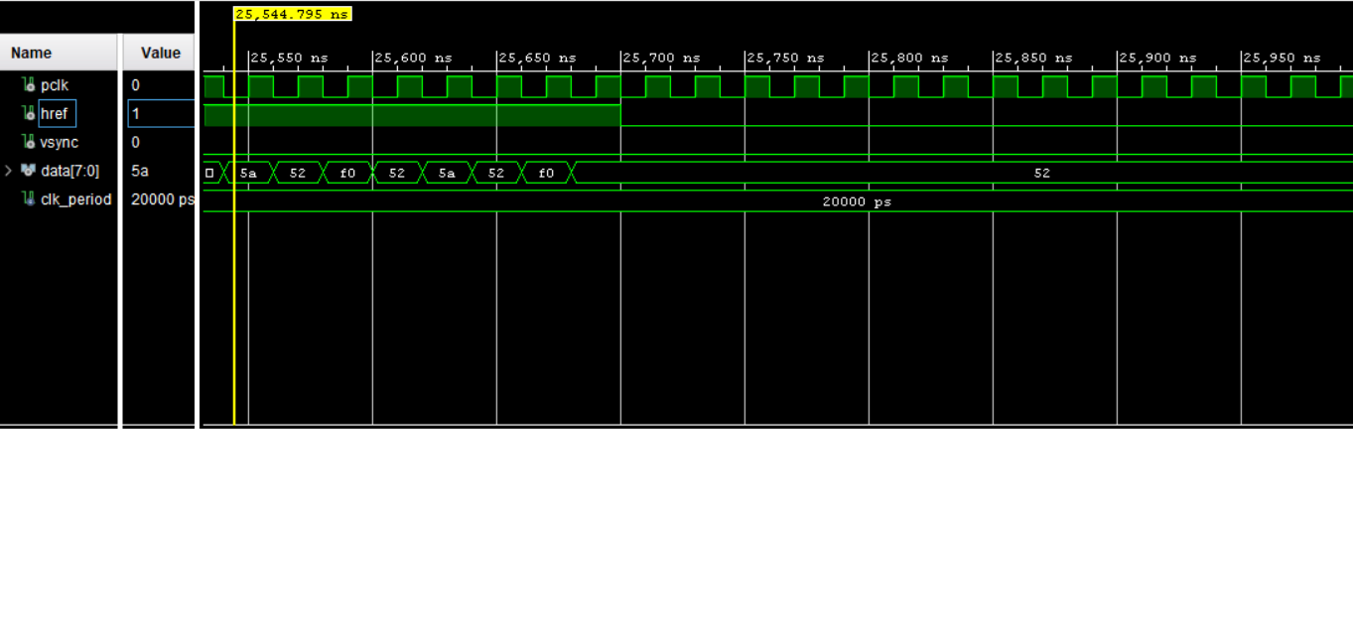

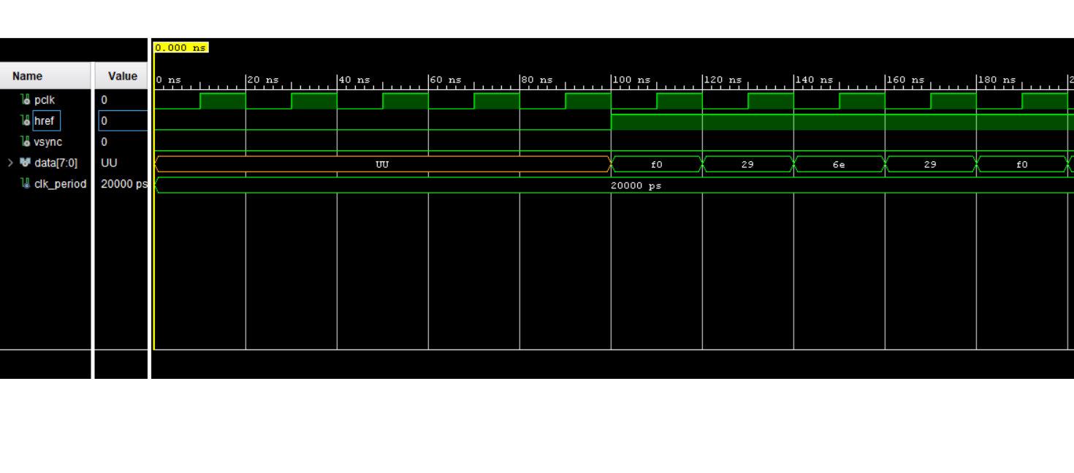

# References

|  |  |
| --- | --- |
| [1] | "VHDL Programming by Example" by Douglas L. Perry |
| [2] | "VHDL: Analysis and Modeling of Digital Systems" by Zainalabedin Navabi |
| [3] | "FPGA Prototyping by VHDL Examples: Xilinx MicroBlaze MCS SoC" by Pong P. Chu |
| [4] | "The Zynq Book" by Louise H. Crockett et al. |
|  |  |