|  |
| --- |
| Digital System Design  SS2024 |
|  |
| Lab 3: JPEG-Encoder |
| Report submitted by:  **Soumya Ranjan Sabat**  Matrikelnr: 1127993  **Azaz Hassan Khan**  Matrikelnr: 1128032 |
|  |
| **June/26/2024** |

Content

1 Introduction 3

1.1 Task1: – Verification of DCT-IP 3

# Introduction

As FPGAs grow in size and complexity, and design timelines become tighter, leveraging third-party IP and design reuse is becoming essential. We utilize a powerful feature within the Vivado Design Suite known as the Vivado IP integrator. This tool allows you to create intricate system designs by instantiating and interconnecting IP from the Vivado IP catalog or other sources.

In this lab, our objective is to analyze a DCT-IP core and synthesize it onto FPGA programmable logic. The goal is to leverage the hardware implementation of the Discrete Cosine Transform (DCT) for rapid JPEG conversion. We employ a Zynq device from Xilinx, a System on Chip (SoC) that integrates an ARM dual-core Cortex-A9 Processing System with FPGA programmable logic.

The workflow involves creating an IP on FPGA programmable logic and interfacing it with a C++ project running on the ARM processor, culminating in a hardware/software co-design. The primary aim of this co-design is performance optimization.

The Discrete Cosine Transform (DCT) is widely used in signal and image processing, particularly for the lossy compression of images, such as JPEG encoding. Various FPGA implementations of the DCT exist. For this lab session, we are utilizing a DCT-IP provided by Unicore Systems, which is freely available via opencores.org.

Part 1: Top level RTL design

## Task1: – Verification of DCT-IP

1.1.1 **Draw a block diagram of the VHDL module,” DCT_AAN”! Briefly explain with the help of IP documentation how to calculate the 2D DCT of an 8x8 matrix**

Task-Description: Describe meaning with the help of IP documentation how to calculate 2D DCT.

Elaboration: Below is the implementation of a 2-D DCT for an 8x8 matrix. The output of the first stage undergoes transposition before being processed by the second stage. Specifically, the output of DCT8AAN1 is connected to DCT8AAN2. The DCT8AAN1 module performs the DCT on each row of the data matrix. The DCT_BUF then converts the data from DCT8AAN1 to the format required by the next module. Subsequently, DCT8AAN2 performs the DCT on each column of the matrix. The output is then passed to another DCT_BUF, which transposes the data matrix obtained from DCT8AAN2 to produce the final desired output.

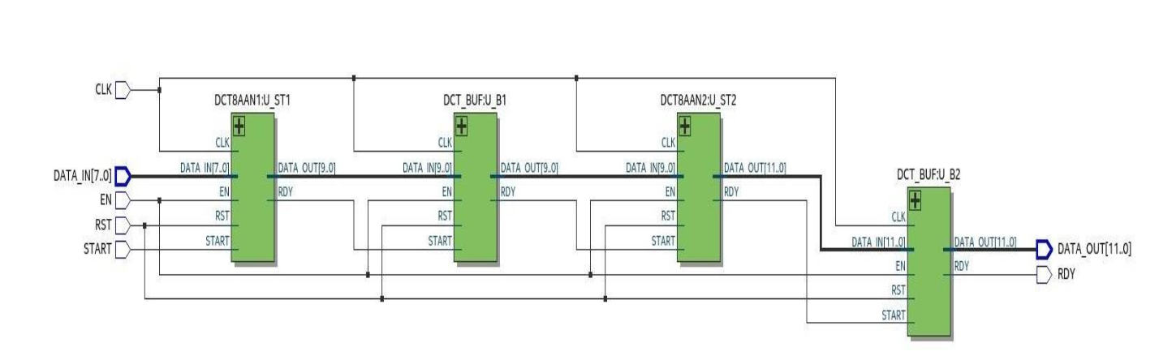

**Fig 1.1 DCT_AAN**

1.1.2 **A test bench for the DCT-IP core is also available. Explain the functions of the three**

**components „TEST_DCT“, „DCT_BEH“ and „BMP_Generator“!**

**What function does the process „ERROR_CALC“ have?**

Task-Description: Explain TEST_DCT, DCT_BEH, BMP_Generator and function ERROR_CALC.

Elaboration:

**TEST_DCT:** This is the test bench for the DCT IP. It instantiates the BMP_GENERATOR, DCT_AAN, and DCT_BEH modules to verify the functionality of the DCT IP. The BMP_GENERATOR creates the data pattern, and the DCT is calculated using two methods within this module. The first method utilizes the DCT_AAN module, while the second method employs the DCT_BEH module.

**DCT_BEH**: This module serves as the behavioral model of the DCT processor, performing 2D DCT calculations using floating-point arithmetic.

**BMP_GENERATOR**: This module generates an 8x8 matrix to serve as input data for the DCT modules.

**ERROR_CALC**: This block computes the difference between the outputs of the DCT_AAN and DCT_BEH modules. The results of these differences are represented by the ERROR signals.

Q2a. **Explain the meaning of the following output signals: DCT[11:0], DCT_STD[11:0], ERROR, QUADMEAN!**

Task-Description: Explain DCT[11:0], DCT_STD[11:0], ERROR, QUADMEAN.

Elaboration:

**DCT[11:0]:** DCT[11:0] is the signal mapped to the output signal data_out[11:0] generated by the module "DCT_AAN".

**DCT_STD[11:0]:** DCT_STD[11:0] is the signal mapped to the output signal data_out[11:0] generated by the module "DCT_BEH".

**ERROR:** The ERROR signal represents the deviation between the two DCT output signals, DCT[11:0] and DCT_STD[11:0].

**QUADMEAN**: The QUADMEAN signal represents the quad mean value of the deviation error derived from the ERROR signal.

1.2.1 **Verify the functionality of the custom IP using the provided test bench. Simulate at least for 20µs (step 4). What is delay (number of clock cycles) between first data input and first data output? How many clock cycles does it take to read in one input matrix? Give min. and max. value of mean square error for this simulation! Attach simulation snapshots to verify your findings!**

Task-Description: Analysis of the waveform.

Elaboration:

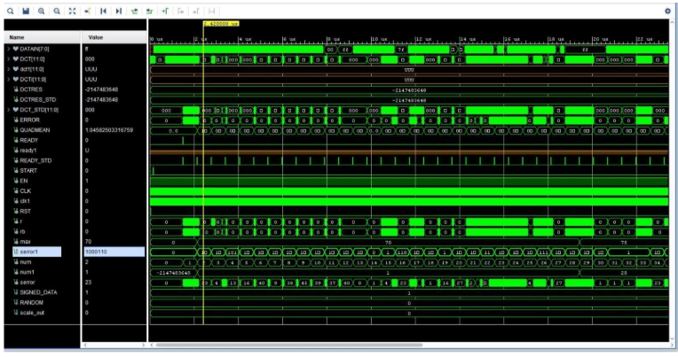

Figure 1.2 Simulation of custom IP

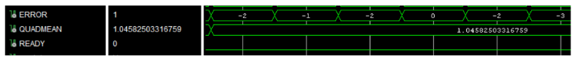

Figure 2.3 Quad Mean Error Max and Min

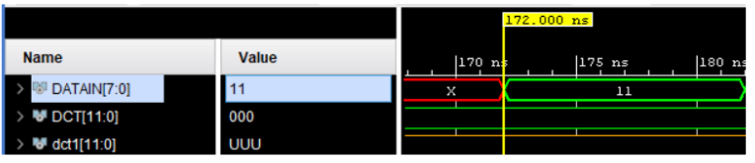

Figure 3.4 First input signal

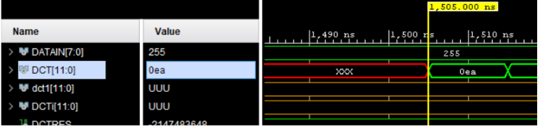

Figure 4.5 First input signal

**First Input Signal**:

- Arrival Time: 172 ns

**First Output Signal**:

- Arrival Time: 1505 ns

**Difference:**

- Time Difference: 1333 ns

**Clock Period**:

- Duration: 10 ns

**Clock Cycles:**

- Number of Clock Cycles between First Input and First Output: Approximately 133 cycles

**Simulation Details:**

- Total Simulation Duration: 20 microseconds

- Observed Delay between First Input and First Output: 132 cycles

- Cycles to Read One 8x8 Input Matrix: 64 cycles

**Quad Mean Error Values:**

- Minimum Value: 0

- Maximum Value: 1.0458

References

|  |  |
| --- | --- |
| [1] | Xilinx, "Zynq-7000 Processing System IP," [Online]. Available: https://www.xilinx.com/products/intellectual-property/processing_system7.html. |
| [2] | Xilinx, "AXI4-Stream Interconnect," ISE Design Suite, [Online]. Available: https://www.xilinx.com/products/intellectual-property/axi4-stream_interconnect.html. [Accessed January 2020]. |
| [3] | Xilinx, "AXI Interconnect," Vivado Design Suite, [Online]. Available: https://www.xilinx.com/products/intellectual-property/axi_interconnect.html. [Accessed January 2020]. |
| [4] |  |
| [5] |  |
| [6] |  |