TGNPDCL Medical Bill Reimbursement Management:
Hospital Login and Bill Upload:
- A Separate Login has to be created for each of the Listed Hospitals in order to Upload the Bills at their end.
- Hospitals to be Categorised as Tier-1 or Tier-2 as per their location.
- Hospitals should input Line-Item wise details (Service Details as per TGNPDCL, Rate, Quantity, Amount and Description as per hospitals).
- Name of a particular Service may be different list as per TGNPDCL and as per Hospital.
- Hospitals should be given an option to manually Type name of their Services as per their Bill.
- Each billing Line Item should have a Document Upload facility.
- After giving Input for Rate and Amount, Total Amount should be auto Calculated
- Similarly Gross Total Amount should be Auto Calculated at the end.
- There Should a Gross Total Field at the end and Final Invoice Upload facility should be there against Gross total Amount. TGNPDCL to confirm the GST part inclusion.
- Apart from Itemized and Final Bill Upload, Hospitals are required to Upload few Mandatory and Optional documents as per the list provided by TGNPDCL.
- Once the Reimbursement Claim with all details are Submitted by Hospitals, it should appear in the TGNPDCL HO Medical Bill Reimbursements Login for Further Scrutiny and Processing.
- Once Any Reimbursement Application is submitted by Hospitals, it should be Submitted with the Unique ID for Future Reference.
- Hospitals should be able to track only the Final Status: Approved/Rejected with Comments
- Required details are provided as per below
  - List of Hospitals (Annexure-A)
  - List of Services (Annexure-B)
  - List of Mandatory Documents to be uploaded by Hospitals (Annexure-C)
  - Header Data Details in the Hospital Form (Annexure-D)

TGNPDCL HO Bill Reimbursement Team Login and Reimbursement Processing:
  - TGNPDCL HO Bill Reimbursement Processing Team will receive the Claims with Unique ID, all details, attachments etc in the Asst./JPO Login as he is the Initiator.
  - Against each Line items from Asst./JPO Login onwards till the Process ends, additional fields for entering Manual data for Approved Rate, Quantity and Amount with Comments should be available.
  - All the Manual data entered by Asst./JPO should appear in all Subsequent work Flows in editable form except the comments field.
  - The amount to be sanctioned must be in general limit, major aliments, minor ailments at the time of creation of file initiation by Assistant/JPO.
  - Reimbursement Limit should not exceed beyond the prescribed limit. For Employees/pensioners/family pensioners ( Minor ceiling 10lakhs+Major ceiling 15 lakhs+ self funding scheme 12lakhs) for Artisans (minor 2 lakhs + self funding scheme 12lakhs). These Limit Amount Can be Manually filled by Assistant/JPO.
  - All the hierarchy should have option to enter comment against each line item if required and that should be saved for next subsequent level.
  - All the Claims has to pass through Work Flows (7 Layers ) and Final Sanction Order released at the end.
  - All Claims has to move to the next level with both the options: Bill for Scrutiny or Bill for Rejection with appropriate comments.
  - Rejection Can be done only by JS (Medical) and Director (HRD and Legal).
  - Any Claim moving in the workflow for Rejection should not hit CGM Audit’s Bucket.
  - Any Claim Approved or Rejected should be Intimated to the respective Hospital with appropriate comments.
  - Approval Work Flow: Asst./JPO PO Asst. Secy G.M (Medical & Personnel) CGM Audit Joint Secy (Medical & Personnel) Director (HRD & Legal Printing of Sanction Order Intimation to Hospital
  - Rejection Work Flow (Scenaria-1): Asst./JPO PO Asst. Secy G.M (Medical & Personnel) Joint Secy (Medical & Personnel) Intimation to Hospital with Comments
  - Rejection Work Flow (Scenaria-2): Asst./JPO PO Asst. Secy G.M (Medical & Personnel) Joint Secy (Medical & Personnel) Director (HRD & Legal Intimation to Hospital with Comments

Annexure-A (Sample list of Hospitals under each Category)

S.No | Name of the Hospital | DISTRICT | Validity Period | Remarks | Category
1 | M/s Omega Hospitals (A unit of Hyderabad Oncology Pvt Ltd), 8-2-293/82/L/276A, SS Plaza Rt.No.12, Banjara Hills, Hyderabad.  Ph.No.040-25551034. | HYD | Up to  15-06-2028 | Renewal | Tier-I
2 | M/s KIMS Hospital Enterprises Pvt. Ltd., 112/86, Sy.No.55/EE, Kondapur, Hyderabad.  Ph: 9140-67505050/47505050. | HYD | Up to  01-02-2027 | Renewal | Tier-I
3 | M/s Kamineni Hospitals , 4-1-1227, Boggulakunta, King Koti Road, Abids, Hyderabad - 500 001.  Ph.No.040-66924444. | HYD | UP to  15-10-2027 | Renewal | Tier-I
4 | Basavatarakam Indo-American Cancer Hospital & Research Institute, Road No.10, Banjara Hills, Hyderabad-34.  Ph.9140-23551235 | HYD | Up to  04-12-2026 | Renewal | Tier-I
5 | M/s Shishira Hospitals, 8-3-903/1/3/3B, Yellareddyguda, Ameerpet, Hyderabad.  Ph:9140-40031777, 40032777, 8609292929. | HYD | Up to  01-02-2026 | New Empanelment | Tier-I
6 | M/s Vijay Advanced Pain Clinic Pvt. Ltd (INDO-BRITISH ADVANCED PAIN CLINIC), 284/A, Road No.12, MLA Colony, Banjara Hills, Hyderabad – 500 034.  Ph.No.9807556789, 040-48504488. | HYD | Up to  28-04-2026 | New Empanelment | Tier-I
7 | National Institute of Gastroenterology and Liver Disease (Renova-NIGL) (A unit of Tejaswini Healthcare services Pvt. Ltd) MLA Colony, Banjara Hills, Hyderabad. | HYD | UP to  13-11-2027 | Renewal | Tier-I
8 | Renova Hospital (A unit of Shakhambari Health Care Services Pvt. Ltd), Petbasheerabad, Secunderabad. | S'BAD | UP to  08-04-2027 | Renewal | Tier-I
9 | Usha Mullapudi Cardiac Centre, Hyderabad | HYD | Up to  22-02-2027 | Renewal | Tier-I
10 | M/s Sai Siddhartha Super Specilaity Hospital, 01076/SSH/8P, Patbasheerabad, Medchal Hyderabad. Ph:833988244, 8333988245. | HYD | Up to  25-03-2027 | New  Empanelment | Tier-I
S.No | Name of the Hospital | DISTRICT | Validity Period | Remarks | Category
1 | Madhukar Reddy Super Speciality Dental Hospital, H.No. 2-2-99, Naimnagar, Hanamkonda, Warangal.  Ph: No.0870-2567577, 9949233559. | WGL | UP to  15-02-2026 | Renewal | Tier-II
2 | Balaji Hospital, Opp: Ram-Laxman theatres, SVN Road, Warangal-506 002. Ph: 0870-2501919, 2426955, 9963641616 | WGL | Up to  19-06-2026 | Renewal | Tier-II
3 | Ajara Hospitals, Ajara Cross Roads, Mulugu Road, Warangal - 506 007. Ph.No.0870-2959555, 2950555 | WGL | Up to  14-04-2026 | Renewal | Tier-II
4 | Laxmi Narasimha Hospital, Beside Pushpanjali Function Hall, Kishanpura, Hanamkonda-506001  Ph.no.0870-2531122, 2531133 | WGL | Up to  16-07-2026 | Renewal | Tier-II
5 | Sri Sharanya Nursing Home & Critical Care Centre,  2-1-1187, Nayeemnagar, Hanamkonda,  Warangal-506009. Ph: 0870-2573835, 8498086890 | WGL | Up to  20-10-2026 | Renewal | Tier-II
6 | M/s Sri Srusti Hospitals, H.No.11-23-1935/1, Beside SR College, Opp: Hp Bunk, Pochammaidan, Warangal.  Cell: 7981623003. | WGL | UP to  27-06-2027 | New Empanelment | Tier-II
7 | M/s Pramoda Hospital, H.No.1-8-283, Near Ekashila Park, Balasamudram, Hanamkonda. Ph: 0870-256889 | WGL | Up to  30-05-2029 | Renewal | Tier-II
8 | M/s Chakravarthy Hospitals (Surgical & Laproscopic Centre), Amuktha Complex, Opp: Ekashila Park, Balasamudram, Hanamkonda, Telangana. Ph.No.9908629966, 7382220123, 7382229123. | HNK | Up to  15-02-2026 | New Empanelment | Tier-II
9 | M/s Sri Chakra Super Speciality Hospital, H.No.1-8-126/4, Opp: Hayagreevachary Compound, Balasamudram, Hanamkonda.  Ph: 0870-3500213, 0870-3500214. | HNK | Up to  11-12-2025 | New Empanelment | Tier-II
10 | M/s Vasan eye care, H.No.6-1-35 & 35/1, Lashkar Bazar, Hanamkonda, Warangal.  Ph: 9144-42820199 | HNK | Up to  25-03-2027 | New Empanelment | Tier-II
S.No | Name of the Hospital | DISTRICT | Validity Period | Remarks | Category
1 | Sri Sai Hospital, Tirumala Chitra Mandir X Road, Phulong, Nizamabad. Ph: 229707 | NZB | Up to  13-08-2026 | RenewalS | Tier-III
2 | Harsha Sai Eye Hospital, H.No. 5-6-305 & 306, Saraswathi Nagar, Nizamabad-503 003. Cell: 9640506574, 8500611450 | NZB | Up to  19-02-2026 | Renewal | Tier-III
3 | M/s Nova Hospitals, H.No.6-6-542, 543, 543/1, Saketh Nagar, Karimnagar. Helpline: 0878-2233108, 7036108555. | KNR | Up to  21-12-2026 | Renewal | Tier-III
4 | M/s Adarsha Multispeciality Hospital, Door No.2-8-85, Beside Padmanayka Kalyana Mandapam, Mukaram Pura, Karimnagar. Ph: 9121000888, 9121999333 | KNR | Up to  07-02-2027 | Renewal | Tier-III
5 | M/s Sai Sindhu Children’s Hospital, H.No.3-1-140, Sawaran Street, Karimangar. Ph.9770108108 | KNR | Up to  04-12-2026 | Renewal | Tier-III
6 | M/s Prathima Dental and Children Hospital, H.No.7-7-24, Jambigadde Road, Jagtial. | JGL | UP to  08-04-2027 | Renewal | Tier-III
7 | M/s Prudence Hospital, Located at H.No.1-12-121/A, Pragathi Nagar, Opp: Yendala Towers, Nizamabad. Ph: 909366666. | NZB | Up to  12-07-2026 | New Empanelment | Tier-III
8 | M/s Jaya Nurshing Home, Near Old Bus Stand, Jagtial. Cell: 9389449999. | JGL | Up to  04-11-2026 | New Empanelment | Tier-III
9 | M/s Brite smile Dental Clinic, Nizamabad District. Ph: 9951888769, 9640167863 | NZB | Up to  28-04-2026 | New Empanelment | Tier-III
10 | M/s Maxcare Hospital, Located at Beside Relieance smart, Kavitha Degree College, Nehru Nagar, Khammam. Ph: 08742-242499, 7799886499. | KMM | Up to  25-10-2026 | New Empanelment | Tier-III

Annexure-B( List Services to be Listed in Hospitals)
SL. No | Service Type
1 | Emergency
2 | Hospital Services
3 | Pharmacy/Drugs/Medicine Charges
4 | Pharmacy/Drugs/Medicine Returns
5 | Intensive Care Units
6 | Room Rent
7 | Investigations
8 | Invasive/Non-Invasive Procedures
9 | Surgery Charges
10 | Procedure Charges
11 | Packages
12 | Blood Bank
13 | Disposables
14 | Consulation Charges
15 | Implants / Medical Appliances
16 | Medical Equipment
17 | Other Hospital Services

Annexure-C (Mandatory List of Documents to be Uploaded by Hospitals)
SL.NO | Document Name
1 | Employee/Pensioner/Artisan- ID card
2 | Approved CC card
3 | Final Hospital bill
4 | Detailed hospital bill
5 | Pharmacy
6 | In-voice
7 | Discharge summary

Annexure-D (Header Data Details)
SL.NO | Header Data Field Name
1 | Hospital Name
2 | Hospital Code
3 | Hospital PAN No.
4 | GST NO.
5 | CIN NO.
6 | Name of the Patient
7 | Designation
8 | Employee ID
9 | Type of Employee: Employee/Pensioner/Family Pensioner/Artisan
10 | Relationship: Self/ Dependent
11 | Credit Card Number
12 | IP NO
13 | Mobile No.
14 | AGE
15 | SEX
16 | Date of Admission
17 | Date od Discharge
18 | Disease Details

Annexure-E (Sample Sanction Oreder)
Page-1
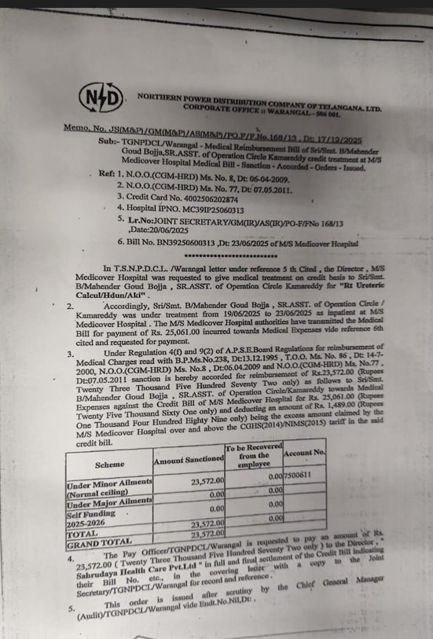

Page-2
