# CHAPTER 1

# INTRODUCTION

## PROJECT DESCRIPTION

Finding jobs that best suits the interests and skill set is quite a challenging task for the job seekers. The difficulties arise from not having proper knowledge on the organization’s objective, their work culture and current job openings. In addition, finding the right candidate with desired qualifications to fill their current job openings is an important task for the recruiters of any organization. Online Job Search Portals have certainly made job seeking convenient on both sides. Job Portal is the solution where recruiter as well as the job seeker meet aiming at fulfilling their individual requirement. They are the cheapest as well as the fastest source of communication reaching wide range of audience on just a single click irrespective of their geographical distance.

The web application “Job Search Portal” provides an easy and convenient search application for the job seekers to find their desired jobs and for the recruiters to find the right candidate. Job seekers from any background can search for the current job openings. Job seekers can register with the application and update their details and skill set. They can search for available jobs and apply to their desired positions. Android, being open source has already made its mark in the mobile application development. To make things handy, the user functionalities are developed as an Android application. Employer can register with the application and posts their current openings. They can view the Job applicants and can screen them according to the best fit. Users can provide a review about an organization and share their interview experience, which can be viewed by the Employers.

**1.2 OBJECTIVE OF THE MINI PROJECT**

* The main objective of the project is to design and develop a user-friendly system.
* Easy to use and efficient computerized system.
* To develop an accurate and flexible system, it will eliminate data redundancy.
* Computerization can be helpful as means of saving time & money.
* To provide better graphical user interface.
* Less chances of information leakage.

**1.3 FEATURES OF MINI PROJECT**

1. Add Members:

Adds the member which can be a job seeker or employer.

1. Add Details:

The employer can add detail of his/her company along with the details on the type of job.

The job seeker can add his/her details and apply through the company website.

1. Add Jobs:

The employer can add details on what kind of job is present its domain, location, date till when the job is valid and other specification.

The job seeker can view these details and search on the basis of location and other specific domains to apply for a job.

1. Managing added Jobs:

The employer can add/delete/edit the jobs already added. They can also maintain the status of the job as filled/required accordingly.

5. Dashboard:

The employer dashboard contains details on jobs added, the company details and other information which are editable.

The job seekers dashboard contains profile information, list of all jobs the person has applied and its status. All these are editable by the person.

6. Featured Jobs:

The main page contains a list of featured jobs and the most trending jobs which makes it easier for the job seeker to apply.

**CHAPTER 2**

**RELATED WORK**

It is always necessary to study and recognize the problems of existing system, which will help in finding out the requirements for the new system. System study helps in finding different alternatives for better solution.

The project study basically deals with different operations and steps involved in generation of examination mark sheets. it includes:

1. Data gathering

2. Study of existing system

3. Analysing problem

4. Studying various documents

5. Feasibility study for further improvements

Following are the steps taken during the initial study: Initially, we collected all the information, which they wanted to store. Then we studied the working of the current system which is done manually. We noted the limitation of that system which motivated them to have new system. With the help of these documents we got basic ideas about the system as well as input output of the developed system.

The most important thing is to study system thoroughly. Here we are studying both existing system and proposed system so that advantages & disadvantages of both the systems can be understood the first task was identifying how system can be computerized. Some analysis and projections were done regarding changes to be made to the existing system. The new developed system for Online Job Portal is simple without complexities.

**2.1 EXISTING AND PROPOSED SYSTEM**

**2.1.1 EXISTING SYSTEM**

The existing system for job recruitment includes traditional methods like Employment agencies, advertising through newspapers, televisions and radios, college fairs etc., which are too slow and stressful. With the advancement of internet, jobseekers rely on the online job portals, which makes the job search efficient. Again, most of these are limited to the web/desktop applications, which requires jobseekers to have a laptop or desktop connected to internet and is not handy.

* Manual maintenance of the records and files
* Improper file tracking system
* More Human resource with less efficiency
* Human errors as forgetfulness, ambiguity in work
* Chances of an error in one department is carried to other departments
* Time consuming process
* Human is restricted to working time
* As files are more the data may repeat in more than one department
* Storage or memory needed is more and causes confusion at the end of the month
* As files are in paper a small damage to the file is huge loss to the company
* Difficult to maintain the duplicates
* It takes lot of time to prepare the file when the original is lost

**2.1.2 PROPOSED SYSTEM**

Job Search Portal is a Java-based web application as well as Android application that provides functionalities of e-recruitment on desktop and on portable devices like Android based smart phones/tablets. Both applications do not require internet to perform the desired functionalities.

* Efficiency of the organization is improved
* Time spent on every work is highly reduced
* Less manpower is needed as computer can replace so many subtasks
* The file systems cannot be needed to store in the sheet of paper
* The electronic media of storage of files in the company save lot of space (paper-less-office)
* The system admin can easily take the back-up of all the office work
* There is no barrier of losing the data when any damage happens to the computer
* It is easy to track the activities of the entire company from dept. to dept. as the software is designed to operate centrally.

**2.2 FEASIBILITY STUDY**

Job Search Portal is developed to provide an effective means for the employers to post job openings with required qualification to have a better penetration into the job market and jobseekers to find out the information regarding the current openings in the organization. In addition, Employers can view the reviews provided by the applicants to make necessary improvements in their system if needed.

After doing the project Online Job Portal study and analysing all the existing or required functionalities of the system, the next task is to do the feasibility study for the project. All project are feasible-given unlimited resources and infinite time.

Feasibility study includes consideration of all the possible ways to provide a solution to the given problem. The proposed solution should satisfy all the user requirements and should be flexible enough so that future changes can be easily done based on the future upcoming requirements.

**A. Economic Feasibility**

This is a very important aspect to be considered while developing a project. We decided the technology based on minimum possible cost factor.

* All hardware and software cost has to be borne by the organization.
* Overall we have estimated that the benefits the organization is going to receive from the proposed system will surely overcome the initial costs and the later on running cost for system.

**B. Technical Feasibility**

This included the study of function, performance and constraints that may affect the ability to achieve an acceptable system. For this feasibility study. We studies complete functionality to be provided in the system as described in the system requirement specification(SRS) and checked if everything was possible using different of frontend and backend platforms.

**C. Operational Feasibility**

No doubt the proposed system is fully GUI based that is very user friendly and all inputs to be taken all self-explanatory even to a layman. Besides, a proper training has been conducted to let known the essence of the system of the system to the users so that they feel comfortable with new system. As far our study is concerned the clients are comfortable and happy as the system has cut down their loads and doing.

**2.3 OBJECTIVE**

The objective of the web is to provide flexibility to the jobseekers by providing the functionalities of both job search and job application in a single application. In addition, this application provides an effective means for the employers to post job vacancies and view the job applications by the interested applicants in a single application. Employers can also view the reviews provided by the jobseekers.

**CHAPTER 3**

**HARDWARE AND SOFTWARE REQUIREMENT**

**3.1 REQUIREMENT SPECIFICATION**

**Hardware Components Used:**

* Processor : Intel processor
* RAM : 256 MB or more
* Hard Disk Space : 8 GB or more

**Software Requirements:**

* Operating System : Microsoft Windows 10 Professional
* Database : MS SQL Server 2018 Management Studio
* IDE : MS Visual Studio 2017
* Technologies : .NET Framework 4.5
* Front End : XML,C#

**3.2 OVERVIEW OF TOOLS:**

* **MS VISUAL STUDIO**:Microsoft Visual Studio is an [integrated development environment](https://en.wikipedia.org/wiki/Integrated_development_environment) (IDE) from [Microsoft](https://en.wikipedia.org/wiki/Microsoft). It is used to develop [computer programs](https://en.wikipedia.org/wiki/Computer_program), as well as [websites](https://en.wikipedia.org/wiki/Web_site), webapps, [web services](https://en.wikipedia.org/wiki/Web_service) and [mobile apps](https://en.wikipedia.org/wiki/Mobile_app). Visual Studio uses Microsoft software development platforms such as [Windows API](https://en.wikipedia.org/wiki/Windows_API), [Windows Forms](https://en.wikipedia.org/wiki/Windows_Forms), [Windows Presentation Foundation](https://en.wikipedia.org/wiki/Windows_Presentation_Foundation), [Windows Store](https://en.wikipedia.org/wiki/Windows_Store) and [Microsoft Silverlight](https://en.wikipedia.org/wiki/Microsoft_Silverlight). It can produce both [native code](https://en.wikipedia.org/wiki/Machine_code) and [managed code](https://en.wikipedia.org/wiki/Managed_code). Visual Studio includes a [code editor](https://en.wikipedia.org/wiki/Code_editor) supporting [IntelliSense](https://en.wikipedia.org/wiki/IntelliSense) (the [code completion](https://en.wikipedia.org/wiki/Code_completion) component) as well as [code refactoring](https://en.wikipedia.org/wiki/Code_refactoring). [The integrated debugger](https://en.wikipedia.org/wiki/Microsoft_Visual_Studio_Debugger) works both as a source-level debugger and a machine-level debugger. Other built-in tools include a [code profiler](https://en.wikipedia.org/wiki/Profiling_(computer_programming)), forms designer for building [GUI](https://en.wikipedia.org/wiki/GUI) applications, [web designer](https://en.wikipedia.org/wiki/Web_designer), [class](https://en.wikipedia.org/wiki/Class_(computing)) designer, and [database schema](https://en.wikipedia.org/wiki/Database_schema) designer. It accepts plug-ins that enhance the functionality at almost every level.
* **.NET FRAMEWORK**:.NET Framework (pronounced as "*dot net"*) is a [software framework](https://en.wikipedia.org/wiki/Software_framework) developed by [Microsoft](https://en.wikipedia.org/wiki/Microsoft) that runs primarily on [Microsoft Windows](https://en.wikipedia.org/wiki/Microsoft_Windows). It includes a large [class library](https://en.wikipedia.org/wiki/Class_library) named as [Framework Class Library](https://en.wikipedia.org/wiki/Framework_Class_Library) (FCL) and provides [language interoperability](https://en.wikipedia.org/wiki/Language_interoperability) (each language can use code written in other languages) across several [programming languages](https://en.wikipedia.org/wiki/Programming_language). Programs written for .NET Framework execute in a [software](https://en.wikipedia.org/wiki/Software) environment (in contrast to a [hardware](https://en.wikipedia.org/wiki/Computer_hardware) environment) named the [Common Language Runtime](https://en.wikipedia.org/wiki/Common_Language_Runtime) (CLR). The CLR is an [application virtual machine](https://en.wikipedia.org/wiki/Process_virtual_machine) that provides services such as security, [memory management](https://en.wikipedia.org/wiki/Memory_management), and [exception handling](https://en.wikipedia.org/wiki/Exception_handling). As such, computer code written using .NET Framework is called "[managed code](https://en.wikipedia.org/wiki/Managed_code)". FCL and CLR together constitute the .NET Framework.
* **XML**:Extensible Mark-up Language (XML) is a [mark-up language](https://en.wikipedia.org/wiki/Markup_language) that defines a set of rules for encoding [documents](https://en.wikipedia.org/wiki/Electronic_document) in a [format](https://en.wikipedia.org/wiki/File_format) that is both [human-readable](https://en.wikipedia.org/wiki/Human-readable_medium) and [machine-readable](https://en.wikipedia.org/wiki/Machine-readable_data). The [W3C](https://en.wikipedia.org/wiki/World_Wide_Web_Consortium)'s XML 1.0 Specificationand several other related specifications all of them free [open standards](https://en.wikipedia.org/wiki/Open_standard)—define XML. The design goals of XML emphasize simplicity, generality, and usability across the Internet. It is a textual data format with strong support via [Unicode](https://en.wikipedia.org/wiki/Unicode) for different [human languages](https://en.wikipedia.org/wiki/Language). Although the design of XML focuses on documents, the language is widely used for the representation of arbitrary [data structures](https://en.wikipedia.org/wiki/Data_structure)[[6]](https://en.wikipedia.org/wiki/XML#cite_note-6) such as those used in [web services](https://en.wikipedia.org/wiki/Web_service).
* **C#** :C# (pronounced *C sharp*) is a general-purpose, [multi-paradigm programming language](https://en.wikipedia.org/wiki/Multi-paradigm_programming_language) encompassing [strong typing](https://en.wikipedia.org/wiki/Strong_typing), [lexically scoped](https://en.wikipedia.org/wiki/Lexically_scoped), [imperative](https://en.wikipedia.org/wiki/Imperative_programming), [declarative](https://en.wikipedia.org/wiki/Declarative_programming), [functional](https://en.wikipedia.org/wiki/Functional_programming), [generic](https://en.wikipedia.org/wiki/Generic_programming), [object-oriented](https://en.wikipedia.org/wiki/Object-oriented_programming) ([class](https://en.wikipedia.org/wiki/Class_(computer_science))-based), and [component-oriented](https://en.wikipedia.org/wiki/Component-based_software_engineering) programming disciplines. It was developed around 2000 by [Microsoft](https://en.wikipedia.org/wiki/Microsoft) within its .NET initiative and later approved as a standard by Ecma (ECMA-334) and [ISO](https://en.wikipedia.org/wiki/International_Organization_for_Standardization) (ISO/IEC 23270:2018). C# is one of the programming languages designed for the [Common Language Infrastructure](https://en.wikipedia.org/wiki/Common_Language_Infrastructure).
* **MS SQl**:SQL Server Management Studio (SSMS) is a software application first launched with [Microsoft](https://en.wikipedia.org/wiki/Microsoft) [SQL Server 2005](https://en.wikipedia.org/wiki/Microsoft_SQL_Server) that is used for configuring, managing, and administering all components within [Microsoft SQL Server](https://en.wikipedia.org/wiki/Microsoft_SQL_Server). The tool includes both script editors and graphical tools which work with objects and features of the server. A central feature of SSMS is the Object Explorer, which allows the user to browse, select, and act upon any of the objects within the server.
* **CSS: CSS tutorial** or CSS 3 tutorial provides basic and advanced concepts of CSS technology. Our CSS tutorial is developed for beginners and professionals. The major points of CSS are given below:
* CSS stands for Cascading Style Sheet.
* CSS is used to design HTML tags.
* CSS is a widely used language on the web.
* HTML, CSS and JavaScript are used for web designing. It helps the web designers to apply style on HTML tags.

**Cascading Style Sheets** (**CSS**) is a style sheet language used for describing the look and formatting of a document written in a mark-up language. While most often used to style web pages and user interfaces written in HTML and XHTML, the language can be applied to any kind of XML document, including plain XML, SVG and XUL. CSS is a cornerstone specification of the web and almost all web pages’ use CSS style sheets to describe their presentation.

CSS is designed primarily to enable the separation of document content from document presentation, including elements such as the layout, colours, and fonts. This separation can improve content accessibility, provide more flexibility and control in the specification of presentation characteristics, enable multiple pages to share formatting, and reduce complexity and repetition in the structural content (such as by allowing for table less web design).

CSS can also allow the same mark-up page to be presented in different styles for different rendering methods, such as on-screen, in print, by voice (when read out by a speech-based browser or screen reader) and on Braille-based, tactile devices. It can also be used to allow the web page to display differently depending on the screen size or device on which it is being viewed. While the author of a document typically links that document to a CSS file, readers can use a different style sheet, perhaps one on their own computer, to override the one the author has specified.

## SQL SERVER EXPRES LIMITATION:

Before deploying SQL Server Express, you should make yourself aware of its [limitations](http://www.ginktage.com/2013/03/what-are-the-limitations-of-sql-server-express-edition/) which include:

* 1GB maximum memory used by the SQL Server Database Engine
* The maximum size of each relational database is 10GB
* SQL Agent is not included in Express. The SQL Agent is a background tool which enables administrators to automate tasks like backing up data, database replication setup, job scheduling, user permissions, and database monitoring.
* The limit on the buffer cache for each instance is 1MB of RAM.
* The relational database engine is restricted to the lesser of 1 socket or 4 cores.

**CHAPTER 4**

**EXISTING AND PROPOSED SYSTEMS**

**4.1 THEORITICAL BACKGROUND**

We have done a project on and database management and transactions. This system is proposed to be an automate database management & transactions. This stores employee, employer, job seeker, job information, and company details. It also provides the facility of search & advanced search for searching the records efficiently & immediately. This system provides data storing & report generation with graphical user interface (GUI).

**4.2 SYSTEM STUDY**

It is always necessary to study and recognize the problems of existing system, which will help in finding out the requirements for the new system. System study helps in finding different alternatives for better solution.

The project study basically deals with different operations:

1: Data Gathering

2: Study of Existing System

3: Analysing Problems

4: Studying various documents

5: Feasibility study for further improvements

**Following are the steps taken during the initial study:**

Initially, we collected all the information, which they wanted to store. Then we studied the working of the current system which is done manually. We noted the limitation of that system which motivated them to have new system. With the help of these documents we got basic ideas about the system as well as input output of the developed system. The most important thing is to study system thoroughly. Here we are studying both existing system and proposed system so that advantages & disadvantages of both the 4 systems can be understood. The first task was identifying how system can be computerized. Some analysis and projections were done regarding changes to be made to the existing system. The new developed system for Online Job Portal is simple without complexities.

**4.3 LIMITATION OF EXISTING SYSTEM:**

1. Time consumption:

As the records are to be manually maintained it consumes a lot of time.

2. Paper work:

Lot of paper work is involved as the records are maintained in the files & registers

3. Storage requirements:

As files and registers are used the storage space requirement is increased.

4. Less reliable:

Use of papers for storing valuable data information is not at all reliable.

5. Accuracy:

As the system is in manual there are lot many chances of human errors. These can cause errors

in calculating mechanism or maintaining customer details.

6. Difficulty in keeping new records:

It is difficult for keeping all the new entries of members, their account and transaction details.

**4.4 SCOPE OF PROPOSED SYSTEM**

The proposed system is managed by the visual basic 6.0, which are user friendly windows for every user and for maintaining the database Microsoft access is used.

Scope of proposed system:

The system proposed has many advantages.

1. The proposed system is highly secured, because for login the system it requires the username and password which is different for each department therefore providing each department a different view of the customer information.

2. It provides wide range of certain criteria in each window the client is working for better and quicker solution.

3. It maintains report for all criteria and transactions.

4. Manages member information separately for all exercise and employee information separately for considering the requirements of gym.

5. Stores information about regular products.

6. This system can run on any windows operating system.

**CHAPTER 5**

**IMPLEMENTATION**

**5.1 ER diagram**

An Entity-Relationship (ER) model is an abstract way to describe a database. It is a popular high-level conceptual data model. Entity-Relationship diagrams are used to present the diagrammatic notations associated with ER model.

**5.1.1 Notations for ER diagram**

**Symbols Meanings**

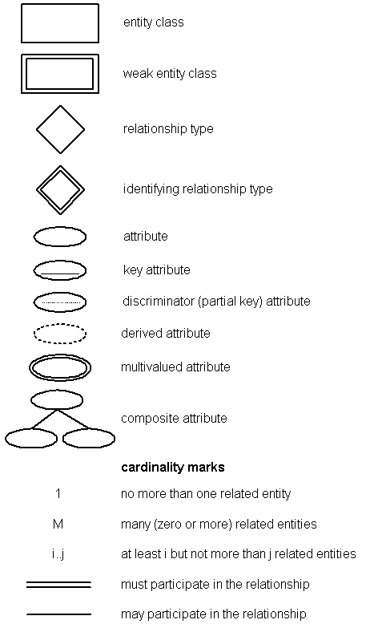

**5.1.2 ER Diagram for Online Job Portal**

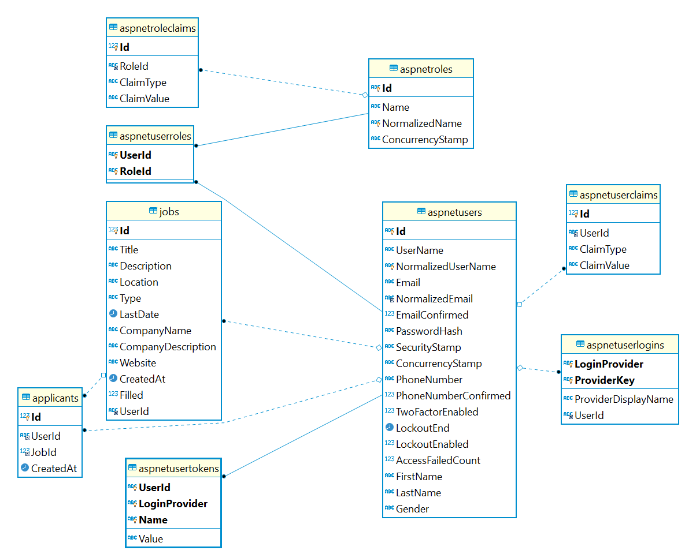

## 5.2 SYSTEM DESIGN

Systems design is the process of defining the architecture, components, modules, interfaces, and data for a system to satisfy specified requirements. Systems design could see it as the application of systems theory to product development. There is some overlap with the disciplines of systems analysis, systems architecture and systems engineering. If the broader topic of product development "blends the perspective of marketing, design, and manufacturing into a single approach to product development," then design is the act of taking the marketing information and creating the design of the product to be manufactured. Systems design is therefore the process of defining and developing systems to satisfy specified requirements of the user.

Until the 1990s systems design had a crucial and respected role in the data processing industry. In the 1990s standardization of hardware and software resulted in the ability to build modular systems. The increasing importance of software running on generic platforms has enhanced the discipline of software engineering.

Object-oriented analysis and design methods are becoming the most widely used methods for computer systems design. The UML has become the standard language in object-oriented analysis and design. It is widely used for modelling software systems and is increasingly used for high designing non-software systems and organizations.

System design is one of the most important phases of software development process. The purpose of the design is to plan the solution of a problem specified by the requirement documentation. In other words, the first step in the solution to the problem is the design of the project.

## 5.3 CONNECTIVITY TO DATABASE

We have implemented a MySQL database for this project, to store the employee data and other relevant information. There are in total 6 tables created. We made use of “Xampp Server” to start and use MySQL Server. Thus, creating the database and respective tables.

My SQL Server is to be turned-on and then the desired database is created to store the information with relationships among different tables.

All the information can be inserted, retrieved as well as updated into the database. MySQL not only stores the data, but also secures the data within the database.

To run the application, one must connect to MySQL Server and perform the below given procedure.

To connect to the database created in MySQL Server, the following steps must be followed:-

1. To on MySQL Server on your local machine, where you want the application to run.
2. Import the database file of this application from the “Database” folder.
3. On successful import, all the data within the database can be visualised from the MySQL command line client or the “localhost/phpMyAdmin” dashboard.

**5.4 .NET FRAMEWORK**

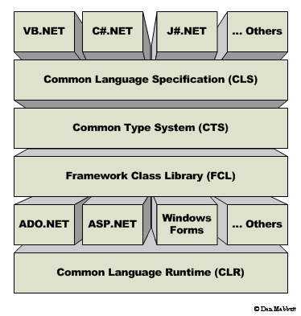The Microsoft .Net Framework is a platform that provides tools and technologies you need to build Networked Applications as well as Distributed Web Services and Web Applications. The .Net Framework provides the necessary compile time and run-time foundation to build and run any language that conforms to the Common Language Specification (CLS).The main two components of .Net Framework are Common Language Runtime (CLR) and .Net Framework Class Library (FCL).

The Common Language Runtime (CLR) is the runtime environment of the .Net Framework , that executes and manages all running code like a Virtual Machine.

The .Net Framework Class Library (FCL) is a huge collection of language-independent and type-safe reusable classes. The .Net Framework Class Libraries (FCL) are arranged into a logical grouping according to their functionality and usability is called Namespaces. In the following sections describes how to .Net Framework manages the code in compile time and run time.

**Microsoft .Net Namespaces**

Namespaces are the way to organize .NET [Framework Class Library](http://vb.net-informations.com/framework/framework_class_library.htm) into a logical grouping according to their functionality, usability as well as category they should belong to, or we can say [Namespaces](http://vb.net-informations.com/framework/namespaces.htm) are logical grouping of types for the purpose of identification.

The [.NET Framework](http://vb.net-informations.com/framework/what_is_net_framework.htm) Class Library (FCL ) is a large collection of thousands of Classes. These Classes are organized in a hierarchical tree. The System Namespaces is the root for types in the .NET Framework. We can uniquely identify any Class in the .NET Framework Class Library (FCL ) by using the full Namespaces of the class .In .Net languages every of a Data Definition Language (DDL), Data Manipulation Language (DML), and Data Control Language (DCL).

**5.5 ASP.NET**

ASP.NET is more than the next version of Active Server Pages (ASP); it provides a unified Web development model that includes the services necessary for developers to build enterprise-class Web applications. While ASP.NET is largely syntax compatible with ASP, it also provides a new programming model and infrastructure for more scalable and stable applications that help provide greater protection. You can feel free to augment your existing ASP applications by incrementally adding ASP.NET functionality to them.

ASP.NET is a compiled, .NET-based environment; you can author applications in any .NET compatible language, including Visual Basic .NET, C#, and Javascript .NET. Additionally, the entire .NET Framework is available to any ASP.NET application. Developers can easily access the benefits of these technologies, which include the managed common language runtime environment, type safety, inheritance, and so on.ASP.NET is a development framework for building web pages and web sites with HTML, CSS, JavaScript and server scripting.

ASP.NET supports three different development model:

* MVC (Model View Controller),
* Web Form,
* Web Pages.

 Developers can use Web Forms or XML Web services when creating an ASP.NET application or combine these in any way they see fit. Each is supported by the same infrastructure that allows you to use authentication schemes, cache frequently used data, or customize your application's configuration, to name only a few possibilities.

Web Forms allow you to build powerful forms-based Web pages. When building these pages, you can use ASP.NET server controls to create common UI elements, and program them for common Works. These controls allow you to rapidly build a Web Form out of reusable built-in or custom components, simplifying the code of a page. For more information, see Web Forms Pages. For information on how to develop ASP.NET server controls, see Developing ASP.NET Server Controls.

An XML Web service provides the means to access server functionality remotely. Using XML Web services, businesses can expose programmatic interfaces to their data or business logic, which in turn can be obtained and manipulated by client and server applications. XML Web services enable the exchange of data in client-server or server-server scenarios, using standards like HTTP and XML messaging to move data across firewalls. XML Web services are not tied to a particular component technology or object-calling convention. As a result, programs written in any language, using any component model, and running on any operating system can access XML Web services. For more information, see XML Web Services Created Using ASP.NET and XML Web Service Clients.

Each of these models can take full advantage of all ASP.NET features, as well as the power of the .NET Framework and .NET Framework common language runtime. These features and how you can use them are outlined as follows:

If you have ASP development skills, the new ASP.NET programming model will seem very familiar to you. However, the ASP.NET object model has changed significantly from ASP, making it more structured and object-oriented. Unfortunately, this means that ASP.NET is not fully backward compatible; almost all existing ASP pages will have to be modified to some extent in order to run under ASP.NET. In addition, major changes to Visual Basic .NET mean that existing ASP pages written with Visual Basic Scripting Edition typically will not port directly to ASP.NET. In most cases, though, the necessary changes will involve only a few lines of code. For more information, see Migrating from ASP to ASP.NET.

Accessing databases from ASP.NET applications is an often-used technique for displaying data to Web site visitors. ASP.NET makes it easier than ever to access databases for this purpose. It also allows you to manage the database from your code. For more information, see Accessing Data with ASP.NET.

**Creating ASP.NET Web Applications**

Creating ASP.NET Web applications involves working with many of the same elements you use in any desktop or client-server application. These include:

**1. Project management features** when creating an ASP.NET Web application, you need to keep track of the files you need, which ones need to be compiled, and which need to be deployed.

**2. User interface**   Your application typically presents information to users; in an ASP.NET Web application, the user interface is presented in Web Forms pages, which send output to a browser. Optionally, you can create output tailored for mobile devices or other Web appliances.

**3. Components** Many applications include reusable elements containing code to perform specific Works. In Web applications, you can create these components as XML Web services, which makes them callable across the Web from a Web application, another XML Web service, or a Windows Form, for example.

**4. Data** most applications require some form of data access. In ASP.NET Web applications, you can use ADO.NET, the data services that are part of the .NET Framework.

**5. Security, performance, and other infrastructure features** as in any application, you must implement security to prevent unauthorized use, test and debug the application, tune its performance, and perform other Works not directly related to the application's primary function.

**5.6 MS SQL SERVER**

Microsoft SQL Server is a full-featured relational database management system (RDBMS) An important feature of relational systems is that a single database can be spread across several tables. This differs from flat-file databases, in which each database is self-contained in a single table. Almost all full-scale database systems are RDBMS's. Small database systems, however, use other designs that provide less flexibility in posing queries. That offers a variety of administrative tools to ease the burdens of database development, maintenance and administration. In this article, we'll cover six of the more frequently used tools: Enterprise Manager, Query Analyzer, SQL Profiler, Service Manager, Data Transformation Services and Books Online.

Enterprise Manager is the main administrative console for SQL Server installations. It provides you with a graphical "birds-eye" view of all of the SQL Server installations on your network. You can perform high-level administrative functions that affect one or more servers, schedule common maintenance Works or create and modify the structure of individual databases.   
Query Analyzer offers a quick and dirty method for performing queries against any of your SQL Server databases. It's a great way to quickly pull information out of a database in response to a user request, test queries before implementing them in other applications, create/modify stored procedures and execute administrative Works.

# CHAPTER 6

**TESTING**

Testing is a process of executing a program with the intent of finding bugs that makes the application fail to meet the expected behaviour. Regardless of the development methodology, the ultimate goal of testing is to make sure that what is created does what it is supposed to do. Testing plays a critical role for assuring quality and reliability of the software. The test cases should be designed with maximum possibilities of finding the errors or bugs. Various level of testing are as follows.

**6.1 Testing Levels**

• Unit testing: Unit testing tests the functionality of individual units of source code. It is the smallest component of a testable software that works in isolation with other parts of the code. I have done unit testing for various individual components of the source code to uncover errors within the boundary of the application.

• Integration testing: Integration testing focuses on the design and construction of the software. Here the individual components that are tested using unit tests are combined and tested as a group. Its primary purpose is to expose the defects associated with the interfacing of modules. It checks if the modules perform the desired functionality when integrated together.

• System testing: System testing is performed on a completely integrated system to see if it meets the requirements.

• Regression testing: Regression testing aims at verifying the functionality of the software that is previously tested and to which changes are made. It is to ensure the old software still works with new changes.

• Acceptance testing: Acceptance testing is conducted to verify if the system compliance the business requirements. Adhering to the levels of testing, Unit testing is performed on individual components of the system ensuring the expected behaviour. Later, I have integrated various components together and performed Integration testing. Once the integration testing is done, I have performed System testing and ensured the application works as per the requirements. Finally, acceptance testing is performed to check if the client accepts the system.

**6.2 STEPS IN THE SOFTWARE TESTING**

**a) The steps involved during Unit testing are as follows:**

a. Preparation of the test cases.

b. Preparation of the possible test data with all the validation checks.

c. Complete code review of the module.

d. Actual testing done manually.

e. Modifications done for the errors found during testing.

f. Prepared the test result scripts.

**b) The unit testing done included the testing of the following items:**

1. Functionality of the entire module/forms.

2. Validations for user input.

3. Checking of the Coding standards to be maintained during coding.

4. Testing the module with all the possible test data.

5. Testing of the functionality involving all type of calculations etc.

6. Commenting standard in the source files.

After completing the Unit testing of all the modules, the whole system is integrated with all its dependencies in that module. While System Integration, We integrated the modules one by one and tested the system at each step. This helped in reduction of errors at the time of the system testing.

**c) The steps involved during System testing are as follows:**

• Integration of all the modules/forms in the system.

• Preparation of the test cases.

• Preparation of the possible test data with all the validation checks.

• Actual testing done manually.

• Recording of all the reproduced errors.

• Modifications done for the errors found during testing.

• Prepared the test result scripts after rectification of the errors.

**d) The System Testing done included the testing of the following items:**

1. Functionality of the entire system as a whole.

2. User Interface of the system.

3. Testing the dependent modules together with all the possible test data scripts.

4. Verification and Validation testing.

5. Testing the reports with all its functionality.

After the completion of system testing, the next following phase was the Acceptance Testing. Clients at their end did this and accepted the system with appreciation. Thus, we reached the final phase of the project delivery.

**e) There are other six tests, which fall under special category. They are described below:**

• **Peak Load Test:** It determines whether the system will handle the volume of activities that occur when the system is at the peak of its processing demand. For example, test the system by activating all terminals at the same time.

• **Storage Testing:** It determines the capacity of the system to store transaction data on a disk or in other files.

• **Performance Time:** Testing: it determines the length of time system used by the system to process transaction data. This test is conducted prior to implementation to determine how long it takes to get a response to an inquiry, make a backup copy of a file, or send a transmission and get a response.

**• Recovery Testing:** This testing determines the ability of user to recover data or re-start system after failure. For example, load backup copy of data and resume processing without data or integrity loss.

• **Procedure Testing:** It determines the clarity of documentation on operation and uses of system by having users do exactly what manuals request. For example, powering down system at the end of week or responding to paper-out light on printer.

**• Human Factors Testing:** It determines how users will use the system when processing data or preparing reports.

**6.3 Performance Testing**

Performance testing is performed to determine how well the system can perform in terms of responsiveness under all kinds of load. The web application is tested to see if it can sustain huge number of requests providing higher throughput under different loads. I have simulated multiple hits on various pages of the application to evaluate the overall performance.

**6.4 Profiling**

GPU Rendering Profile GPU Rendering gives you a quick visual representation of how much time it takes to render the frames of a UI window relative to the 16-ms-per-frame benchmark. It helps you to see how a UI window performs against the 16-ms-per-frame target. It helps in identifying if any part of the rendering pipeline stands out in using processing time. The tool displays a graph for each application. The tool shows up vertical bars on the screen, graphing performance of the application. The taller the bar, the longer it takes to render. The graph has coloured sections representing the phase of the rendering pipeline.

• The green line is the 16 milliseconds Reference Bar. Any time a bar pushes above this line, there may be pauses in the animations.

• The blue section of the bar represents the time used to create and update the View's display lists.

• The purple section of the bar represents the time spent transferring resources.

• The red section of the bar represents the time spent by Android's 2D renderer issuing commands to OpenGL to draw and redraw display lists.

• The orange section of the bar represents the time the CPU is waiting for the GPU to finish its work.

# CHAPTER 7

# SNAPSHOTS

This section describes the screens of the “Online Job Portal”.

The snapshots are shown below for each module.

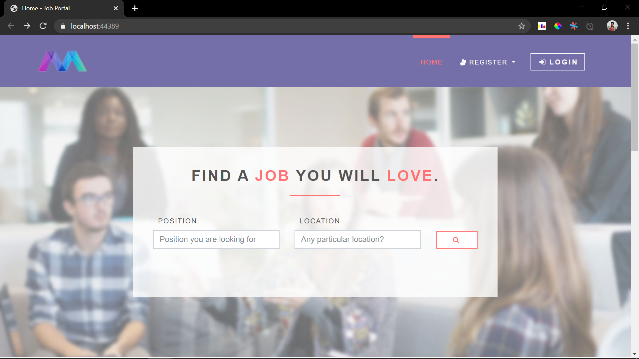

Fig 1: Dashboard

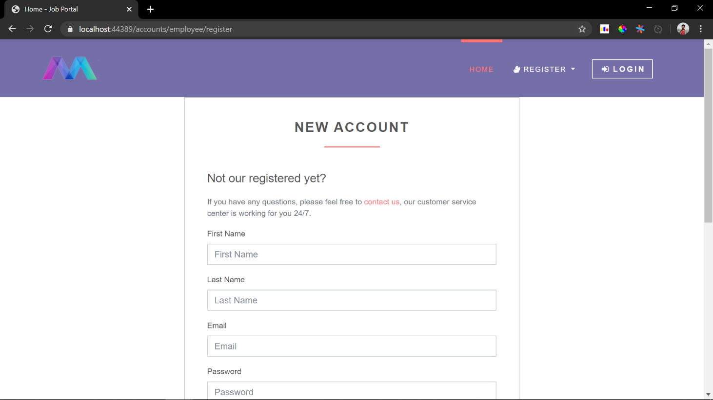

Fig 2: Signup screen

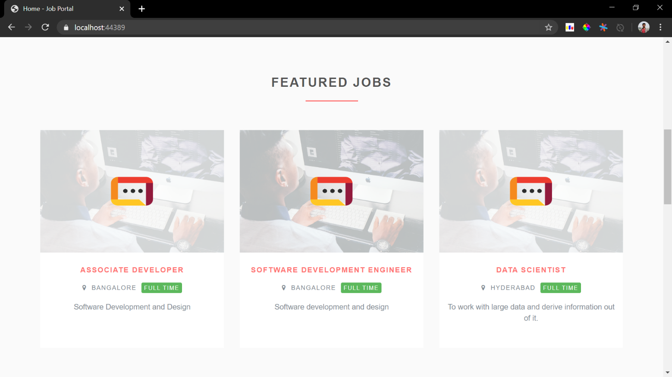

Fig 3: Employers Dashboard

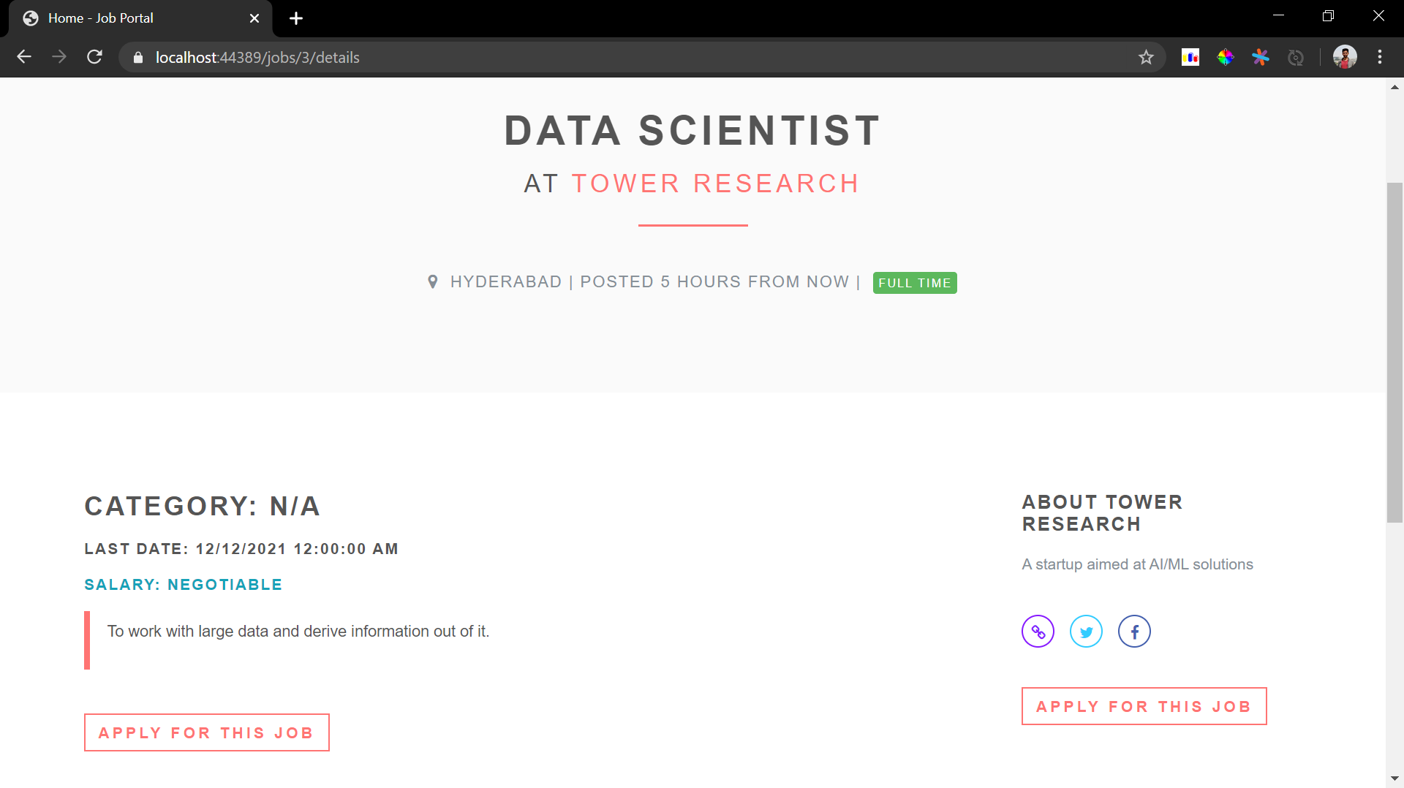

Fig 4: Employee Application

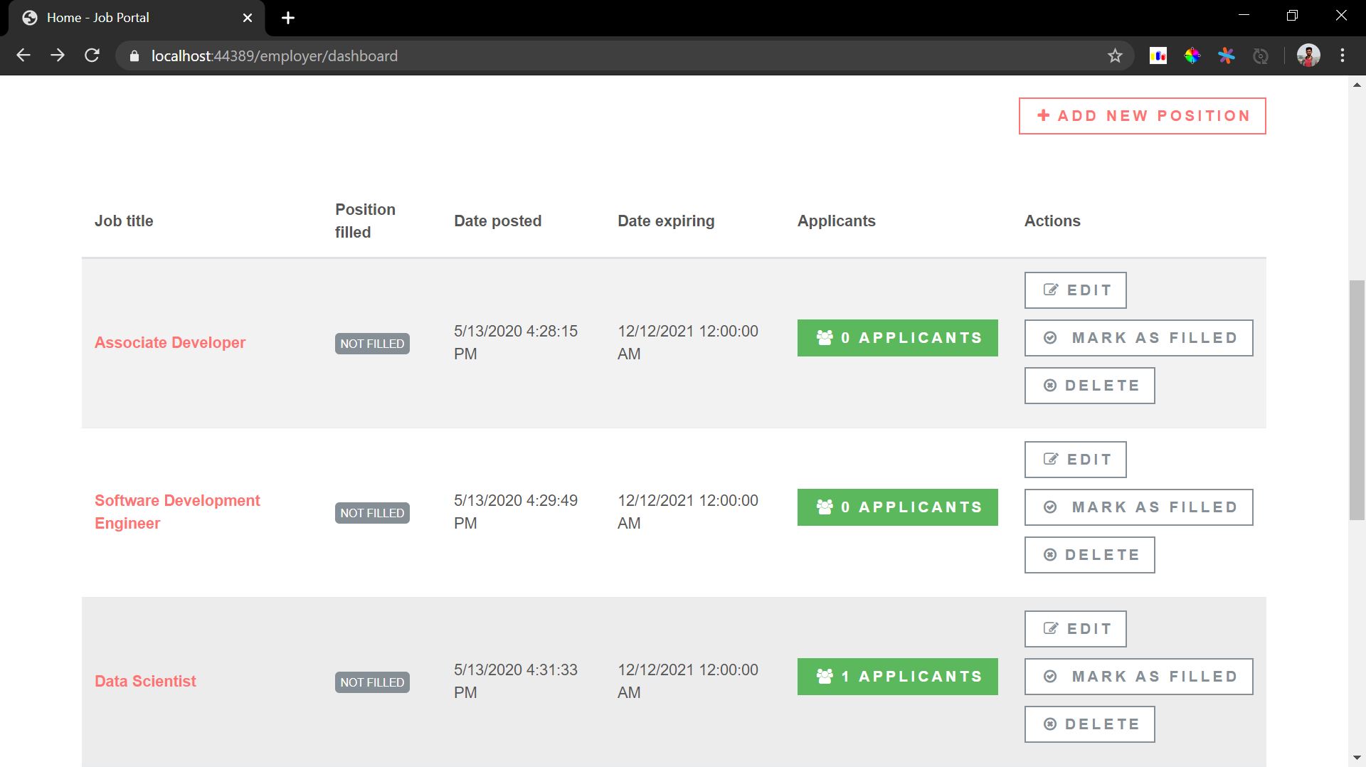

Fig 5: Job List

# CONCLUSION AND ENHANCEMENT

**CONCLUSION**

Job Search Portals stands as a revolutionizing element in the sphere of recruitment. They act as a communication bridge between applicants and recruiters facilitating their requirements. This application helps organizations to have a greater exposure to the candidate pool and also job seekers facilitating wide search of jobs matching their interests. The android application provides flexibility to the jobseekers to view the openings and applied jobs without the need to carry a laptop. This application provides an enhanced user experience for both employer and jobseeker. It provides user friendly interface which facilitates in reaching wide range of audience. The application has achieved all the requirements that were initially set in the requirements gathering phase. This project taught me some best practices in the technology stack like C#, MySQL and ASP.NET framework. Starting from requirements elicitation to design, construction, implementation and testing, I have gained a very good experience working with various technologies at every phase. Development of this project boosted my confidence in web development.

**FUTURE WORK**

The Online Job Portal System developed using C# and MySQL fully meet the objective of the system for which it is developed. The system is operated at high level of efficiency and is advantageous for all its users be it the employer or the job seeker. This system solves the problem it was intended to solve as the specific requirement. This project fulfils the primary requirements of the job seekers and employers. It can be extended in several ways – We can provide recommendations and email updates for new job postings based on the job seeker’s search history. Since, the job seekers might be interested in building a strong Resume, we can provide tips and information for the same. We can also provide templates for building the Resumes which might interest most applicants.

**BIBLIOGRAPHY**

The following resources provided useful means in the completion of this project:

1. Karli Watson, Jacob Vibe Hammer, Daniel Kemper, Christian Nagel, Beginning Visual C# 2012 Programming, December 2005.
2. [www.w3schools.com](http://www.w3schools.com)
3. [www.charpprogramming.org](http://www.charpprogramming.org)