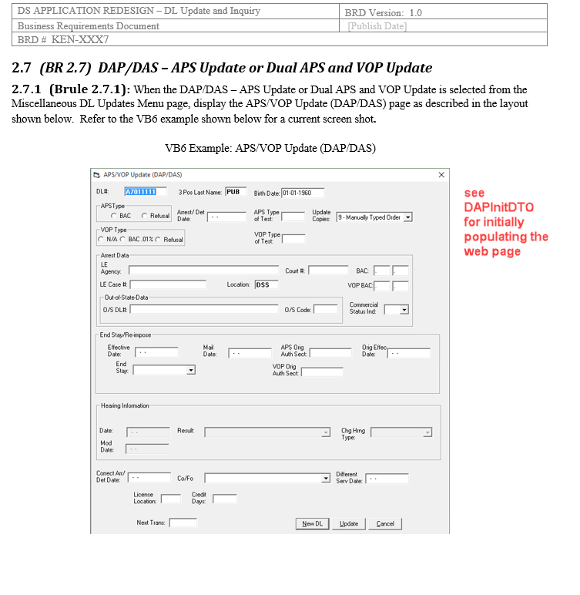

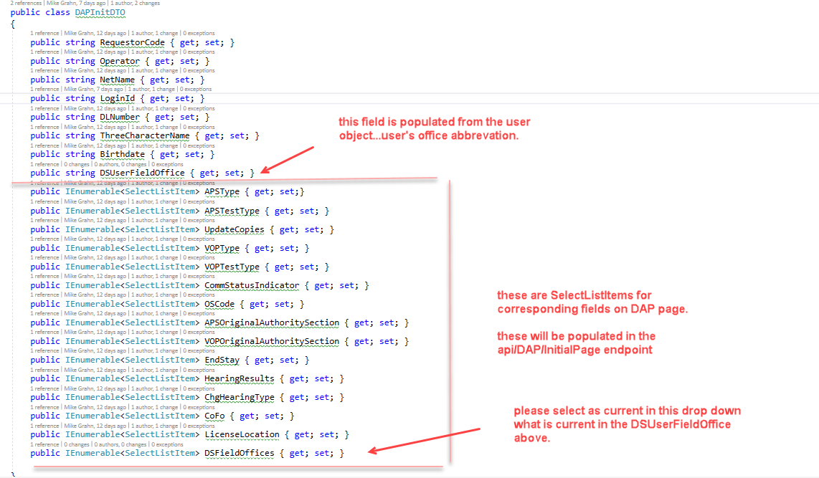

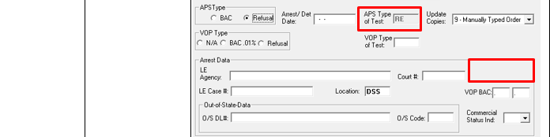

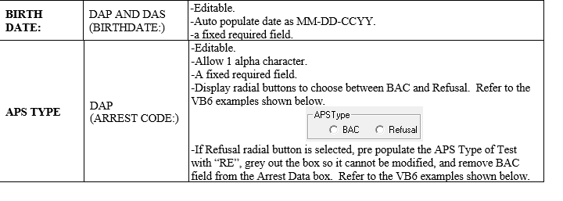



If Arrest/Det Date gains focus and

If optAPSBAC = False And optAPSRefusal = False Then

Display message "APS Type must be selected"

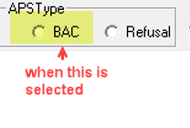

chkOrigAPS = 0

chkOrigAPS.Enabled = False

txtAPSTestType = ""

txtAPSTestType.Enabled = True

lblBAC.Visible = True

medBAC1.Visible = True

medBAC2.Visible = True

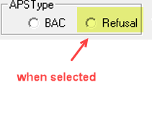

chkOrigAPS.Enabled = True

txtAPSTestType = "RE"

txtAPSTestType.Enabled = False

lblBAC.Visible = False

medBAC1.Visible = False

medBAC2.Visible = False

----------------------------------------------------------------------------------------------------------------------------------------

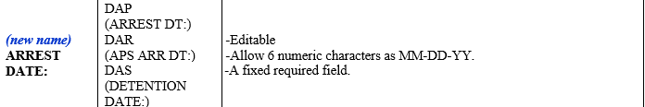

When focus has left Arrestdate field…..

If Arrest Date is greater than current date, display message “Arrest Date cannot be in the future”

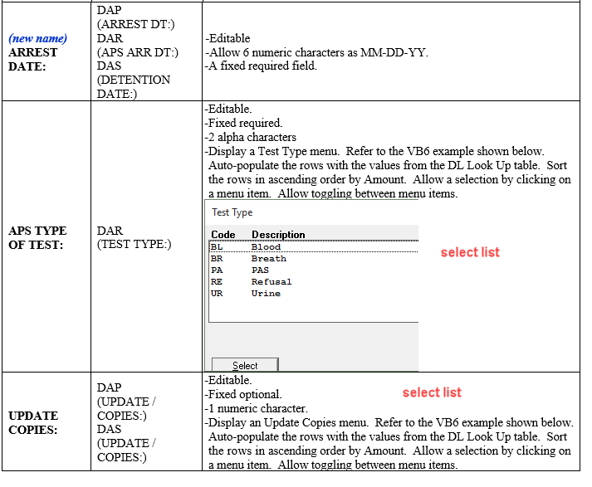

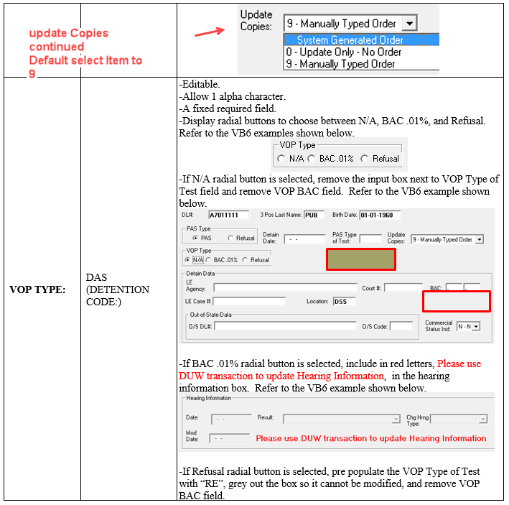

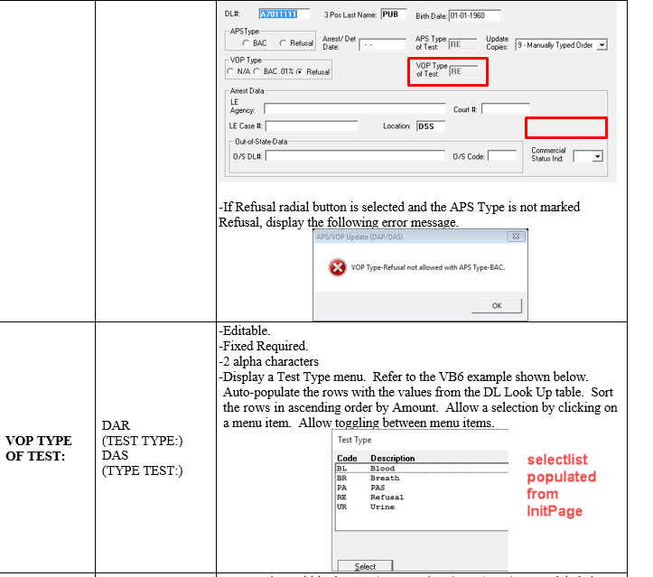

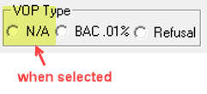

lblPVBAC.Visible = False

pvBAC1.Visible = False

pvBAC2.Visible = False

txtPVTestType.Visible = False

txtPVTestType = ""

txtPVTestType.Enabled = True

txtPVOrigAuthSect.Enabled = False

txtPVOrigAuthSect.BackColor = vbButtonFace

lblDUWMessage.Visible = False

medHearingDate.Enabled = True

cboResult.Enabled = True

medModDate.Enabled = True

cboHearingType.Enabled = True

medHearingDate.BackColor = vbWhite

cboResult.BackColor = vbWhite

medModDate.BackColor = vbWhite

cboHearingType.BackColor = vbWhite

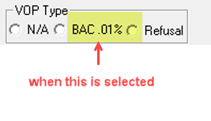

Take action to the following controls:

pvBAC1.Visible = True

lblPVBAC.Visible = True

pvBAC2.Visible = True

txtPVTestType.Visible = True

txtPVTestType = ""

txtPVTestType.Enabled = True

Me.lblDUWMessage.Visible = True

medHearingDate.Enabled = False

cboResult.Enabled = False

medModDate.Enabled = False

cboHearingType.Enabled = False

medHearingDate.BackColor = vbButtonFace

cboResult.BackColor = vbButtonFace

medModDate.BackColor = vbButtonFace

cboHearingType.BackColor = vbButtonFace

txtPVOrigAuthSect.Enabled = True

txtPVOrigAuthSect.BackColor = vbWhite

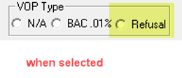

Take action

If optPVRefusal = True And optAPSBAC = True Then

MsgBox "VOP Type-Refusal not allowed with APS Type-BAC.", vbCritical, Me.Caption

optPVBAC.SetFocus

optPVBAC = False

Exit Sub

End If

If optPVRefusal = True Then

lblPVBAC.Visible = False

pvBAC1.Visible = False

pvBAC2.Visible = False

txtPVTestType.Visible = True

txtPVTestType = "RE"

txtPVTestType.Enabled = False

Me.lblDUWMessage.Visible = True

medHearingDate.Enabled = False

cboResult.Enabled = False

medModDate.Enabled = False

cboHearingType.Enabled = False

medHearingDate.BackColor = vbButtonFace

cboResult.BackColor = vbButtonFace

medModDate.BackColor = vbButtonFace

cboHearingType.BackColor = vbButtonFace

txtPVOrigAuthSect.Enabled = True

txtPVOrigAuthSect.BackColor = vbWhite

End If

txtPVTestType = "RE"

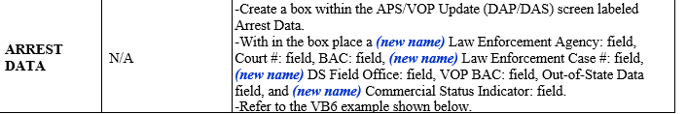

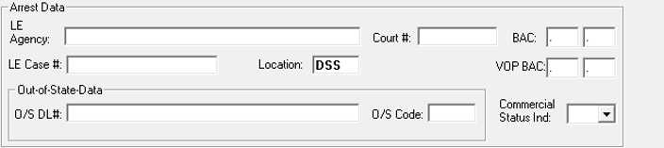

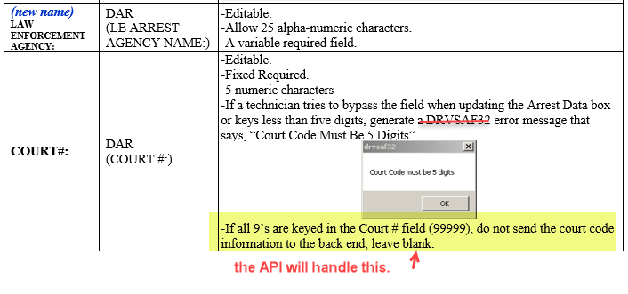

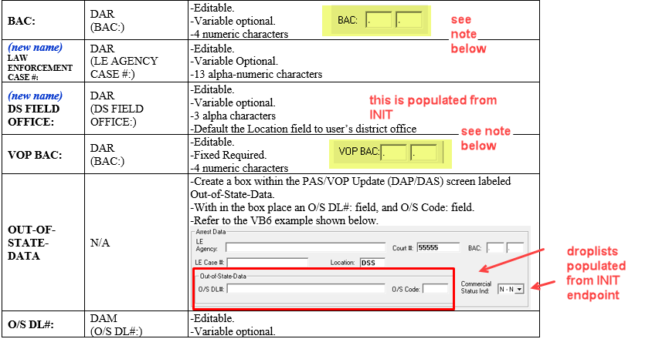



For each box in BAC and VOP BAC:

If BAC1 <> "" Then

If BAC1 / 100 < 0 Or BAC1 / 100 > 0.6 Then

MsgBox "Invalid BAC value", 16, Me.Caption

BAC1.SetFocus

End If

End If

End Sub

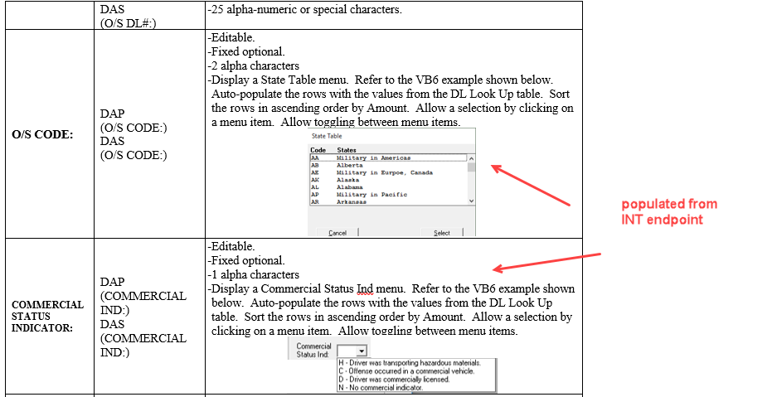



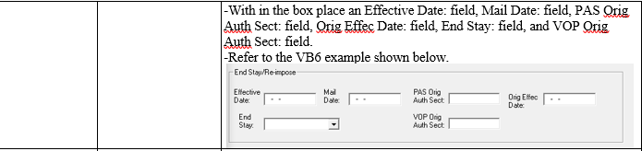

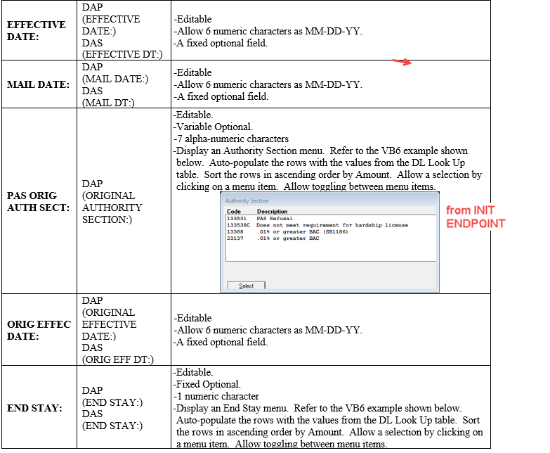

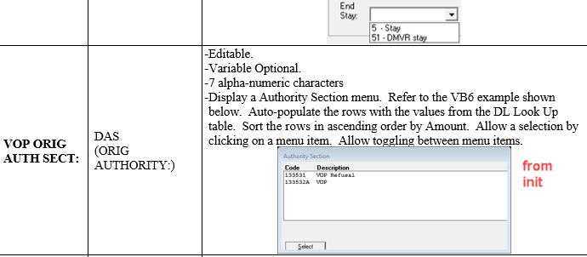

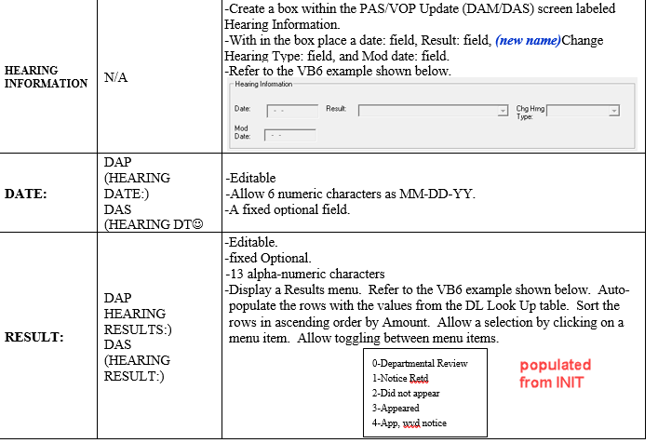

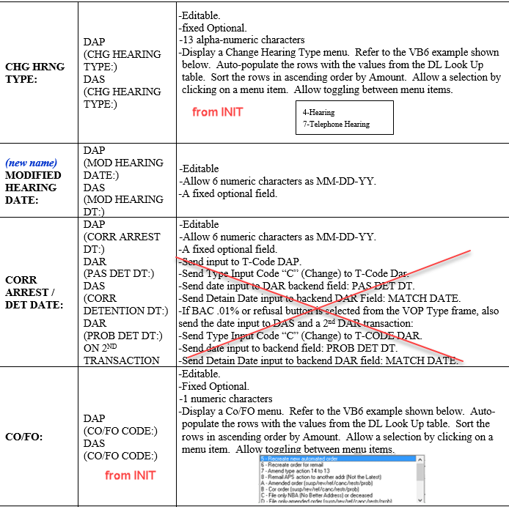

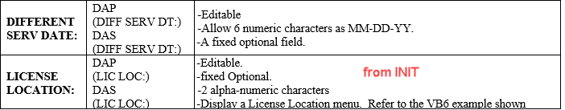

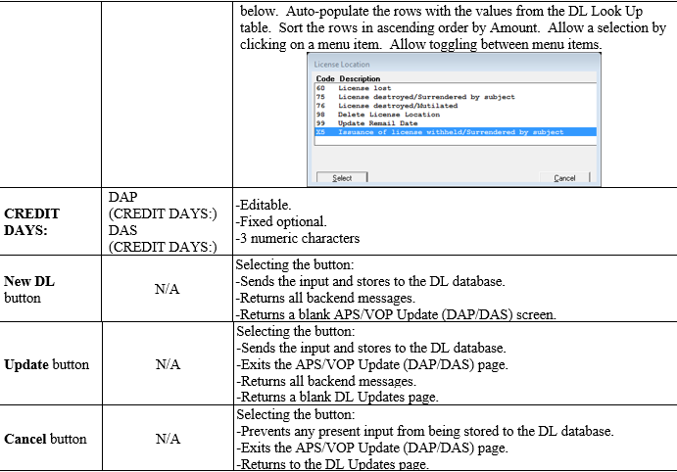

When New DL or Update button is pressed use endpoint ProcessDAP

If NewDL button is pressed, the field on the DAPUIDTO “NextDLNumber” is required as is the “NextTrans” text box.

