TCODE ME3 – Medical Certificate Correction Update

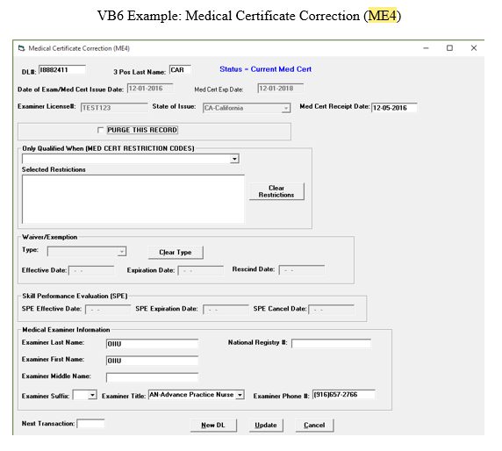





When calling the endpoint InitialPage for ME4, pass in the DL Number and lastname

The endpoint will call the ME1 Tcode in the background to retrieve MED Cert data if it exists.

If ME1 data is not found, the message in the ME4INITDTO will have the verbiage;

Medical and Self Certificate Information: NONE

With a return code of 200. In the ME4INITDTO

ME4INITDTO….

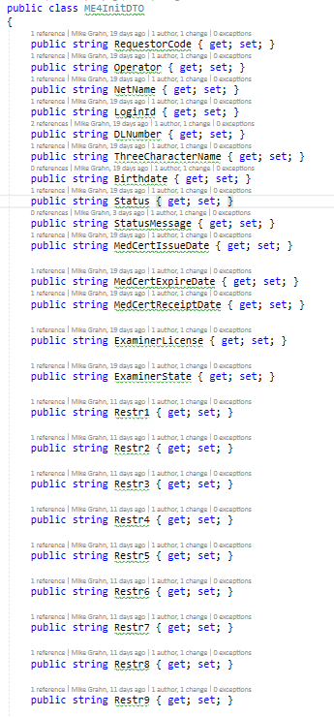

if (dto.Status == "I")

{

dto.StatusMessage = "Status - Invalid Med Cert";

}

else if (dto.Status == "N")

{

dto.StatusMessage = "Status - Non Current Med Cert";

}

else

{

dto.StatusMessage = "Status - Current Med Cert";

}

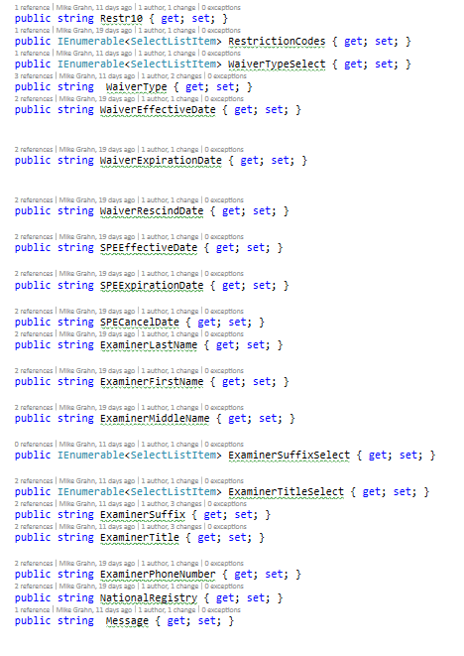

If ME1 data exists, the above DTO will be populated with the resulting data.

Status and Status message are populated as follows

if (dto.Status == "I")

{

dto.StatusMessage = "Status - Invalid Med Cert";

}

else if (dto.Status == "N")

{

dto.StatusMessage = "Status - Non Current Med Cert";

}

else

{

dto.StatusMessage = "Status - Current Med Cert";

}

If Status = “I” - invalid, disable Update , NewDL and next Trans buttons, Med Cert cannot be updated.

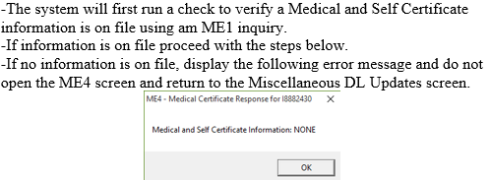

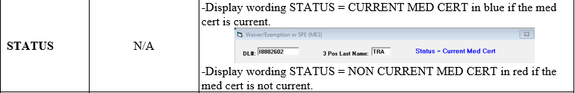

When data for a found Medical Cert, the “key” data is protected, except for DL number and name…

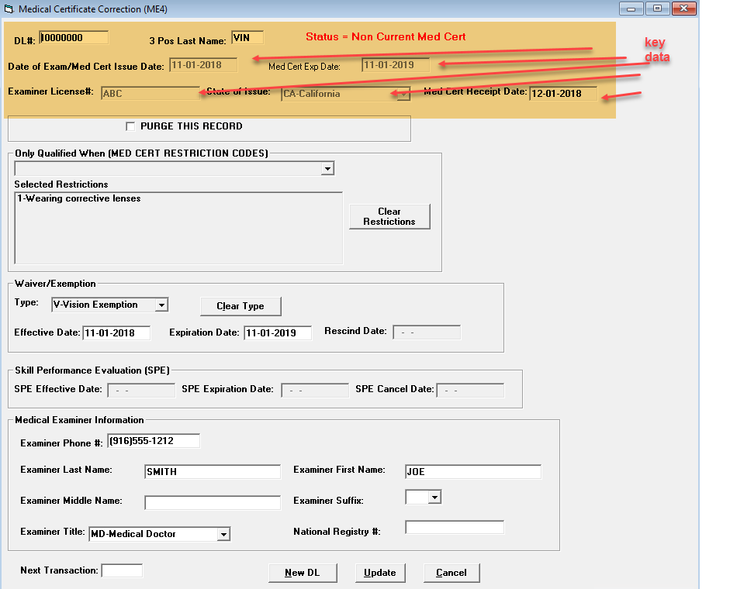

All other data fields are editable.

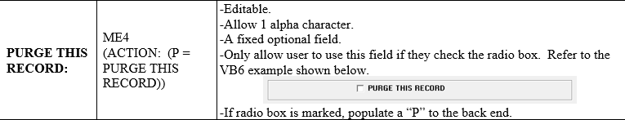

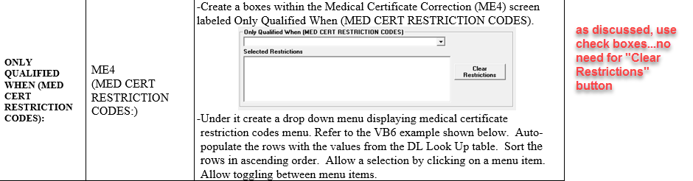

As the current restriction code(s) are populated in the ME4InitiDTO, only select the current restrictions in the check boxes.

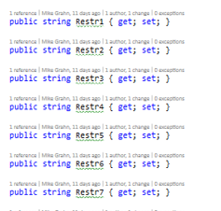

The following items are populated in the ME4InitDTO during the ME4 InitialPage EndPoint..  
  
 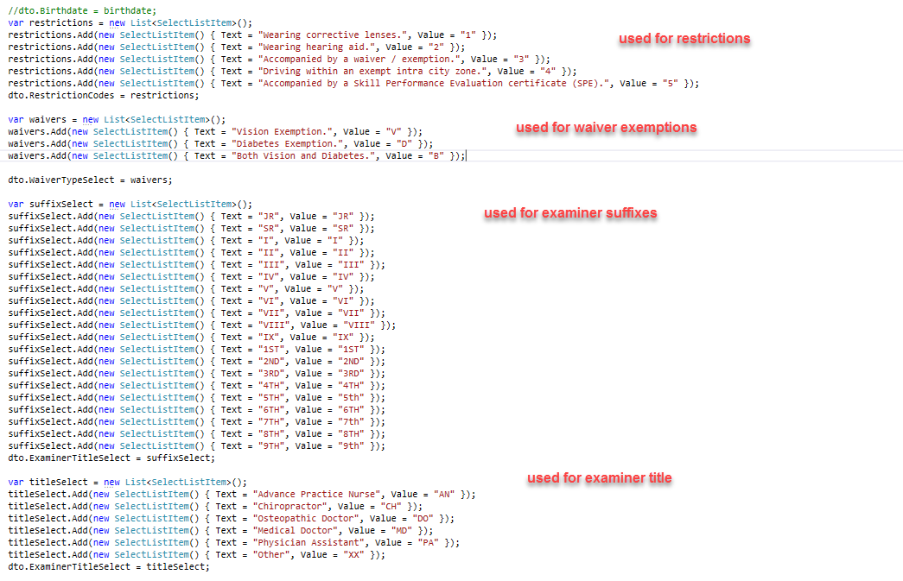

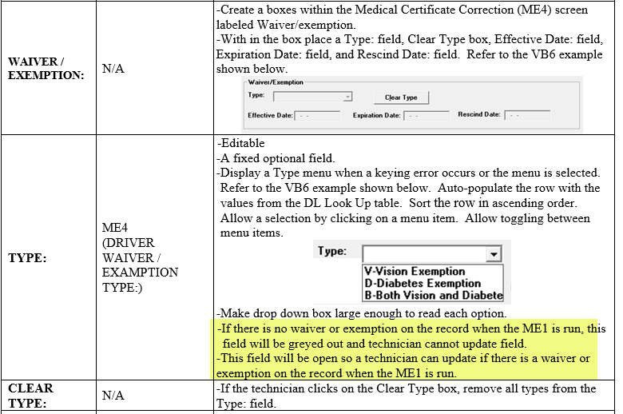



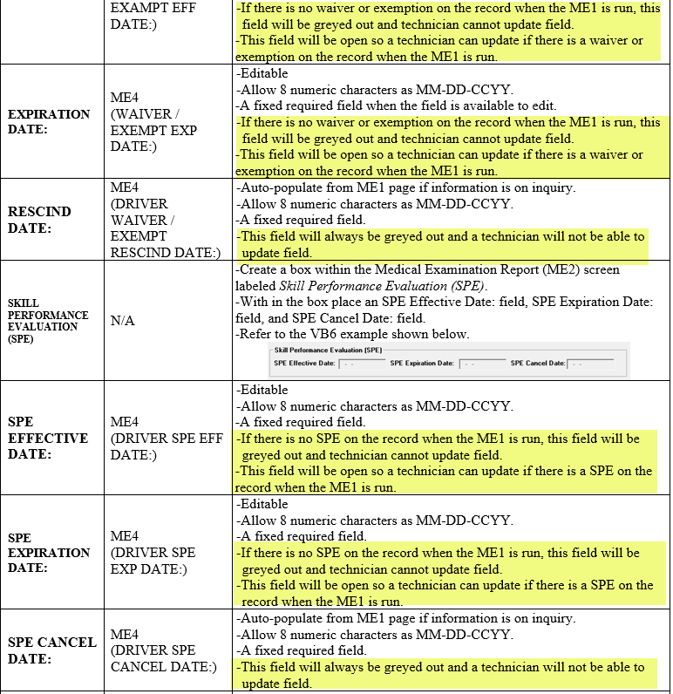





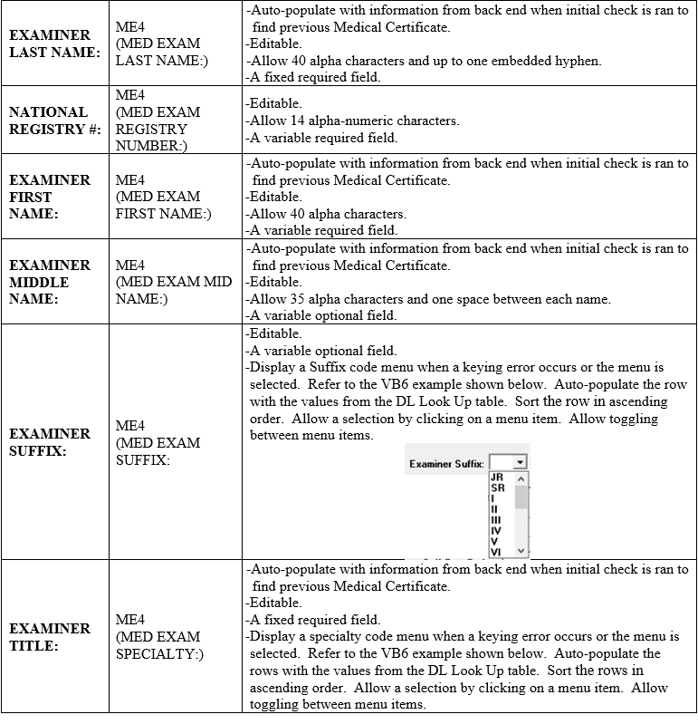

For examiner suffix and title are populated in the ME4InitiDTO, select current value as selected from the selectlist.

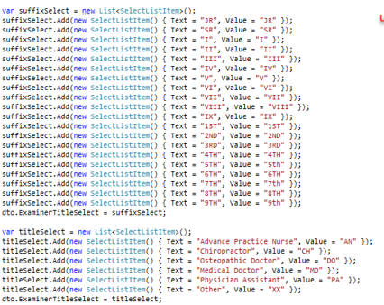

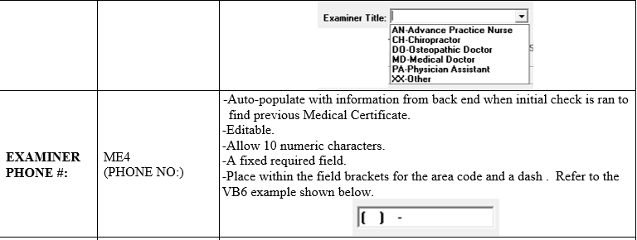

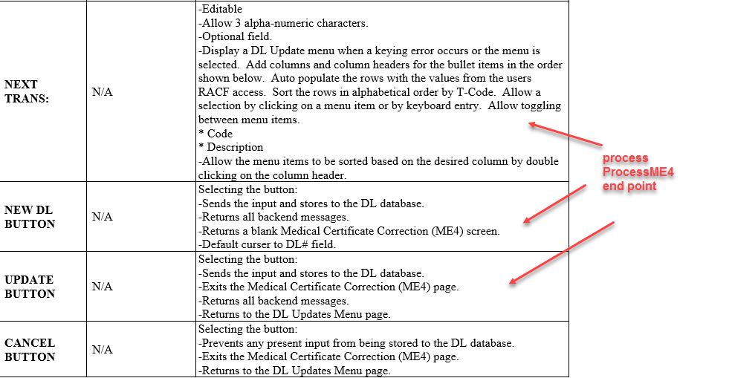

If Status = “I” - invalid, disable Update , NewDL and next Trans buttons, Med Cert cannot be updated.

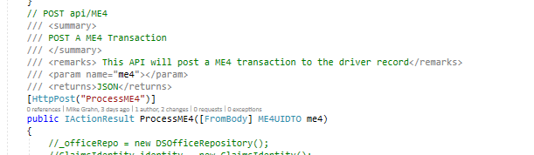

Special 03-01-1996 rule.

If 03-01-1996 or earlier is displayed in the Waiver Effective date, from the INITPAGE endpoint, protect all waiver and SPE fields except for the Waiver effective and expiration dates.

If the user changes the Waiver Effective date to 03/01/1996 or earlier, Protect Waiver expiration date, SPE Effective Date, SPE Expiration date.