TCODE ME5 – Mark Medical Certificate Invalid

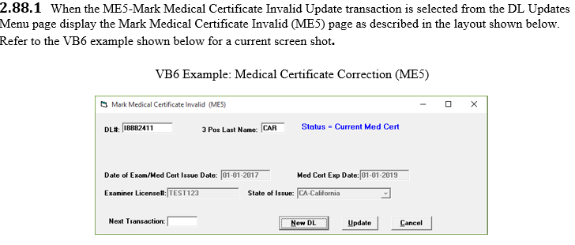

Run the following End Point “InitialPage” to initiate the screen above. Pass in the DL Number and Last name from the Update screen. ME1Inquiry runs in the background to populate the screen above.





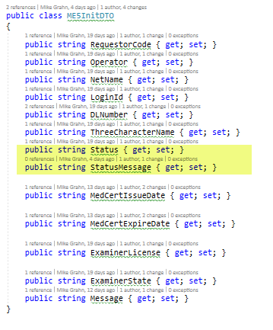

All fields are protected…..

The following MED Cert statuses are determined from ME1 inquiry:

dto.Status = results.Substring(0, 1);

if (dto.Status == "I")

{

dto.StatusMessage = "Status - Invalid Med Cert";

}

else if (dto.Status == "N")

{

dto.StatusMessage = "Status - Non Current Med Cert";

}

else

{

dto.StatusMessage = "Status - Current Med Cert";

}

If Status = “I” - invalid, disable Update , NewDL and next Trans buttons, Med Cert cannot be updated.

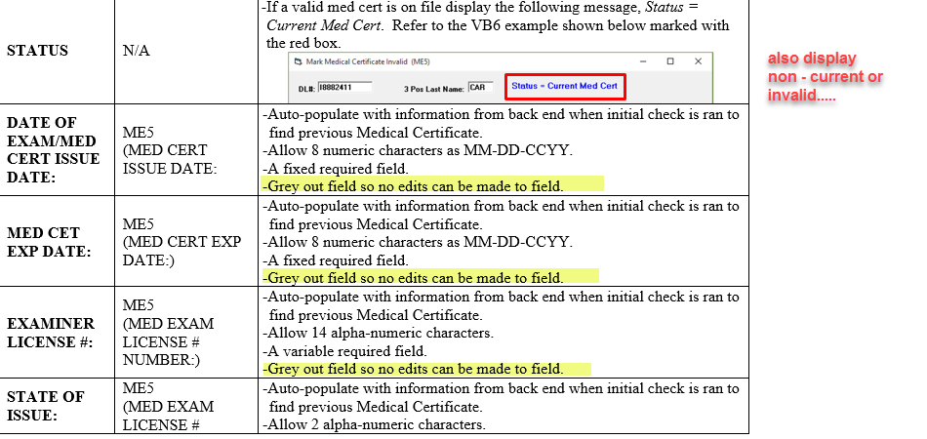



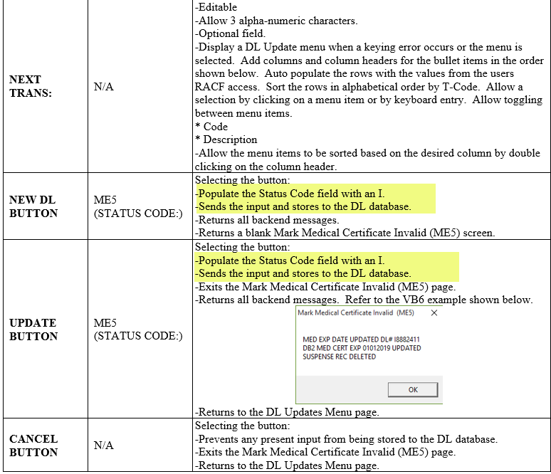

Use the following End Point to update the MED CERT:



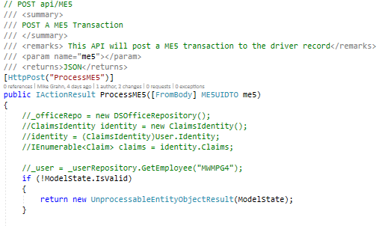

TCODE ME6 – Self Certification Update

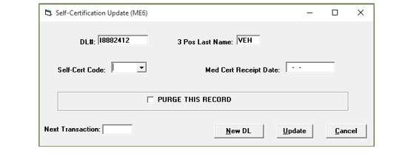

Run the following End Point “InitialPage” to initiate the screen above. Pass in the DL Number and Last name from the Update screen. ME1Inquiry runs in the background to populate the screen above.





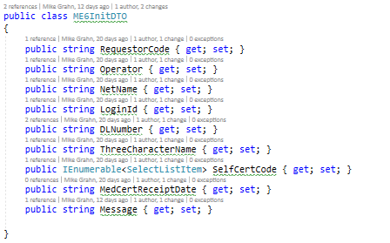





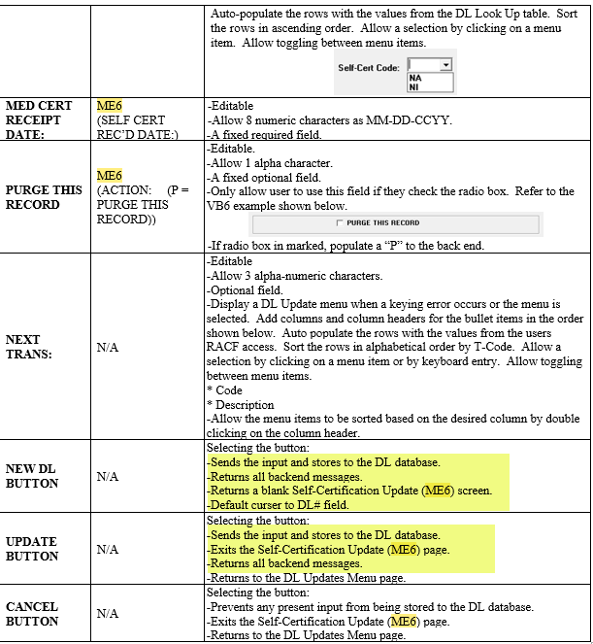

Uses the following end point to process the ME6:

 