## DAS-VOP Update

### When the DAS-VOP Update is selected from the Miscellaneous DL Updates Menu page, display the APS DUI Probation Violation Update (DAS) page as described in the layout shown below. Refer to the VB6 example shown below for a current screen shot.

VB6 Example: APS DUI Probation Violation Update (DAS)

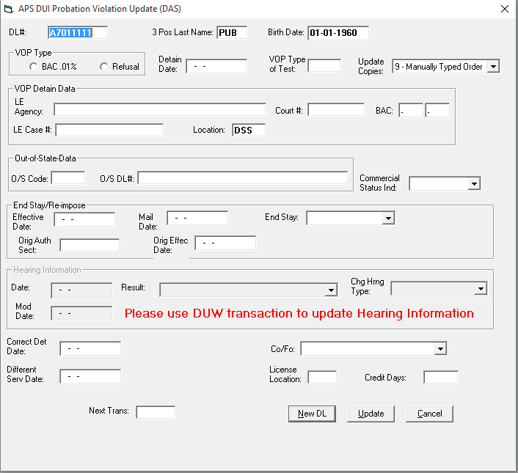

The DAS TCode is basically a subset of DAP TCode with the same validation rules. Similar fields without some from the DAP.

Use the following end point to initiate the screen.



Here is the DTO for initialization:

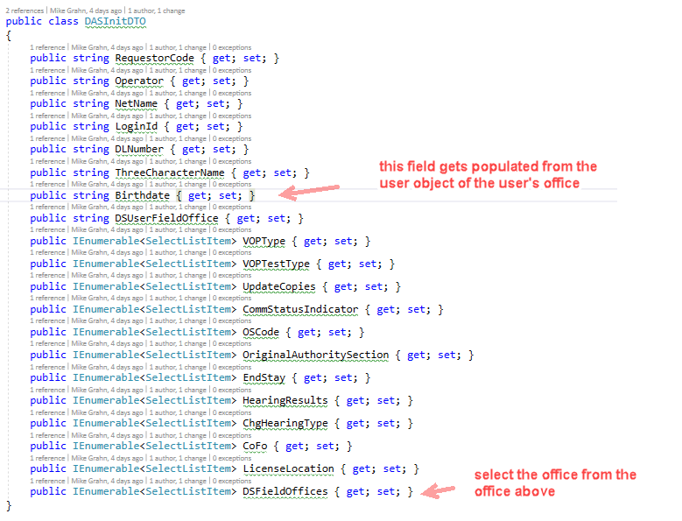

Example Backend/Rumba Screen DAS

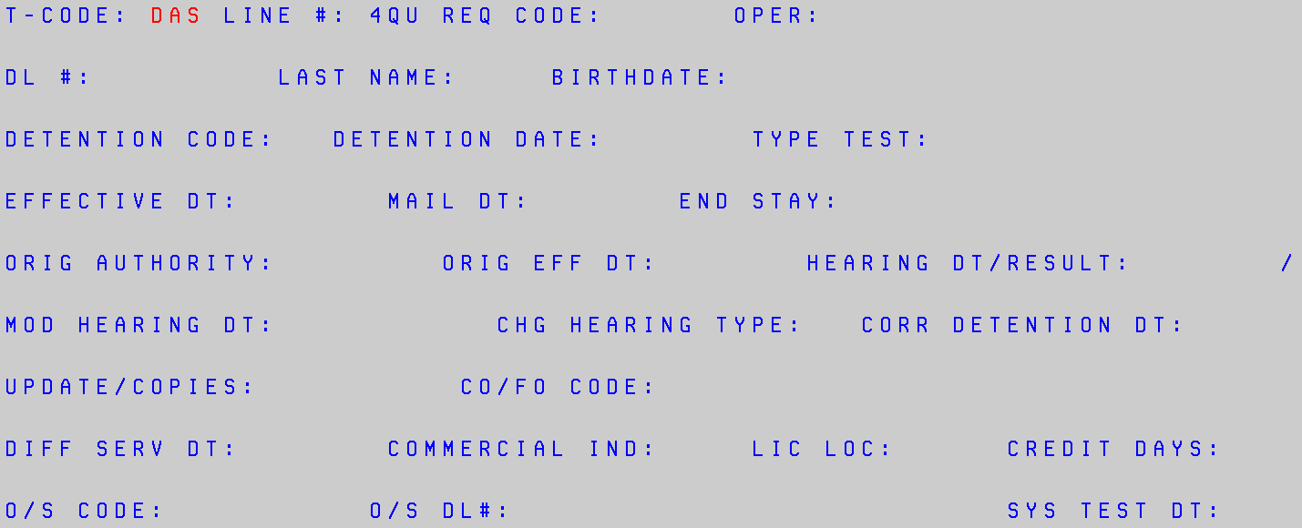

|  |  |  |  |  |
| --- | --- | --- | --- | --- |
| Elements | | Send to Backend T-Code & Field | | APS DUI probation violation update (DAs) page LAYOUT  Field Attributes & RULES |
| APS DUI Probation Violation Update (DAS) page caption | | | | |
| **Close box** | | N/A | |  |
| **N/A** | | DAS  (T-CODE) | | -DAS  -Hide from page.  -3 alpha/numeric characters  -A fixed required field. |
| **DAS** | N/A | | -When APS/VOP Update (DAS) screen is updated, first update DAS in back end, second update DAR in back end, and then update DAS. | |
| **N/A** | DAr / das  (T-CODE) | | -DAR, DAS  -Hide from page.  -3 alpha-numeric characters  -A fixed required field. | |
| **N/A** | DAR / das  (REQ CODE:) | | -Send Requester Code from the Office table based on user’s Office RU from Employee table.  -Hide from page.  -5 numeric characters  -A fixed required field. | |
| **N/A** | dar / das  (Oper:) | | -Send 3 alpha-numeric characters (the third, fourth, and fifth positions of the User ID from Employee table) to the DAN transaction.  -Hide from page.  -A fixed required field. | |
| **DL#:** | das / dar  (DL #:) | | -Auto-populate from DL Updates menu page.  -Editable.  -Allow 8 alpha-numeric characters.  -A fixed required field. | |
| **3 Pos Last name:** | dar / das  (Last Name:) | | -Editable.  -Auto-populate first three positions of last name.  -A fixed required field. | |
| **Birth Date:** | Das  (birthdate:) | | -Editable.  -Auto populate date as MM-DD-CCYY.  -a fixed required field. | |
| **VOP Type** | | daS  (Arrest code:) | | -Editable.  -Allow 1 alpha character.  -A fixed required field.  -Display radial buttons to choose between BAC and Refusal. Refer to the VB6 examples shown below.    -If Refusal radial button is selected, pre populate the VOP Type of Test with “RE”, grey out the box so it cannot be modified, and remove BAC field from the VOP Detain box. Refer to the VB6 examples shown below.    -If BAC button is selected, send Detention code A.  -If Refusal button is selected, send Detention code R. |
| **Detain Date:** | dar  (Prob det dt:)  das  (detention date:) | | -Editable  -Allow 6 numeric characters as MM-DD-YY.  -A fixed required field. | |
| **VOP type of test:** | dar  (test TYPE:)  das  (type test:) | | -Editable.  -Fixed required.  -2 alpha characters  -Display a Test Type menu. Refer to the VB6 example shown below. Auto-populate the rows with the values from the DL Look Up table. Sort the rows in ascending order by Amount. Allow a selection by clicking on a menu item. Allow toggling between menu items. | |
| **update copies:** | das  (update / copies:) | | -Editable.  -Fixed optional.  -1 numeric character.  -Display an Update Copies menu. Refer to the VB6 example shown below. Auto-populate the rows with the values from the DL Look Up table. Sort the rows in ascending order by Amount. Allow a selection by clicking on a menu item. Allow toggling between menu items. | |
| **VOP Detain data** | n/a | | -Create a box within the APS DUI Probation Violation Update (DAS) screen labeled VOP Detain Data.  -With in the box place a ***(new name)*** Law Enforcement Agency: field, Court #: field, BAC: field, ***(new name)*** Law Enforcement Case #: field, and ***(new name)*** DS Field Office: field.  -Refer to the VB6 example shown below. | |
| ***(new name)***  **Law enforcement agency:** | DAR  (LE Arrest Agency Name:) | | -Editable.  -Allow 25 alpha-numeric characters.  -A variable required field. | |
| **court#:** | dar  (court #:) | | -Editable.  -Fixed Required.  -5 numeric characters  -If a technician tries to bypass the field when updating the Arrest Data box or keys a number less than 5 digits, generate a DRVSAF32 error message that says, “Court Code Must Be 5 Digits”.  cid:image001.png@01D33C2B.41F10090  -If all 9’s are keyed in the Court # field (99999), do not send the court code information to the back end, leave blank. | |
| **BAc:** | dar  (bac:) | | -Editable.  -Variable optional.  -4 numeric characters | |
| ***(new name)***  **LAW ENFORCEMENT CASE #:** | DAR  (le AGENCY CASE #:) | | -Editable.  -Variable Optional.  -13 alpha-numeric characters | |
| ***(new name)***  **ds field office:** | dar  (ds field office:) | | -Editable.  -Variable optional.  -3 alpha characters  -Default the Location field to user’s district office | |
| **VOP Detain data box special instructions** | N/A | | -If “End Stay” field is present, then VOP Detain Data frame is not required.  -Send Type Input Code “A” (Add) to T-Code DAR if any Detain Data frame fields are present and the Correct Detain Date field is not present.  -Default the Location field to user’s district office | |

|  |  |  |
| --- | --- | --- |
| **out-of-state data** | n/a | -Create a box within the APS DUI Probation Violation Update (DAS) screen labeled Out-of-State Data.  -With in the box place an O/S Code: field, and O/S DL#: field.  -Refer to the VB6 example shown below. |
| **o/s code:** | das  (o/s code:) | -Editable.  -Fixed optional.  -2 alpha characters  - Display an State Table menu. Refer to the VB6 example shown below. Auto-populate the rows with the values from the DL Look Up table. Sort the rows in ascending order by Amount. Allow a selection by clicking on a menu item. Allow toggling between menu items. |
| **o/s dl#:** | das  (o/s DL#:) | -Editable.  -Variable Optional.  -25 alpha-numeric and special characters |
| **commercial status indicator:** | das  (commercial ind:) | -Editable.  -Fixed optional.  -1 alpha characters  -Display a Commercial Status Ind menu. Refer to the VB6 example shown below. Auto-populate the rows with the values from the DL Look Up table. Sort the rows in ascending order by Amount. Allow a selection by clicking on a menu item. Allow toggling between menu items. |
| **End Stay / re-impose** | n/a | -Create a box within the APS DUI Probation Violation Update (DAS) screen labeled End Stay/Re-impose.  -With in the box place an Effective Date: field, Mail Date: field, End Stay: field, Orig Auth Sect: field, and Orig Effect Date: field.  -Refer to the VB6 example shown below. |
| **effective date:** | das  (effective dt:) | -Editable.  -Allow 6 numeric characters as MM-DD-YY.  -A Fixed Optional field.  -Must be present if CO/FO code “B” is input. Otherwise, return cursor to field and display error message: EFFECTIVE DT REQUIRED WITH CO/FO CODE.  -Must be greater than or equal to detention date input. Otherwise, return cursor to field and display error message: EFF DT NOT AFTER DETENTION DATE. |
| **mail date:** | das  (mail dt:) | -Editable.  -Allow 6 numeric characters as MM-DD-YY.  -A Fixed Optional field.  -Must be present with End Stay Code 4 or 5.  -Must be present if both CO/FO Code “B” and Update/Copies Code “(“ are input. Otherwise, return cursor to field and display error message: MAIL DATE REQUIRED. |
| **end stay:** | das  (end stay:) | -Editable.  -Fixed Optional.  -1 numeric character  -Display this End Stay menu for units other than DS Headquarters. Refer to the VB6 example shown below. Auto-populate the rows with the values from the DL Look Up table. Sort the rows in ascending order by Amount. Allow a selection by clicking on a menu item. Allow toggling between menu items.    -Display this End Stay menu for DS Headquarters. Refer to the VB6 example shown below. Auto-populate the rows with the values from the DL Look Up table. Sort the rows in ascending order by Amount. Allow a selection by clicking on a menu item. Allow toggling between menu items.    4 – Court Stay  5 – Stay  51 – DMVR Stay |
| **orig auth sect:** | das  (orig authority:) | -Editable.  -Allow 7 alpha-numeric characters.  -A variable optional field.  -Display this Authority Section menu. Refer to the VB6 example shown below. Auto-populate the rows with the values from the DL Look Up table. Sort the rows in ascending order by Amount. Allow a selection by clicking on a menu item. Allow toggling between menu items. |

|  |  |  |
| --- | --- | --- |
| **Orig effec date:** | DAS  (orig eff dt:) | -Editable  -Allow 6 numeric characters as MM-DD-YY.  -A fixed optional field.  -If a radio button in “APS Type” field is selected, send input data to T-Code DAP  -If a radio button in “VOP Type” field is selected, send input data to T-Code DAS.  -If radio button in both the “APS Type” and “VOP Type” fields are selected, send input data to both T-Codes DAP and DAS. |
| **Hearing Information** | n/a | -Create a box within the APS DUI Probation Violation Update (DAS) screen labeled Hearing Information.  -With in the box place a date: field, Result: field, ***(new name)***Change Hearing Type: field, and Mod date: field.  -Include the following language in red, “Please use DUW transaction to update Hearing Information”.  -Refer to the VB6 example shown below. |
| **date:** | das  (hearing dt☺ | -Editable  -Allow 6 numeric characters as MM-DD-YY.  -A fixed optional field. |
| **result:** | DAS  (hearing result:) | -Editable.  -fixed Optional.  -1 numeric characters  -Display a Results menu. Refer to the VB6 example shown below. Auto-populate the rows with the values from the DL Look Up table. Sort the rows in ascending order by Amount. Allow a selection by clicking on a menu item. Allow toggling between menu items.  0-Departmental Review  1-Notice Retd  2-Did not appear  3-Appeared  4-App, wvd notice |
| **chg hrng type:** | das  (chg hearing type:) | -Editable.  -fixed Optional.  -1 numeric characters  -Display a Change Hearing Type menu. Refer to the VB6 example shown below. Auto-populate the rows with the values from the DL Look Up table. Sort the rows in ascending order by Amount. Allow a selection by clicking on a menu item. Allow toggling between menu items.  4-Hearing  7-Telephone Hearing |

|  |  |  |
| --- | --- | --- |
| ***(new name)***  **Modified hearing Date:** | DAS  (mod hearing dt:) | -Editable  -Allow 6 numeric characters as MM-DD-YY.  -A fixed optional field.  -Cannot be more than 6 months prior nor more than 1 year beyond the Hearing Date. |
| **corr arrest / det date:** | dar  (prob det dt:)  das  (corr detention dt:) | -Editable  -Allow 6 numeric characters as MM-DD-YY.  -A fixed optional field.  -Send input to T-Code DAS.  -Send input to backend DAR field: PROB DET DT.  -Send Type Input Code “C” (Change) to T-Code DAR.  -Send Detain Date Input to backend DAR field: MATCH DATE. |
| **Co/fo:** | das  (co/fo code:) | -Editable.  -Fixed Optional.  -1 numeric characters  -Display a Co/FO menu. Refer to the VB6 example shown below. Auto-populate the rows with the values from the DL Look Up table. Sort the rows in ascending order by Amount. Allow a selection by clicking on a menu item. Allow toggling between menu items. |
| **different serv date:** | das  (diff serv dt:) | -Editable  -Allow 6 numeric characters as MM-DD-YY.  -A fixed optional field.  -Must be greater than Detention Date but no more than 30 days after Detention Date.  -If Diff Serv DT field is present, then Update/Copies “9” must be present. |
| **license location:** | DAS  (Lic loc:) | -Editable.  -fixed Optional.  -2 alpha-numeric characters  -Display a License Location menu. Refer to the VB6 example shown below. Auto-populate the rows with the values from the DL Look Up table. Sort the rows in ascending order by Amount. Allow a selection by clicking on a menu item. Allow toggling between menu items. |
| **credit days:** | das  (credit days:) | -Editable.  -Fixed optional.  -3 numeric characters  -If Credit Days field is present, then End Stay “4” or “5” must be present. |

|  |  |  |  |  |
| --- | --- | --- | --- | --- |
| **New DL** button | N/A | | Selecting the button:  -Sends the input and stores to the DL database.  -Returns all backend messages.  -Returns a blank APS DUI Probation Violation Update (DAS) screen. | |
| **Update** button | | N/A | | Selecting the button:  -Sends the input and stores to the DL database.  -Exits the APS DUI Probation Violation Update (DAS) page.  -Returns all backend messages.  -Returns a blank DL Updatespage. |
| **Cancel** button | | N/A | | Selecting the button:  -Prevents any present input from being stored to the DL database.  -Exits the APS DUI Probation Violation Update (DAS) page.  -Returns to the DL Updates page. |

When the new dl or update button is pressed, process this endpoint.

