## DUH-Service Code for Driver Safety users

### When the DUH-Service Code is selected from the Miscellaneous DL Updates Menu page display the Service Code/License Location (DUH) page as described in the layout shown below. Refer to the VB6 example shown below for a current screen shot.

VB6 Example: Service Code/License Location (DUH)

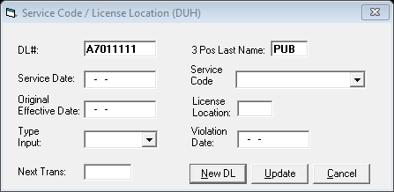

Example Backend/Rumba Screen DUH

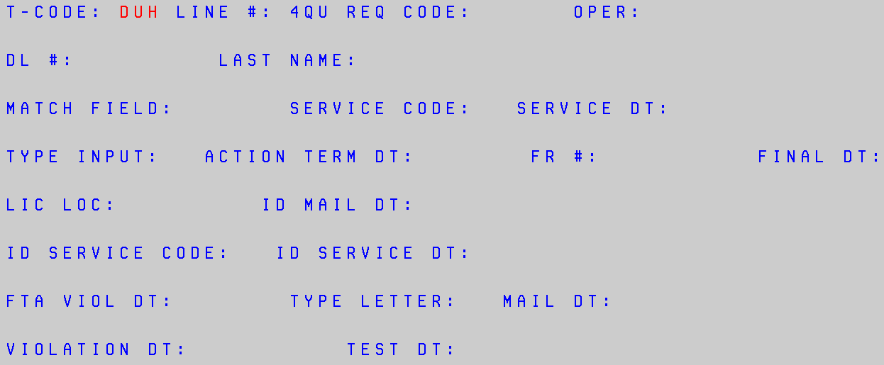

|  |  |  |
| --- | --- | --- |
| Elements | Send to Backend T-Code & Field | SERVICE CODE/LICENSE LOCATION (DUH)page LAYOUT  Field Attributes & RULES |
| Service Code/License Location (DUH)page caption | | |
| **Close box** | N/A |  |
| **N/A** | DUH  (T-CODE) | -DUH  -Hide from page.  -3 alpha characters  -A fixed required field. |
| **n/a:** | dUH  (REQ CODE:) | -Send Requester Code from the Office table based on user’s Office RU from Employee table.  -Hide from page.  -5 numeric characters  -A fixed required field. |
| **N/A** | dUH  (Oper:) | -Send 3 alpha-numeric characters (the third, fourth, and fifth positions of the User ID from Employee table) to the DUH transaction.  -Hide from page.  -A fixed required field. |
| **DL#:** | DUH  (DL #:) | -Auto-populate from DL Updates page.  -Editable.  -Allow 8 alpha-numeric characters.  -A fixed required field. |
| **3 Pos Last name:** | DUH  (Last Name:) | -Editable.  -Auto-populate first three positions of last name.  -A fixed required field. |
| **Service date:** | DUH  (service dt:) | -Editable  -Allow 6 numeric characters as MM-DD-YY.  -A fixed optional field. |
| **service code:** | duh  (service code:) | -Editable.  -A fixed optional field.  -Display Service Code menu. Refer to the VB6 example shown below. Auto-populate the rows with the values from the DL Look Up table. Sort the rows in ascending order. Allow a selection by clicking on a menu item. Allow toggling between menu items. |
| **Original Effective Date:** | duh  (match field:) | -Editable.  -Allow 6 numeric characters.  -A fixed optional field. |
| **license location:** | duh  (lic loc:) | -Editable.  -A fixed optional field.  -Display License Location menu. Refer to the VB6 example shown below. Auto-populate the rows with the values from the DL Look Up table. Sort the rows in ascending order. Allow a selection by clicking on a menu item. Allow toggling between menu items. |

|  |  |  |
| --- | --- | --- |
| **type input:** | duh  (type input:) | -Editable.  -A fixed optional field.  -Display Type Input menu. Refer to the VB6 example shown below. Auto-populate the rows with the values from the DL Look Up table. Sort the rows in ascending order. Allow a selection by clicking on a menu item. Allow toggling between menu items. |
| **violation date:** | duh  (violation dt:) | -Editable  -Allow 6 numeric characters as MM-DD-YY.  -A fixed optional field. |
| **Next Trans:** | N/A | -Editable  -Allow 3 alpha-numeric characters.  -Optional field.  -Display a DL Update menu when a keying error occurs or the menu is selected. Add columns and column headers for the bullet items in the order shown below. Auto populate the rows with the values from the users RACF access. Sort the rows in alphabetical order by T-Code. Allow a selection by clicking on a menu item or by keyboard entry. Allow toggling between menu items.  * Code  * Description  -Allow the menu items to be sorted based on the desired column by double clicking on the column header. |
| **New DL button** | N/A | Selecting the button:  -Sends the input and stores to the DL database.  -Returns all backend messages.  -Returns a blank Service Code/License Location (DUH) screen.  -Default curser to DL# field. |
| **Update button** | N/A | Selecting the button:  -Sends the input and stores to the DL database.  -Exits the Service Code/License Location (DUH) page.  -Returns all backend messages. Refer to the VB6 example shown below.  -Returns to the DL Updates Menu page. |
| **Cancel button** | N/A | Selecting the button:  -Prevents any present input from being stored to the DL database.  -Exits the Service Code/License Location (DUH) page.  -Returns to the DL Updates Menu page. |

## DUJ-Suspense

### When the DUJ-Suspense is selected from the DL Updates Menu page display the Suspense (DUJ) page as described in the layout shown below. Refer to the VB6 example shown below for a current screen shot.

VB6 Example: Suspense (DUJ)

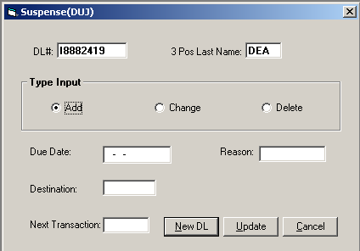

Example Suspense DUJ

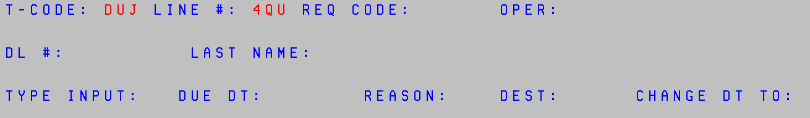

|  |  |  |
| --- | --- | --- |
| Elements | Send to Backend T-Code & Field | SUSPENSE (DUJ)page LAYOUT  Field Attributes & RULES |
| Suspense (DUJ)page caption | | |
| **Close box** | N/A |  |
| **N/A** | DUJ  (T-CODE) | -DUJ  -Hide from page.  -3 alpha characters  -A fixed required field. |
| **n/a:** | dUJ  (REQ CODE:) | -Send Requester Code from the Office table based on user’s Office RU from Employee table.  -Hide from page.  -5 numeric characters  -A fixed required field. |
| **N/A** | dUJ  (Oper:) | -Send 3 alpha-numeric characters (the third, fourth, and fifth positions of the User ID from Employee table) to the DUJ transaction.  -Hide from page.  -A fixed required field. |

|  |  |  |
| --- | --- | --- |
| **DL#:** | DUJ  (DL #:) | -Auto-populate from DL Updates page.  -Editable.  -Allow 8 alpha-numeric characters.  -A fixed required field. |
| **3 Pos Last name:** | DUJ  (Last Name:) | -Editable.  -Auto-populate first three positions of last name.  -A fixed required field. |
| **TYPE INPUT:** | DUJ  (TYPE INPUT:) | -Editable.  -Allow 1 alpha character.  -A fixed required field.  -Create radio buttons for Add, Change, and Delete for user to click on.  -If Change is selected, add a Change To Date field to the Suspense (DUJ) screen. Refer to the VB6 example shown below. |
| **due date:** | duj  (due dt:) | -Editable  -Allow 6 numeric characters as MM-DD-YY.  -A fixed required field. |
| **reason:** | duj  (reason:) | -Editable.  -A fixed required field.  -Display Suspense Reason menu. Refer to the VB6 example shown below. Auto-populate the rows with the values from the DL Look Up table. Sort the rows in ascending order. Allow a selection by clicking on a menu item. Allow toggling between menu items. |
| **destination:** | duj  (reason:) | -Editable.  -Allow 4 numeric characters.  -A fixed required field. |
| **change to date:** | duj  (change dt to:) | -Editable  -Allow 6 numeric characters as MM-DD-YY.  -A fixed optional field. |
| **Next Trans:** | N/A | -Editable  -Allow 3 alpha-numeric characters.  -Optional field.  -Display a DL Update menu when a keying error occurs or the menu is selected. Add columns and column headers for the bullet items in the order shown below. Auto populate the rows with the values from the users RACF access. Sort the rows in alphabetical order by T-Code. Allow a selection by clicking on a menu item or by keyboard entry. Allow toggling between menu items.  * Code  * Description  -Allow the menu items to be sorted based on the desired column by double clicking on the column header. |
| **New DL button** | N/A | Selecting the button:  -Sends the input and stores to the DL database.  -Returns all backend messages.  -Returns a blank Suspense (DUJ) screen.  -Default curser to DL# field. |
| **Update button** | N/A | Selecting the button:  -Sends the input and stores to the DL database.  -Exits the Suspense (DUJ) page.  -Returns all backend messages. Refer to the VB6 example shown below.  -Returns to the DL Updates Menu page. |
| **Cancel button** | N/A | Selecting the button:  -Prevents any present input from being stored to the DL database.  -Exits the Suspense (DUJ) page.  -Returns to the DL Updates Menu page. |