Hi Team,

This is a representative document of a sample application I am building as part of CRA- Angular training.

This is an accounting app which lets a small business or vendor maintain a record of its customers, suppliers and sales figures.

This is the landing page. There is an addition of login option that I will be implementing to authorize the person.

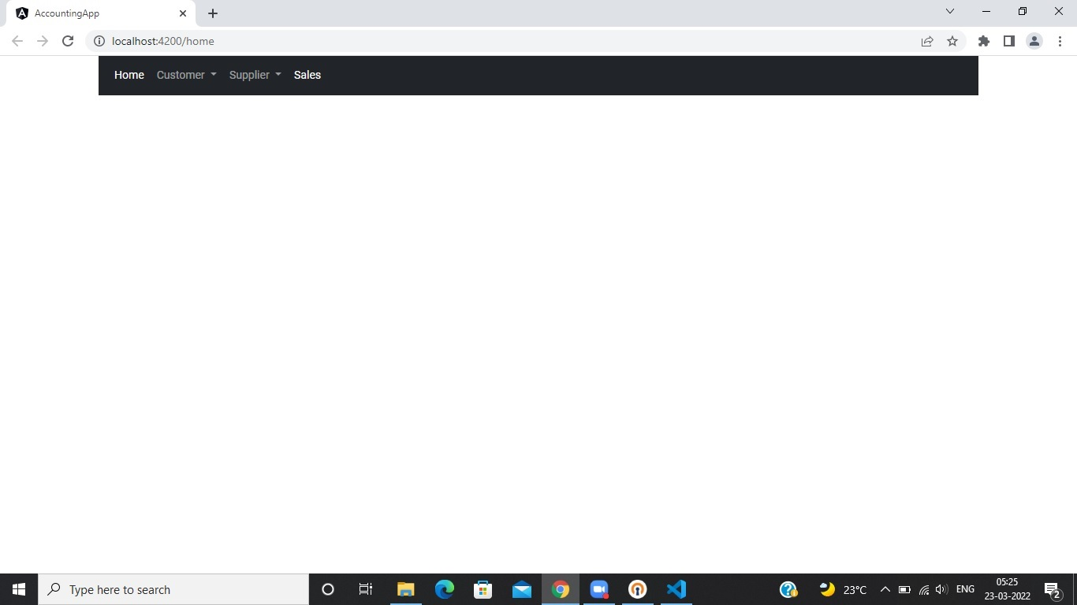

An authorized person can access all the pages and options of creating, editing the customers and suppliers and modifying and the sales data.

Following are the page screenshots that an authorized person can access:

1. Customer list page.

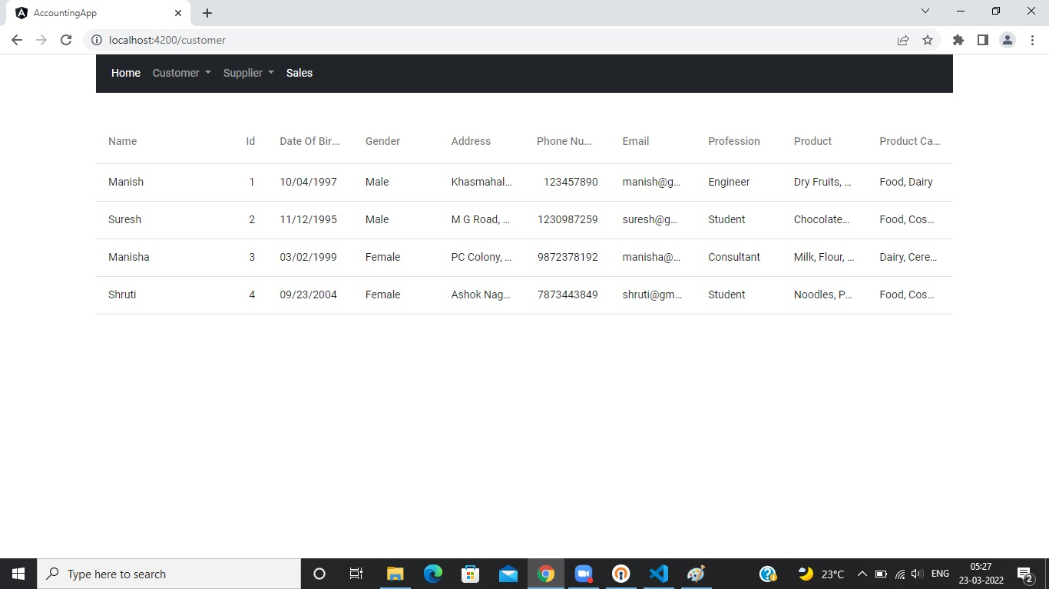

2. Create Customer page

.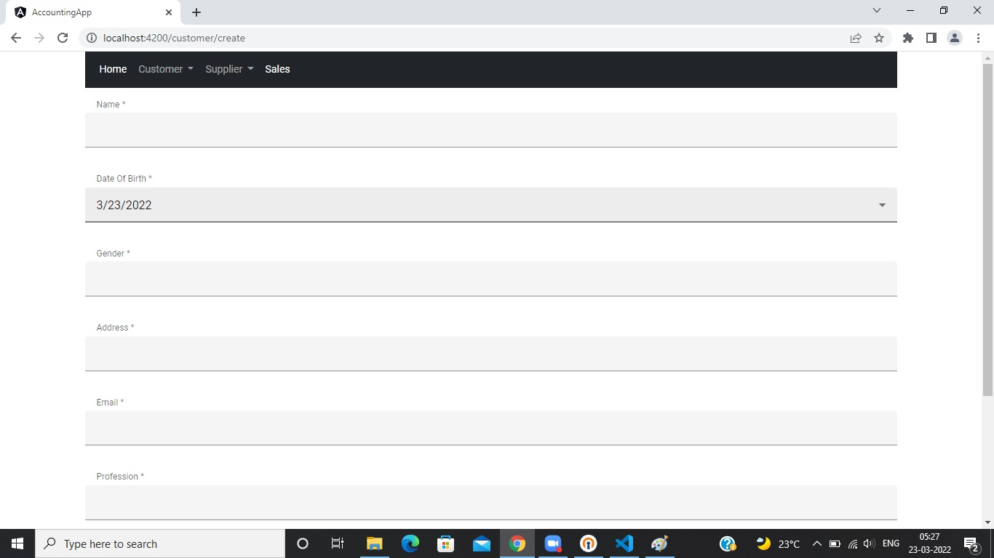

Similar functionality with supplier's page,

1. Sales figures page.

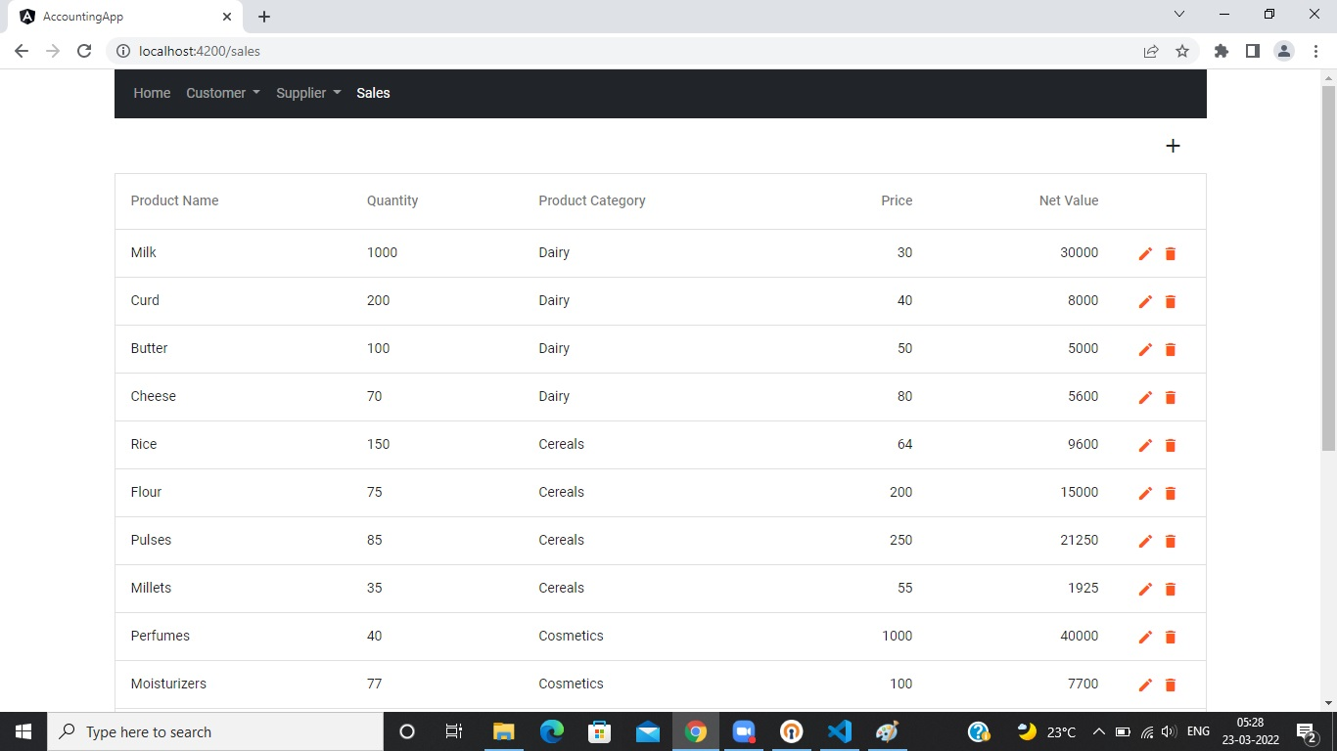

All the feature modules of customer, supplier and sales will be lazy-loaded. Implementation of Auth guard and interceptor to access the modification of data and devextreme control will be implemented.

Basic Data flow of my application

