**ABSTRACT**

**Project Topic: Online Home Service System**

The main idea of this system is to overcome the difficulties facing for finding a person for various house cleaning and maintenance purpose. It will help user to choose the nearby staffs for their various house based requirements, if the staffs are available.

Home service system where a customer gets to order different kind of services like cleaning, painting, carpenting furniture supply etc. The customer unique experiences where he gets to choose the service and the vendor based on various parameters like cost, rating of vendor and availability.

There are mainly 3 modules;

1. Admin Module

2. Vendor Module

3. User Module

1. Admin Module

Admin of the site will have easy access to each and every order details of vendor and cost and sales profit making of various services. He has the privilege to change the daily wages of the vendor.

2. Vendor

* Vendor can cancel and agree the request from user.
* Can add the availability status in the calendar.

3. User

* User can login into the site.
* He can choose the vendor.
* He can view the details of the vendor.

**API**

This Home service system uses Google map services to find out location of nearest vendor.

**USECASE DIAGRAMS**

**Usecase Diagram for Admin**

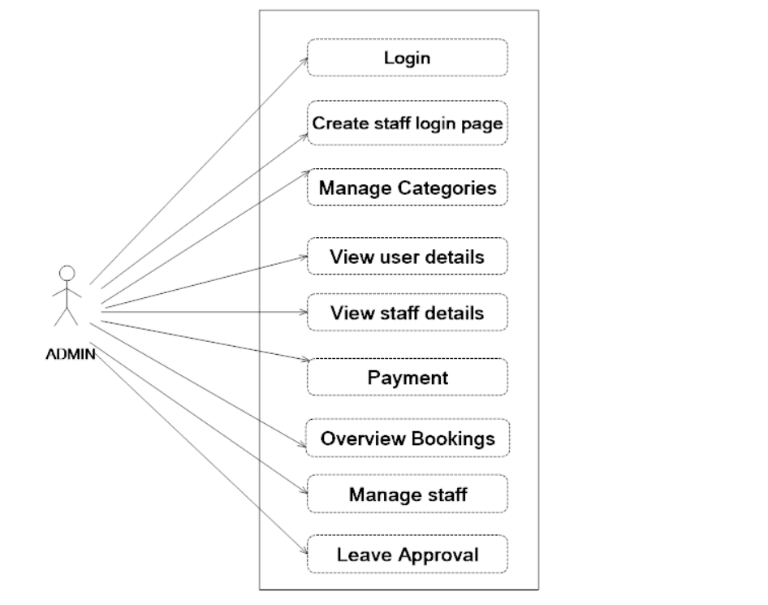

**Usecase Diagram for Vendor**

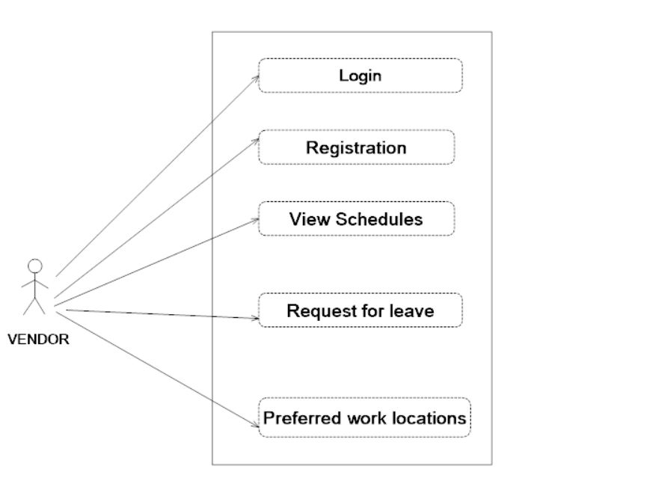

**Usecase Diagram for User**

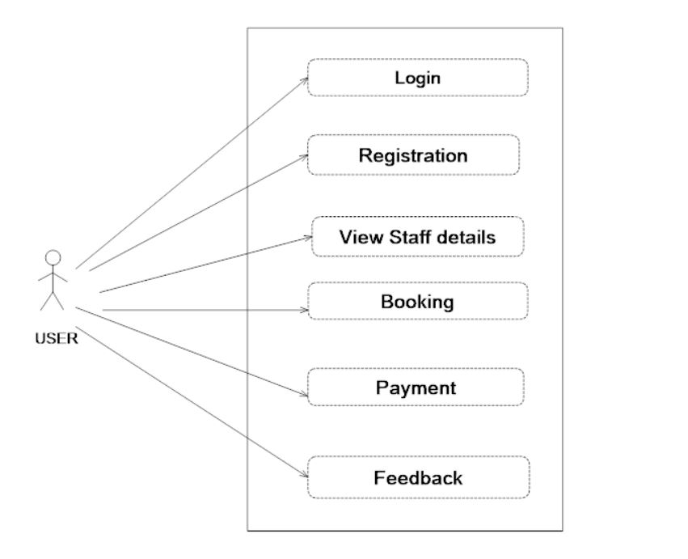

**TABLES**

**Table No. : 1**

**Table name : TBL_LOGIN**

**Primary Key: Log-id**

|  |  |  |  |
| --- | --- | --- | --- |
| **Field** | **Data type** | **Size** | **Description** |
| Log_id | Int | 11 | User login id primary key |
| Username | Varchar | 20 | (Registration) |
| Password | Varchar | 50 | Password |
| Role_id | Int | 11 | login role (admin, buyer, seller) |
| Status | Int | 11 | Valid/invalid |

**Table No. : 2**

**Table name : TBL_USER_REGISTRATION**

**Primary Key : Reg_Id Foreign Key : Log_Id**

|  |  |  |  |
| --- | --- | --- | --- |
| **Field** | **Data type** | **Size** | **Description** |
| Reg_id | Int | 11 | Primary key |
| Log_id | Int | 11 | Foreign key |
| Username | Varchar | 20 | Username |
| Password | Varchar | 50 | Password |
| First_name | Varchar | 30 | First Name |
| Last_name | Varchar | 30 | Last Name |
| Address | Varchar | 30 | Address |
| City | Varchar | 30 | City |
| Pin | Int | 30 | Pin |
| Contact | Int | 30 | Contact Number |
| Email_id | Varchar | 30 | Email id |

**Table No. : 3**

**Table name : TBL_EMP_REGISTRATION**

**Primary Key : Emp_Id**

|  |  |  |  |
| --- | --- | --- | --- |
| **Field** | **Data type** | **Size** | **Description** |
| Emp_id | Int | 11 | Primary key |
| First Name | Varchar | 20 | First Name |
| Last Name | Varchar | 20 | Last Name |
| Place | Varchar | 20 | Place |
| Mobile | Int | 50 | Mobile Number |
| Email | Varchar | 30 | Email id |
| Gender | Varchar | 30 | Gender |
| DOB | Int | 11 | DOB |
| Password | Varchar | 30 | Password |
| Photo | Varchar | 30 | Photo |
| Category | Varchar | 30 | Category |
| Aadhar | Varchar | 30 | Aadhar |
| Status | Int | 11 | Status of the Employe |

**Table No. : 4**

**Table name : TBL_ CATEGORY**

**Primary Key : Cid**

|  |  |  |  |
| --- | --- | --- | --- |
| **Field** | **Data type** | **Size** | **Description** |
| Cid | Int | 11 | Primary key |
| Name | Varchar | 30 | Category Name |
| Desc | Varchar | 100 | Description |

**Table No. : 5**

**Table name : TBL_BANK**

**Primary Key: Bid**

|  |  |  |  |
| --- | --- | --- | --- |
| **Field** | **Data type** | **Size** | **Description** |
| Bid | Int | 11 | Primary key |
| Name | Varchar | 20 | Bank Name |
| Type | Varchar | 50 | Bank Type |

**Table No. : 6**

**Table name : TBL_PAYMENT**

**Primary Key : Reg_Id Foreign Key : Log_Id**

|  |  |  |  |
| --- | --- | --- | --- |
| **Field** | **Data type** | **Size** | **Description** |
| Pay_id | Int | 11 | Primary key |
| Reg_id | Int | 11 | Foreign key (Registration of user) |
| Log_id | Int | 11 | Foreign key(Login) |
| Service_id | Int | 11 | Foreign key(Service) |
| Book_id | Int | 11 | Foreign key(Booking) |
| Bankname | Varchar | 30 | Bank Name |
| Type | Varchar | 30 | Bank Type |
| Amount | Int | 11 | Payment amount |
| Status | Int | 30 | Status of payment |

**Table No. : 7**

**Table name : TBL_SERVICE**

**Primary Key: Service-id**

|  |  |  |  |
| --- | --- | --- | --- |
| **Field** | **Data type** | **Size** | **Description** |
| Service_id | Int | 11 | Primary key |
| Service_name | Varchar | 20 | Sevice Name |
| Service_type | Varchar | 50 | Type of Service |
| Service_charge | Int | 11 | Charge of the service |
| Image | Varchar | 30 | Photo |

**Table No. : 8**

**Table name : TBL_BOOKING**

**Primary Key : Book_Id Foreign Key: Service_Id**

**Foreign Key: Reg_Id Foreign Key: Log_Id**

|  |  |  |  |
| --- | --- | --- | --- |
| **Field** | **Data type** | **Size** | **Description** |
| Book_id | Int | 11 | Primary key |
| Log-id | Int | 11 | Foreign key(Login) |
| Service-id | Int | 11 | Foreign key(Service) |
| Reg-id | Int | 11 | Foreign key |
| Date | Date/Time | 2 | Booking date |
| Status | Int | 11 | Status of booking |

**Table No. : 9**

**Table name : TBL_FEEDBACK**

**Primary Key : Feed_Id Foreign Key : Username**

|  |  |  |  |
| --- | --- | --- | --- |
| **Field** | **Data type** | **Size** | **Description** |
| Feed_id | Int | 11 | Feedback id |
| Username | Varchar | 20 | Foreign key(Login) |
| Place | Varchar | 20 | Place |
| Mobile | Int | 50 | Mobile Number |
| Email | Varchar | 30 | Email id |
| Feedback | Varchar | 70 | Feedback |

**Table No. : 10**

**Table name : TBL_SALARY**

**Primary Key : Sal_Id Foreign Key : Reg_Id**

|  |  |  |  |
| --- | --- | --- | --- |
| **Field** | **Data type** | **Size** | **Description** |
| Sal_id | Int | 11 | Primary key |
| Reg_id | Int | 11 | Foreign key (Registration of Employee) |
| Hra | Int | 11 | HRA |
| Pf | Int | 11 | PF |
| Da | Int | 11 | DA |
| Gross | Int | 11 | Gross Pay |
| Net | Int | 11 | Net Amount |
| Basic salary | Int | 11 | Basic Salary |

**Table No. : 11**

**Table name : TBL_CHARGE**

**Primary Key : Cid**

|  |  |  |  |
| --- | --- | --- | --- |
| **Field** | **Data type** | **Size** | **Description** |
| Cid | Int | 11 | Primary key |
| Charge | Int | 11 | Charge |

**Table No. : 12**

**Table name : TBL_PLACE**

**Primary Key : Pid**

|  |  |  |  |
| --- | --- | --- | --- |
| **Field** | **Data type** | **Size** | **Description** |
| Pid | Int | 11 | Primary key |
| Place | Varchar | 30 | Place |

**FORM DESIGN**

