Fixed Files and Folders

Revamped the home page for applicants:

* Moved the dynamic things above
* Moved the radar chart below

Redirected how I want the recruiter profile to look like:

* Changed from company’s review to how to manage applications (data will most likely be retrieved from manual input/their own database.

Create a new dummy DB for the updation of information on the cards:

* 5 attributes for each row

Update the cards:

* Used FastAPI
* JS
* _babel which I removed then started working

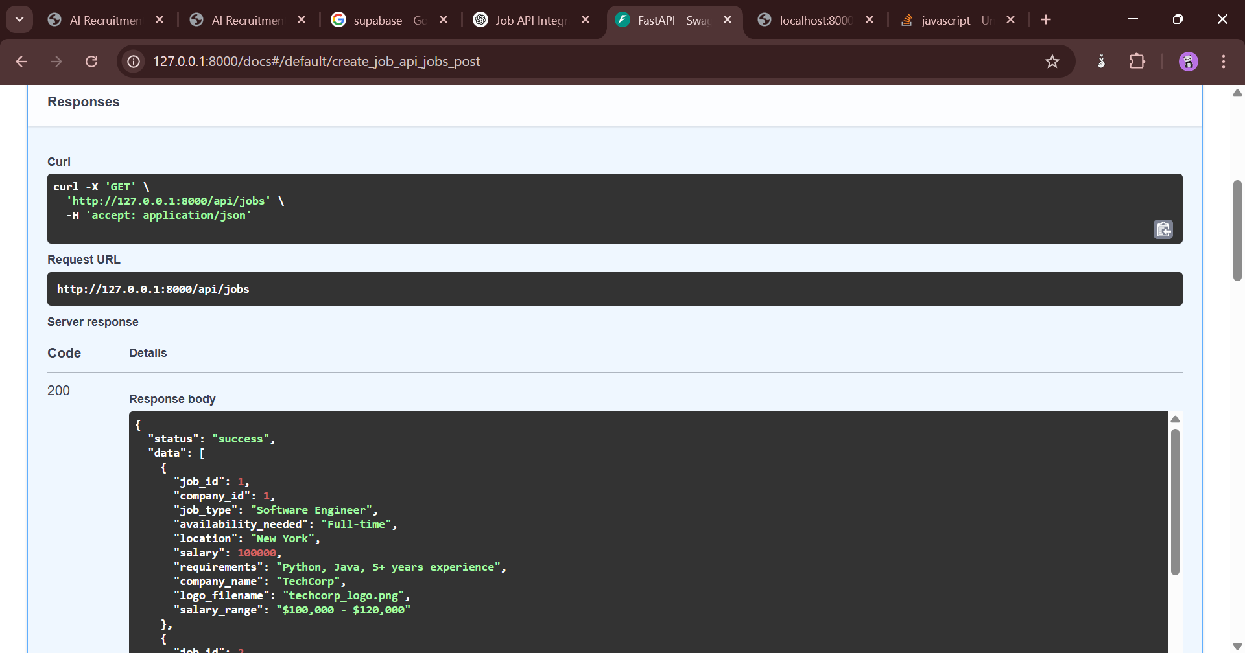

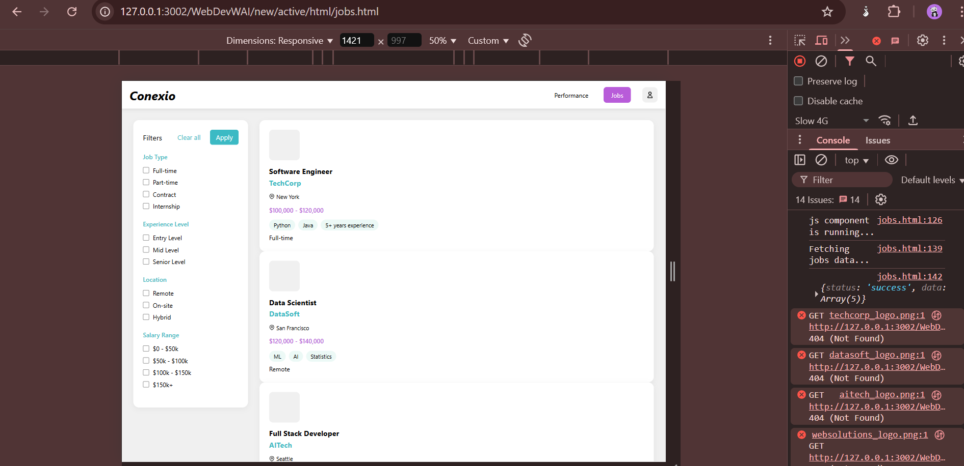

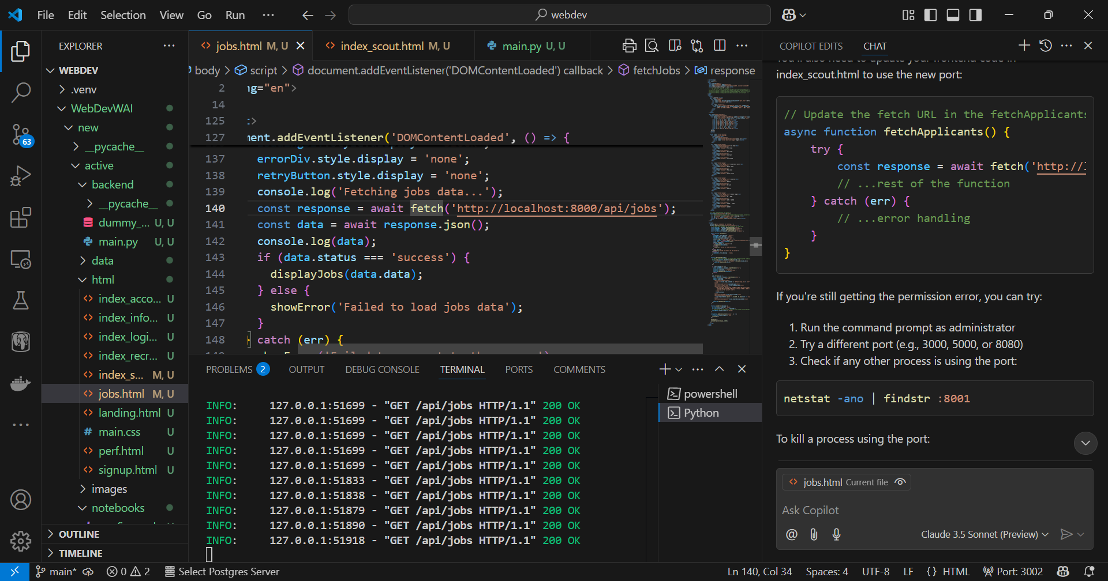

Same implemented on applicants

Watchlist

* Used FastAPI

Login info api (username + password)

Signup api (authentication)

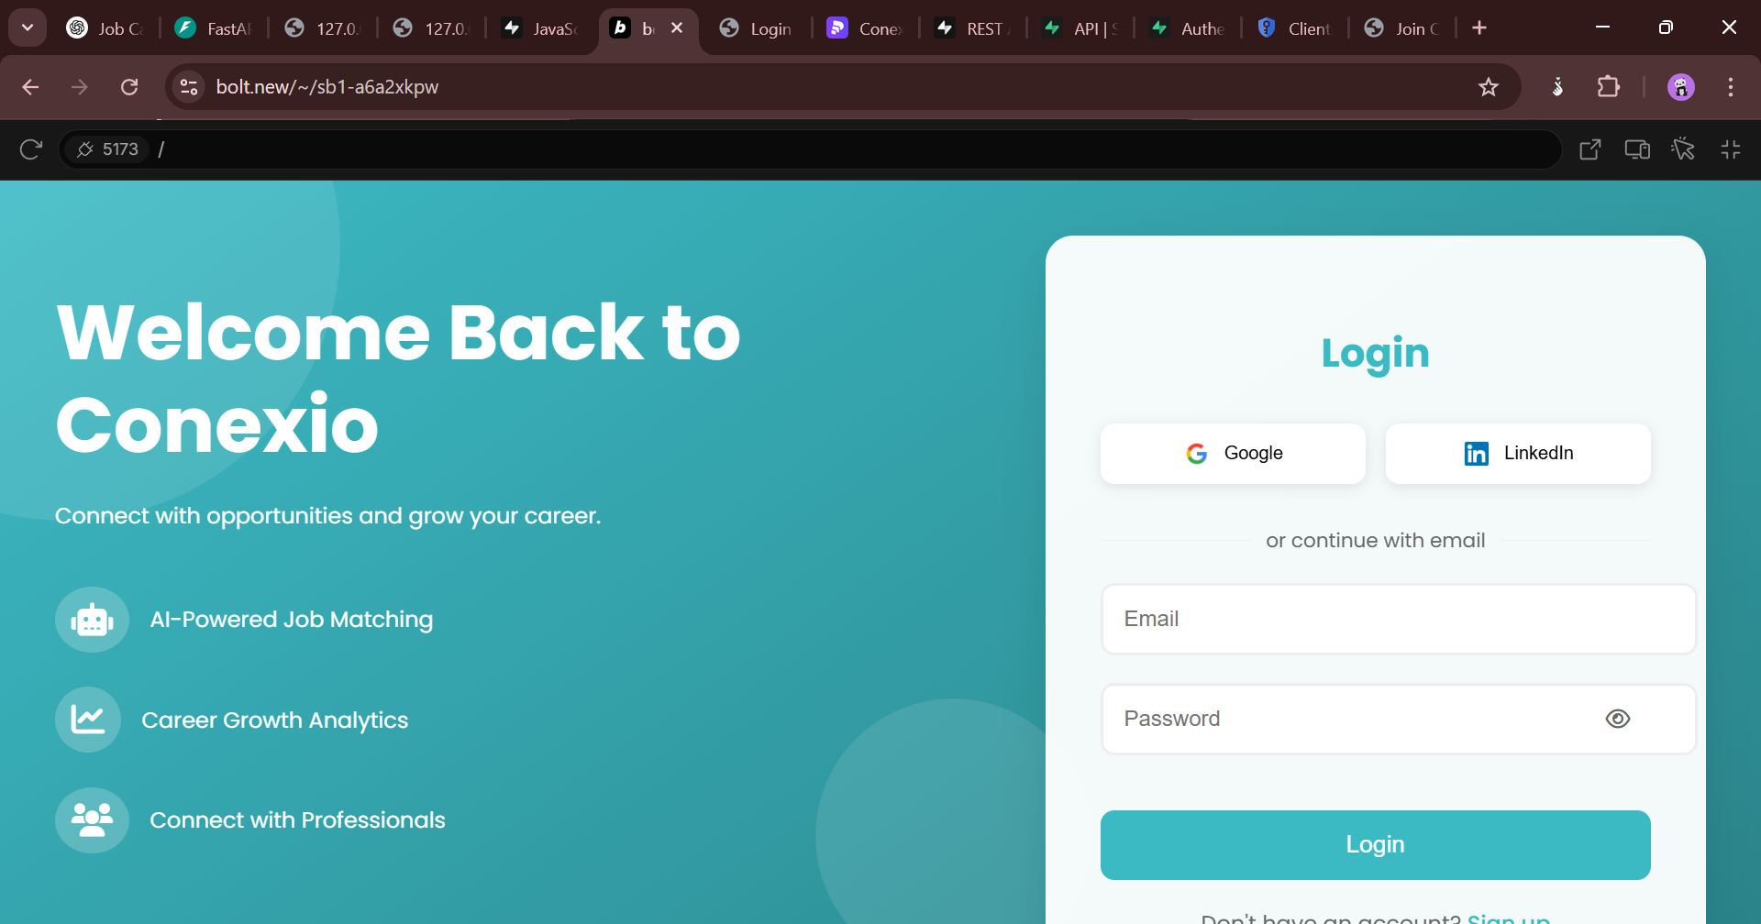

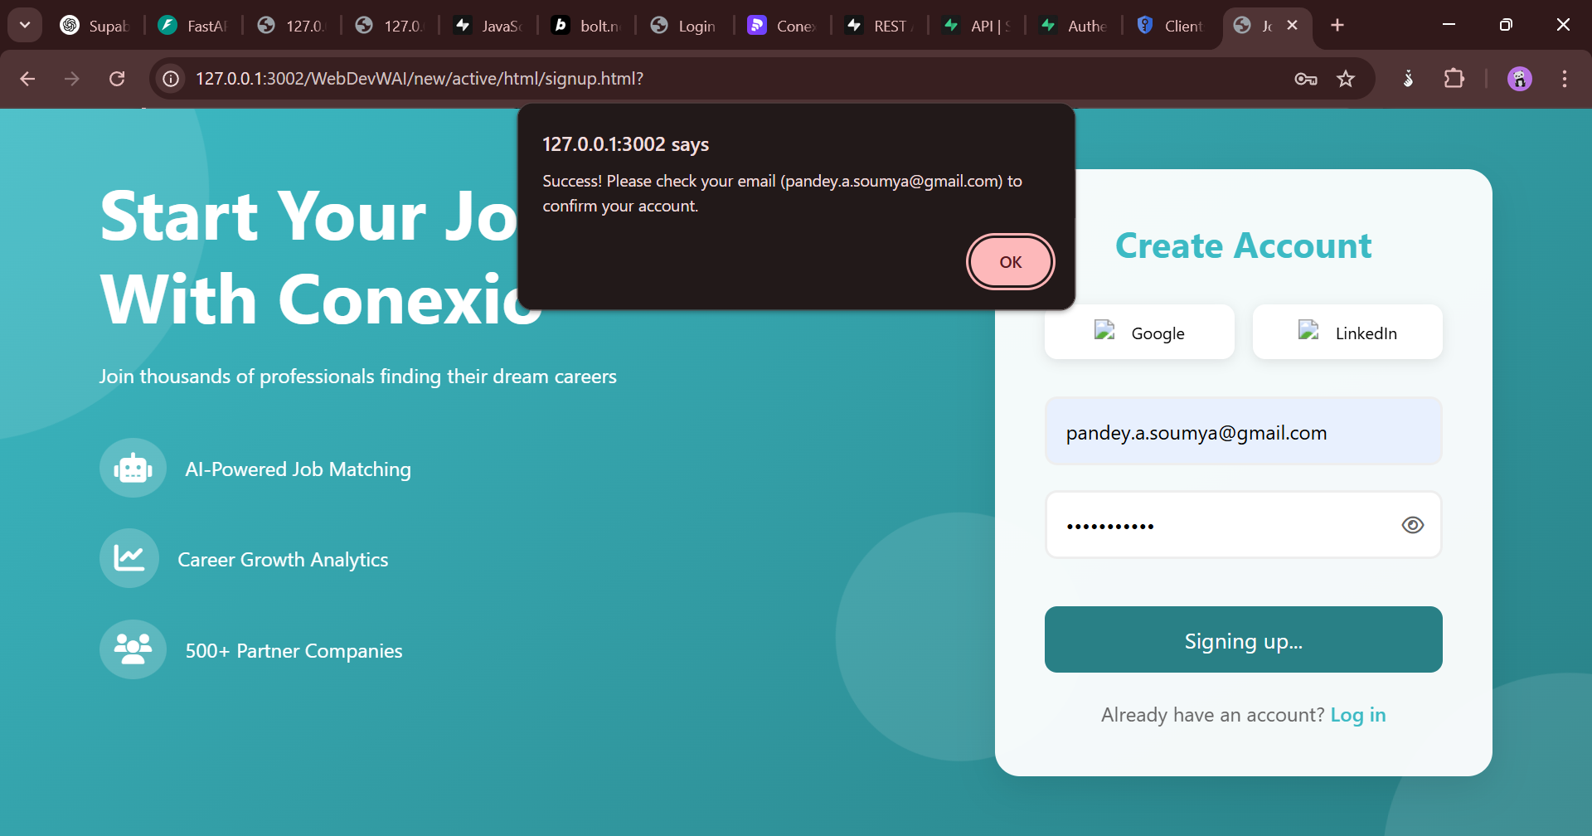

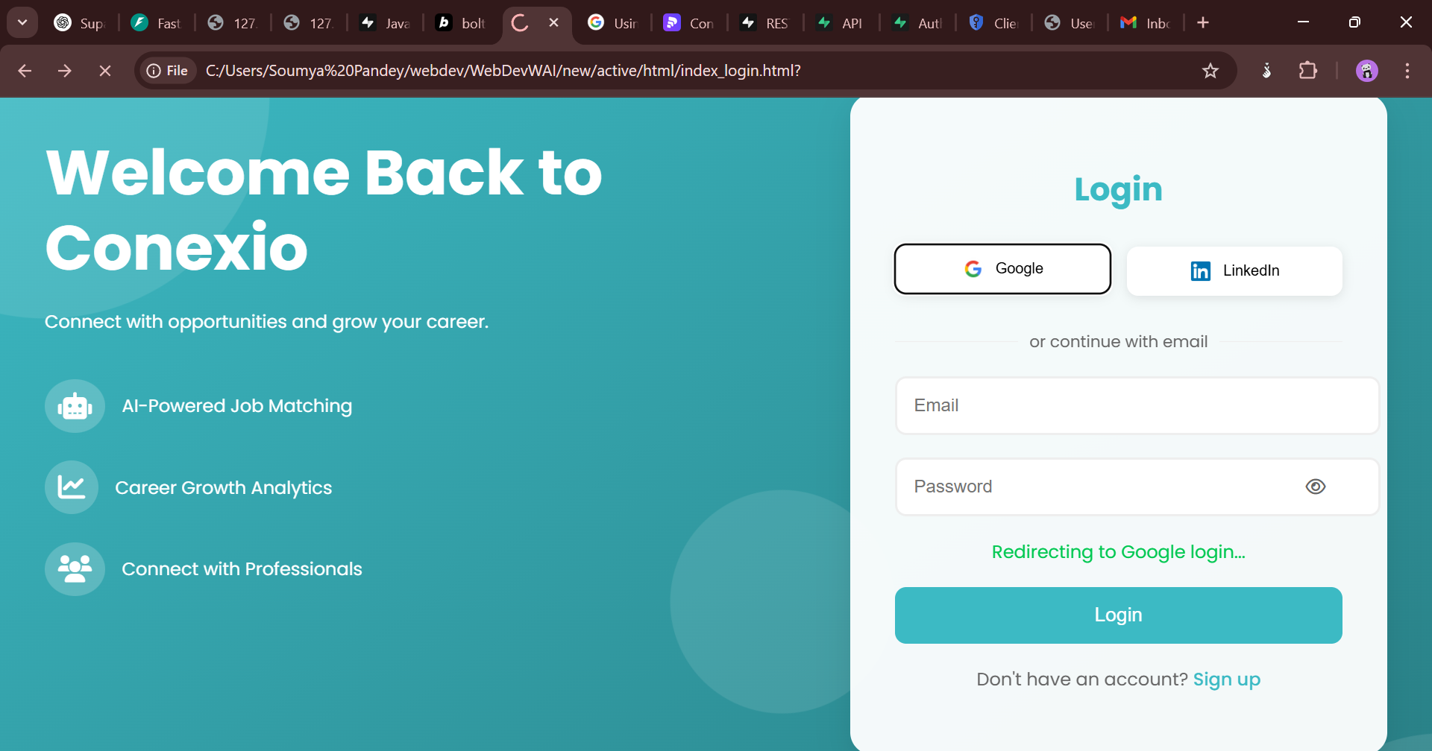

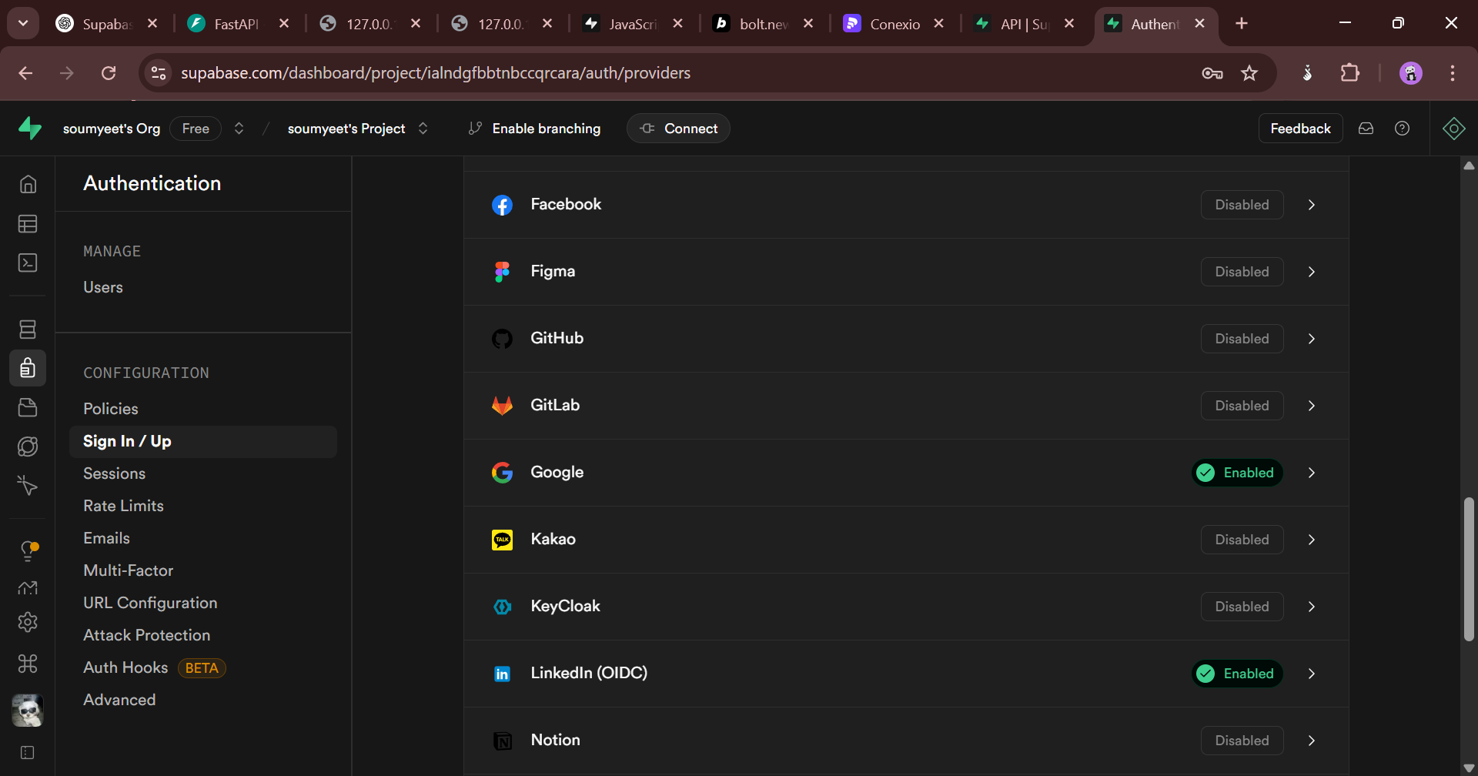

User information (supabase)

Collect files resume/hiring protocol

* Updated **applicant & recruiter cards**
  + Used **FastAPI for backend**
  + Integrated with **JavaScript frontend**
  + Faced **_babel issue**, removed it & continued

**6. What I Tried & What I Could Have Done Better**

✅ Successfully used **FastAPI with JS**  
✅ Explored **Supabase for authentication & data handling**  
⚠️ Faced **_babel dependency issue**, had to remove it  
⚠️ **UI can be further improved** for a better user experience

**7. Insights on AI Prompting**

* Used **AI to structure API endpoints** efficiently
* Improved **prompt engineering** for debugging issues
* Learned to refine **queries for AI-assisted coding**

**8. Conclusion & Next Steps**

✅ Successfully integrated **FastAPI & Supabase**  
✅ Improved **authentication & data handling**  
➡️ Future improvements: **UI enhancements & API optimizations**  
➡️ Continue refining **AI prompts for better development workflow**

|  |  |  |
| --- | --- | --- |
| **Primary Purpose** | Database & authentication | API development & backend logic |
| **Code Generation** | ❌ No, only auto-generates REST API for DB | ✅ Yes, fully customizable API endpoints |
| **Authentication** | ✅ Built-in user authentication (OAuth, JWT) | ⚠️ Requires manual implementation |
| **Database Handling** | ✅ PostgreSQL-based with real-time updates | ❌ Needs separate database setup (SQLAlchemy, etc.) |
| **Business Logic** | ❌ Limited (basic triggers & functions) | ✅ Supports complex backend logic & workflows |
| **Custom Endpoints** | ❌ No, only predefined API routes | ✅ Yes, fully customizable API routes |
| **Error Handling** | ❌ Limited (manual debugging in logs) | ✅ Built-in exception handling & validation |
| **Best Use Case** | No-code/low-code DB API & authentication | Custom APIs, backend logic, and integrations |