This is a tab where students can add their info and review how what are their strengths and weaknesses in terms of applications  
- use shades 7ed9ca, a2e8dc, d8fff8, 2fbcbc, 5bc8b2 and shades of green as your color scheme, and maybe similar darker shades if needed  
- have a navbar on top where there are options for jobs and dashboard, and an indication youre on the performance tab, and a circle for user info. thsi navbar should have the words darken when hovered over with an underlining.  
- the first thing the student will see on their left is a radar chart with the skills: communication, creativity, technical skills, problem solving, leadership.  
- on the right of the radar chart it should say the strengths and weaknesses as bullet points and tell which part of their skills point out to what and whats lacking  
- below that it has boxes with 3 boxes in one row (for desktop) and three boxes in one column (for phones) with the heading above the boxes saying 'Companies In your List' and in the box it has the companys logo and the name, and a set of bullet points that show what skills are matched (with tick) and what skills arent there  
- below all of this, there are dropdowns for: experince, projects, positions of responsibility, skills and achievements. It also has a button on the right to add new   
- this all needs to be responsive

007878

make a website that has:  
- a header that has tabs for Resume, Companies, Performance  
- a light theme with blue, teal, green color scheme  
- a big box that has radar chart with communication, technical skills, problem solving skills, leadership skills, creativity as the metrics, and on to the right it has how to improve as the heading and bullet points that highlight the bad parts  
- below there are boxes, 3 boxes in a row, which has company logo, company name, requirements and interview date

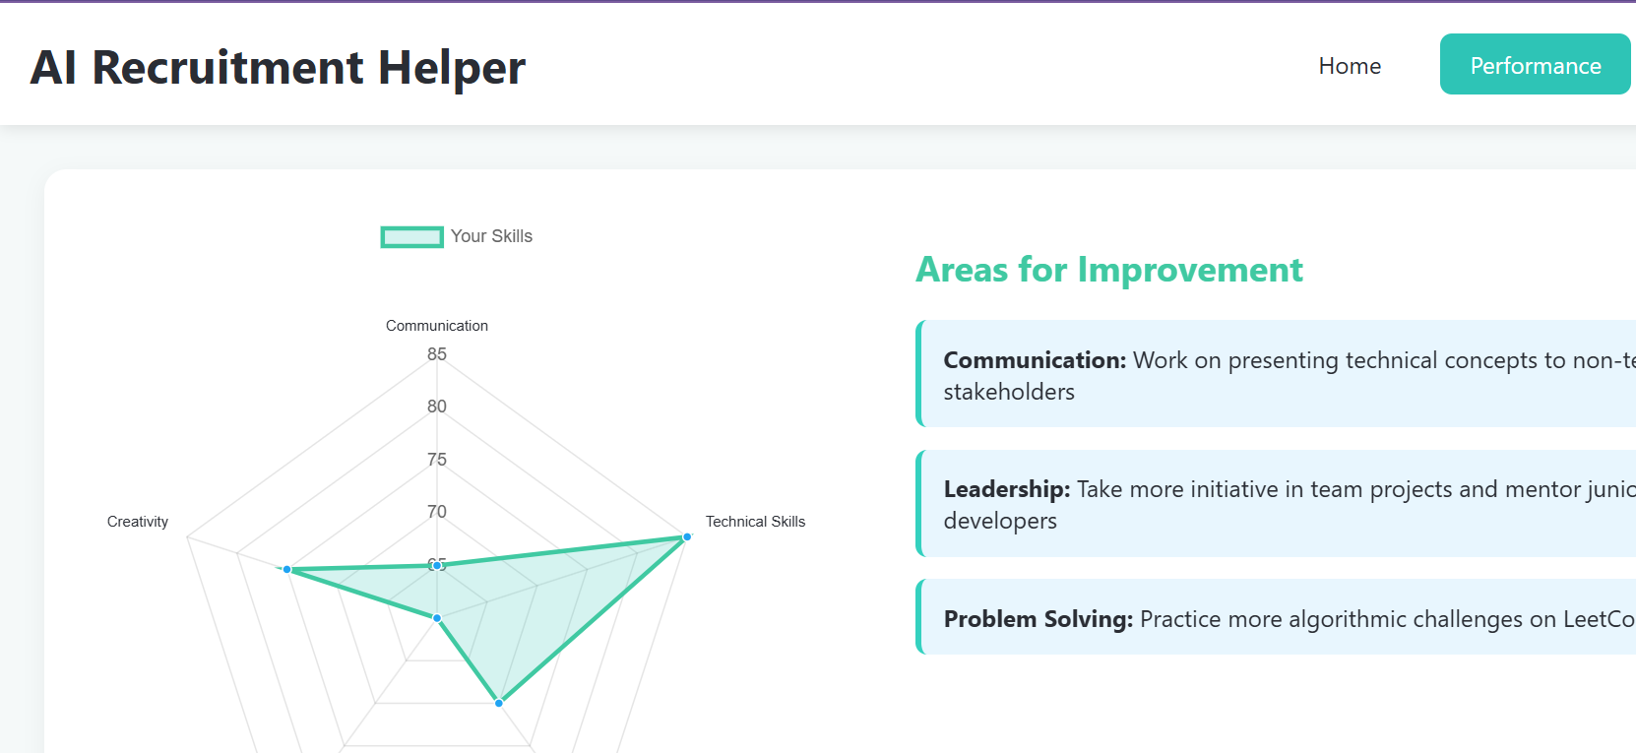

add a statement saying: Companies in your list:  
this is to be put before the boxes, and in the boxes, instead of requirements, put the skills matched and skills not present and a green tick or red cross as representation  
- also change the accent color to spomething more green or teal

make it more responsive

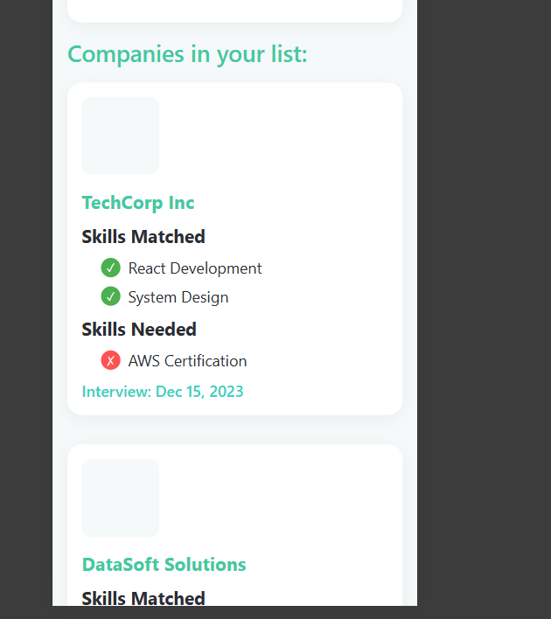

maybe add areas of strength along with areas for improvement

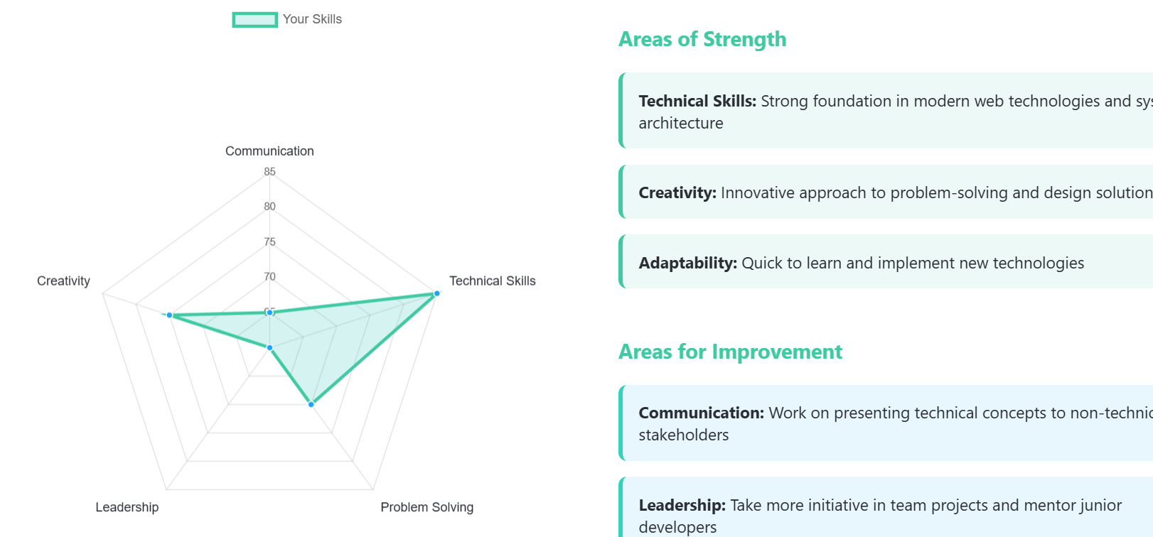

experince, projects, positions of responsibility,skills and achievements. It also has a button on the right to add new   
- this all needs to be responsive

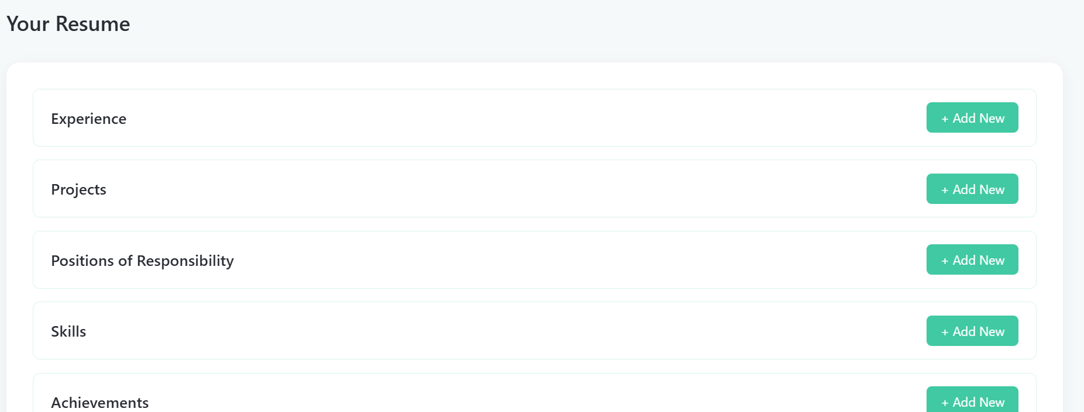

when i click the box with the job, i want it to open another radar chart with your skills and companies required skills overlapping each other to show the difference from your desired state and on the right some info to improve

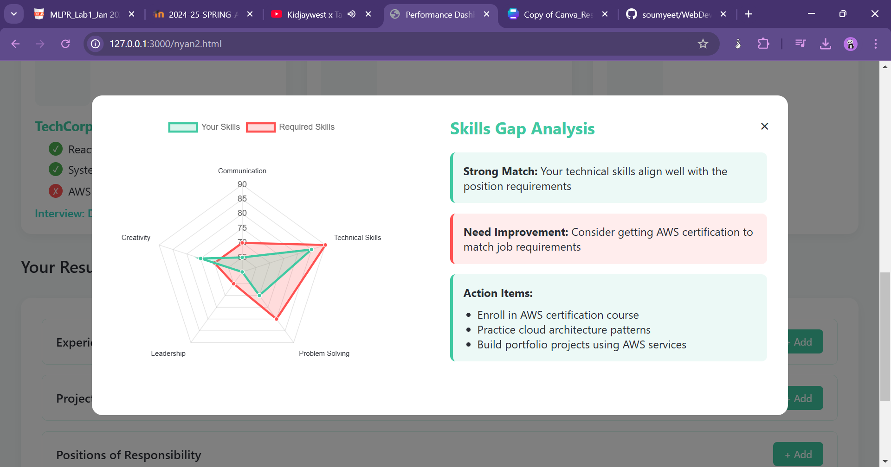

in home:  
- add a heading 'benefits for students' and below that have an image on the left and a text on right that explains some functionality of the website and below that an image on the right and text on left that again explains some functionality  
- repeat the above thing with the heading 'benefits for the recruiters'

below everything add a section describing how our AI helps with this

add a filter section on the left (1/4th of the width of the screen, for phones its an openable filter section) that lets you filter out types of jobs and put the boxes as same in nyan2 on the right that gives the job requirements and package and etc

add a search bar and remove the ticks and crosses, add more filters for like types of jobs and area and everything