WORKMATE.AI: AI‑Enabled Organisation, Project and Task Management with Hybrid Intent Parsing Benchmarking
A PROJECT REPORT
Submitted in partial fulfilment of the requirement for the award of the degree of
BACHELOR OF TECHNOLOGY (B.Tech) in Information Technology
by
Soumye Gupta (Reg. No. 229302024)
Department of Information Technology
MANIPAL UNIVERSITY JAIPUR
JAIPUR‑303007, RAJASTHAN, INDIA
Month Year

CERTIFICATE
This is to certify that the project titled “WORKMATE.AI: AI‑Enabled Organisation, Project and Task Management with Hybrid Intent Parsing Benchmarking” is a record of the bonafide work done by Soumye Gupta (Reg. No. 229302024) submitted in partial fulfilment of the requirements for the award of the Degree of Bachelor of Technology (B.Tech) in Information Technology of Manipal University Jaipur, during the academic year 2025–26.

Dept Guide Name
Project Guide, Department of Information Technology
Manipal University Jaipur

HOD Name
HOD, Department of Information Technology
Manipal University Jaipur

ACKNOWLEDGMENTS
I would like to express my sincere gratitude to Dept Guide Name, Project Guide, Department of Information Technology, Manipal University Jaipur, for continuous guidance, timely feedback, and encouragement throughout the development and research phases of this project.
I am thankful to HOD Name, HOD, Department of Information Technology, for providing the academic environment and resources required to complete this project successfully.
I also extend my appreciation to the faculty members and lab staff of the Department of Information Technology for their support and assistance whenever needed. Finally, I thank my family and friends for their motivation and support during the project work.

ABSTRACT
Modern teams frequently face fragmented coordination across chats, spreadsheets, and partial project tools, leading to unclear ownership, delayed execution, and loss of task context. WorkMate.AI addresses these gaps by providing a unified organisation–project–task platform combined with an AI assistant that converts natural language commands into structured workflow actions. The objective of this project is to develop a practical productivity system and to conduct a research benchmark comparing multiple intent‑parsing approaches, demonstrating that a hybrid method improves reliability and accuracy for real‑world task automation.
The system is implemented as a full‑stack web application with a React‑based frontend, Node.js/Express backend APIs, and a Supabase PostgreSQL database. The AI pipeline uses a locally hosted LLM (Ollama) for intent and entity extraction and combines it with deterministic post‑processing, validation, and safe entity matching in the workflow executor. For the research component, a benchmark dataset of natural language prompts (JSONL) with expected structured outputs was curated, and three methods were evaluated: rule‑based parsing, LLM‑only parsing, and hybrid parsing.
Results from the benchmark show that the hybrid approach achieves the best end‑to‑end reliability, with higher intent accuracy and field accuracy and fewer failures compared to LLM‑only parsing, while remaining more adaptable than purely rule‑based extraction. These results highlight that production‑grade natural language automation requires both LLM reasoning and deterministic safeguards such as schema validation, normalization, and ambiguity‑aware matching.
Tools and technologies used include React.js, Node.js/Express, Supabase (PostgreSQL), Ollama (local LLM), structured JSON prompting, Zod validation, and an automated benchmarking script that measures intent accuracy, exact match accuracy, field accuracy, latency, and fail rate.

LIST OF TABLES
Table No. | Table Title | Page No.
3.1 | Benchmark Metrics Definition | __
3.2 | Dataset Distribution (Clean / Noisy / Ambiguous) | __
3.3 | Method Summary (Rule‑based vs LLM‑only vs Hybrid) | __
5.1 | WorkMate.AI Benchmark Summary (Rule‑based vs LLM‑only vs Hybrid) | __
5.2 | Method‑wise Error Pattern Summary | __

LIST OF FIGURES
Figure No. | Figure Title | Page No.
Figure 4.1 | Login Screen | __
Figure 4.2 | Register Screen (Create Account) | __
Figure 4.3 | OTP Verification Screen | __
Figure 4.4 | Dashboard: All Organisations + AI Assistant widget | __
Figure 4.5 | Create Organisation – Step 1 | __
Figure 4.6 | Create Organisation – Step 2 (Description + Team size + Logo) | __
Figure 4.7 | Organisation Overview | __
Figure 4.8 | Projects Page (3 projects) | __
Figure 4.9 | Team Members Page | __
Figure 4.10 | AI Assistant Page | __
Figure 4.11 | Tasks Board (Kanban) | __
Figure 4.12 | Project Overview (Core Platform stats) | __
3.1 | System Architecture of WorkMate.AI | __
3.2 | AI Pipeline: Prompt → JSON → Validation → Execution | __

TABLE OF CONTENTS
Note: In Word, go to References → Table of Contents to generate automatically.

Chapter 1 — INTRODUCTION

1.1 Introduction to work done / Motivation (Overview, Applications & Advantages)
WorkMate.AI is a web‑based work management platform designed for realistic organisational workflows such as creating organisations, managing members, creating projects, assigning tasks, and tracking progress. In practice, many teams still rely on informal chat instructions and scattered notes. As a result, tasks are often not recorded, ownership becomes unclear, and follow‑ups depend on manual reminders. This problem becomes more serious in multi‑person projects where tasks evolve quickly and the team needs a single source of truth.
The core motivation of this project is to reduce the friction between human language planning and structured execution. A team member might naturally say: “Create a task to stabilize OTP login and assign it to Tanmay under Core Platform with high priority.” Converting such text into structured records using forms is repetitive and time‑consuming. WorkMate.AI introduces an AI assistant layer that can interpret natural language and transform it into a structured action that the backend can safely execute.
Deploying AI in a productivity system is not only about intelligence; it is about reliability. Raw LLM outputs may contain missing fields, inconsistent formats, or unsafe assumptions such as assigning tasks to the wrong project. Therefore, this project is designed around a hybrid AI approach: LLM reasoning combined with deterministic post‑processing, strict validation, and safe entity matching. Additionally, the project includes a research benchmark to quantify improvements over alternative parsing approaches.
Applications include student project teams, small organisations, and rapid task capture from natural language.
Advantages include faster updates, fewer manual errors, and research‑proven reliability improvements.

1.2 Project Statement / Objectives of the Project
Project Statement: To build an AI‑enabled organisation/project/task management system and to evaluate multiple intent‑parsing approaches using a benchmark dataset, demonstrating that a hybrid approach improves reliability and accuracy of natural language to workflow execution.
Objectives:
- Implement core modules: authentication, organisations, projects, tasks, members, notifications, attachments.
- Design a robust database schema using enums, constraints, indexes, and triggers for integrity.
- Build an AI service capable of producing structured JSON actions from prompts.
- Implement workflow execution with safe entity matching and default handling.
- Create a benchmark dataset of realistic prompts and expected outputs.
- Compare rule‑based, LLM‑only, and hybrid methods using measurable metrics.
- Analyze results with limitations and future work.

1.3 Organization of Report
Chapter 1 introduces motivation and objectives. Chapter 2 presents background concepts and technology stack. Chapter 3 describes methodology and benchmarking. Chapter 4 explains implementation and prototype. Chapter 5 presents results and analysis, followed by conclusions and future scope.

Chapter 2 — BACKGROUND MATERIAL

2.1 Conceptual Overview (Concepts / Theory used)

2.1.1 Intent Parsing and Slot Filling
In natural language interfaces, a user command is modeled as an intent (what action the user wants) and a set of slots/entities (parameters required to execute that action). For example, “Create a task called OTP stabilization and assign it to Tanmay in Core Platform with high priority” can be represented as intent create_task with slots: title=OTP stabilization, assignee=Tanmay, project=Core Platform, priority=high. This representation maps directly to backend operations.
In productivity systems, errors have visible consequences. A wrong project or assignee reduces trust and can damage coordination. Therefore, evaluation must measure both intent correctness and field/slot correctness.

2.1.2 Structured Outputs (JSON Actions) and Schema Constraints
LLMs generate free-form text by default. To connect LLM outputs to software workflows, outputs are constrained to structured JSON actions. WorkMate.AI uses an action-based JSON format (action + payload) which is parsed and validated before execution. This reduces ambiguity and supports repeatable evaluation.
Even with strict prompts, outputs may include extra text, partial JSON, or invalid enum values. Hence, a robust parser and schema validation step is required before any database operation is performed.

2.1.3 Deterministic Validation, Normalization, and Defaults
Validation checks required keys, allowed value ranges, and enum mapping. Normalization converts user-friendly phrases into standard values (e.g., “in review” → in_review; “critical” → urgent). Defaults are applied when safe (e.g., default status=todo, priority=medium). These steps reduce failures caused by missing/invalid fields.
The system is designed to avoid silent corruption. If an entity match is uncertain, the workflow executor should request clarification rather than guessing. This principle improves correctness in real-world usage.

2.1.4 Entity Matching and Ambiguity Handling
Entity matching maps user mentions (project/member names) to database records. WorkMate.AI prefers exact case-insensitive matches, then prefix matches; if ambiguity remains, clarification is required. This prevents incorrect assignment to default projects and supports trustworthy automation.

2.1.5 Database Constraints as Correctness Guards
Database constraints enforce valid states regardless of UI/AI behavior. For example, the rule “status=done implies completed_at is not null” guarantees that a completed task has a completion timestamp. Constraints prevent invalid records and highlight application bugs early in development.
Constraint-driven integrity is essential when operations originate from multiple paths such as manual forms, drag-and-drop interactions, and AI-assisted commands. Central schema rules ensure all paths converge to consistent data quality.
In this project, constraint feedback was used as an engineering signal to improve backend handlers rather than bypassing checks. This improves robustness and reduces hidden inconsistencies in long-term usage.
Constraint-driven development also simplifies long-term maintenance. As features grow, it becomes difficult to guarantee that every API path enforces every rule. By encoding core invariants in the schema, the project avoids silent drift and ensures correctness even when new modules are introduced later.
During implementation, constraint violations acted as useful feedback loops. Instead of ignoring errors, the backend was improved to satisfy lifecycle requirements automatically (for example, setting completion timestamps when moving tasks to DONE). This approach strengthens both reliability and auditability.

2.2 Technologies Involved

2.2.1 Frontend
- React.js (Vite) for component-based UI and routing.
- Fetch-based API client with configurable API base URL.
- AI prompt UX improvements such as draft persistence to prevent re-typing on failure.

2.2.2 Backend
- Node.js + Express for REST APIs and middleware-based request handling.
- Workflow executor to safely execute AI actions with validation and defaults.
- Authentication middleware and request validation for protected routes.

2.2.3 Database (Supabase PostgreSQL)
- Relational schema: users, organisations, projects, tasks, members, notifications, attachments.
- Integrity mechanisms: enums, foreign keys, indexes, CHECK constraints, triggers.
- Attachment storage support for scalable file handling.

2.2.4 AI Runtime and Research Tooling
- Ollama local LLM for intent parsing and structured JSON generation.
- Benchmark dataset (JSONL) and automated benchmark runner.
- Metrics: intent accuracy, exact match, field accuracy, latency, and fail rate.

2.3 System Design Considerations
Beyond correctness, the system is designed for maintainability and operational safety. The backend follows a controller-service-repository pattern where request handling, business logic, and database operations remain separated. This allows validation logic to evolve without rewriting persistence code and keeps AI-specific logic isolated from core CRUD modules.
Another design consideration is observability. Logs in AI parsing and workflow execution are critical for debugging ambiguous prompts, failed assignments, and database constraint violations. Rather than treating errors as one-off issues, WorkMate.AI captures repeatable failure patterns that can be used to improve prompts, normalization rules, and matching heuristics in subsequent iterations.
Security and access control are also part of the architecture. Sensitive operations such as deleting tasks or performing admin-only actions are checked at API level. Combined with relational constraints in Supabase, this creates a defense-in-depth model where both application logic and database rules protect integrity.
Scalability is considered at both data and feature levels. Database indexing supports efficient retrieval by project and status, while modular services allow independent optimization of AI parsing, task operations, and reporting flows. This separation makes the system suitable for iterative growth.
The design also prioritizes explainability for academic review. Since each major step is explicit (parse, validate, match, execute), it is easier to justify behavior and discuss trade-offs in viva discussions compared to opaque end-to-end automation.
This layered architecture also supports controlled extensibility. Future enhancements such as role policies, analytics modules, or model replacement can be introduced with limited impact on core flows, because responsibilities are clearly separated.

Chapter 3 — METHODOLOGY

3.1 Detailed methodology that will be adopted

3.1.1 System Development Methodology
Development was carried out in stages: (i) database schema design with constraints and enums, (ii) backend APIs for authentication, organisations, projects, and tasks, (iii) frontend UI flows including Kanban board and AI assistant interface, and (iv) AI workflow execution with validation and safe entity matching. Each stage was iteratively hardened based on observed failures and database constraint feedback.

3.1.2 Research Methodology Overview
The research component evaluates three parsing methods on the same dataset: rule-based parsing, LLM-only parsing, and hybrid parsing. The benchmark measures intent accuracy, exact match accuracy, field accuracy, latency, and fail rate.

3.1.3 Dataset Construction (JSONL)
A dataset of user prompts was constructed in JSONL format. Each entry contains an id, a prompt string, and an expected structured action (JSON). The dataset includes clean prompts, noisy prompts (typos/slang), and ambiguous prompts (missing fields). This design evaluates robustness and practical usability.
Category | Description | Purpose
Clean | Well-formed and complete commands | Baseline performance
Noisy | Typos/shorthand/informal phrasing | Noise robustness
Ambiguous | Missing/unclear fields or entities | Clarification behavior
Dataset examples were curated to reflect realistic communication patterns, not only textbook commands. This includes shortened words, mixed syntax, and partial context references commonly observed in team chat environments.
Each expected output is intentionally structured to reflect executable actions rather than abstract labels. This allows the benchmark to evaluate practical utility: can the parsed output be used directly by the workflow executor with minimal correction?
Prompt diversity includes assignment requests, status updates, project membership actions, and mixed-language patterns to approximate realistic team usage. This improves external validity of the study.

3.2 Benchmark Metrics and Scoring
Correctness is measured at two levels: (1) intent correctness (action type) and (2) field/slot correctness (payload keys and values). Usability is captured by latency and fail rate. Table 3.1 defines the metrics.
Metric | Definition | Why it matters
Intent Accuracy | Predicted action matches expected action | High-level correctness
Exact Match | Strict match after normalization | Schema reliability
Field Accuracy | Percent of expected fields correct | Slot/entity correctness
Avg Latency (ms) | Mean time per prediction | User experience
Fail Rate | Invalid output or timeout | Operational reliability

3.3 Methods Compared
Method | Core idea | Strengths | Limitations
Rule-based | Regex/keyword extraction | Fast, deterministic | Brittle to paraphrases
LLM-only | Prompt LLM to output JSON | Flexible understanding | Format drift, missing fields
Hybrid | LLM + validation + recovery + safe matching | Most reliable | Higher latency than regex

3.4 Experimental Setup
All methods were evaluated on the same dataset and environment. LLM calls used timeouts to prevent indefinite hangs. Outputs were normalized (case/whitespace) before scoring. The benchmark runner logs per-case details and generates a summary table and a detailed JSON file for analysis.
The benchmark execution follows a fixed order: dataset loading, method execution, output normalization, scoring, and summary generation. The same prompts are passed to each method to ensure fair comparison. Any method-level timeouts or parsing errors are recorded as failures and included in fail-rate computation. This prevents performance inflation through silent error drops.
For scoring, expected and predicted outputs are compared on both action labels and field paths. This allows the evaluation to reflect partial correctness (for example: correct intent but missing assignee) and provides a more diagnostic view than only exact match metrics.

3.5 Threats to Validity / Limitations
- Results depend on dataset diversity; larger datasets provide stronger evidence.
- LLM behavior depends on model choice and prompting style.
- Latency is hardware-dependent for local inference.
- Entity matching depends on project/member names present in the database.

3.6 Reproducibility and Evaluation Protocol
The evaluation protocol is reproducible: the same dataset file, the same predictor methods, and the same scoring logic are used for every run. Output artifacts (`results-latest.json` and `results-latest.md`) provide traceability from aggregate metrics to case-level behavior. This helps reviewers verify claims and inspect specific failure modes.
To reduce runtime uncertainty, benchmark scripts include timeout handling for LLM-based calls. Environment variables support controlled sample sizes for pilot runs and full runs. This enables both quick iteration and stronger final evidence with larger datasets.

3.7 Detailed Evaluation Workflow
For each prompt, the benchmark runner records the predicted action, computed field matches, latency, and any error state. After method execution, aggregate counters are calculated and written to result files. This process ensures that summary percentages are directly traceable to row-level outcomes, reducing reporting ambiguity.
Normalization is applied before comparison to avoid penalizing superficial formatting differences. For example, capitalization and surrounding whitespace are normalized so that evaluation focuses on semantic correctness. However, genuinely missing or wrong fields are not forgiven, preserving rigor in reported metrics.
This evaluation strategy mirrors realistic deployment expectations: a useful assistant must return valid structured actions consistently, not just occasionally produce correct free-form text. Hence, fail-rate and field-accuracy are treated as primary reliability indicators.
The benchmark therefore serves two purposes: quantitative comparison across methods and diagnostic guidance for system hardening. Failure clusters are reviewed and translated into implementation improvements.
The benchmark summary is accompanied by case-level logs so that outliers can be inspected. This helps identify whether a drop in score is caused by intent confusion, entity extraction failure, format errors, or post-processing mismatch.
Such traceability is critical for research credibility because it enables reproducible debugging and supports evidence-based improvements in prompts, normalization rules, and matching logic.

3.2 Circuit Layouts / block diagrams
Figure 3.1: System Architecture of WorkMate.AI (to be inserted).
Figure 3.2: AI Pipeline (to be inserted).

Chapter 4 — IMPLEMENTATION

4.1 Modules
- Authentication & User Profiles (signup/login/OTP verification).
- Organisations & Membership management.
- Projects module with status and progress representation.
- Tasks module with lifecycle board and strict DB constraints.
- AI Assistant module: natural language → structured actions.
- Workflow Executor: validation, normalization, safe matching, defaults.
- Research Benchmark module: dataset, runner, metrics, result export.
The implementation is designed for practical reliability rather than a prototype-only demo. Backend modules use normalized payloads and repository-level schemas, while frontend modules expose a clean UX for lifecycle operations such as creating organisations, creating projects, assigning tasks, and moving tasks across Kanban states. The AI assistant is integrated as an operational feature, not as a detached chatbot, meaning generated actions immediately map to database operations through validated workflows.

4.1.1 Authentication and User Lifecycle
Authentication includes sign-up, OTP verification, login, and session continuity checks. This module ensures that user identity in auth and user profile records remain synchronized. Error handling is implemented to avoid duplicate-creation failures during retries, improving robustness in real usage.

4.1.2 Organisation and Membership Management
The organisation module supports workspace creation and member administration. Team composition and role visibility are represented in the interface to mimic real organizational setups. Membership data is used by task/project flows to constrain assignments and improve consistency.

4.1.3 Project and Task Lifecycle
Projects use explicit states and priorities, while tasks follow a lifecycle from TODO to DONE. The Kanban board provides direct manipulation through drag-and-drop transitions. Database constraints enforce lifecycle integrity (for example, completed tasks requiring completion timestamps), and backend handlers satisfy these constraints automatically.

4.1.4 AI Assistant and Workflow Execution
AI commands are converted into structured action objects and passed to a workflow executor. The executor validates required fields, normalizes values, resolves project/member references safely, and applies defaults. If ambiguity remains, the assistant asks clarifying questions instead of guessing, reducing operational errors.

4.1.5 Research Integration in Product Pipeline
Unlike isolated research scripts, benchmark logic is tied to the same AI service used in the application. This ensures that measured improvements correspond to actual product behavior, strengthening the research contribution and practical relevance of the project.

4.1.6 Constraint-Aware Task Lifecycle Handling
Task lifecycle operations are implemented with explicit awareness of database rules. When a task is moved to DONE, the backend automatically sets completion timestamps to satisfy integrity checks. When moved out of DONE, completion metadata is reset appropriately. This avoids UI-only assumptions and guarantees consistency at data level.

4.1.7 User Experience Reliability Improvements
The frontend includes resilience-oriented UX improvements such as preserving AI prompt drafts and handling failed requests without losing user input. This reduces friction in iterative workflows and ensures users can retry quickly without re-entering long prompts.
Board interactions are designed for direct status transitions while preserving backend integrity. Optimistic UI updates improve perceived responsiveness, and rollback handling ensures visual consistency if the backend rejects an update.
These UX safeguards are important in collaborative settings because users repeatedly create and update tasks throughout the day. Reducing repeated typing and preserving partial inputs contributes significantly to practical productivity.

4.3 Sample End-to-End Scenarios
Scenario 1: A user enters “Create task OTP stabilization and assign to Tanmay in Core Platform with high priority.” The AI service extracts intent and fields, workflow executor validates project and assignee membership, and the task is inserted with normalized status/priority. The Kanban board updates with a new card.
Scenario 2: A user enters an ambiguous command without project name. Instead of assigning the task to an arbitrary project, the assistant asks a clarification question. This behavior prevents silent mis-assignment and improves trust.
Scenario 3: A user moves a task to DONE from the board. Backend lifecycle handling sets completion metadata and ensures compliance with relational constraints. The board reflects the new status and project progress metrics.

4.2 Prototype
This section presents the working prototype screenshots of the WorkMate.AI system, covering authentication, organisation/project management, team members, AI assistant, and task lifecycle board.
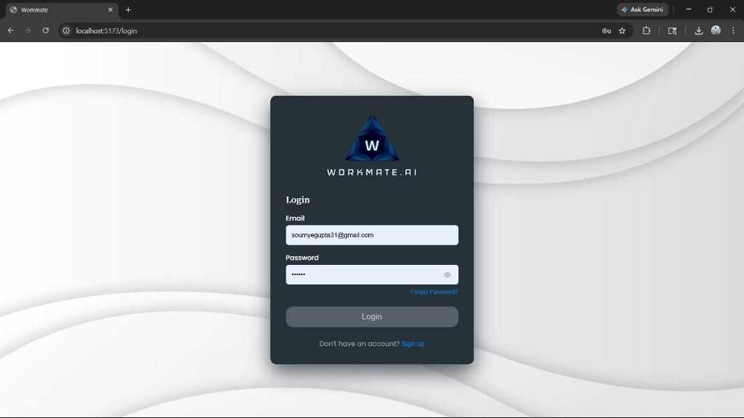 | 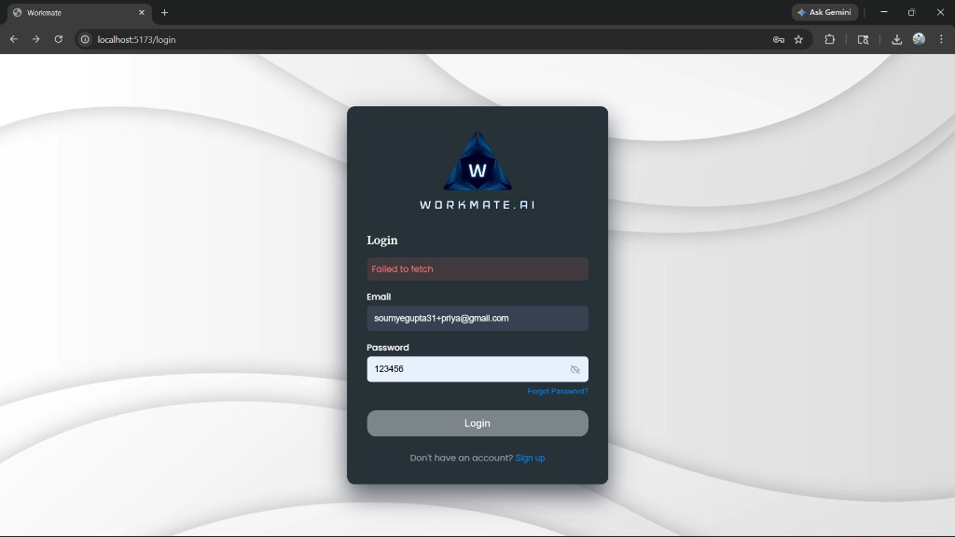
Figure 4.1: Login Screen | Figure 4.2: Register Screen (Create Account)

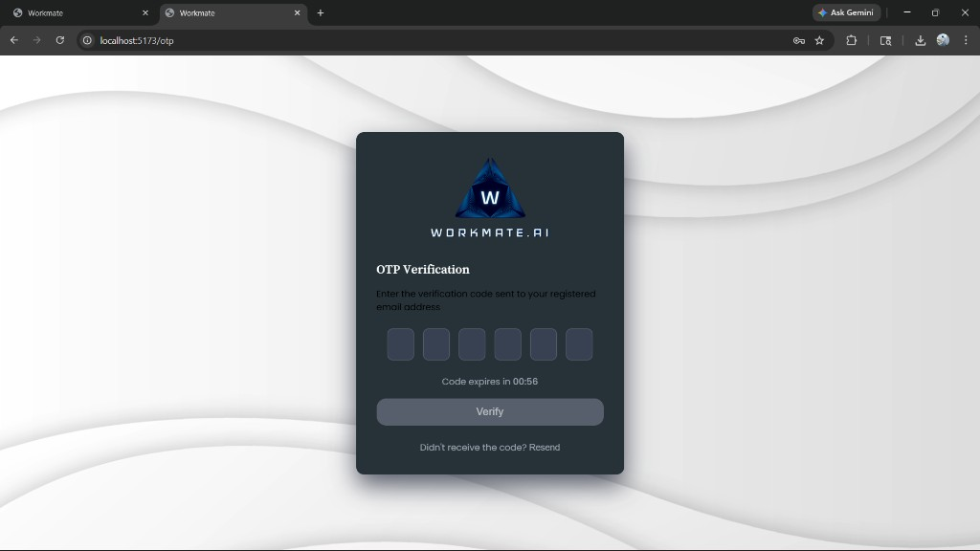 | 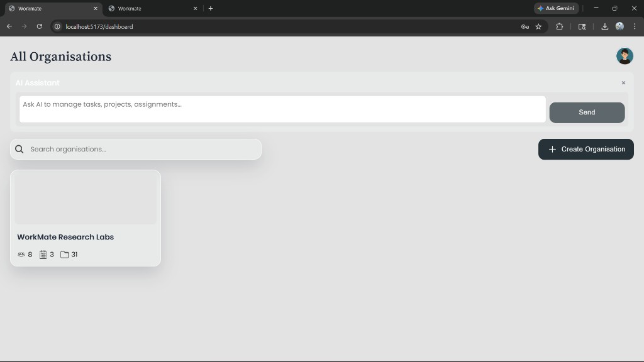
Figure 4.3: OTP Verification Screen | Figure 4.4: Dashboard: All Organisations + AI Assistant widget

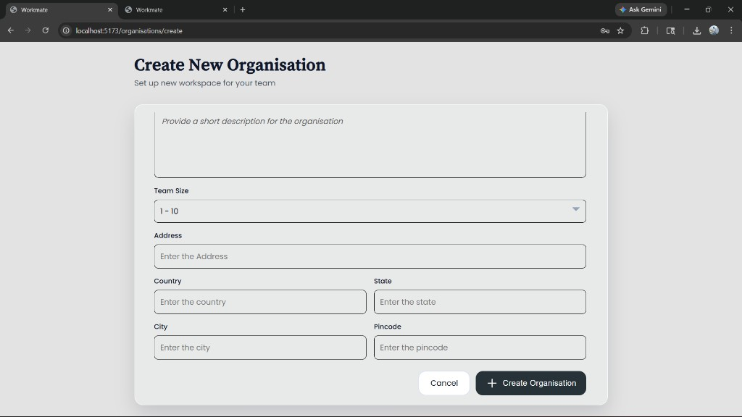 | 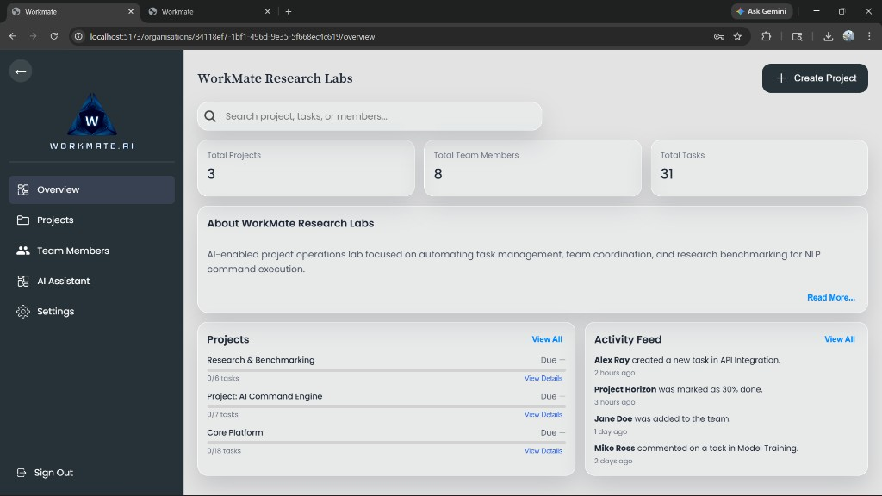
Figure 4.5: Create Organisation – Step 1 | Figure 4.6: Create Organisation – Step 2 (Description + Team size + Logo)

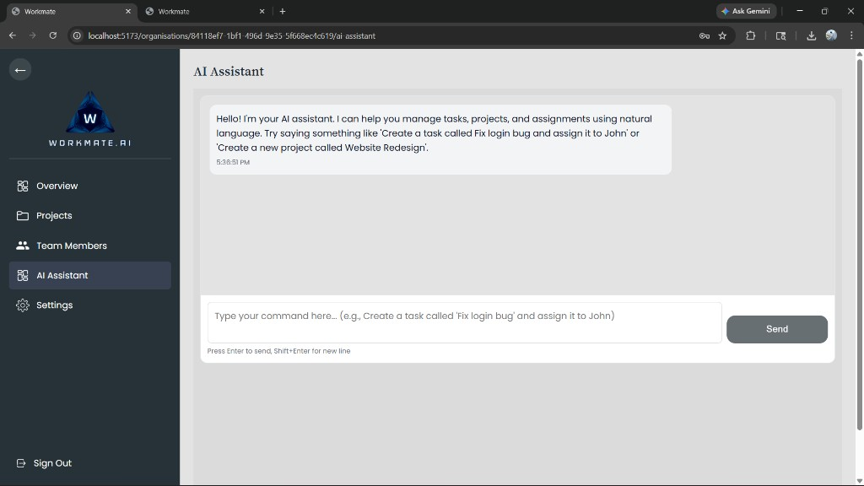 | 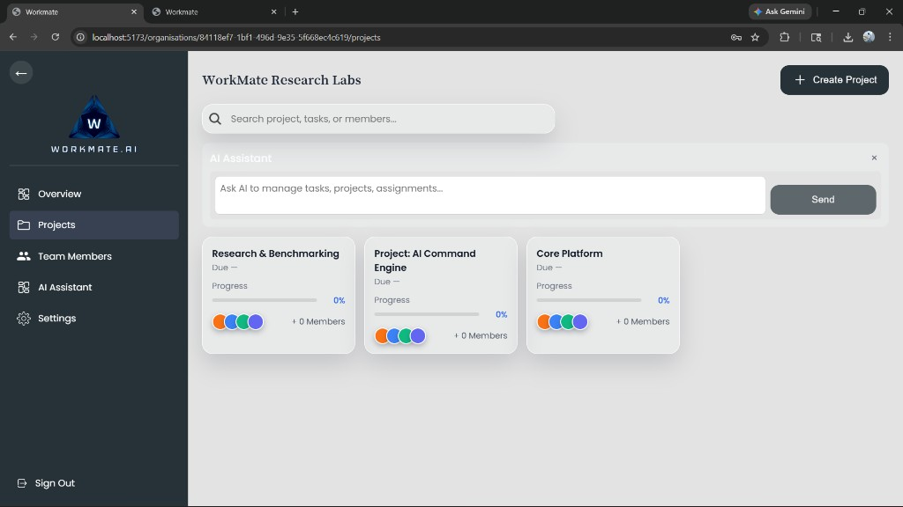
Figure 4.7: Organisation Overview | Figure 4.8: Projects Page (3 projects)

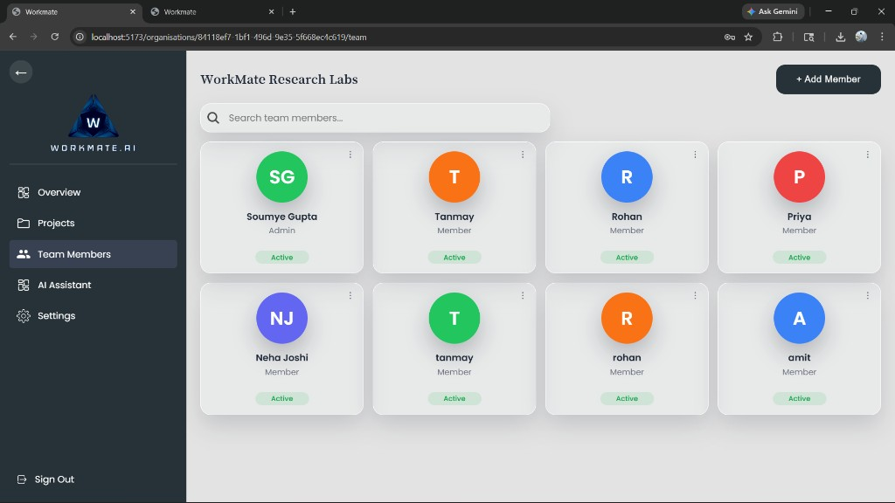 | 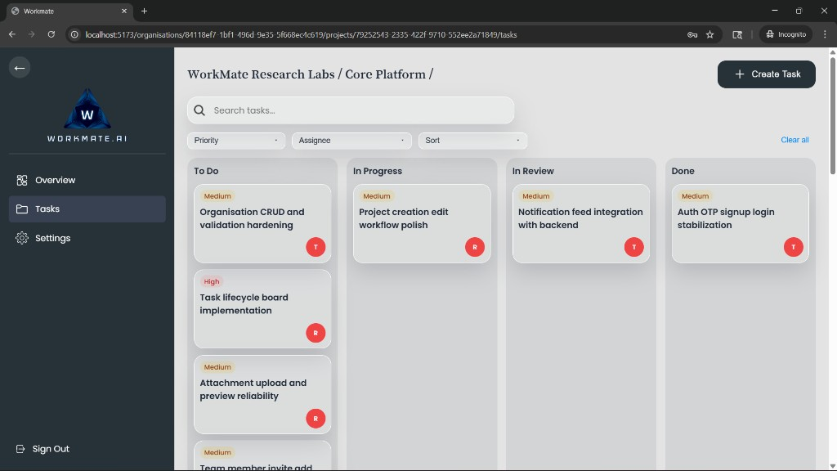
Figure 4.9: Team Members Page | Figure 4.10: AI Assistant Page

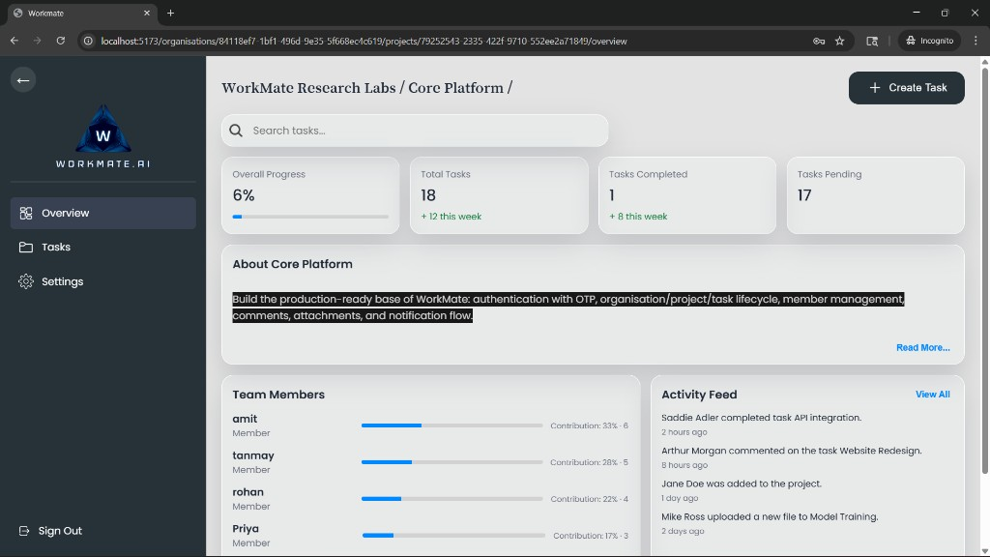 | 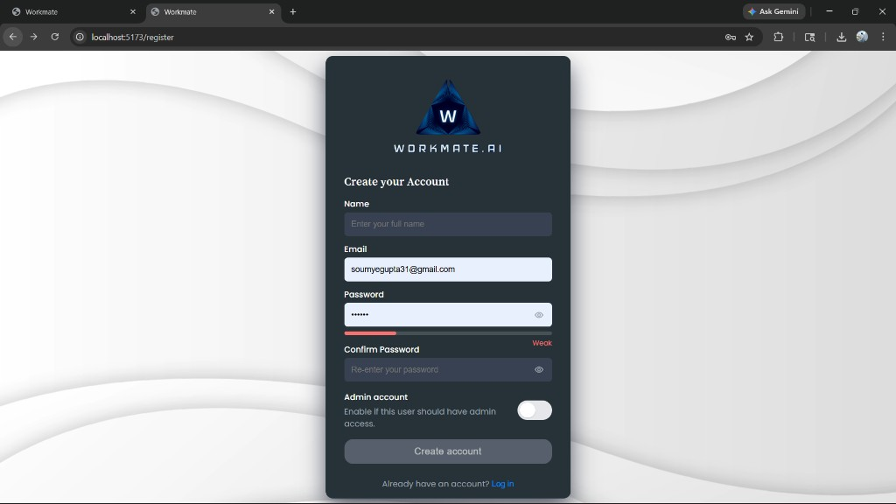
Figure 4.11: Tasks Board (Kanban) | Figure 4.12: Project Overview (Core Platform stats)

Chapter 5 — RESULTS AND ANALYSIS

5.1 Benchmark Summary
Table 5.1 summarizes benchmark results generated by the research benchmark runner.
Method | Intent Accuracy | Exact Match | Field Accuracy | Avg Latency (ms) | Fail Rate
rule-based | 85.00% | 50.00% | 60.27% | 0.10 | 0.00%
llm-only | 15.00% | 0.00% | 4.11% | 5349.15 | 5.00%
hybrid | 95.00% | 40.00% | 69.86% | 3279.40 | 0.00%

5.2 Interpretation of Results
The hybrid method achieves the best end-to-end reliability. The primary improvement is field accuracy and fail rate, which directly impacts whether the system can safely execute actions. Rule-based extraction remains valuable for speed, but it does not generalize to all paraphrases. LLM-only is flexible but unreliable without strict constraints.

5.3 Method-wise Analysis

5.3.1 Rule-based Method
Rule-based parsing uses deterministic patterns and is extremely fast. It works well for predictable phrasing but fails on paraphrases, missing fields, and uncommon word orders. Maintenance effort increases as more patterns are added.

5.3.2 LLM-only Method
LLM-only parsing can understand paraphrases but often produces extra text around JSON, incomplete fields, or incorrect keys. In workflow systems, even small format drift can cause failures. This explains low exact match and high latency.

5.3.3 Hybrid Method
Hybrid parsing combines LLM understanding with deterministic safeguards: JSON extraction, schema validation, value normalization, safe entity matching, and defaults. These steps significantly reduce failures and improve field correctness.
A practical advantage of the hybrid approach is stage-level debuggability. Engineers can identify whether errors originate in model output, parsing, normalization, matching, or persistence, enabling focused corrections and faster iteration.

5.4 Error Pattern Summary
Method | Common Error Patterns | Impact | Mitigation in WorkMate.AI
Rule-based | Regex gaps for paraphrases | Wrong/missing fields | Fallback to LLM / extend patterns
LLM-only | Format drift; missing/extra keys; hallucinated entities | Failures or wrong assignments | Schema validation + safe matching
Hybrid | Higher latency; rare ambiguity | Slower responses; clarification required | Timeouts + clarification

5.5 Latency Discussion
Latency is a trade-off. Rule-based parsing is near-instant, while LLM-based methods require inference. Hybrid pays a latency cost to achieve reliability suitable for automation. Practical optimizations include caching, smaller models, and limiting prompt context.

5.6 Qualitative Case Analysis
Case analysis complements numeric metrics by showing real behavior on representative prompts. In clean prompts, all methods may identify intent, but field completeness differs. In noisy prompts, rule-based methods miss variants while hybrid methods maintain reasonable extraction quality due to model understanding + deterministic checks.
In ambiguous prompts (e.g., missing project name), robust behavior is not to fabricate a value but to ask a clarifying question. This behavior is critical for dependable automation in collaborative systems where wrong actions can propagate confusion across teams.

5.7 Practical Impact on Team Workflows
From a team perspective, the hybrid approach reduces manual correction overhead, improves consistency of task records, and increases confidence in AI-assisted operations. Even when latency is higher than regex-based logic, the reduction in correction cycles and failed actions provides net productivity gains.
The project demonstrates that production-grade AI features should be measured using both accuracy and operational reliability metrics. This research insight is directly transferable to other AI-enabled workflow systems.

5.8 Comparative Discussion Against Baseline Approaches
Compared with form-only workflows, WorkMate.AI reduces friction in task capture and update operations by allowing natural language commands. Compared with pure rule-based NLP, the hybrid model handles broader language variation. Compared with LLM-only execution, hybrid processing provides stronger safety through deterministic checks.
From an engineering standpoint, the key outcome is not merely higher model accuracy but improved end-to-end transaction reliability. In practical project management contexts, a lower fail rate and better field completeness translate to less manual cleanup, fewer wrong assignments, and faster decision cycles.

5.9 Key Learnings
- AI integration should be treated as structured system design, not just prompt engineering.
- Database constraints are essential quality guards and should shape application logic.
- Benchmarking with noisy/ambiguous prompts reveals real-world robustness better than clean prompts alone.
- Hybrid methods provide a practical balance between flexibility and deterministic control.
Overall, the results indicate that robust AI-assisted workflow systems are best built as layered architectures. Model outputs should pass through deterministic controls before execution, and evaluation should track both semantic correctness and operational reliability.
The project also demonstrates that research and product development can be integrated: benchmark findings directly influenced implementation fixes, and implementation constraints informed benchmark design. This closed-loop process strengthens both academic and practical outcomes.
This integrated approach improves both scientific credibility and software quality, because each reported result is tied to actual code behavior and each code improvement is validated through measurable outcomes.

CONCLUSIONS & FUTURE SCOPE

5.1 Conclusions
WorkMate.AI demonstrates that natural language automation can be safely integrated into a productivity system by combining LLM understanding with deterministic safeguards and strict database constraints. Benchmarking provides measurable evidence that a hybrid approach improves accuracy and reliability compared to LLM-only or rule-based parsing.

5.2 Future Scope of Work
- Expand dataset and implement active-learning loop from unclear prompts.
- Add role-based permissions and audit logs for AI-triggered actions.
- Introduce retrieval-augmented context for better entity grounding.
- Add advanced analytics dashboards (burndown, workload, SLA metrics).

REFERENCES
[1] Name 1 and Name 2, “Paper Title,” Full Journal Name, vol. X, year, pp. XX–XX.
[2] Name 1 and Name 2, “Paper Title,” Proceedings of Conference, Institution, Country, year.
[3] Name 1, “Book Title,” Publication Name, Edition, ISBN.
[4] Topic, website name, Last accessed: DD Month YYYY.

ANNEXURES (OPTIONAL)
This section provides concise technical excerpts for reference. Detailed source code is available in the project repository.

Annexure A: Supabase PostgreSQL Schema (Excerpt)
-- WorkMate base schema for Supabase/Postgres
-- Run this in Supabase SQL Editor.

create extension if not exists "pgcrypto";

do $$ begin
create type user_status as enum ('active', 'invited', 'suspended', 'deleted');
exception when duplicate_object then null;
end $$;

do $$ begin
create type project_status as enum ('planning', 'active', 'completed', 'archived');
exception when duplicate_object then null;
end $$;

do $$ begin
create type project_priority as enum ('low', 'medium', 'high');
exception when duplicate_object then null;
end $$;

do $$ begin
create type task_status as enum ('todo', 'in_progress', 'in_review', 'done');
exception when duplicate_object then null;
end $$;

do $$ begin
create type task_priority as enum ('low', 'medium', 'high', 'urgent');
exception when duplicate_object then null;
end $$;

do $$ begin
create type project_member_role as enum ('viewer', 'member', 'manager', 'owner');
exception when duplicate_object then null;
end $$;

do $$ begin
create type attachment_entity_type as enum ('task', 'comment', 'project', 'organisation', 'user');
exception when duplicate_object then null;
end $$;

create table if not exists users (
id uuid primary key default gen_random_uuid(),
created_at timestamptz not null default now(),
updated_at timestamptz not null default now(),
email text not null unique,
name text,
password_hash text,
profile_image_url text,
status user_status not null default 'active',
is_admin boolean not null default false
);

create table if not exists organisations (
id uuid primary key default gen_random_uuid(),
created_at timestamptz not null default now(),
updated_at timestamptz not null default now(),
org_name text not null,
email text,
phone text,
address_line_1 text,
address_line_2 text,
country text,
state text,
city text,
postal_code text,
about text
);

create table if not exists org_members (
id uuid primary key default gen_random_uuid(),
created_at timestamptz not null default now(),
updated_at timestamptz not null default now(),
org_id uuid not null references organisations(id) on delete cascade,
user_id uuid not null references users(id) on delete cascade,
department text,
joined_at timestamptz not null default now(),
is_admin boolean not null default false,
unique(org_id, user_id)
);

create table if not exists projects (
id uuid primary key default gen_random_uuid(),
created_at timestamptz not null default now(),
updated_at timestamptz not null default now(),
org_id uuid references organisations(id) on delete cascade,
name text not null,
description text,
status project_status not null default 'planning',
priority project_priority not null default 'medium',
start_date date,
end_date date,
created_by uuid references users(id) on delete set null
);

create table if not exists project_members (
id uuid primary key default gen_random_uuid(),
created_at timestamptz not null default now(),
updated_at timestamptz not null default now(),
project_id uuid not null references projects(id) on delete cascade,
user_id uuid not null references users(id) on delete cascade,
role project_member_role not null default 'member',
joined_at timestamptz not null default now(),
unique(project_id, user_id)
);

create table if not exists tasks (
id uuid primary key default gen_random_uuid(),
created_at timestamptz not null default now(),
updated_at timestamptz not null default now(),
title text not null,
description text,
status task_status not null default 'todo',
priority task_priority not null default 'medium',
due_date timestamptz,
project_id uuid references projects(id) on delete cascade,
assignee_id uuid references users(id) on delete set null,
assigner_id uuid references users(id) on delete set null,
completed_at timestamptz
);

create table if not exists comments (
id uuid primary key default gen_random_uuid(),
created_at timestamptz not null default now(),
updated_at timestamptz not null default now(),
task_id uuid references tasks(id) on delete cascade,
author_id uuid references users(id) on delete set null,
parent_comment_id uuid references comments(id) on delete cascade,
content text not null
);

create table if not exists attachments (
id uuid primary key default gen_random_uuid(),
created_at timestamptz not null default now(),
entity_type attachment_entity_type not null,
entity_id uuid not null,
file_name text,
file_url text,
file_size bigint
);

create table if not exists notifications (
id uuid primary key default gen_random_uuid(),
created_at timestamptz not null default now(),
org_id uuid references organisations(id) on delete cascade,
project_id uuid references projects(id) on delete cascade,
task_id uuid references tasks(id) on delete cascade,
sender_id uuid references users(id) on delete set null,
recipient_id uuid references users(id) on delete cascade,
title text not null,
content text,
is_read boolean not null default false
);

-- Backfill new columns for already-existing tables in older DBs.
alter table notifications
add column if not exists recipient_id uuid references users(id) on delete cascade;

-- Research-friendly storage for comparing multiple AI methods.
create table if not exists ai_benchmark_runs (
id uuid primary key default gen_random_uuid(),
created_at timestamptz not null default now(),
model_name text not null,
method_name text not null,
dataset_name text not null,
total_cases integer not null default 0,
correct_cases integer not null default 0,
exact_match_accuracy numeric(5,2) not null default 0,
field_accuracy numeric(5,2) not null default 0,
avg_latency_ms numeric(10,2),
p95_latency_ms numeric(10,2),
notes text
);

create index if not exists idx_org_members_org_id on org_members(org_id);
create index if not exists idx_org_members_user_id on org_members(user_id);
create index if not exists idx_projects_org_id on projects(org_id);
create index if not exists idx_project_members_project_id on project_members(project_id);
create index if not exists idx_project_members_user_id on project_members(user_id);
create index if not exists idx_tasks_project_id on tasks(project_id);
create index if not exists idx_tasks_assignee_id on tasks(assignee_id);
create index if not exists idx_tasks_status on tasks(status);
create index if not exists idx_tasks_project_status_priority on tasks(project_id, status, priority);
create index if not exists idx_comments_task_id on comments(task_id);
create index if not exists idx_notifications_org_id on notifications(org_id);
create index if not exists idx_notifications_project_id on notifications(project_id);
create index if not exists idx_notifications_task_id on notifications(task_id);
create index if not exists idx_notifications_recipient_id on notifications(recipient_id);
create index if not exists idx_users_email_lower on users(lower(email));
create index if not exists idx_projects_org_name on projects(org_id, name);
create index if not exists idx_ai_benchmark_runs_method_created on ai_benchmark_runs(method_name, created_at desc);

do $$
begin
if not exists (
select 1
from pg_constraint
where conname = 'chk_projects_date_order'
) then
alter table projects
add constraint chk_projects_date_order
check (end_date is null or start_date is null or end_date >= start_date);
end if;
end $$;

do $$
begin
if not exists (
select 1
from pg_constraint
where conname = 'chk_tasks_completed_when_done'
) then
alter table tasks
add constraint chk_tasks_completed_when_done
check (status <> 'done' or completed_at is not null);
end if;
end $$;

do $$
begin
if not exists (
select 1
from pg_constraint
where conname = 'chk_ai_benchmark_counts'
) then
alter table ai_benchmark_runs
add constraint chk_ai_benchmark_counts
check (total_cases >= 0 and correct_cases >= 0 and correct_cases <= total_cases);
end if;
end $$;

// ... truncated ...

Annexure B: Research Benchmark Runner (Excerpt)
'use strict';

const fs = require('fs');
const path = require('path');
const http = require('http');
const https = require('https');
const { processPrompt } = require('../services/aiService');

const DATASET_PATH = path.join(__dirname, 'dataset.jsonl');
const RESULTS_JSON_PATH = path.join(__dirname, 'results-latest.json');
const RESULTS_MD_PATH = path.join(__dirname, 'results-latest.md');
const OLLAMA_API_URL = process.env.OLLAMA_API_URL || 'http://localhost:11434';

function loadDataset(filePath) {
const raw = fs.readFileSync(filePath, 'utf8');
return raw
.split('\n')
.map((line) => line.trim())
.filter(Boolean)
.map((line) => JSON.parse(line));
}

function normalize(value) {
if (value === undefined || value === null) return '';
return String(value).trim().toLowerCase();
}

function getByPath(obj, keyPath) {
return keyPath.split('.').reduce((acc, key) => (acc && acc[key] !== undefined ? acc[key] : undefined), obj);
}

function expectedPaths(expectedObj) {
const paths = [];
function walk(node, prefix = '') {
if (!node || typeof node !== 'object' || Array.isArray(node)) {
if (prefix) paths.push(prefix);
return;
}
for (const key of Object.keys(node)) {
const next = prefix ? `${prefix}.${key}` : key;
walk(node[key], next);
}
}
walk(expectedObj);
return paths;
}

function extractJson(text) {
if (!text) return null;
const direct = String(text).trim();
try {
return JSON.parse(direct);
} catch {
// continue
}

const match = direct.match(/\{[\s\S]*\}/);
if (!match) return null;
try {
return JSON.parse(match[0]);
} catch {
return null;
}
}

function makeRequest(url, options = {}) {
return new Promise((resolve, reject) => {
const urlObj = new URL(url);
const client = urlObj.protocol === 'https:' ? https : http;
const req = client.request(
url,
{
method: options.method || 'GET',
headers: options.headers || {},
},
(res) => {
let body = '';
res.on('data', (chunk) => {
body += chunk;
});
res.on('end', () => {
let parsed = null;
try {
parsed = JSON.parse(body);
} catch {
parsed = { raw: body };
}
resolve({
ok: res.statusCode >= 200 && res.statusCode < 300,
status: res.statusCode,
data: parsed,
});
});
}
);
req.on('error', reject);
req.setTimeout(options.timeoutMs || 20000, () => {
req.destroy(new Error(`Request timeout after ${options.timeoutMs || 20000}ms`));
});
if (options.body) {
req.write(typeof options.body === 'string' ? options.body : JSON.stringify(options.body));
}
req.end();
});
}

function ruleBasedPredict(prompt) {
const p = String(prompt || '').trim();
const lower = p.toLowerCase();

if (lower.includes('add') && lower.includes('project') && lower.includes('member')) {
const m = p.match(/add(?:\s+project\s+member)?\s+(.+?)\s+to\s+(?:project\s*:?\s*)?(.+?)(?:\s+project)?$/i);
return {
action: 'add_project_member',
data: {
user: m ? String(m[1]).trim() : undefined,
project: m ? String(m[2]).trim() : undefined,
},
};
}

if (lower.startsWith('create') && lower.includes('task')) {
const m = p.match(/create(?:\s+a)?\s+task(?:\s+called)?\s+(.+?)\s+(?:and\s+)?assign(?:\s+it)?\s+to\s+(.+?)\s+in\s+(.+?)(?:\s+project)?(?:\s+with\s+(.+?)\s+priority)?$/i);
if (m) {
return {
action: 'create_task',
data: {
title: String(m[1]).trim(),
assignee: String(m[2]).trim(),
project: String(m[3]).replace(/^project\s*:\s*/i, '').trim(),
priority: m[4] ? String(m[4]).trim().toLowerCase() : undefined,
},
};
}
return { action: 'create_task', data: {} };
}

if (lower.startsWith('create') && lower.includes('project')) {
const m = p.match(/create\s+project(?:\s+called|\s+named)?\s+(.+?)(?:\s+starting\s+(.+))?$/i);
return {
action: 'create_project',
data: {
name: m ? String(m[1]).trim() : undefined,
start_date: m && m[2] ? String(m[2]).trim() : undefined,
},
};
}

if (lower.includes('update') && lower.includes('task')) {
const m = p.match(/update\s+task(?:\s+called)?\s+(.+?)\s+(?:to|status)\s+(.+)$/i);
return {
action: 'update_task',
filters: { title: m ? String(m[1]).trim() : undefined },
update: { status: m ? normalize(m[2]).replace(/\s+/g, '_') : undefined },
};
}

if (lower.includes('assign')) {
const m = p.match(/assign(?:\s+task)?\s+(.+?)\s+to\s+(.+?)(?:\s+by\s+(.+))?$/i);
return {
action: 'assign',
filters: { title: m ? String(m[1]).trim() : undefined },
update: {
assignee: m ? String(m[2]).trim() : undefined,
due_date: m && m[3] ? String(m[3]).trim() : undefined,
},
};
}

if (lower.includes('comment')) {
const m = p.match(/(?:comment(?:\s+on)?\s+task\s+(.+?)\s*:\s*(.+))|(?:comment:\s*(.+))/i);
if (m && m[1] && m[2]) {
return { action: 'comment', filters: { title: String(m[1]).trim() }, data: { body: String(m[2]).trim() } };
}
return { action: 'comment', data: { body: m && m[3] ? String(m[3]).trim() : undefined } };
}

return { action: 'unknown' };
}

async function llmOnlyPredict(prompt) {
const system = 'Convert instruction to JSON with action/data/filters/update only.';
const response = await makeRequest(`${OLLAMA_API_URL}/api/generate`, {
method: 'POST',
headers: { 'Content-Type': 'application/json' },
timeoutMs: 25000,
body: {
model: 'phi3',
prompt: String(prompt),
system,
stream: false,
options: { temperature: 0.1, top_p: 0.9, top_k: 40 },
},
});
if (!response.ok) throw new Error(`llm-only HTTP ${response.status}`);
const text = response.data?.response || response.data?.text || response.data?.raw || '';
return extractJson(text) || { action: 'parse_error' };
}

async function hybridPredict(prompt) {
return Promise.race([
processPrompt(String(prompt)),
new Promise((_, reject) => setTimeout(() => reject(new Error('Hybrid timeout after 30s')), 30000)),
]);
}

function scorePrediction(expected, actual) {
const paths = expectedPaths(expected);
let matched = 0;
for (const keyPath of paths) {
const e = normalize(getByPath(expected, keyPath));
const a = normalize(getByPath(actual, keyPath));
if (e && e === a) matched += 1;
}
const total = paths.length;
const fieldAccuracy = total > 0 ? matched / total : 0;
const exact = total > 0 && matched === total;
const intentCorrect = normalize(expected.action) === normalize(actual.action);
return { totalFields: total, matchedFields: matched, fieldAccuracy, exact, intentCorrect };
}

async function runMethod(methodName, predictor, dataset) {
const rows = [];
let intentHits = 0;
let exactHits = 0;
let totalFields = 0;
let matchedFields = 0;
let latencySum = 0;
let failCount = 0;

// ... truncated ...

Annexure C: AI Service (Selected Excerpt)
'use strict';

const http = require('http');
const https = require('https');
const { readFileSync } = require('fs');
const { join } = require('path');

const OLLAMA_API_URL = process.env.OLLAMA_API_URL || 'http://localhost:11434';

/**
* Read dataset for few-shot learning examples
*/
function loadDataset() {
try {
const datasetPath = join(process.cwd(), 'dataset');
const content = readFileSync(datasetPath, 'utf-8');
const lines = content.trim().split('\n').filter(line => line.trim());
const parsed = lines.map(line => {
try {
return JSON.parse(line);
} catch {
return null;
}
}).filter(Boolean);

// Prioritize examples that match common patterns
const prioritized = [];
const others = [];

parsed.forEach(ex => {
const instruction = ex.instruction?.toLowerCase() || '';
// Prioritize examples with "create task" and assignment patterns
if (instruction.includes('create') && instruction.includes('task') &&
(instruction.includes('assign') || instruction.includes('to '))) {
prioritized.push(ex);
} else {
others.push(ex);
}
});

// Return prioritized examples first, then others, up to 25 total
const selected = [...prioritized, ...others].slice(0, 25);
return selected;
} catch (error) {
console.warn('Could not load dataset:', error.message);
return [];
}
}

/**
* Generate system prompt with few-shot examples
*/
function generateSystemPrompt() {
const examples = loadDataset();
const examplesText = examples.map(ex => {
return `Instruction: "${ex.instruction}"\nOutput: ${JSON.stringify(ex.output)}`;
}).join('\n\n');

return `You are an AI assistant that converts natural language instructions into structured JSON actions for task management.

CRITICAL EXTRACTION RULES:
1. For "create_task" action:
- Extract task title from phrases like "task called [title]", "task named [title]", "create [title] task", or just "[title]"
- Extract project name from phrases like "in [project] project", "under [project]", "for [project]", or "[project] project"
- Extract assignee from phrases like "assign it to [name]", "assign to [name]", "for [name]", or "[name]"
- Extract priority from "low/medium/high/critical priority" or "priority [level]"
- Extract due date from "by [date]", "due [date]", or relative dates like "tomorrow", "next week"

2. For "create_project" action:
- Extract project name from "project called [name]", "project named [name]", or just "[name]"
- Extract team_lead from "team lead [name]" or "lead [name]"
- Extract start_date from "starting [date]" or relative dates

3. For "add_project_member" action:
- Extract user/member name from "add [name]", "add member [name]", "add [name] to", or "[name]"
- Extract project name from "to project [name]", "to [name] project", "in [name] project", or "[name]"
- Recognize patterns like "Add [name] to project [project]", "Add project member [name] to [project]"

4. Field extraction patterns:
- "task called X" or "task named X" → title: "X"
- "in X project" or "under X" → project: "X"
- "assign it to X" or "assign to X" → assignee: "X"
- "X priority" → priority: "X"
- "by X" or "due X" → due_date: "X"

Available actions and their required fields:
- create_project: { name (required), team_lead (optional), start_date (optional) }
- create_task: { title (required), project (required), assignee (optional), priority (optional), due_date (optional) }
- update_project: { filters: { name (required) }, update: { status/priority/name (optional) } }
- update_task: { filters: { title (required) }, update: { status/priority/due_date/assignee (optional) } }
- assign: { filters: { title/status/team (optional) }, update: { assignee (required), due_date (optional) } }
- add_project_member: { data: { project (required), user (required) } }
- comment: { filters: { title (required) }, data: { body (required) } }
- notify: { data: { user (required), title (required), message (required) } }

Examples:
${examplesText}

IMPORTANT EXAMPLES - Study these patterns carefully:

Example 1: "Create a task called Fix login bug and assign it to Tanmay in workmate project"
Output: {"action": "create_task", "data": {"title": "Fix login bug", "assignee": "Tanmay", "project": "workmate"}}

Example 2: "Create a task called Header Alignment Bug under the Website Revamp project and assign it to Rohan"
Output: {"action": "create_task", "data": {"title": "Header Alignment Bug", "project": "Website Revamp", "assignee": "Rohan"}}

Example 3: "Create task Backend API Integration for Amit in E-commerce Portal project"
Output: {"action": "create_task", "data": {"title": "Backend API Integration", "assignee": "Amit", "project": "E-commerce Portal"}}

Example 4: "Add project member Tanmay to project workmate"
Output: {"action": "add_project_member", "data": {"user": "Tanmay", "project": "workmate"}}

Example 5: "Add Tanmay to workmate project"
Output: {"action": "add_project_member", "data": {"user": "Tanmay", "project": "workmate"}}

CRITICAL: When you see patterns like:
- "Create a task called [TITLE] and assign it to [NAME] in [PROJECT] project"
→ Extract: title, assignee, project
- "Create task [TITLE] for [NAME] in [PROJECT]"
→ Extract: title, assignee, project
- "Create [TITLE] task and assign to [NAME] in [PROJECT] project"
→ Extract: title, assignee, project
- "Add project member [NAME] to project [PROJECT]"
→ Extract: action="add_project_member", user="[NAME]", project="[PROJECT]"
- "Add [NAME] to [PROJECT] project"
→ Extract: action="add_project_member", user="[NAME]", project="[PROJECT]"

You MUST extract ALL fields mentioned. Do NOT ask for missing fields if they are clearly stated in the instruction.

Return only valid JSON with the "action" field and appropriate "data", "filters", or "update" fields. No additional text, no explanations, no markdown.`;
}

/**
* Make HTTP/HTTPS request
*/
function makeRequest(url, options = {}) {
return new Promise((resolve, reject) => {
const urlObj = new URL(url);
const isHttps = urlObj.protocol === 'https:';
const client = isHttps ? https : http;

const req = client.request(url, {
method: options.method || 'GET',
headers: options.headers || {},
}, (res) => {
let data = '';
res.on('data', chunk => { data += chunk; });
res.on('end', () => {
try {
resolve({ ok: res.statusCode >= 200 && res.statusCode < 300, status: res.statusCode, json: () => Promise.resolve(JSON.parse(data)) });
} catch {
resolve({ ok: res.statusCode >= 200 && res.statusCode < 300, status: res.statusCode, json: () => Promise.resolve({ response: data }) });
}
});
});

req.on('error', reject);

if (options.body) {
req.write(typeof options.body === 'string' ? options.body : JSON.stringify(options.body));
}

req.end();
});
}

/**
* Call Ollama API to generate response
*/
async function callOllama(prompt) {
const ollamaUrl = OLLAMA_API_URL || 'http://localhost:11434';

try {
const response = await makeRequest(`${ollamaUrl}/api/generate`, {
method: 'POST',
headers: {
'Content-Type': 'application/json',
},
body: {
model: 'phi3',

// ... truncated ...

