Song Recommendation System Using Content-Based Filtering
Abstract
This research presents a content-based song recommendation system that leverages both audio features and textual lyrics to recommend songs similar to a user’s recently heard track. Unlike collaborative filtering systems, which depend on user–user or item–item interactions, this system analyzes intrinsic song properties to generate personalized recommendations, making it suitable for cold-start scenarios or applications with limited user history. The model uses the FMA 100k+ dataset for audio features, lyrics extracted via external APIs, TF–IDF vectorization, dimensionality reduction of audio features, and a hybrid KMeans + cosine similarity approach for efficient and accurate retrieval. A user interface integrates the system workflow, allowing the user to upload a song and obtain the top five recommended tracks.

1. Introduction
Recommender systems have become essential across digital platforms, particularly in entertainment services such as music streaming. Broadly, recommendation systems employ two major strategy families: collaborative filtering and content-based filtering. Collaborative filtering relies on user interactions such as ratings, playlist behavior, and co-listening patterns. While powerful, it suffers from the cold-start problem, high data dependency, and sparsity issues. Content-based recommendation focuses on the attributes of the items themselves—such as song lyrics, tempo, timbre, genre, or mood—allowing recommendations even for new or unpopular songs.
Since this research aims to recommend songs based on what the user most recently heard, and since the system should work even if no historical user data is present, a content-based strategy is most appropriate. This approach also ensures interpretability, as recommendations are based on concrete features extracted from audio signals and lyrics.

2. Related Work
Existing literature on music recommendation systems broadly explores either collaborative filtering approaches or hybrid architectures that combine multiple signals. Traditional collaborative filtering techniques such as matrix factorization and user–item interactions have been widely adopted by major streaming platforms; however, they require large-scale user activity logs. In contrast, content-based approaches make use of audio descriptors, metadata, and textual analysis. Previous studies have used Mel-frequency cepstral coefficients (MFCCs), chroma features, spectral contrast, or rhythm descriptors to cluster songs based on their acoustic characteristics.
More recent research has highlighted the importance of leveraging lyrics for recommendation, as textual content often reflects mood, emotion, and themes not captured in audio features. TF–IDF and transformer-based models have been used to embed these lyrics for similarity retrieval. While cosine similarity remains a popular similarity metric for recommendation tasks, clustering techniques such as KMeans have proven effective for speeding up retrieval in large datasets. This work follows a similar philosophy but presents a hybrid method that balances accuracy with computational efficiency.

3. Methodology
The architecture of the proposed system is divided into four major components: dataset construction, feature engineering, model design, and recommendation generation. The dataset was built from the FMA 100k+ audio dataset containing song metadata and acoustic features. Duplicate song titles were removed, and lyrics for each track were obtained using the LyricsGenius API. Songs without lyrics or with null audio attributes were removed, resulting in a cleaned custom dataset.

3.1 Dataset Construction
The dataset was constructed using the Free Music Archive (FMA) large dataset consisting of over 100,000 songs. The following operations were performed during dataset construction:
- Removal of duplicate song titles and inconsistent entries.
- Extraction of lyrics for each track using the LyricsGenius API.
- Removal of songs missing lyrics or containing null audio feature values.
- Final dataset prepared consisting of audio-extracted features and lyrics for each song.
This dataset forms the backbone of both the training and recommendation pipeline, ensuring each song is represented with complete audio–lyrical data.

3.2 Feature Engineering
Feature engineering plays a pivotal role in deriving meaningful representations from both audio and lyrical content. TF–IDF vectorization was used to convert song lyrics into high-dimensional sparse vectors. For audio features, descriptive statistics derived from the 518-dimensional librosa-generated feature set were analyzed for correlation, and feature selection techniques compressed the representation to a 336-dimensional vector without significant loss of musical information.
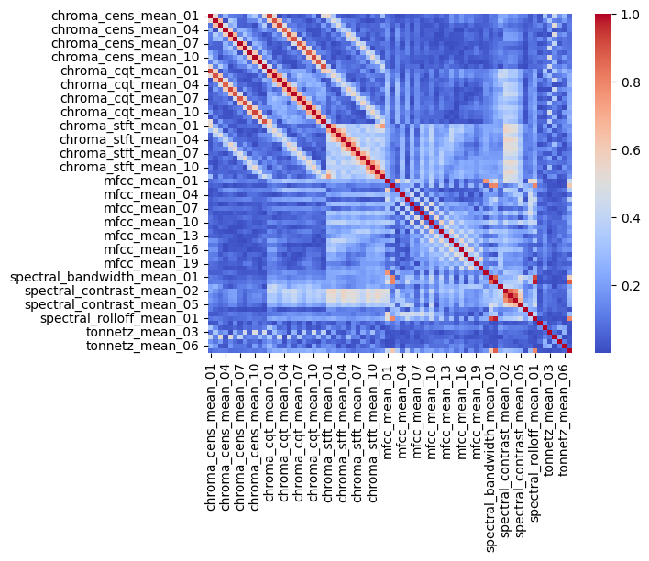
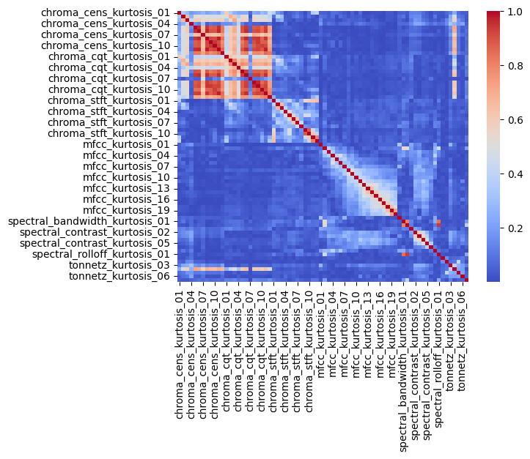
Fig 1 : Feature Selection Technique On Audio Features
A combined embedding vector was produced for each song by concatenating the TF–IDF lyrical vector with the reduced-dimensional audio vector. This multimodal representation enables the system to capture both semantic and acoustic similarity.

3.3 Algorithmic Framework
A hybrid approach incorporating unsupervised clustering (KMeans) followed by cosine similarity scoring was implemented. The rationale behind this choice stems from balancing speed and accuracy. While a pure cosine similarity model across the entire dataset may yield higher precision, it becomes slow as dataset size grows. Clustering songs into KMeans clusters helps restrict the similarity search to only relevant subsets, achieving almost 5× faster retrieval times with minimal loss in quality.
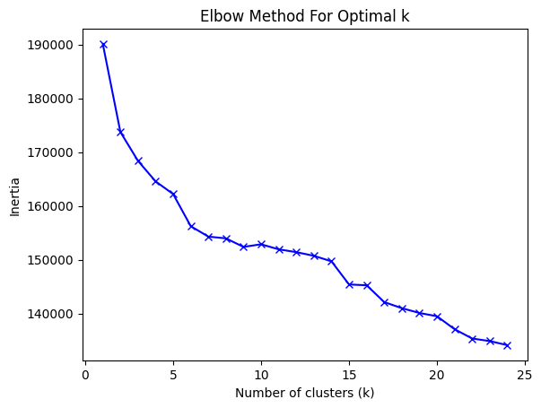
Fig. 2 : Elbow Method For Optimal K
The recommendation workflow proceeds as follows:
1. Generate the audio + lyrics embedding for the input song.
2. Identify the nearest KMeans cluster of the input vector.
3. Compute cosine similarity within the cluster.
4. Rank the songs by similarity score and return the top five recommendations.
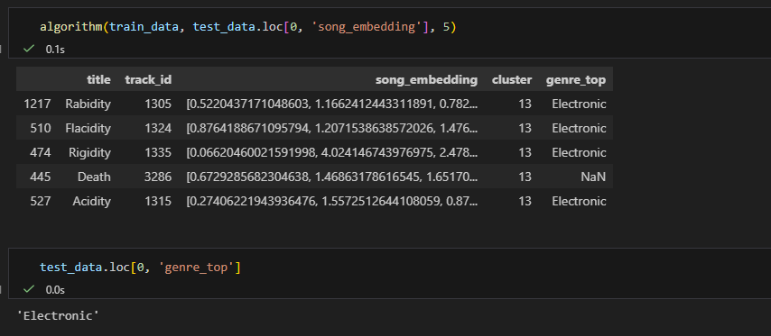
Fig 3 : Getting Songs Of Same Genre

4. Proposed Content-Based Song Recommendation System
The proposed system focuses on identifying the song’s intrinsic properties to generate recommendations. Audio embeddings capture rhythm, tone, and texture, while TF–IDF lyrical embeddings capture mood, emotion, and semantics. Combining these two domains enables the system to provide deeper, context-aware recommendations.
Through clustering and similarity computation, the system ensures efficiency even for large-scale datasets with more than 100k records.

5. User Workflow
The user workflow was designed for simplicity and seamless interaction. The user provides two inputs: the audio file of the recently heard track and its lyrics. The system then:

Fig 4 : Simple Web Interface For Users
• Extracts audio features and vectorizes the lyrics using TF–IDF.
• Combines these features to form a multimodal embedding.
• Applies the hybrid KMeans + cosine similarity framework.
• Returns the top five most similar songs from the dataset.
The workflow allows for automated, real-time recommendations, enabling users to discover musically and lyrically aligned tracks effortlessly.

Fig 5 : Top 5 Songs In Output

6. Conclusion
This research demonstrates an effective content-based song recommendation system combining audio and lyrical features. By leveraging TF–IDF, dimensionality reduction, clustering, and cosine similarity, the system delivers fast and accurate recommendations. Unlike collaborative filtering, the model does not rely on user interaction data, making it resilient to cold-start conditions. Future enhancements may include transformer-based lyric embeddings, deep audio embeddings, or hybrid integration with collaborative filtering to produce richer recommendations.

References
1. FMA Dataset Documentation.
2. Librosa Audio Feature Extraction Toolkit.
3. LyricsGenius API Documentation.
4. Research on Content-Based Music Recommendation Systems.
5. Studies integrating TF–IDF and audio features for music retrieval.

