

**School of Engineering & Technology**

**Paralakhemundi Campus**

**Applied and Action Learning\***

Experiment No: Date:

Aim

Write a PHP code on calculator.

**Software‘s / Material, Tools & Equipment required (if any)**

|  |  |  |  |
| --- | --- | --- | --- |
| **Slno.** | **Name** | **Specification** | **Qnty.** |
| 1  2 | Personal laptop  XAMP | Asus, 8th Generation, 8 GB RAM.  3.2.2 | 1  1 |

**\*Hands on & experimental Learning Page No:**

<?php

if(isset($_POST['add'])){

$first=$_POST['first'];

$second=$_POST['second'];

$res=$first+$second;

echo "<h1>The Addtion is:$res</h1>";

}

if(isset($_POST['sub'])){

$first=$_POST['first'];

$second=$_POST['second'];

$res=$first-$second;

echo "<h1>The Subtraction is:$res</h1>";

}

if(isset($_POST['mul'])){

$first=$_POST['first'];

$second=$_POST['second'];

$res=$first*$second;

echo "<h1>The Multiplication is:$res</h1>";

}

if(isset($_POST['div'])){

$first=$_POST['first'];

$second=$_POST['second'];

$res=$first/$second;

echo "<h1>The Division is:$res</h1>";

}

?>

**Learning Page No:**

**CODING**

**\*Hands on & experimental Learning Page No:**

<!DOCTYPE html>

<html>

<head>

<title>Calculator</title>

</head>

<body>

<form action="" method="post">

<label>Enter the first number:</label>

<input type="number" name="first" placeholder="Enter the first number">

<label>Enter the second number:</label>

<input type="number" name="second" placeholder="Enter the second number">

<input type="submit" value="Add" name="add">

<input type="submit" value="Subtraction" name="sub">

<input type="submit" value="Multiplication" name="mul">

<input type="submit" value="Division" name="div">

</form>

</body>

</html>

**Learning Page No:**

**CODING**

**\*Hands on & experimental Learning Page No:**

**Conclusion / Inference:**

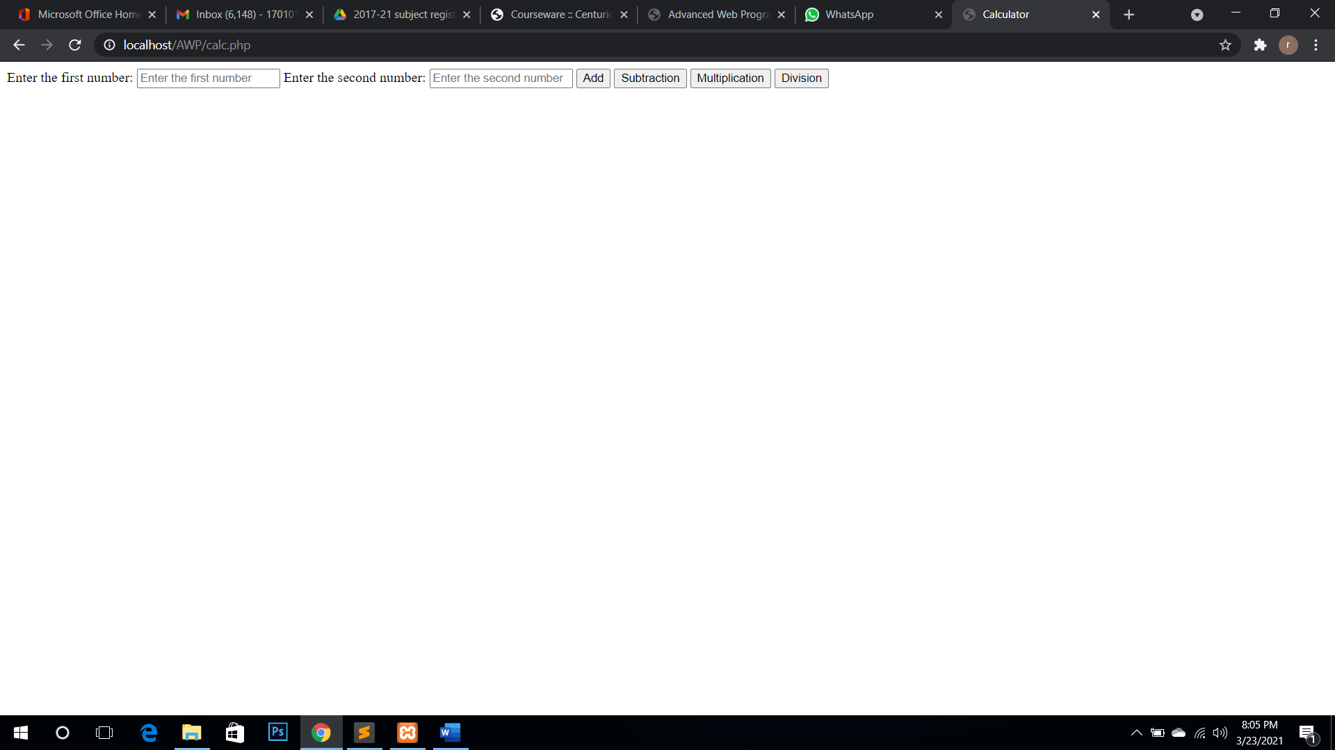

**Learning Page No:**

Assessment

|  |  |  |  |  |  |  |  |
| --- | --- | --- | --- | --- | --- | --- | --- |
| **Marking Procedure** | | **Full Marks** | | **Marks Obtained** | | **Remarks** | |
| Accuracy  & Process | Conduct of Experiment | | 10 | |  | |  | |
| Observation/Calculation/Implementation | | 10 | |  | |  | |
| Result / Inference / Output | | 10 | |  | |  | |
| Observation | | 5 | |  | |  | |
| Report | Observations(5), Implantation(20) | | 25 | |  | |  | |
| Viva |  | | 10 | |  | |  | |
| Inference |  | | 30 | |  | |  | |
| Total |  | | 100 | |  | |  | |

**Signature of Faculty Signature of the Student**

**\*Hands on & experimental Learning Page No:**