

**School of Engineering & Technology**

**Paralakhemundi Campus**

**Applied and Action Learning\***

Experiment No: Date:

Aim

Image mapping code.

**Software‘s / Material, Tools & Equipment required (if any)**

|  |  |  |  |
| --- | --- | --- | --- |
| **Slno.** | **Name** | **Specification** | **Qnty.** |
| 1  2 | Personal laptop  XAMP | Asus, 8th Generation, 8 GB RAM.  3.2.2 | 1  1 |

**\*Hands on & experimental Learning Page No:**

<!DOCTYPE html>

<html>

<body>

<h1>The map and area elements</h1>

<p>Click on the computer, the phone, or the cup of coffee to go to a new page and read more about the topic:</p>

<img src="workplace.jpg" alt="Workplace" usemap="#workmap" width="400" height="379">

<map name="workmap">

<area shape="rect" coords="34,44,270,350" alt="Computer" href="computer.htm">

<area shape="rect" coords="290,172,333,250" alt="Phone" href="phone.htm">

<area shape="circle" coords="337,300,44" alt="Cup of coffee" href="coffee.htm">

</map>

</body>

</html>

**Learning Page No:**

**CODING**

**\*Hands on & experimental Learning Page No:**

**Conclusion / Inference:**

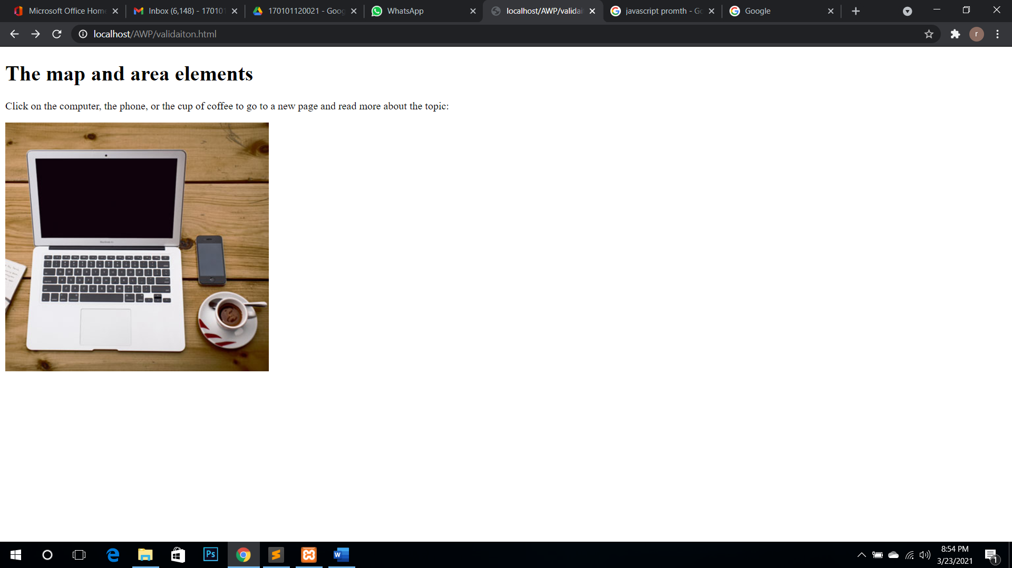

**Learning Page No:**

Assessment

|  |  |  |  |  |  |  |  |
| --- | --- | --- | --- | --- | --- | --- | --- |
| **Marking Procedure** | | **Full Marks** | | **Marks Obtained** | | **Remarks** | |
| Accuracy  & Process | Conduct of Experiment | | 10 | |  | |  | |
| Observation/Calculation/Implementation | | 10 | |  | |  | |
| Result / Inference / Output | | 10 | |  | |  | |
| Observation | | 5 | |  | |  | |
| Report | Observations(5), Implantation(20) | | 25 | |  | |  | |
| Viva |  | | 10 | |  | |  | |
| Inference |  | | 30 | |  | |  | |
| Total |  | | 100 | |  | |  | |

**Signature of Faculty Signature of the Student**

**\*Hands on & experimental Learning Page No:**