

**School of Engineering & Technology**

**Paralakhemundi Campus**

**Applied and Action Learning\***

Experiment No: Date:

Aim

Write a PHP code on Login Page.

**Software‘s / Material, Tools & Equipment required (if any)**

|  |  |  |  |
| --- | --- | --- | --- |
| **Slno.** | **Name** | **Specification** | **Qnty.** |
| 1  2 | Personal laptop  XAMP | Asus, 8th Generation, 8 GB RAM.  3.2.2 | 1  1 |

**\*Hands on & experimental Learning Page No:**

<?php

session_start();

error_reporting(0);

include("config.php");

if(isset($_POST['submit']))

{

$regno=$_POST['regno'];

$password=md5($_POST['password']);

$query=mysqli_query($con,"SELECT * FROM student WHERE email='$regno' and password='$password'");

$num=mysqli_fetch_array($query);

if($num>0)

{

$_SESSION['login']=$_POST['regno'];

$_SESSION['id']=$num['stu_id'];

$_SESSION['sname']=$num['name'];

$uip=$_SERVER['REMOTE_ADDR'];

$status=1;

header("location:dash.php");

exit();

}

else

{

$_SESSION['errmsg']="Invalid Email or Password";

header("location:login.php");

exit();

}

**Learning Page No:**

**CODING**

**\*Hands on & experimental Learning Page No:**

<!DOCTYPE html>

<html xmlns="http://www.w3.org/1999/xhtml">

<head>

<meta charset="utf-8" />

<meta name="viewport" content="width=device-width, initial-scale=1, maximum-scale=1" />

<meta name="description" content="" />

<meta name="author" content="" />

<title>Student Login</title>

</head>

<body>

<div class="content-wrapper"> <div class="container">

<div class="row">

<div class="col-md-12">

<h4 class="page-head-line">Please Enter Student Login Credentials </h4>

</div>

</div>

<span style="color:red;" ><?php echo htmlentities($_SESSION['errmsg']); ?><?php echo htmlentities($_SESSION['errmsg']="");?></span>

<form name="admin" method="post">

<div class="row">

<div class="col-md-6">

<label>Enter Email Address : </label>

<input type="email" name="regno" class="form-control" />

<label>Enter Password : </label>

<input type="password" name="password" class="form-control" />

<hr />

<button type="submit" name="submit" class="btn btn-info"><span class="glyphicon glyphicon-user"></span> &nbsp;Log Me In </button>&nbsp;</body></html>

</div>

</body>

</html>

**Learning Page No:**

**CODING**

**\*Hands on & experimental Learning Page No:**

**Conclusion / Inference:**

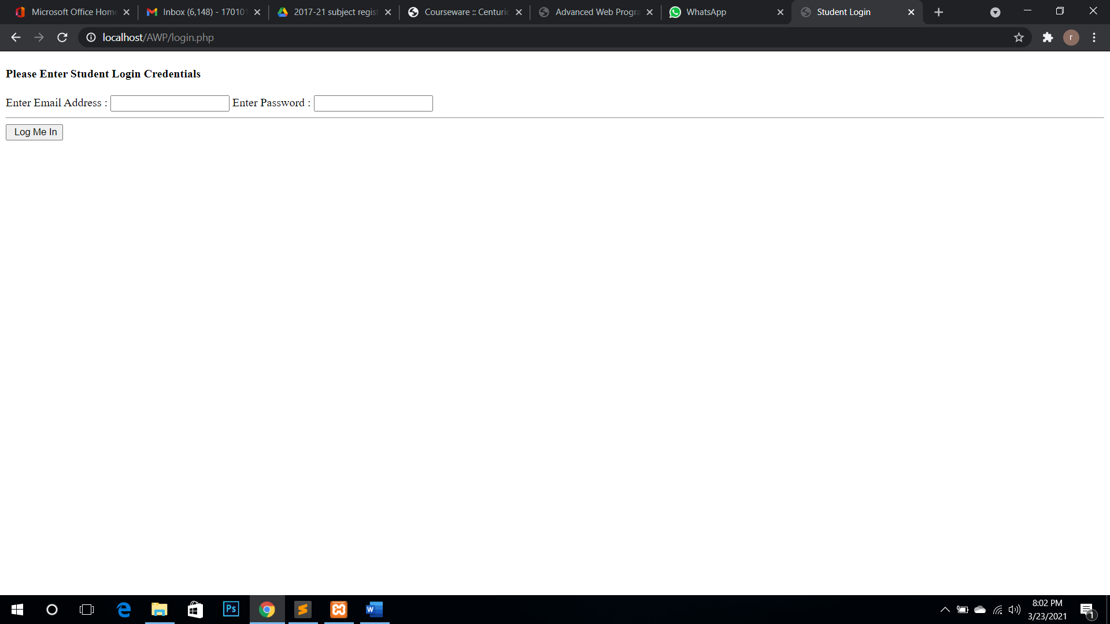

**Learning Page No:**

Assessment

|  |  |  |  |  |  |  |  |
| --- | --- | --- | --- | --- | --- | --- | --- |
| **Marking Procedure** | | **Full Marks** | | **Marks Obtained** | | **Remarks** | |
| Accuracy  & Process | Conduct of Experiment | | 10 | |  | |  | |
| Observation/Calculation/Implementation | | 10 | |  | |  | |
| Result / Inference / Output | | 10 | |  | |  | |
| Observation | | 5 | |  | |  | |
| Report | Observations(5), Implantation(20) | | 25 | |  | |  | |
| Viva |  | | 10 | |  | |  | |
| Inference |  | | 30 | |  | |  | |
| Total |  | | 100 | |  | |  | |

**Signature of Faculty Signature of the Student**

**\*Hands on & experimental Learning Page No:**