

**School of Engineering & Technology**

**Paralakhemundi Campus**

**Applied and Action Learning\***

Experiment No: Date:

Aim

Write a HTML code for table creation.

**Software‘s / Material, Tools & Equipment required (if any)**

|  |  |  |  |
| --- | --- | --- | --- |
| **Slno.** | **Name** | **Specification** | **Qnty.** |
| 1  2 | Personal laptop  XAMP | Asus, 8th Generation, 8 GB RAM.  3.2.2 | 1  1 |

**\*Hands on & experimental Learning Page No:**

<!DOCTYPE html>

<html lang="en">

<head>

<title>Table</title>

<meta charset="utf-8">

<meta name="viewport" content="width=device-width, initial-scale=1">

<link rel="stylesheet" href="https://maxcdn.bootstrapcdn.com/bootstrap/4.5.2/css/bootstrap.min.css">

<script src="https://ajax.googleapis.com/ajax/libs/jquery/3.5.1/jquery.min.js"></script>

</head>

<body>

<div class="container">

<h2>Basic Table</h2>

</p>

<table class="table">

<thead>

<tr>

<th>Firstname</th>

<th>Lastname</th>

<th>Email</th>

</tr>

</thead>

<tbody>

<tr>

<td>Voona</td>

<td>Pranayraj</td>

<td>raj@gmail.com</td>

</tr>

<tr>

<td>Gedala</td>

<td>Krsihna</td>

<td>krsih@gmail.com</td>

</tr>

<tr>

<td>Potnuru</td>

<td>Vamsi</td>

<td>vamsi@gmail.com</td>

</tr>

</tbody>

</table>

</div>

</body>

</html>

**Learning Page No:**

**CODING**

**\*Hands on & experimental Learning Page No:**

<td>Gedala</td>

<td>Krsihna</td>

<td>krsih@gmail.com</td>

</tr>

<tr>

<td>Potnuru</td>

<td>Vamsi</td>

<td>vamsi@gmail.com</td>

</tr>

</tbody>

</table>

</div>

</body>

</html>

**Learning Page No:**

**CODING**

**\*Hands on & experimental Learning Page No:**

**Conclusion / Inference:**

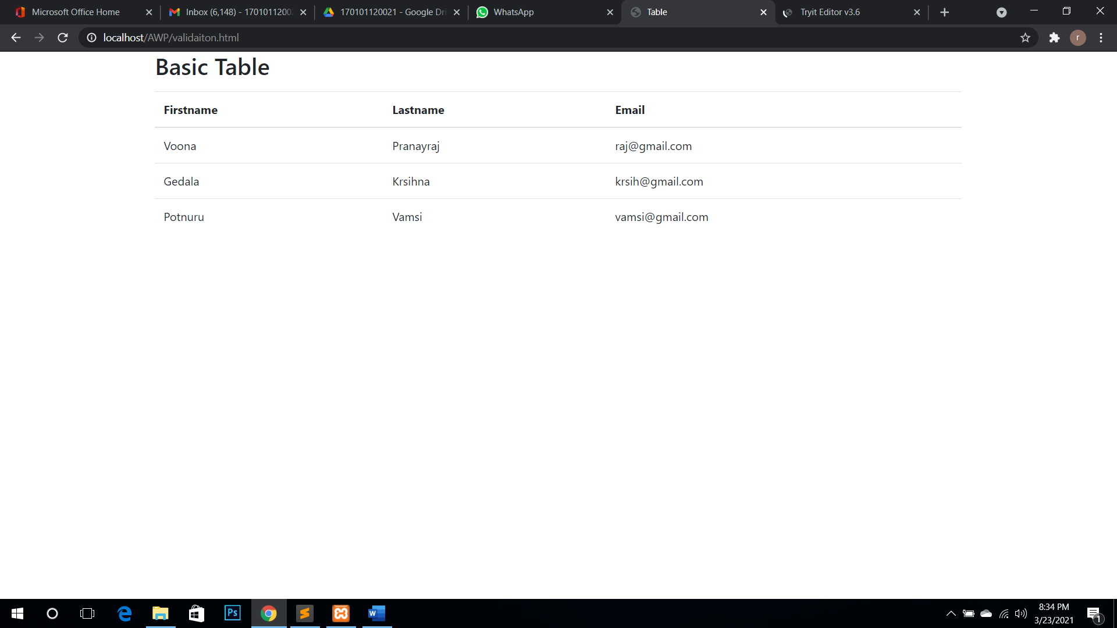

**Learning Page No:**

Assessment

|  |  |  |  |  |  |  |  |
| --- | --- | --- | --- | --- | --- | --- | --- |
| **Marking Procedure** | | **Full Marks** | | **Marks Obtained** | | **Remarks** | |
| Accuracy  & Process | Conduct of Experiment | | 10 | |  | |  | |
| Observation/Calculation/Implementation | | 10 | |  | |  | |
| Result / Inference / Output | | 10 | |  | |  | |
| Observation | | 5 | |  | |  | |
| Report | Observations(5), Implantation(20) | | 25 | |  | |  | |
| Viva |  | | 10 | |  | |  | |
| Inference |  | | 30 | |  | |  | |
| Total |  | | 100 | |  | |  | |

**Signature of Faculty Signature of the Student**

**\*Hands on & experimental Learning Page No:**