

**School of Engineering & Technology**

**Paralakhemundi Campus**

**Applied and Action Learning\***

Experiment No: Date:

Aim

Write a HTML code to create the registration form and validate using javascript.

**Software‘s / Material, Tools & Equipment required (if any)**

|  |  |  |  |
| --- | --- | --- | --- |
| **Slno.** | **Name** | **Specification** | **Qnty.** |
| 1  2 | Personal laptop  XAMP | Asus, 8th Generation, 8 GB RAM.  3.2.2 | 1  1 |

**\*Hands on & experimental Learning Page No:**

<!DOCTYPE html>

<html>

<head>

<title></title>

</head>

<body>

<h1 class="text-white text-center font-weight-bold bg-success" style="font-size: 55px;"> </h1>

<div class="container"><br>

<div class="col-lg-6 m-auto d-block">

<form action="#" onsubmit="return validation()" class="bg-light">

<div class="form-group">

<label for="user" class="font-weight-bold"> Username: </label>

<input type="text" name="user" class="form-control" id="user" autocomplete="off">

<span id="username" class="text-danger font-weight-bold"> </span>

</div>

<div class="form-group">

<label class="font-weight-bold"> Password: </label>

<input type="text" name="pass" class="form-control" id="pass" autocomplete="off">

<span id="passwords" class="text-danger font-weight-bold"> </span>

</div>

<label class="font-weight-bold"> Confirm Password: </label>

<input type="text" name="conpass" class="form-control" id="conpass"

**Learning Page No:**

**CODING**

**\*Hands on & experimental Learning Page No:**

<div class="form-group">

<label class="font-weight-bold"> Confirm Password: </label>

<input type="text" name="conpass" class="form-control" id="conpass" autocomplete="off">

<span id="confrmpass" class="text-danger font-weight-bold"> </span>

</div>

<div class="form-group">

<label class="font-weight-bold"> Mobile Number: </label>

<input type="text" name="mobile" class="form-control" id="mobileNumber" autocomplete="off">

<span id="mobileno" class="text-danger font-weight-bold"> </span>

</div>

<div class="form-group">

<label class="font-weight-bold"> Email: </label>

<input type="text" name="email" class="form-control" id="emails" autocomplete="off">

<span id="emailids" class="text-danger font-weight-bold"> </span>

</div>

<input type="submit" name="submit" value="submit" class="btn btn-success" autocomplete="off">

</form><br><br>

</div>

</div>

<script type="text/javascript">

function validation(){

var user = document.getElementById('user').value;

var pass = document.getElementById('pass').value;

var confirmpass = document.getElementById('conpass').value;

var mobileNumber = document.getElementById('mobileNumber').value;

var emails = document.getElementById('emails').value;

**Learning Page No:**

**CODING**

**\*Hands on & experimental Learning Page No:**

if(user == ""){

document.getElementById('username').innerHTML =" ** Please fill the username field";

return false;

}

if((user.length <= 2) || (user.length > 20)) {

document.getElementById('username').innerHTML =" ** Username lenght must be between 2 and 20";

return false;

}

if(!isNaN(user)){

document.getElementById('username').innerHTML =" ** only characters are allowed";

return false;

}

if(pass == ""){

document.getElementById('passwords').innerHTML =" ** Please fill the password field";

return false;

}

if((pass.length <= 5) || (pass.length > 20)) {

document.getElementById('passwords').innerHTML =" ** Passwords lenght must be between 5 and 20";

return false;

}

if(pass!=confirmpass){

document.getElementById('confrmpass').innerHTML =" ** Password does not match the confirm password";

return false;

}

if(confirmpass == ""){

document.getElementById('confrmpass').innerHTML =" ** Please fill the confirmpassword field";

return false;

}

if(mobileNumber == ""){

document.getElementById('mobileno').innerHTML =" ** Please fill the mobile NUmber field";

return false;

}

if(isNaN(mobileNumber)){

document.getElementById('mobileno').innerHTML =" ** user must write digits only not characters";

return false;

}

if(mobileNumber.length!=10){

document.getElementById('mobileno').innerHTML =" ** Mobile Number must be 10 digits only";

return false;

}

if(emails == ""){

document.getElementById('emailids').innerHTML =" ** Please fill the email idx` field";

return false;

}

if(emails.indexOf('@') <= 0 ){

document.getElementById('emailids').innerHTML =" ** @ Invalid Position";

return false;

}

if((emails.charAt(emails.length-4)!='.') && (emails.charAt(emails.length-3)!='.')){

document.getElementById('emailids').innerHTML =" ** . Invalid Position";

return false;

}

}

</script>

</body>

</html>

**Learning Page No:**

**CODING**

**\*Hands on & experimental Learning Page No:**

**Conclusion / Inference:**

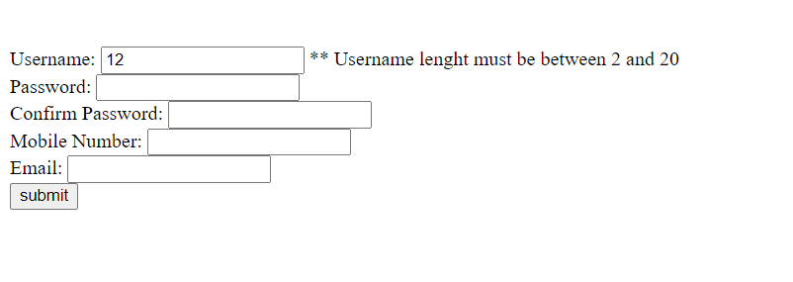

**Learning Page No:**

Assessment

|  |  |  |  |  |  |  |  |
| --- | --- | --- | --- | --- | --- | --- | --- |
| **Marking Procedure** | | **Full Marks** | | **Marks Obtained** | | **Remarks** | |
| Accuracy  & Process | Conduct of Experiment | | 10 | |  | |  | |
| Observation/Calculation/Implementation | | 10 | |  | |  | |
| Result / Inference / Output | | 10 | |  | |  | |
| Observation | | 5 | |  | |  | |
| Report | Observations(5), Implantation(20) | | 25 | |  | |  | |
| Viva |  | | 10 | |  | |  | |
| Inference |  | | 30 | |  | |  | |
| Total |  | | 100 | |  | |  | |

**Signature of Faculty Signature of the Student**

**\*Hands on & experimental Learning Page No:**