

**School of Engineering & Technology**

**Paralakhemundi Campus**

**Applied and Action Learning\***

Experiment No: Date:

Aim

Write a HTML code to perform image hyperlink.

**Software‘s / Material, Tools & Equipment required (if any)**

|  |  |  |  |
| --- | --- | --- | --- |
| **Slno.** | **Name** | **Specification** | **Qnty.** |
| 1  2 | Personal laptop  XAMP | Asus, 8th Generation, 8 GB RAM.  3.2.2 | 1  1 |

**\*Hands on & experimental Learning Page No:**

<!DOCTYPE html>

<html>

<body>

<h1>Add a hyperlink to an image </h1>

<p><a href="image7.jpg">

<img src="image6.jpg"  >

</a></p>

</body>

</html>

**Learning Page No:**

**CODING**

**\*Hands on & experimental Learning Page No:**

**Conclusion / Inference:**

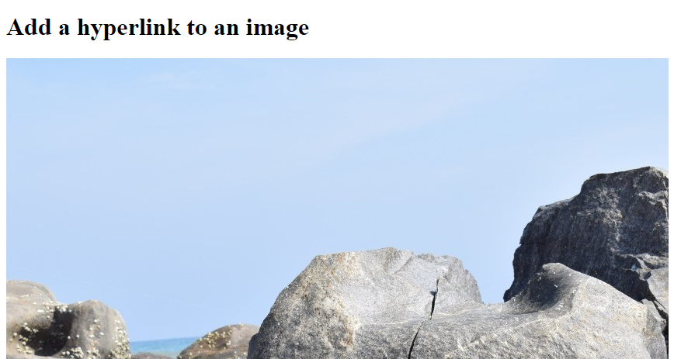

**Learning Page No:**

Assessment

|  |  |  |  |  |  |  |  |
| --- | --- | --- | --- | --- | --- | --- | --- |
| **Marking Procedure** | | **Full Marks** | | **Marks Obtained** | | **Remarks** | |
| Accuracy  & Process | Conduct of Experiment | | 10 | |  | |  | |
| Observation/Calculation/Implementation | | 10 | |  | |  | |
| Result / Inference / Output | | 10 | |  | |  | |
| Observation | | 5 | |  | |  | |
| Report | Observations(5), Implantation(20) | | 25 | |  | |  | |
| Viva |  | | 10 | |  | |  | |
| Inference |  | | 30 | |  | |  | |
| Total |  | | 100 | |  | |  | |

**Signature of Faculty Signature of the Student**

**\*Hands on & experimental Learning Page No:**