

**School of Engineering & Technology**

**Paralakhemundi Campus**

**Applied and Action Learning\***

Experiment No: Date:

Aim

Write a HTML code to perform mathematical operations.

**Software‘s / Material, Tools & Equipment required (if any)**

|  |  |  |  |
| --- | --- | --- | --- |
| **Slno.** | **Name** | **Specification** | **Qnty.** |
| 1  2 | Personal laptop  XAMP | Asus, 8th Generation, 8 GB RAM.  3.2.2 | 1  1 |

**\*Hands on & experimental Learning Page No:**

<html>

<head>

<Script type="text/javascript">

function add()

{

var num1 = document.getElementById("firstnum").value;

var num2 = document.getElementById("secnum").value;

num1 = parseInt(num1)

num2 = parseInt(num2)

var res = num1+num2

alert("The sum of x and y is:"+ res);

}

function sub()

{

var num1 = document.getElementById("firstnum").value;

var num2 = document.getElementById("secnum").value;

var res = num1-num2

alert("The difference between x and y is:"+ res);

}

function mul()

{

var num1 = document.getElementById("firstnum").value;

var num2 = document.getElementById("secnum").value;

alert("The munltiplication of x and y is:"+ num1*num2);

}

function divide()

{

var num1 = document.getElementById("firstnum").value;

var num2 = document.getElementById("secnum").value;

alert("division of x and y is:"+ num1/num2);

}

</script>

</head>

<body>

<form>

X:<input type="text" id="firstnum" /><br><br>

Y:<input type="text" id="secnum" /><br><br>

<input type="submit" value="x+y" onclick="add();">

<input type="submit" value="x-y" onclick="sub();"><br><br>

<input type="submit" value="x*y" onclick="mul();">

<input type="submit" value="x/y" onclick="divide();">

</form>

</body>

</html>

**Learning Page No:**

**CODING**

**\*Hands on & experimental Learning Page No:**

var num2 = document.getElementById("secnum").value;

alert("division of x and y is:"+ num1/num2);

}

</script>

</head>

<body>

<form>

X:<input type="text" id="firstnum" /><br><br>

Y:<input type="text" id="secnum" /><br><br>

<input type="submit" value="x+y" onclick="add();">

<input type="submit" value="x-y" onclick="sub();"><br><br>

<input type="submit" value="x*y" onclick="mul();">

<input type="submit" value="x/y" onclick="divide();">

</form>

</body>

</html>

**Learning Page No:**

**CODING**

**\*Hands on & experimental Learning Page No:**

**Conclusion / Inference:**

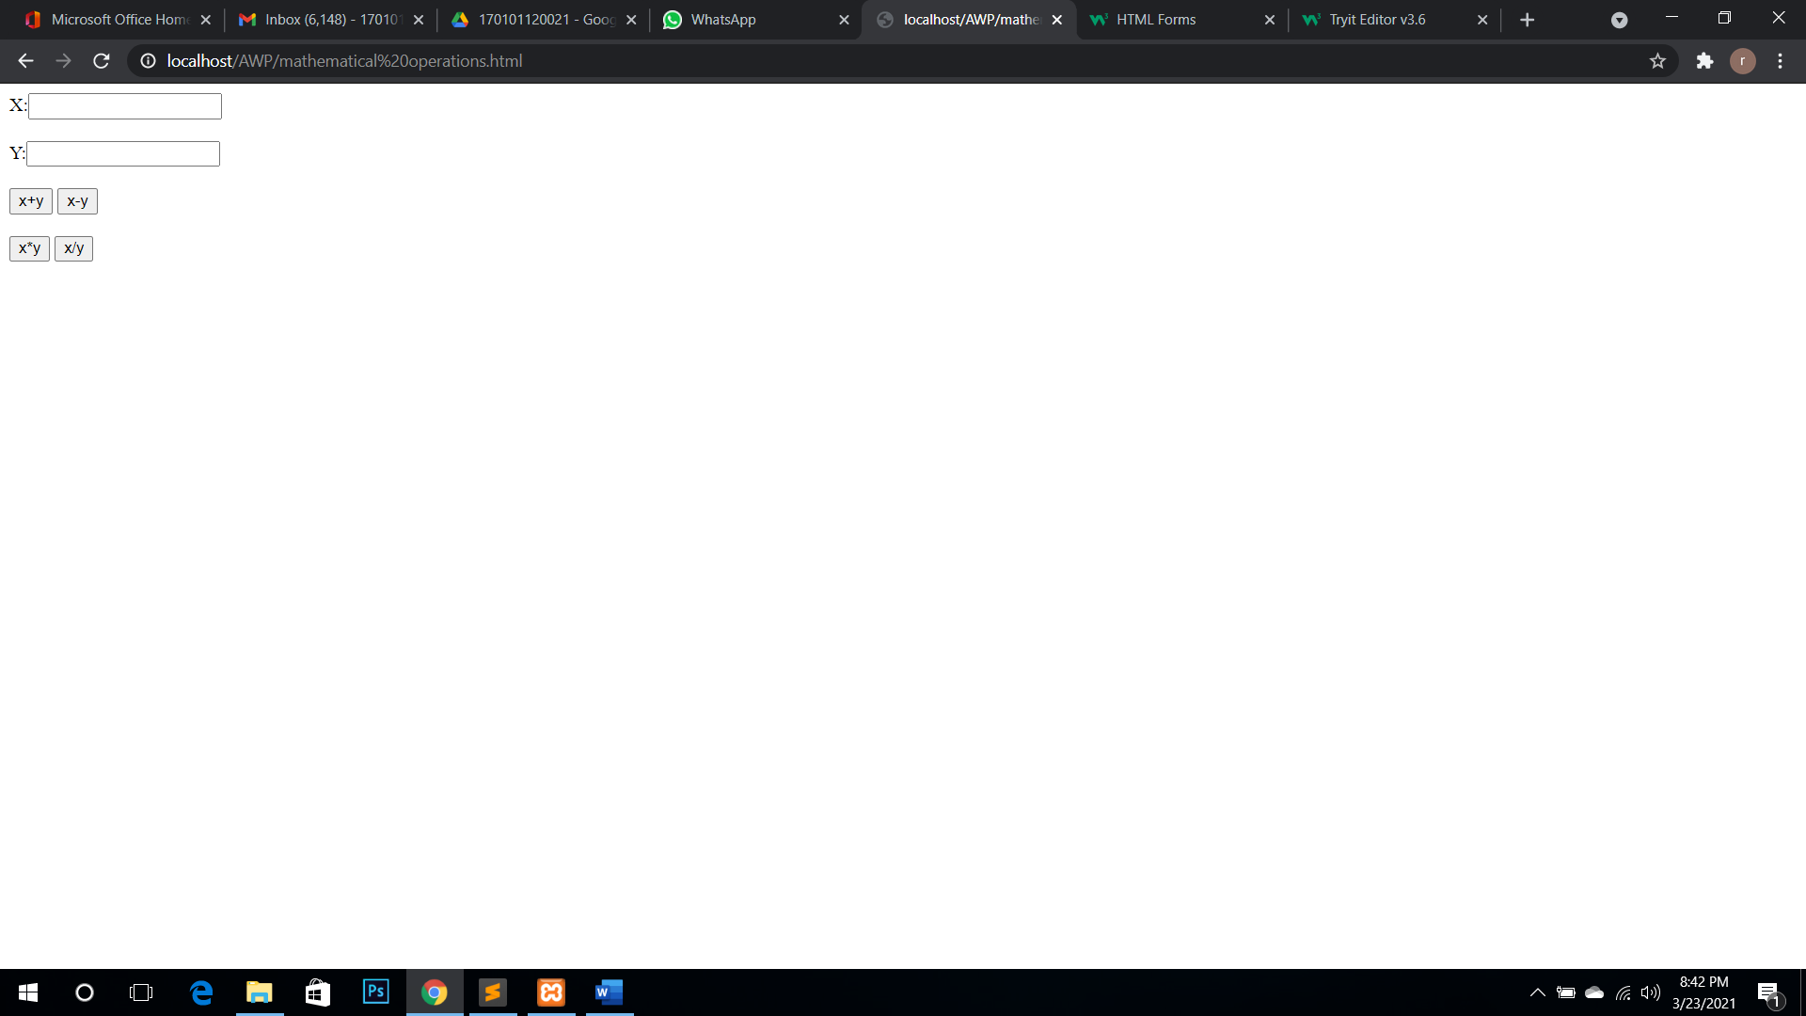

**Learning Page No:**

Assessment

|  |  |  |  |  |  |  |  |
| --- | --- | --- | --- | --- | --- | --- | --- |
| **Marking Procedure** | | **Full Marks** | | **Marks Obtained** | | **Remarks** | |
| Accuracy  & Process | Conduct of Experiment | | 10 | |  | |  | |
| Observation/Calculation/Implementation | | 10 | |  | |  | |
| Result / Inference / Output | | 10 | |  | |  | |
| Observation | | 5 | |  | |  | |
| Report | Observations(5), Implantation(20) | | 25 | |  | |  | |
| Viva |  | | 10 | |  | |  | |
| Inference |  | | 30 | |  | |  | |
| Total |  | | 100 | |  | |  | |

**Signature of Faculty Signature of the Student**

**\*Hands on & experimental Learning Page No:**