HTML/CSS/JAVASCRIPT

HTML Body

CSS Beauty

JAVASCRIPT Brain

1. How does a website work?

First a website has a domain name which we search for on the net, the domain name requests to the server for the IP address of the domain name and using the domain name it opens the website.



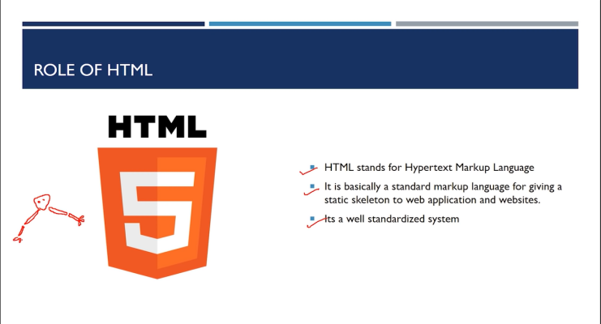

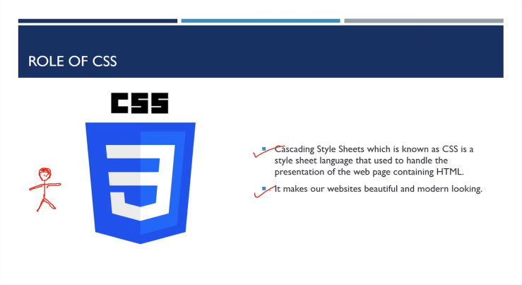

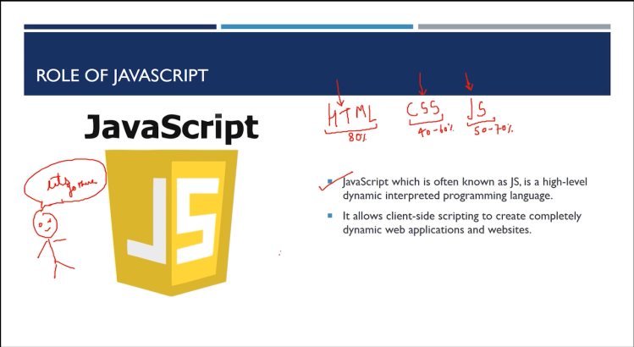

1. Understanding HTML Boiler plate

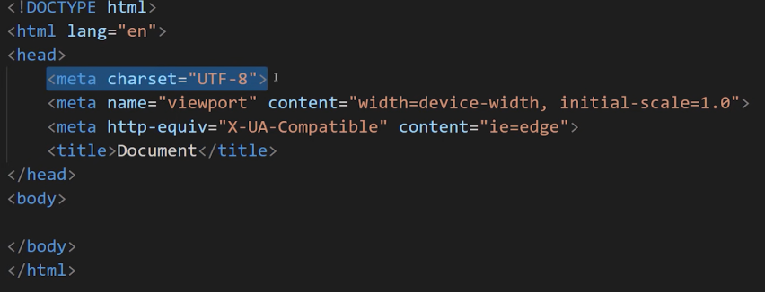

DOCTYPE html: Browser understands many languages but HTML is basic language understood by the web.

Lang=en means english

Meta tag is tag that gives info about data we write

1. Comment <!-- comment --> shortcut ctrl+/
2. What is SEO?

SEO stands for “search engine optimization.” In simple terms, it means the process of improving your site to increase its visibility when people search for products or services related to your business in Google, Bing, and other [search engines](https://searchengineland.com/guide/google-searching-search-engines). The better visibility your pages have in search results, the more likely you are to garner attention and attract prospective and existing customers to your business.

Meta tag helps a lot in SEO.

<meta name="description" content="This is description">

    <meta name="keywords" content="HTML,CSS,JS">

    <meta name="Robots" content="INDEX,FOLLOW">

Description gives description of the website

Keywords are used to match search engine inputs

Robot ranks our website and follows the links given inside

1. Linking CSS AND js

<!-- This is how you link css file -->

    <link rel="stylesheet" href="style.css">

    <!-- This is how you link Javascript file-->

    <script src="Demo.js"></script>

<!-- There are ONLY 6 Heading tags in HTML (h1-h6) -->

    <h1>Heading 1</h1>

    <h2>Heading 2</h2>

    <h3>Heading 3</h3>

    <h4>Heading 4</h4>

    <h5>Heading 5</h5>

    <h6>Heading 6</h6>

    <!-- press lorem and then number of words you want e.g lorem10 then press enter,then automatically dummy text of 10 words are inserted -->

    <!-- Press alt+z if text is not going to the next line and you are getting a horizontal bar to view the text -->

    <!-- strong is to make text bold

    em is used to make text italics

    br is used for a line break

    br is a SELF-CLOSING TAG

    hr is for horizontal line -->

1. Anchor tag:

The <a> tag (anchor tag) in HTML is used to create a hyperlink on the webpage.hyperlink is used to link the webpage to other web pages or some section of the same web page. It's either used to provide an absolute reference or a relative reference as its “href” value.

The HREF is an attribute of the anchor tag, which is also used to identify sections within a document. The HREF contains two components: the URL, which is the actual link, and the clickable text that appears on the page, called the "anchor text." Relative (implicit) and Absolute (explicit) Links.

The target attribute specifies where to open the linked document

Eg

<a href="https://www.google.com/" target="_blank">Google</a><br>

1. Img tag

Image tag is used to insert image

<!-- img is the image tag, src is used to find image source and alt is text shown incase the picture doesn't load -->

        <br><img src="https://source.unsplash.com/random" alt="Error loading">

1. Tables

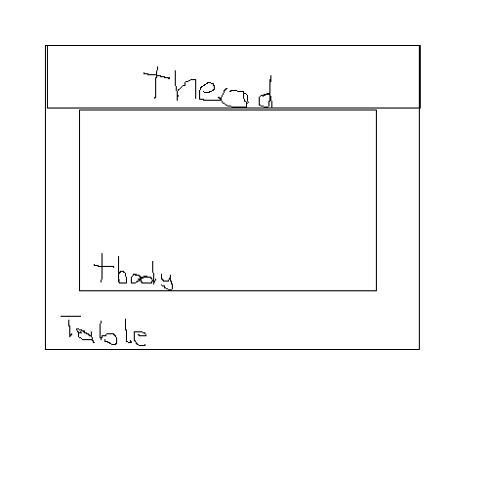

Table tag is used to create table

Thead is used for the column names

Tbody is for column data

Tr is used everytime we are going to a new row

Td is used when entering data

1. What is div?

The <div> tag defines a division or a section in an HTML document. The <div> tag is used as a container for HTML elements - which is then styled with CSS or manipulated with JavaScript

1. What is name in form?

The name attribute specifies the name of an <input> element. The name attribute is used to reference elements in a JavaScript, or to reference form data after a form is submitted.

Example name <input type=”text” name=”my name”>

1. What is block element?

A block-level element always starts on a new line, and the browsers automatically add some space (a margin) before and after the element.

A block-level element always takes up the full width available (stretches out to the left and right as far as it can).

Two commonly used block elements are: <p> and <div>.

The <p> element defines a paragraph in an HTML document.

The <div> element defines a division or a section in an HTML document.

1. What is inline element?

An inline element does not start on a new line.

An inline element only takes up as much width as necessary

Eg <span>,strong,em,anchor tag

1. What are classes and ids?

Classes he class attribute specifies one or more classnames for an element. The class attribute is mostly used to point to a class in a style sheet. Those using class name will get properties of the class

Id is unique identification to identify a certain element

Class can be used by all but id is unique to everyone

1. Emmet for class and id?

. is for class and #is for id

If I write span.classname then it becomes <span class=”classname”></span>

If I write span#idname then it becomes <span id=”idname”></span>

If I write span.class1.class2 then it becomes <span class=”class1 class2”></span>

NOTE:Emmet takes div as default

So If I write .class1 then it becomes <div class=”class1”></div>

If I write span.classname*4 then it becomes <span class=”classname”></span> written 4 times

EMMET IS ONLY FOR VSCODE

1. What are HTML entities?

HTML entities are used to display reserved characters in html like $,<,>

Refer this <https://dev.w3.org/html5/html-author/charref>

1. What is details?

The <details> tag specifies additional details that the user can open and close on demand.

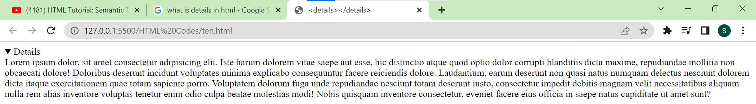

1. What are sematic tags?

A semantic element clearly describes its meaning to both the browser and the developer.

Examples of non-semantic elements: <div> and <span> - Tells nothing about its content.

Examples of semantic elements: <form>, <table>, and <article> - Clearly defines its content.

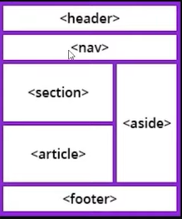

1. What is CSS?

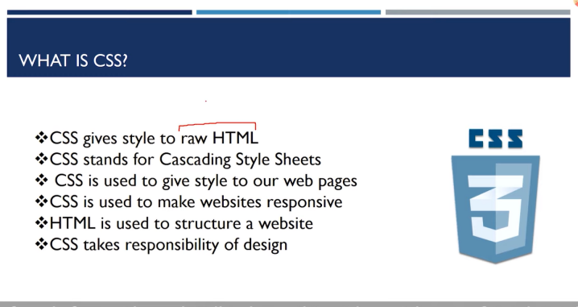

1. What is responsiveness?

Responsive web design (RWD) is a web development approach that creates dynamic changes to the appearance of a website, depending on the screen size and orientation of the device being used to view it

1. Syntax of CSS?

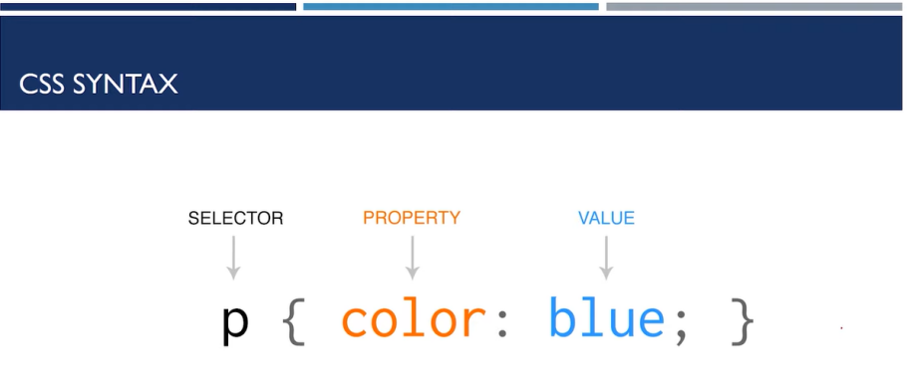

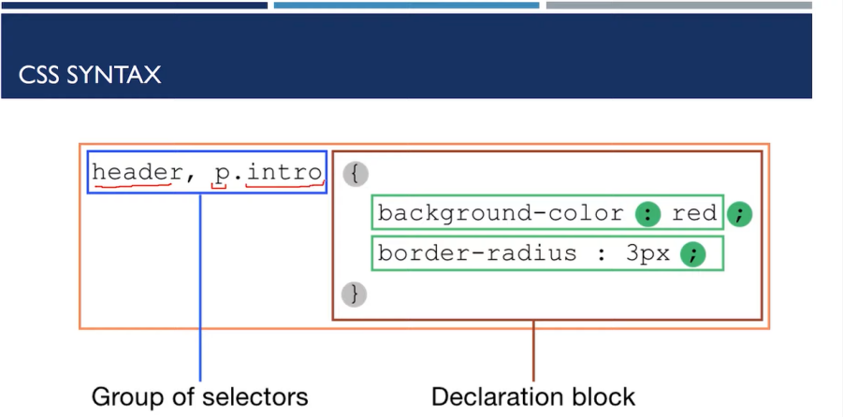

1. What is markup?

Markup is name for HTML

1. Ways to add CSS?

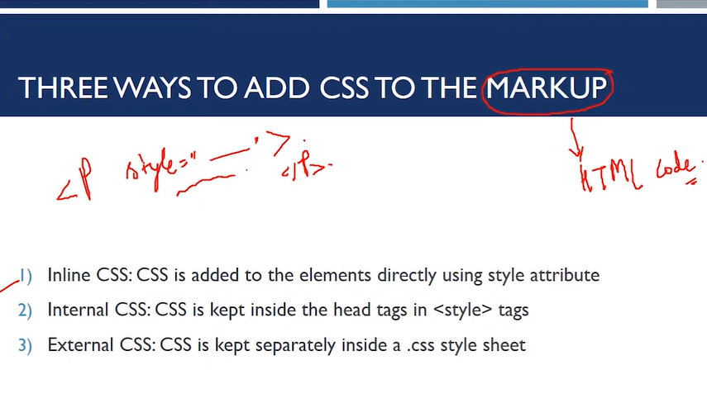

1. If I use both internal and external CSS then which will be implemented?

Whoever comes last will overwrite the previous one.

1. How to stop overwrite?

To stop overwrite put !important.

Example:

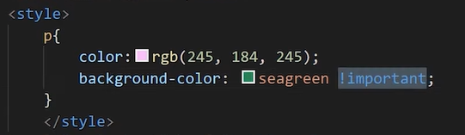

1. Syntax to apply internal css for a specific id?

Syntax:

#idname{ style property}

1. What are span and footer?

The <footer> tag defines a footer for a document or section.

A <footer> element typically contains:

authorship information

copyright information

contact information

sitemap

back to top links

A <span> element which is used to color a part of a text:

<p>My mother has <span style="color:blue">blue</span> eyes.</p>

1. What are the ways to use CSS selectors?

4 ways:

CSS element selector

CSS id selector

CSS class selector

CSS group selector

Universal selector

1. How to add comment in CSS?

/* */

1. What is font family,font size,line height?

The font-family property specifies the font for an element.

The font-family property can hold several font names as a "fallback" system. If the browser does not support the first font, it tries the next font.

Example

font-family: 'Franklin Gothic Medium', 'Arial Narrow', Arial, sans-serif;

We can use google fonts to add more fonts

Font size is to determine size of the font

Line height is the **spacing** between two lines

1. Web safe fonts are fonts supported by the OS
2. Pixels to em to inches

1 pixel=1/16 em=1/96 inches

1. 3 ways of adding colour in CSS?

Color,rgb,hex value

In CSS, a color can be specified using a hexadecimal value in the form:

#rrggbb

Where rr (red), gg (green) and bb (blue) are hexadecimal values between 00 and ff (same as decimal 0-255).

For example, #ff0000 is displayed as red, because red is set to its highest value (ff) and the others are set to the lowest value (00).

The rgb() function define colors using the Red-green-blue (RGB) model.

An RGB color value is specified with: rgb(red, green, blue). Each parameter defines the intensity of that color and can be an integer between 0 and 255 or a percentage value (from 0% to 100%).

1. What is CSS box?

Basically in CSS box

First there is content,then if we use padding then distance between content and border changes

Then comes border and finally margin changes space between webpage and the border.

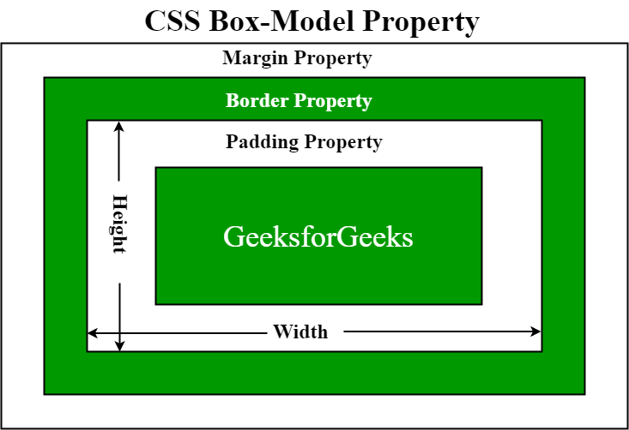

1. The box-sizing property allows us to include the padding and border in an element's total width and height.
2. What is overflow in CSS?

The CSS overflow property controls what happens to content that is too big to fit into an area.



Types of positioning in CSS:

1. Static(By default)
2. Absolute
3. Relative
4. Fixed
5. Sticky

